**e|-------------------0-----------------------------------|**

**B|---0-2-0-------0-2--1/2---------2-2-3-2---------3-1/2--|**

**G|-2-------2-2-2----------2---2-----------1---1-1-1-1/2--|**

**D|--------------------------2-------------2--------------|**

**A|------------------------------0------------------------|**

**E|------------------------------------------0------------|**

**e|---------------------0-------------------------0---0-------|**

**B|---0-2-0---------0-2---1/2-------2-2-3-2---------0---0---2-|**

**G|-2---2-----2---2-----------2-------------0-1-------------2-|**

**D|---------2-------------------2---------------2---------2---|**

**A|-------------0-----------------0---------------------------|**

**E|-----------------------------------------------------------|**

**e|------------------------------|**

**B|-------2-2-----2--------2-2---|**

**G|-2--2------2-2----2--2------2-|**

**D|------------------------------|**

**A|------------------------------|**

**E|------------------------------|**

**e|---------------------------0-------------------------------|**

**B|---0-2-0-------------0-1/2---1/2-----------2-2-2-3-2-------|**

**G|-2-------2---------2-----------------------2---------0-1---|**

**D|-----------2---------------------2-----------------------2-|**

**A|-------------0-0-0-----------------0-0-0-0-----------------|**

**E|-----------------------------------------------------------|**

**e|---------------------|**

**B|-3-----3-1-2---------|**

**G|---1---1-1-2---------|**

**D|-----2-2-----2-------|**

**A|---------------0-0-0-|**

**E|---------------------|**

[Verse]

A G A

Tender is the night, lying by your side

A G A

Tender is the touch, of someone that you love too much

A G A

Tender is the day, the demons go away

A G A

Lord, I need to find, someone who can heal my mind

[Chorus]

A D C

Come on, come on, come on get through it

A C#m D

Come on, come on, come on, love's the greatest thing

A D C

Come on, come on, come on get through it

A C#m D

Come on, come on, come on, love's the greatest thing

C#m D

that we have

C#m D

I'm waiting for that feeling

C#m D

Waiting for that feeling

A D/G A

Waiting for that feeling to come

[Bridge]

A E7 A

Oh my baby, oh my baby, oh why, oh my

A E7 A

Oh my baby, oh my baby, oh why, oh my

[Verse]

A G A

Tender is the ghost, the ghost I love the most

A G A

Hiding from the sun, just waiting for the night to come

A G A

Tender is my heart, for screwing up my life

A G A

Lord, I need to find, someone who can heal my mind

[Chorus]

A D C

Come on, come on, come on get through it

A C#m D

Come on, come on, come on, love's the greatest thing

A D C

Come on, come on, come on get through it

A C#m D

Come on, come on, come on, love's the greatest thing

C#m D

that we have

C#m D

I'm waiting for that feeling

C#m D

Waiting for that feeling

A D/G A

Waiting for that feeling to come

[Bridge] (CHOIR JOINS IN)

A E7 A

Oh my baby, oh my baby, oh why, oh my

A E7 A

Oh my baby, oh my baby, oh why, oh my

**[Solo]**

**e|----------------------------------5-3-0-2-3-2-0--------------------|**

**B|-------5--------------------2--------------------------------------|**

**G|-5-5-5---5-0------------------2-----------------5-0----------------|**

**D|----------------0-2-0-----------------------------------0-2-0------|**

**A|------------0-2-------2-0-0-----0-------------------0-2------2-0-0-|**

**E|-------------------------------------------------------------------|**

[Chorus]

A D C

Come on, come on, come on get through it

A C#m D

Come on, come on, come on, love's the greatest thing

A D C

Come on, come on, come on get through it

A C#m D

Come on, come on, come on, love's the greatest thing

C#m D

that we have

C#m D

I'm waiting for that feeling

C#m D

Waiting for that feeling

A D/G A

Waiting for that feeling to come

A E7 A

Oh my baby, oh my baby, oh why, oh my x8

Strumming pattern:

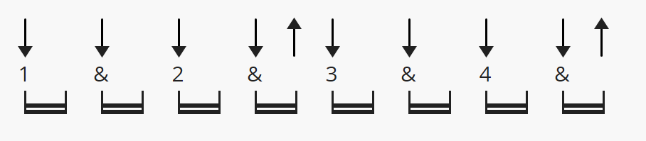

**TENDER**……….

blur………..