Xenomorph Firmware Update Instructions

Download to Xenomorph requires a terminal program, such as Hyperterminal for the PC, that can send a characters from key presses and send a text file to the controller (with no headings, just plain text).

The following document assumes that the user has access to a PC with hyperterminal. Please discuss with Codemonkey if this is not the case!!

PLEASE FOLLOW THESE INSTRUCTIONS VERY CAREFULLY Failure to do so can cause engine damage or damage to your Xenomorph

Save your parameters in TunerStudio! Downloading will overwrite them!!

Turn your engine and ignition off!!! (The controller can be updated away from the car if desired )

Connect the USB cable to your computer. Do not open TunerStudio (close if it is open).

Open hyperterminal on the PC (standard software under All Programs\Accessories\Communications\Hyperterminal)

Create a new connection called ‘GTti’

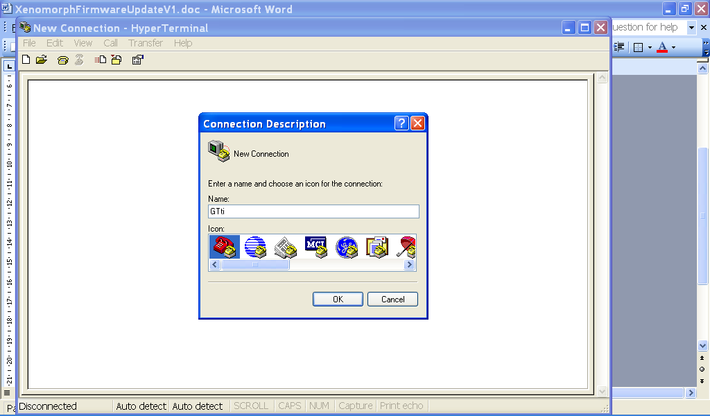

Connect using the COM port that your computer allocates to Xenomorph (e.g. COM3, or COM9 etc.)

Adjust the communications settings as below: (115200, 8, None, 1, None)

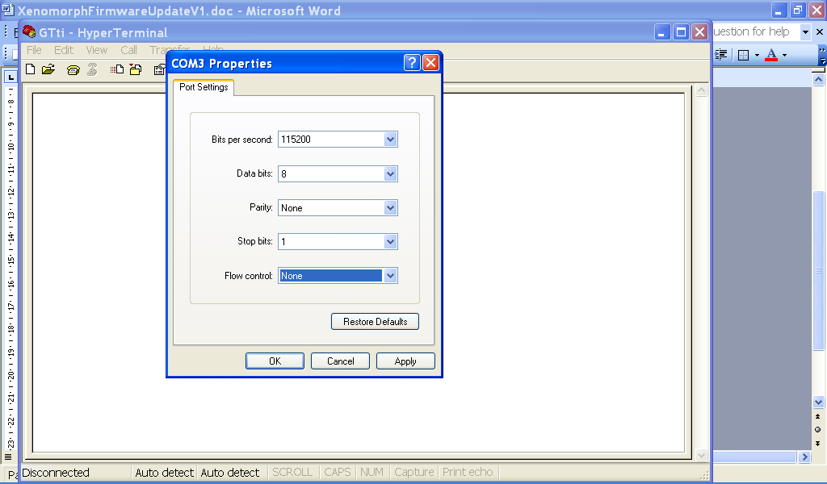

Click ‘Apply’ then the communications screen is presented.

Press ‘Q’ or ‘q’ on the keyboard, and Xenomorph will reply with the running software version

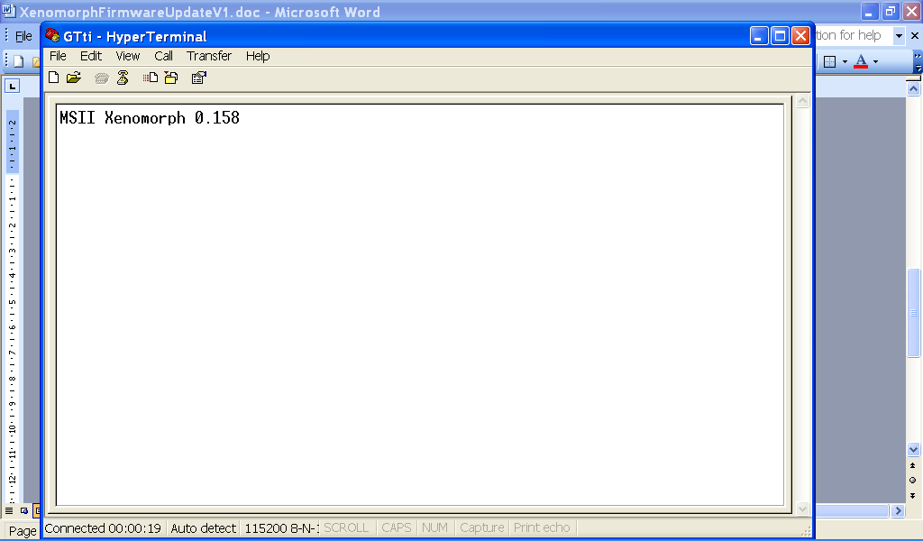

To get the controller ready for download, press the following keys in quick succession:

X B L

(meaning Xeno Boot Loader)

The unit should (if you were quick enough) reply with
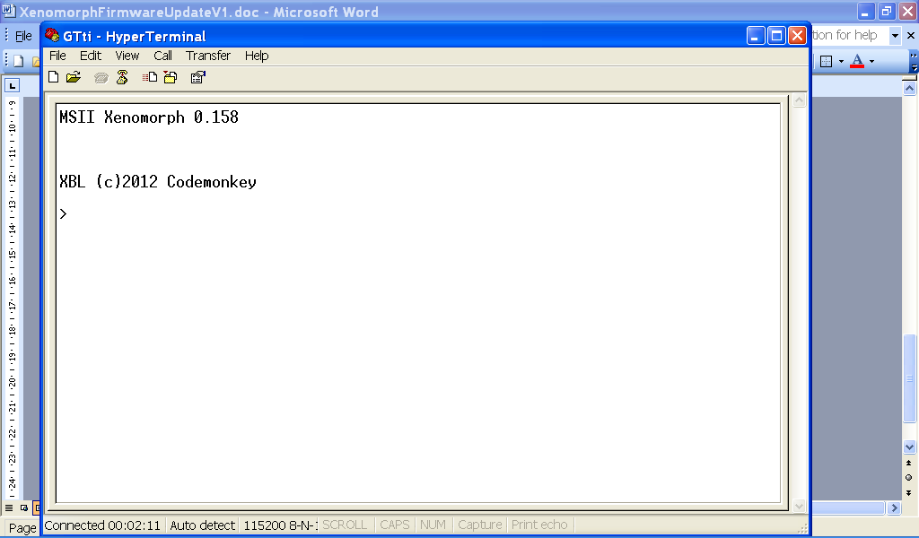

….indicating that it is in bootloader, ready for software download.

If you get to this point by accident, and want to get back to the application, press ‘R’

The bootloader has some hidden commands. Please do not randomly press any keys, you may well destroy the unit!

Commands available are:

‘R’ or ‘r’ – reboot the controller (exit bootloader, or download finished)
‘Z’ or ‘z’ – Report the unit serial number and build date
‘W’ or ‘w’ – Erase the application software ready for a download MUST BE DONE BEFORE SENDING NEW SOFTWARE!!

To download, press ‘W’ or ‘w’. After a short delay, the unit will reply:
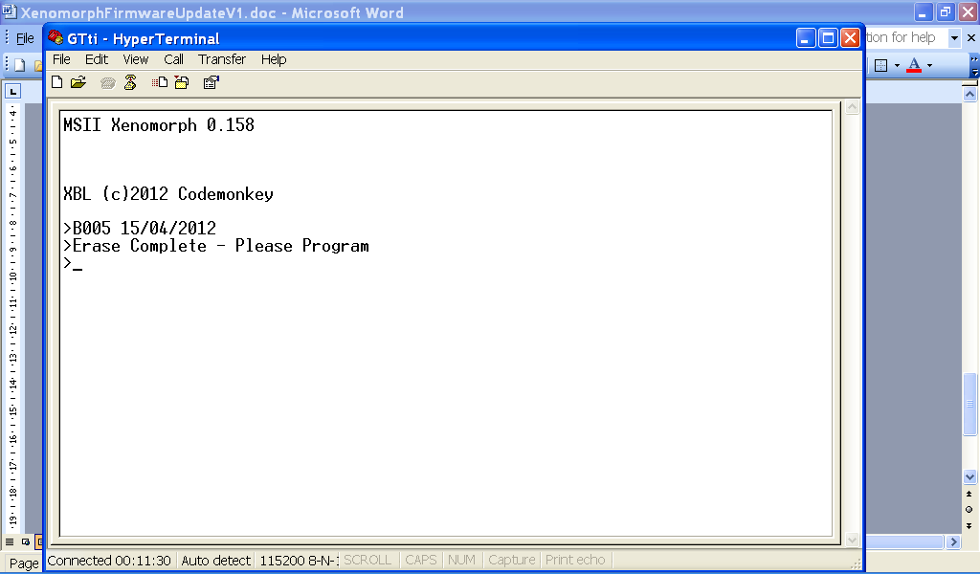

Then, select ‘Transfer->Send Text File…’

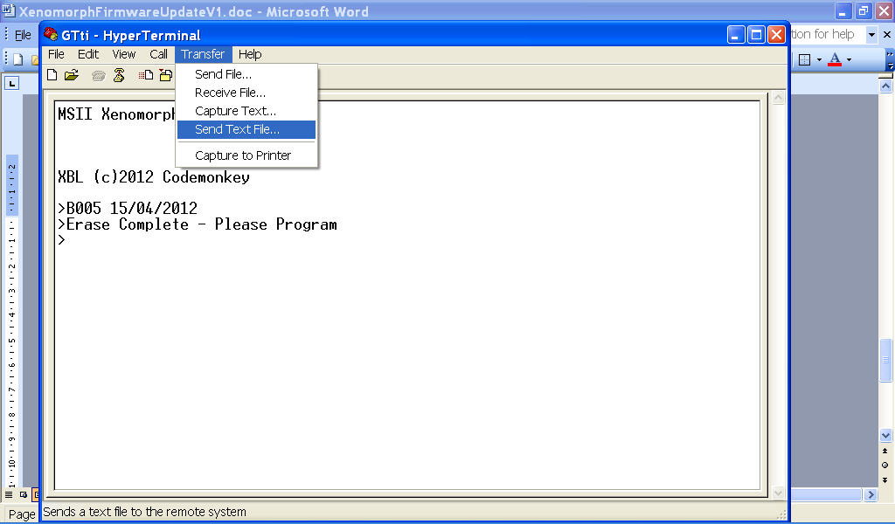

And select the file to download….

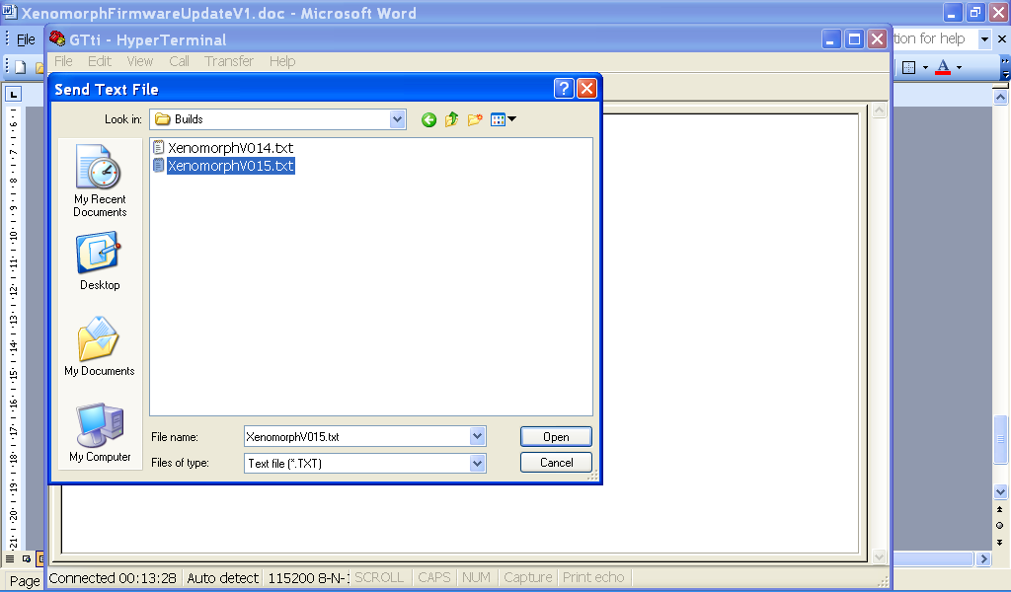

Select the file, then select ‘Open’

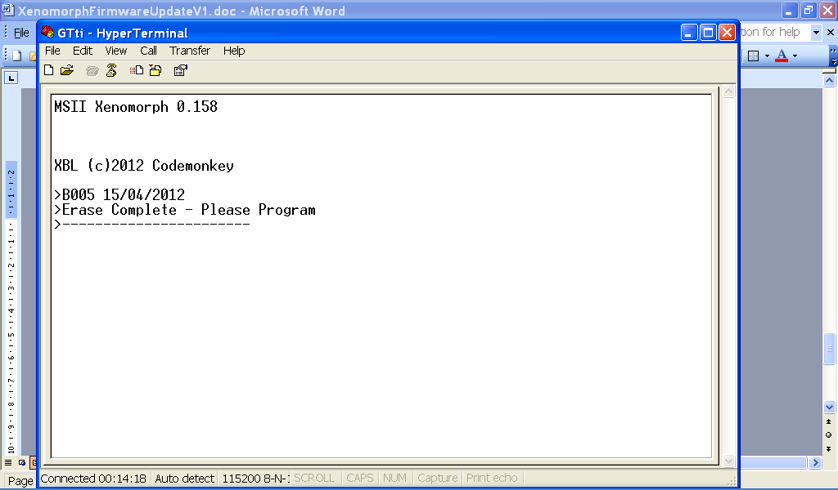

The unit will slowly reply a chain of ‘-‘ indicating that it is receiving blocks. This will take 2-3 minutes in total. When finished, the unit will report….

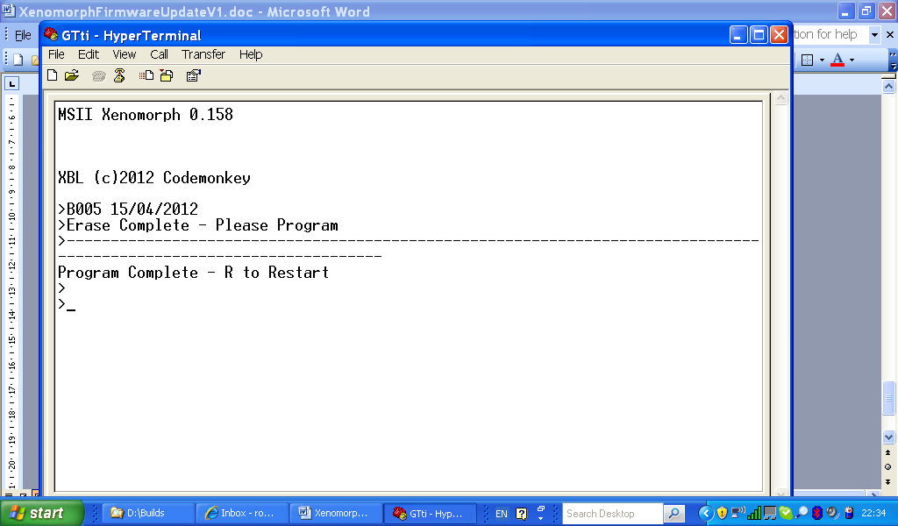

Press ‘R’ and the new application should start to run. Pressing ‘Q’ should return the new software version, such as…..

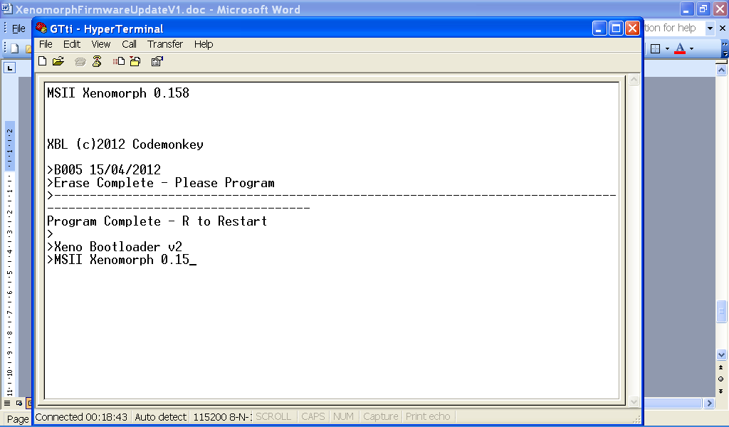

Exit Hyperterminal – the process is complete.

Before opening TunerStudio, you will need to place the following files that come with the build as explained….(the file names will be similar to the below only)

Xenomorphx.x.x.ini - this is a label file for the software build in the controller, and you need to put in (default directory - after downloading TunerStudioMSLite):
c:\Program Files\EFIAnalytics\TunerStudioMS\config\ecuDef\

XenomorphGTtixxx.dash - This is the standard dashboard (guage cluster) that I use for Xenomorph. You need to put it in:
c:\Program Files\EFIAnalytics\TunerStudioMS\Dash\

