Xenomorph GTti

Installation and Setup

© 2011-onwards Codemonkey

Installation/Getting Started

You will need a PC laptop, with a USB port, and preferably Windows XP or similar. The following notes are from an installation on a computer that has not had Xenomorph near it.

- Go to https://www.efianalytics.com/TunerStudio/download/ , and download Tuner Studio MS Lite (it’s a free download of the MS lite version)
- Run the installer
- Install to the default C:\Program Files\EFIAnalytics\TunerStudioMS
- Let the installer finish, then let it launch the program (just to make sure that it works)
- Exit the program
- Download the latest version of firmware and configuration files from http://www.gttioc.com/index.php/downloads/xenomorph
- Unzip the file into an empty folder
- From the unzipped files, copy the file ‘Xenomorph.x.y.z.ini to C:\Program Files\EFIAnalytics\TunerStudioMS\config\ecuDef and file XenomorphGTTiXYZ.dash to C:\Program Files\EFIAnalytics\TunerStudioMS\Dash
- Download the device driver for Xenomorph from http://www.silabs.com/products/mcu/pages/usbtouartbridgevcpdrivers.aspx under the VCP Driver Kit link. The device that Xenomorph uses is CP2101.
- Connect the USB lead from the Xenomorph to your computer (This will power the Xenomorph up from the USB power supply, so be careful with the unit from here).
- The PC should now recognise it with the drivers that were installed
- Start TunerStudio from the program files menu
- In Tuner Studio go to ‘File’ then ‘New Project’
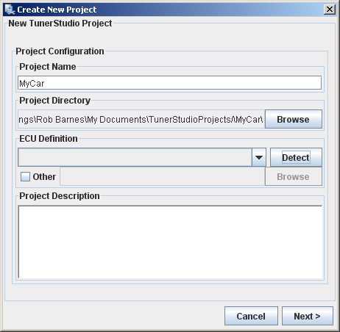

- The above dialogue will open. Set the name to Project Name to GTti.
- Click ‘Detect’ under ECU Definition.
- If all is well so far, you should get….

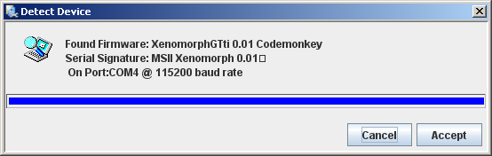

- ..or something similar. It must show the XenomorphGTti X.YZ Codemonkey Firmware.
- Accept the ‘Detect Device’ window, then Click ‘Next>’ and ‘Next>’ again on the next window (specific for MS-II – don’t worry about it)
- If all is well, the next window should say….

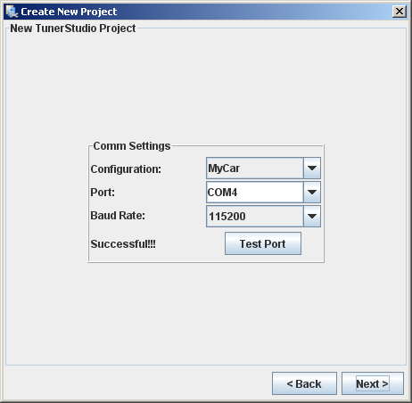

- You can click ‘Test Port’ if there are any problems. It might get upset about COM ports (the prototype is a COM port emulation just so that TunerStudio can be used)
- Click ‘Next>’, and you will be presented with …

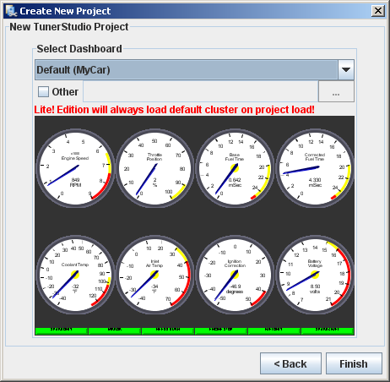

- Just click ‘Finish’ at this stage – you can’t change display just yet in the lite version.
- Tunerstudio will have a chat with Xenomorph for a minute or so (you can see a bar increasing on the bottom sometimes), then you will get 2-8 guages showing random information (this is because the ECU internal power supply is off at this stage)
- Hopefully you will get a screen looking like….

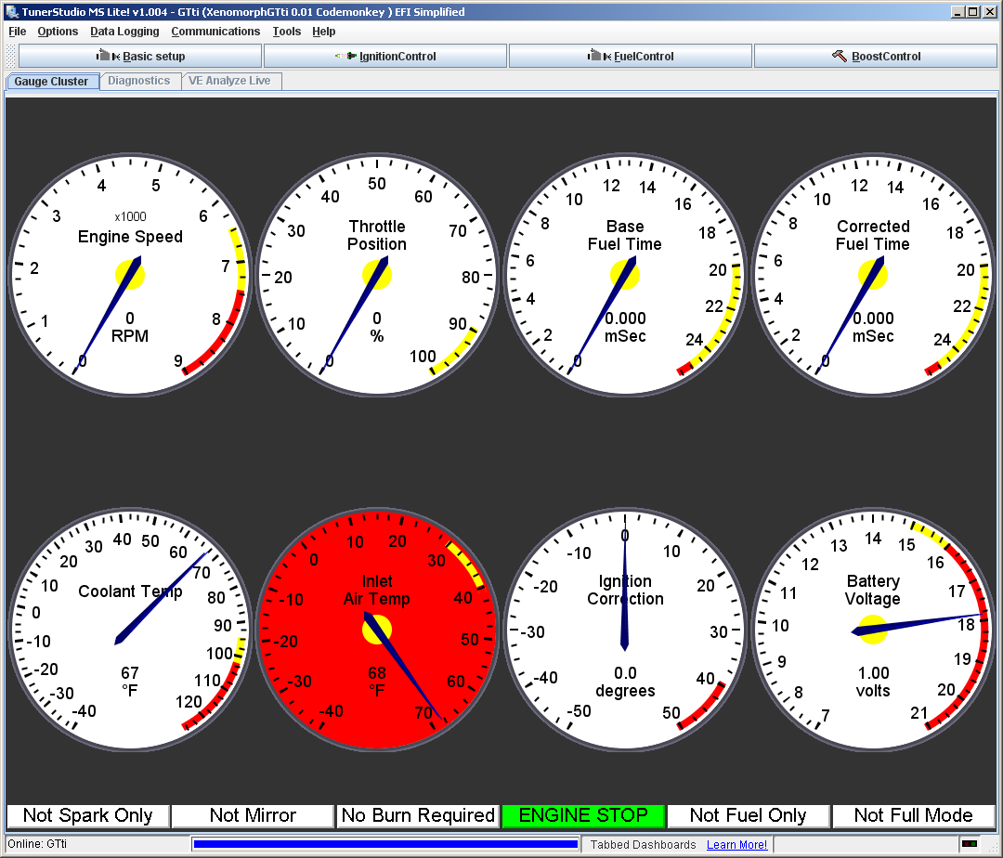

- Now, go to ‘File’, then ‘Gauge Cluster>Load/Save>Load Dashboard’

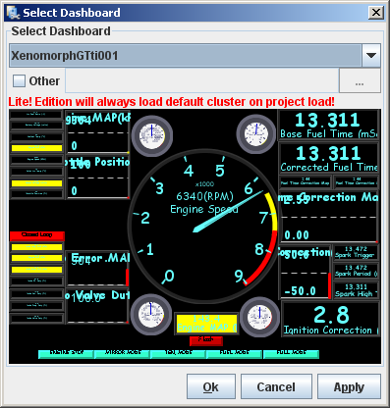

- The above window will appear (with standard gauges in it). Select XenomorphGTtiXYZ from the pull down list under ‘Select Dashboard’ at the top, and the black dash will appear.
- Select ‘Apply’
- Select ‘Okay’
- The full dash should now be shown.
- Your Xenomorph is ready to be installed in the car. Disconnect the unit from the PC, and connect to the vehicle connectors in the passenger glove box, making sure that the ignition is OFF

In the Car

WARNING: Xenomorph is not designed/intended for use on a public road. It is for experimental use only. The user must accept all liability for the operation and use of Xenomorph. Like any engine management system, the unit has the capability to damage the engine of your car. It has had no formal EMC/EMI testing. Any use is at the risk of the user!!
WARNING: Use of TunerStudio can distract the driver. Never attempt to use TunerStudio when the vehicle is moving. Use the datalogging feature to measure data, then return to a safe place before viewing.
WARNING: Calibration changes will INSTANTLY change the operation of Xenomorph. It is possible to destroy an engine instantly with an incorrect entry – you have been warned!

- Disconnect the original GTti ECU above the glove box, and connect the modified ECU.
- Connect the USB cable to your laptop.
- Start logging (menu ‘Data Logging’ > ‘Start Logging’)
- Turn the ignition on (only), and quickly confirm that the Battery Voltage is reading 11 – 12V, and that the Sensor Voltage is close to, or exactly 5.00V. If either are wrong, turn the ignition off, and stop.
- From here, perform a sensor check. You should expect the following:
  - Coolant Temp should be sensible (Units are degrees C, not F!)
  - Engine MAP should be around 100.0kPa (which is around atmospheric pressure)
  - Engine RPM should be zero.
  - Inlet Air Temp should be sensible (and similar to coolant temp if the car is cold)
  - Throttle position – this has not been adjusted, but should move when you move the throttle pedal (check this).
  - Under the ‘Tools’ menu, select ‘Calibrate TPS’

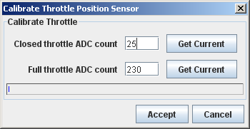

  - Release the throttle pedal completely, and hit ‘Get Current’ next to ‘Closed Throttle ADC count’.
  - Press the throttle all the way down, and hit ‘Get Current’ next to the ‘Full Throttle ADC count’
  - Hit ‘Accept’

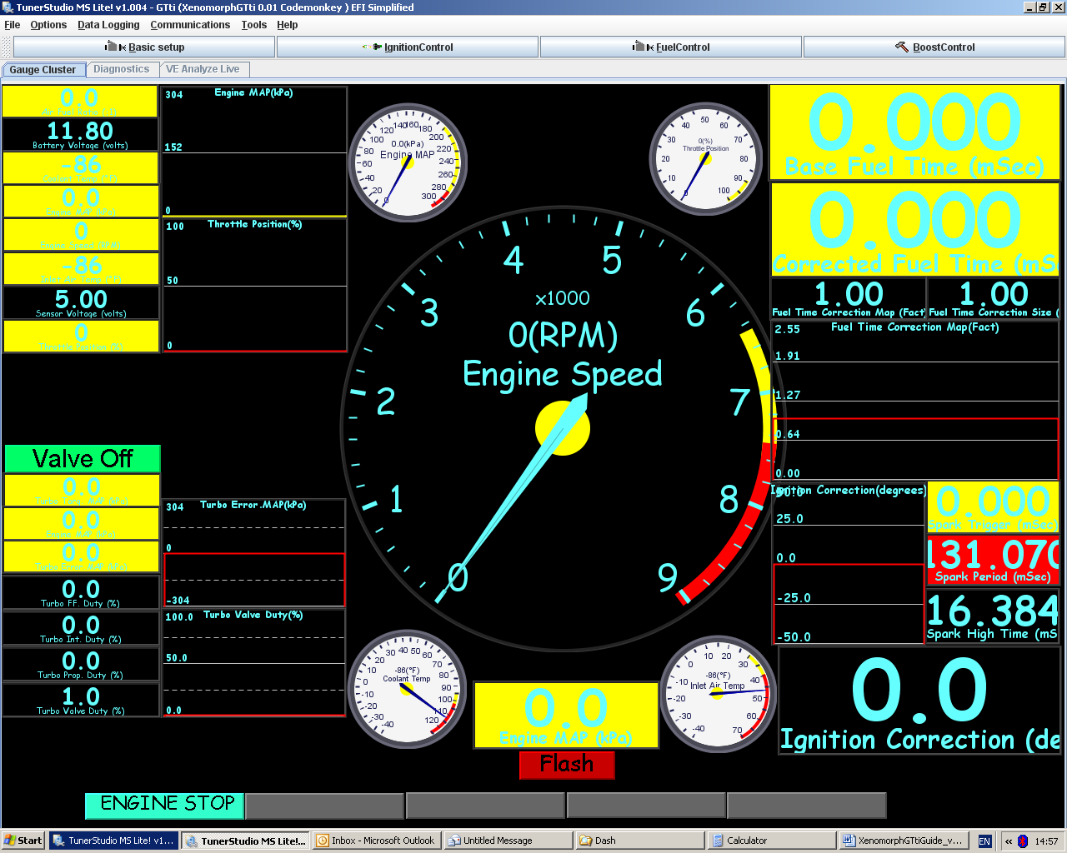

- If any change has been made, a red light saying ‘Flash’ will now appear at the bottom of the dashboard. This will appear if any changes are made to the parameters of the Xenomorph (it is indicating that the working ‘live’ page of the Xenomorph is different from the values that it knows when it is sleeping, so it is warning you that it will need your assistance to remember that data as it goes to sleep)
- To save the parameters, leave the USB lead connected to your laptop, and turn the ignition off. The red ‘Flash’ light should, after a second or so, change to a green ‘No Flash’. This means that Xenomorph has seen you turn the ignition off, and it still had a power supply from the USB lead (your laptop), so it has remembered the data for when it sleeps. Xenomorph cannot sleep until BOTH the ignition is off, and the USB lead is disconnected.
- Stop logging (‘Data Logging’ then ‘Stop’)

In the car – Engine configuration

- Select the ‘Basic Setup’ button, then ‘Xenomorph Setup Main’
- You will be presented with the following screen (numbers may be different!!)

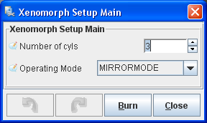

- Number of cylinders is 3. The CB70/CB80 engine has 3 cylinders, it always will have, and that’s why we love it. Don’t change this!
- Operating Mode. Xenomorph can operate in 4 modes. These are: (leave MIRROR MODE enabled for initial testing!!!)
  - MIRRORMODE – Xenomorph will pass the original ECU fuel and spark straight through without offset. The engine will always be started in this mode. Useful for basic setup tests, and for measuring the original ECU pulse widths against load.
  - SPARKONLY – Xenomorph will pass the original ECU fuel straight through without offset. It will offset the spark by the data contained in the ‘Ignition Control’, ‘Ignition Table x’ table (against MAP in kPa and engine speed in RPM), where ‘x’ is the selected map, using ‘Ignition Control’ ‘Ignition Map Select.
  - FUEL ONLY – Xenomorph will pass the original ECU spark straight through without offset. It will multiply the fuel pulse widths (measured from the original ECU) by the data contained in the table ‘Fuel Control’ ‘Fuel Table x’ (factor 1.0 means normal, 1.5 means 50% more etc), where the fuel table is selected by ‘Fuel Control’ ‘Fuel Map Select’. Once it has done this, it will then further multiply the fuel pulse width by ‘Fuel Control’ ‘Injector Size Setup’, where the original injector size, and the new injector size can be entered, if different. NOTE: Xenomorph will have to have it’s working (live) page saved, and must have COMPLETELY gone to sleep for the new injector size information to be used (ignition off, wait for green ‘No Flash’ button, Disconnect USB lead for 5 seconds)
  - FULL MODE – Xenomorph will alter both the fuel and ignition settings, using the methods described above.

Note: Xenomorph disconnects the original ECU connection to the boost solenoid, and puts Xenomorph control in place instead. This means that the boost control within Xenomorph is active whenever it is connected to the vehicle.

Note: On engine start, until Xenomorph has synced to the original ECU, MIRROR MODE is automatically selected to allow the engine speed to build.

- Select the ‘Basic Setup’ button, then ‘Xenomorph Setup Analogue’

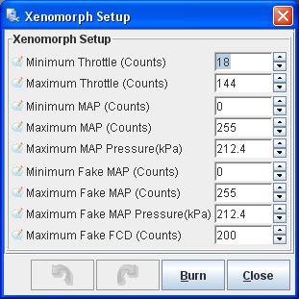

- The Minimum throttle and Maximum throttle are set in the ‘Calibrate TPS’ section that you have already done, but can be manually changed here if required (not recommended)
- Minimum MAP is the minimum input that Xenomorph should expect from your map sensor. This is in 8 bit ADC counts (0 = 0Volts, 255 = 5 Volts). For all voltage calculations, use the formula:

Counts = (Volts * 256) / 5.0

So, 0.5V = 25.6 = 26 counts (round the number to the nearest whole number)
- Minimum MAP and Maximum MAP are set according to the standard Daihatsu MAP sensor.
- Set the Maximum MAP Pressure (kPa to the maximum pressure that the sensor reads at Maximum MAP counts. So, the default sensor maximum is 212.4kPa pressure (16.5Psi, or 1.1 Bar above atmospheric pressure = 1.1Bar boost) at 5 Volts (255 counts)
- The Minimum Fake MAP, Maximum Fake MAP, Maximum Fake MAP Pressure, and Maximum Fake FCD are the settings for the sensor that Xenomorph is emulating back to the Daihatsu controller (it is the setting for the ‘pretend’ MAP sensor output to keep the original ECU happy). Don’t change these unless instructed to do so.

- Select the ‘Basic Setup’ button, then ‘Xenomorph Setup Speeds’

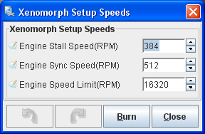

- Engine Stall Speed is the engine speed, less than which Xenomorph assumes that the engine is stopping, so stops calculating fuel/spark offsets.
- Engine Sync Speed is the engine speed, more than which Xenomorph starts to try to lock on to the original ECU fuel/ignition requests.
- Engine Speed Limit is your own requested engine maximum speed. If it is more than 7600RPM, the OEM limiter will cut the engine

- Select the ‘Basic Setup’ button, then ‘Xenomorph Setup Speeds’

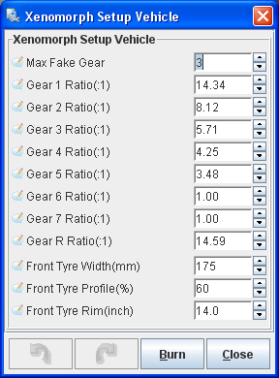

- Max Fake Gear – For future use – do not change
- Gear x Ratio – The installed gear ratios in the transmission. If any gears are not fitted, change the calibration to 1.00
- Front Tyre Width/Profile/Rim – Information about the size of the vehicles driving tyres. So for 175/60R14, the calibration above is correct. (Change to suit your car)

- Select the ‘Basic Setup’ button, then ‘Xenomorph Setup Limiter’

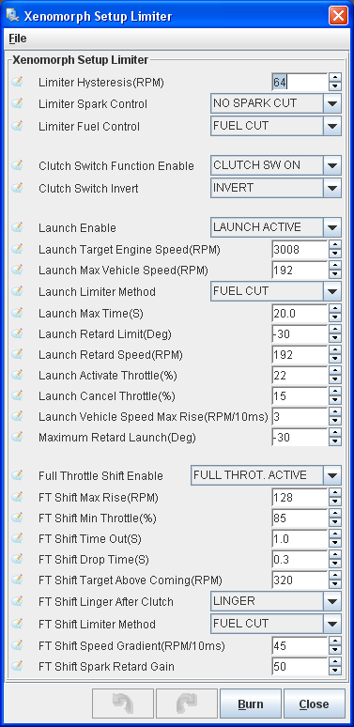

- Limiter hysteresis – The change (drop) in engine RPM required before the limiter will go from limiting to not limiting state.
- Limiter Spark Control – Request for spark cut on operation of the limiter. Note: The fuel to the engine is not cut from this!
- Limiter Fuel Control – Request for fuel cut on operation of the limiter.
- Clutch Switch Function Enable – Enables the ability to have launch control and full throttle shift from the clutch switch (ONLY IF CLUTCH SWITCH IS FITTED!)
- Clutch Switch Invert – Ability to invert the operation of the switch (if needed). When pressed, the clutch should read ‘Clutch Down’, and ‘Clutch Up’ when released.
- Launch Active – Switch to enable the launch control function
- Launch Target Engine Speed – The engine speed at which the engine will be limited in the initial part of launch control
- Launch max vehicle speed – Maximum rotational speed of the transmission output shafts (drive shafts) for launch function
- Launch Limiter method – The method that Xenomorph uses to achieve an engine speed limiter (Fuel is advised!)
- Launch Max Time – Maximum time to remain in launch control, before the engine is released
- Launch Retard Limit – Maximum limit of spark retard for launch control (after which a full cut occurs)
- Launch Retard Gain – Gain of spark retard vs RPM for launch control
- Launch Activate Throttle – Minimum throttle to activate launch control
- Launch Cancel Throttle – Throttle position below which launch will be cancelled
- Launch Vehicle Speed Max Rise – Maximum rate of change of vehicle speed during launch (prevents wheel spin from being recognised as high acceleration)
- FT Shift enable – Enable for full throttle gear shifts
- FT Shift Max Rise – Maximum RPM rise during the start of a full throttle gear shift (during clutch dip)
- FT Shift Min Throttle – Minimum throttle considered to be a full throttle shift
- FT Shift Time Out – Timeout for interventions during a full throttle gear shift (end of shift time)
- FT Shift Drop Time – Time for sharp engine target drop in full throttle gear shifts (no longer used)
- FT Shift Target Above Coming – Target RPM above new gear speed before engine interventions are released
- Fuel tables – The axis of the fuel tables are engine speed (RPM) and MAP pressure (kPa). The data points are factors on the OEM fuelling level. So, 1.0 is exactly the same fuel as OEM. 2.0 = twice the fuel of OEM. 0.5 = half the fuel.

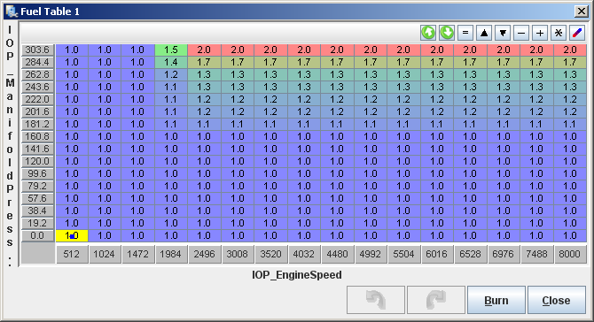

- Fuel map selection – Select either fuel map 1 or fuel map 2 with this switch (allows 2 engine tunes to be stored on board Xenomorph for normal/track.)
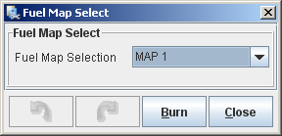

- Injection correction. Type the original fuel injector size, and your replacement fuel injector size in (if you have changed them). This automatically scales the OEM fuel based on the new injector size. Note: Make sure that the injection rate for the new injectors is with the SAME fuel rail pressure as you use on the car!

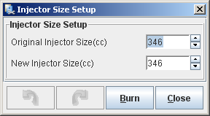

- Ignition table (Spark table) - The axis of the spark tables are engine speed (RPM) and MAP pressure (kPa). The data points are offsets on the OEM ignition angle. So, 0 is exactly the same fuel as OEM. -2 is 2 degrees more RETARDED than OEM

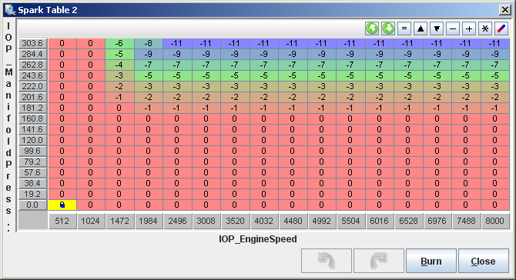

- Ignition map selection – Select either ignition map 1 or ignition map 2 with this switch (allows 2 engine tunes to be stored on board Xenomorph for normal/track.)

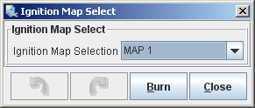

- Turbo control (using the original boost valve) is set using the following:
  - Open loop valve duty request is set using the table ‘Boost Control’ ‘Boost Duty Table x’ (in % duty) against throttle percent and engine speed. You will most likely not touch this table.
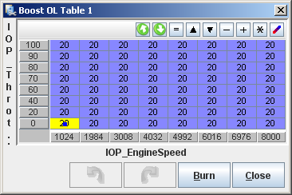
  - Closed loop boost pressure target is set using ‘Boost Control’ ‘Boost Target Table x’ ( in kPa) against throttle percent and engine speed. This is where you set your desired boost pressure!

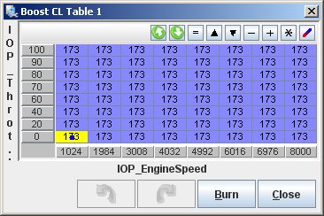

  - The main settings for boost control are found in ‘Boost Control’ ‘Boost Control Settings’ (screen below). The settings are:
    - Boost Map selection – sets the ‘x’ in the map select for boost duty and boost target
    - Boost Prop. Gain. Proportional gain of Boost Control Loop (leave it unless you understand controller theory)
    - Boost Integ. Gain. Integral gain of Boost Control Loop (leave it unless you understand controller theory)
    - Boost Integ. Duty Max (%) Maximum Integral part of controller (leave it unless you understand controller theory)
    - Boost Integ. Duty Min (%) Minimum Integral part of the controller (leave it unless you understand controller theory)
    - Boost Integ. Error Max (kPa) Maximum error for controller integral part (leave it unless you understand controller theory)
    - Boost Integ. Error Min (kPa) Maximum error for controller integral part (leave it unless you understand controller theory)
    - Min Map closed loop (kPa) Minimum MAP pressure before valve will start to bleed pressure
    - Min TPS closed loop (kPa) Minimum throttle before valve will start to bleed pressure
    - Valve Off Duty – Duty cycle of valve when not being controlled
    - Valve Max Duty – Maximum duty cycle of valve when controlling
    - Valve Min Duty – Minimum duty cycle of valve when controlling

