Flappy It Bird

Samuel Benoit

samuelbenoit@georgebrown.ca - 101007189

# Table Of Contents

Table of Contents

Table Of Contents 2

Game Description 3

Controls Description 4

Interface Sketch 5

Screen Description 6

Enemies 8

Scoring 9

Sound Index 10

Parrot Call #2 – Sound made by bird on collision. 10

Drumming Sticks – Looped background music that plays as the game scene is live. 10

Art / MultiMedia Index 11

# Game Description

The Flappy It Bird game is a fast-paced, exciting ‘side scroller’. The game follows a simple structure. A player may move freely within the bounds of the screen while the background loops continuously from the right to the left. The allows the player to feel as if the character is really flying through the sky. The player must dodge enemies who fly at different rates of speed across the screen from right to left. If the player is hit by the enemy they lose a life. If the player loses five lives they lose the game. Coins float from right to left and reward the player points when the player collides with the coin. The objective of the game is to survive and collect coins.

# Controls Description

The controls of the game are the A,W,S,D and the Up, Down, Right, Left arrow keys. The A & Left key allow the player to move left. The W & Up keys allow the player to move up. The S & Down key allow the player to move down. The D & Right key allow the player to move right.

# Interface Sketch

Plank Power Up

Coin

Rocket

Bomb

Player

Background

# Screen Description

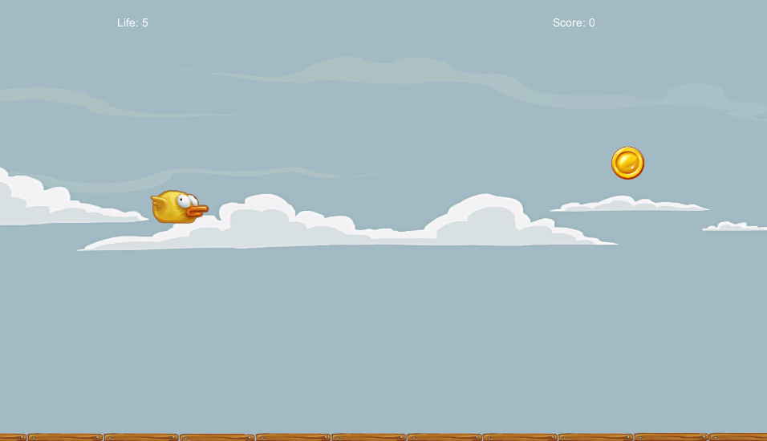

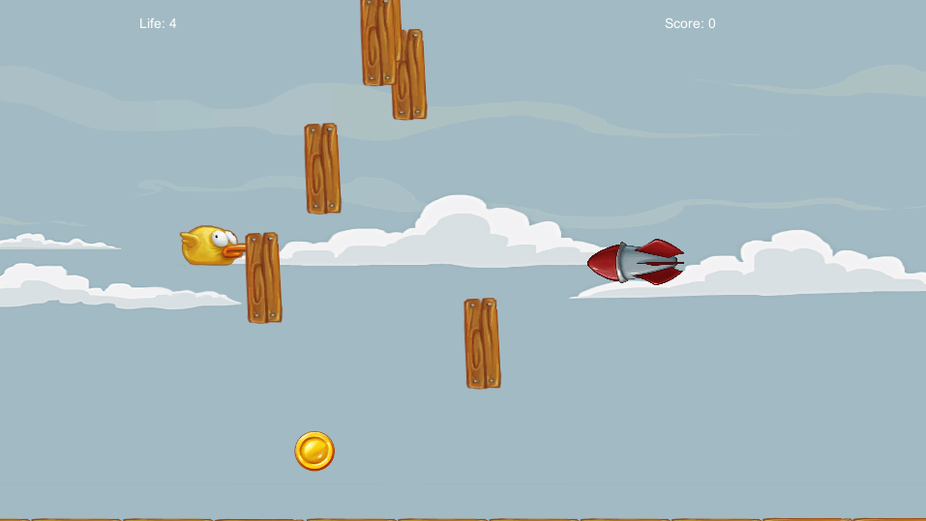

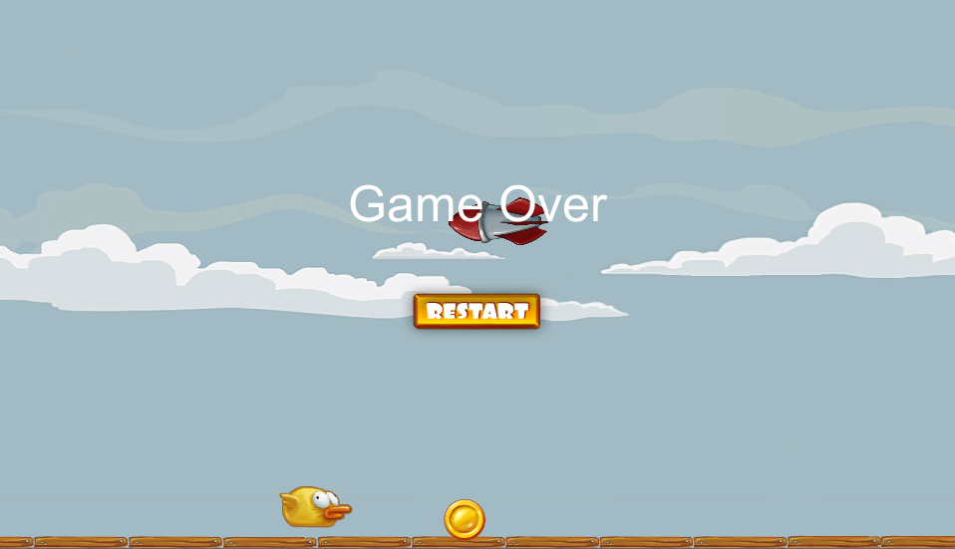

# Enemies

Rocket: A fast enemy that spawns randomly to the right of the scene. The spawn is of a random y value within the range of the screens height. After the rocket has hit the player or past the left side of the scene the rocket resets. This enemy does -1 life damage.

Bomb: A slow enemy that spawns from above the player. The enemy spawns in between the range of the scenes width. This enemy does -1 life damage.

Master Bomb: A slow enemy that spawns from above the player. The enemy spawns in between the range of the scenes width. This enemy does no damage but does spawn 26 single use bomb enemies if hit.

Single Use Bomb: A slow enemy that spawns from above the player. The enemy spawns in between the range of the scenes width. This enemy does -1 life damage and spawns when the enemy collides with a master bomb.

# Scoring

The player earns points by collecting coins. When the player hits a new record in coin collection. This high score is shared with the user in the game over canvas.

# Sound Index

## Parrot Call #2 – Sound made by bird on collision.

## Drumming Sticks – Looped background music that plays as the game scene is live.

# Art / MultiMedia Index

|  |  |
| --- | --- |
| ../../../Desktop/Screen%20Shot%202017-10-20%20at%208.55.41%20PM.png | Background Sky |
| ../../../Desktop/Screen%20Shot%202017-10-20%20at%208.56.12%20PM.png | Bird |
| ../../../Desktop/Screen%20Shot%202017-10-20%20at%208.56.07%20PM.png | Plank Power Up |
| ../../../Desktop/Screen%20Shot%202017-10-20%20at%208.56.02%20PM.png | Explosion |
| ../../../Desktop/Screen%20Shot%202017-10-20%20at%208.55.57%20PM.png | Coin |
| ../../../Desktop/Screen%20Shot%202017-10-20%20at%208.55.53%20PM.png | Bomb |
| ../../../Desktop/Screen%20Shot%202017-10-20%20at%208.55.50%20PM.png | Lit Bomb |
| ../../../Desktop/Screen%20Shot%202017-10-20%20at%208.55.45%20PM.png | Restart Button Image |
| ../../../Desktop/Screen%20Shot%202017-10-20%20at%208.55.37%20PM.png | Rocket |