Assignment #1 COIS 3200– Testing Documentation

Screen cap of process successfully generating csv files and concatenating the tests into their respective files:  
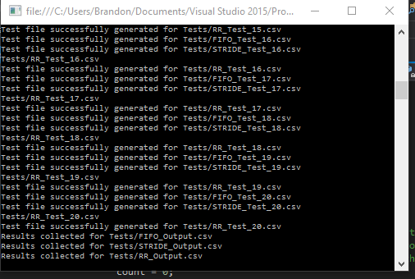  
  
Here are some example tests generated for their respective algorithms:

FIFO: Successfully processes tasks in the order they arrive until completion moving on to the next task until they are all complete.  
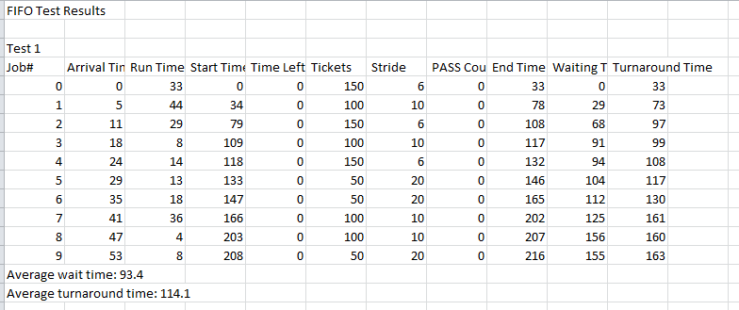

Pre-Emptive Shortest Job First: Successfully seeks the next shortest job in the queue to process before moving onto the next job.  
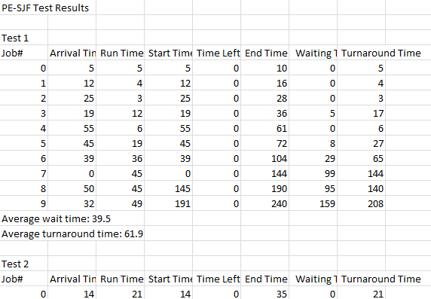  
Shortest Job First: Runs the shortest job first before moving on to the next shortest job that has arrived.

