Multi-Line Insurance Policy and Claims Management System
Salesforce Developer - Group Project Report
Prepared by: Kabilan
Salesforce org: (Salesforce Developer Edition)
Project link: https://myskillwallet.ai/dashboard/skillwallet/module/salesforce-developer-nm-eng-6a69e3b28beabdd402737070/group-projects/6a6b1d37dafa0b21ea8a0900/Multi-Line-Insurance-Policy-and-Claims-Management-System-6ab601b2fa5e5219dc38104e?tab=2

About this report
This report documents the Salesforce configuration carried out for the Multi-Line Insurance Policy and Claims Management System project, some of them weren’t able to be finish because of having trouble with unique data violation

Work status
Item | Status
Policy object, Auto record type, Vehicle field set, VIN validation rule | Completed
Claim object with Approval Status and Claim Amount fields | Completed
AutoQuotingFlow (Get Vehicle RT ID, two screens, Create Draft Policy, varPolicyId) | Completed and Active (Customer, Policy Start Date and Policy State mappings pending missing fields)
Submission Automation Flow (Claim over 50000 -> approval) | Having trouble with unique data violation constarint
Claim Approver Screen Flow | Partially built, not saved
Calculate Premium action / Update Policy With Premium | Pending - Premium field missing on Policy
Claim routing flow, Apex controller and tests, LWC dashboard | Pending - queues and Policy.Customer__c missing
Approval process, sharing rules, permission sets | Pending - requires administrator access

1. Data Model Setup - Policy and Claim Objects
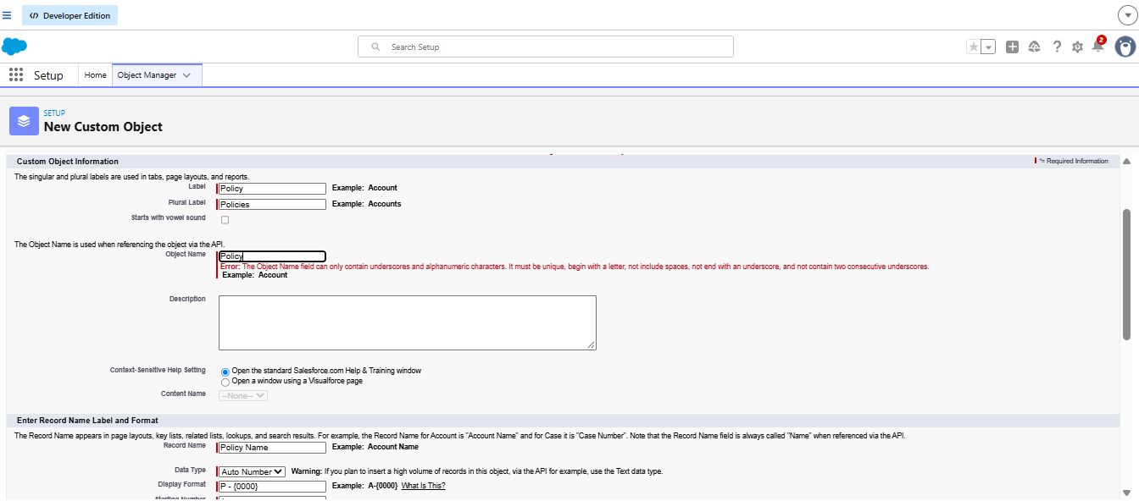
Figure: Creating the custom object Policy (Label: Policy, Plural: Policies, Record Name: Policy Name, Auto Number).
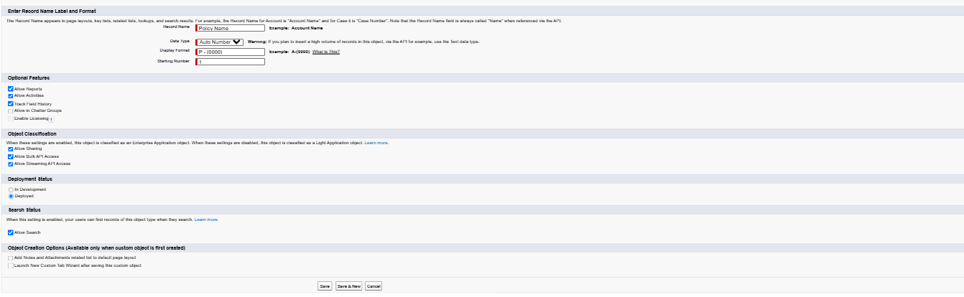
Figure: Object creation options and Save for the Policy object.
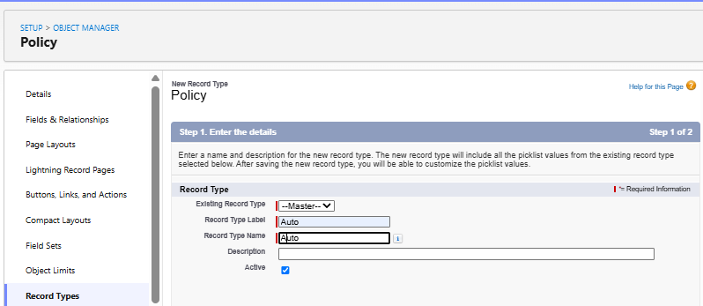
Figure: New record type 'Auto' on the Policy object.
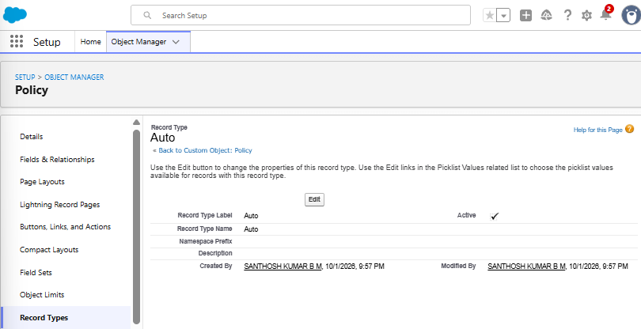
Figure: Auto record type created and Active (Record Type Name: Auto).
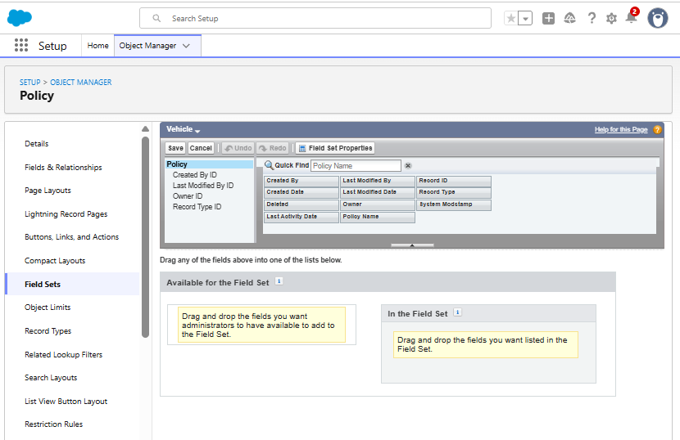
Figure: Field Set 'Vehicle' created on Policy - available fields.
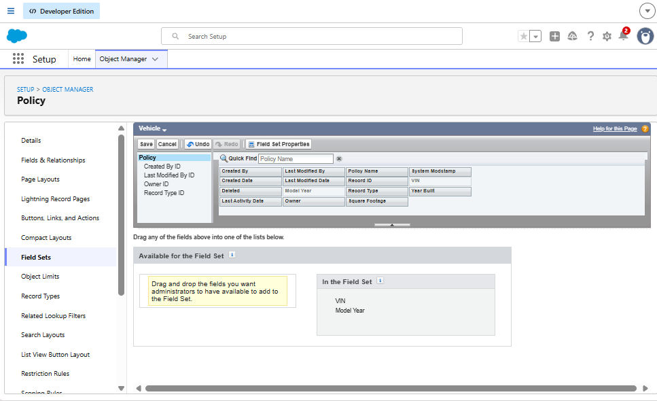
Figure: Vehicle field set with VIN and Model Year added.
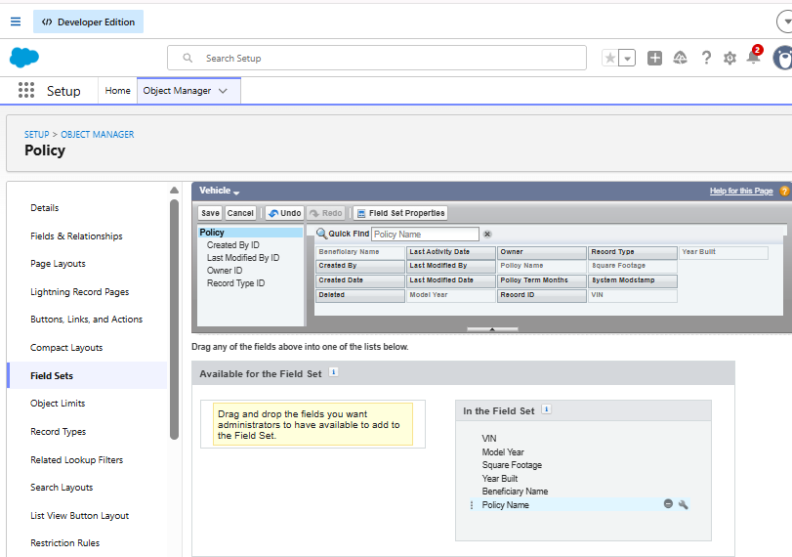
Figure: Vehicle field set containing VIN, Model Year, Square Footage, Year Built, Beneficiary Name, Policy Name.
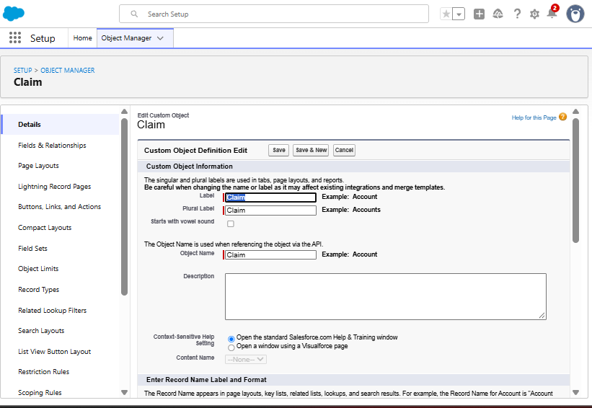
Figure: Creating the custom object Claim.
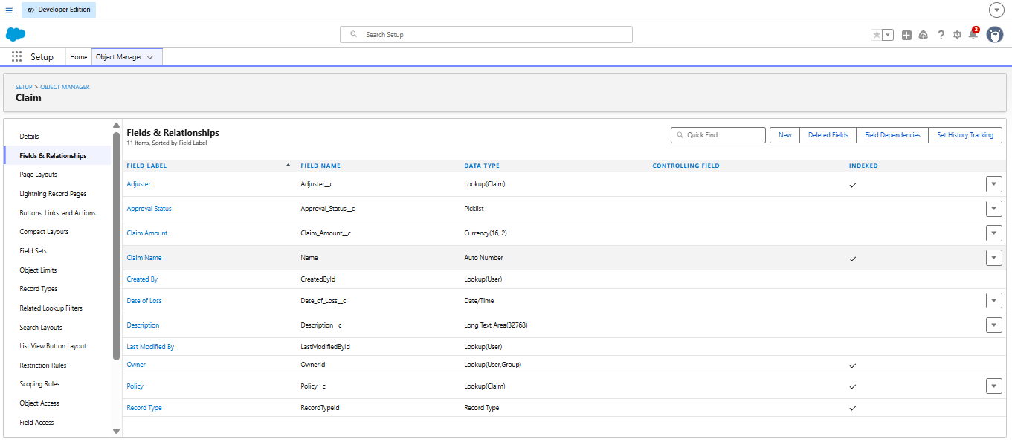
Figure: Claim fields: Adjuster, Approval Status, Claim Amount, Date of Loss, Description, Policy lookup, Record Type.
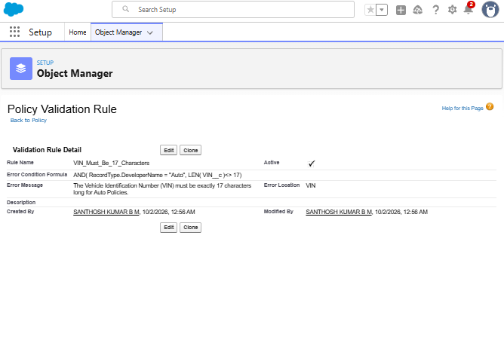
Figure: Validation rule VIN_Must_Be_17_Characters on Policy (Auto record type).

2. AutoQuotingFlow - Screen Flow
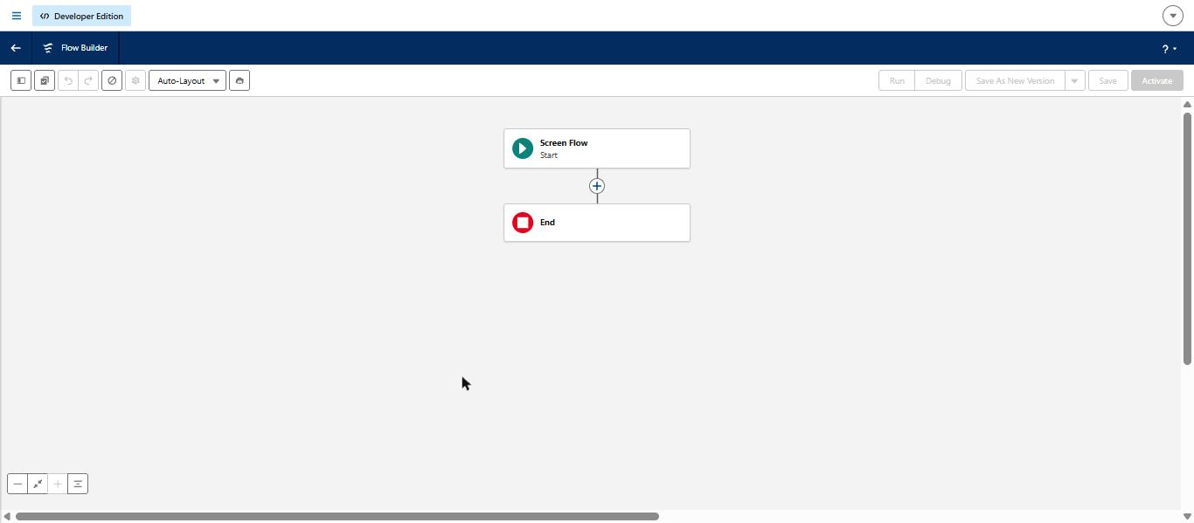
Figure: New Screen Flow canvas (Start and End) in Flow Builder.
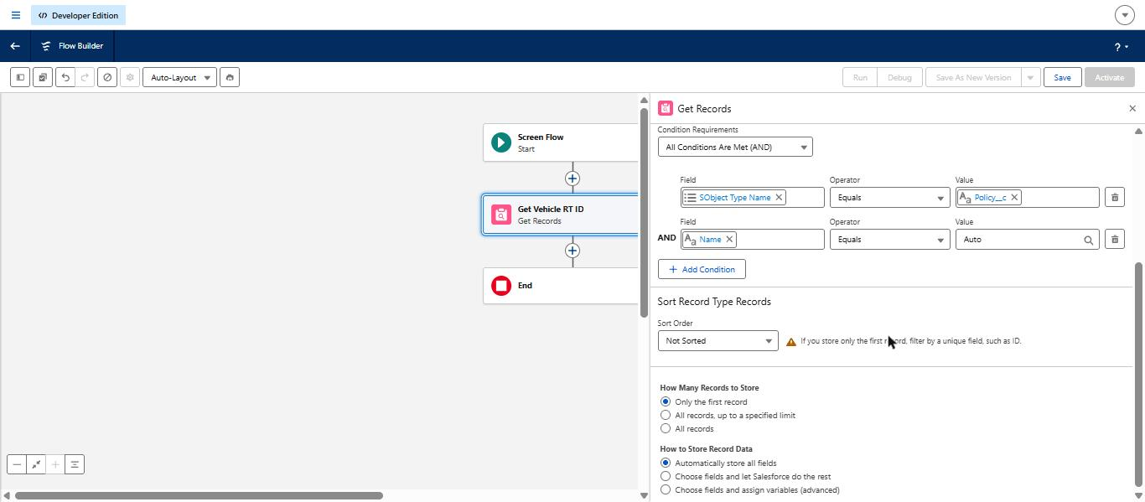
Figure: Get Vehicle RT ID - Record Type where SObject Type Name = Policy__c AND Name = Auto.
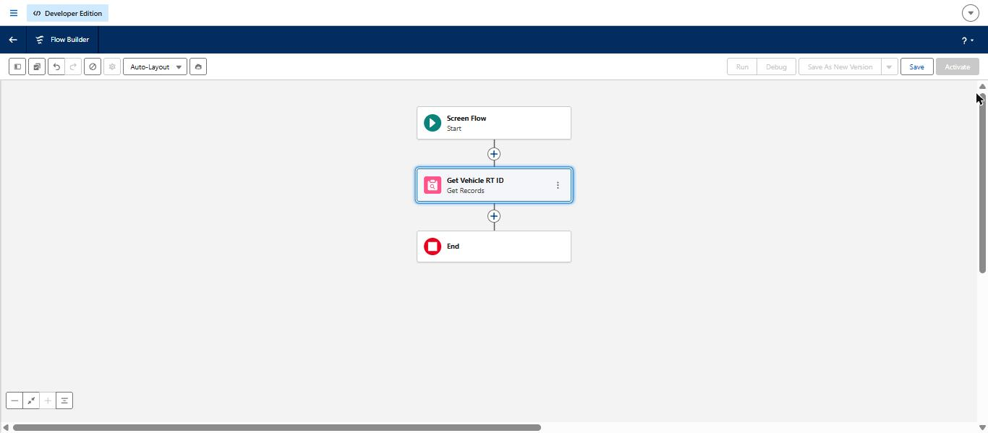
Figure: Get Vehicle RT ID element added after Start.
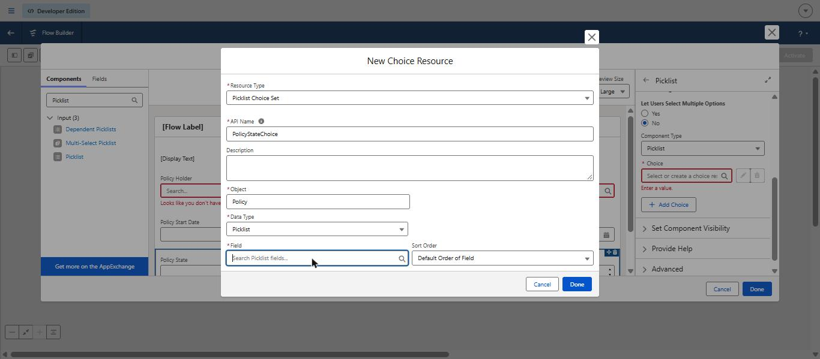
Figure: Limitation found: no Policy State picklist field exists, so the Picklist Choice Set could not be built.
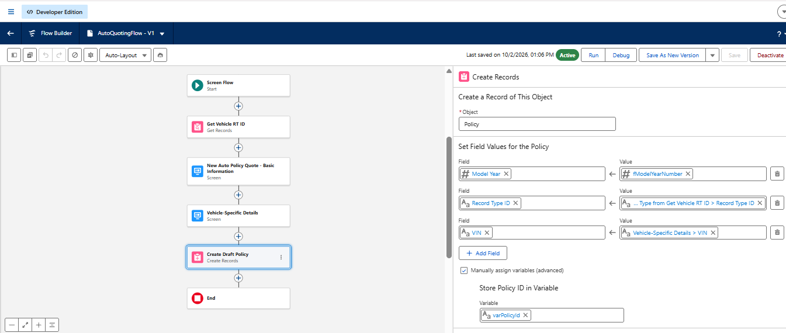
Figure: Flow canvas: Get Vehicle RT ID, Basic Information screen, Vehicle-Specific Details screen, Create Draft Policy.
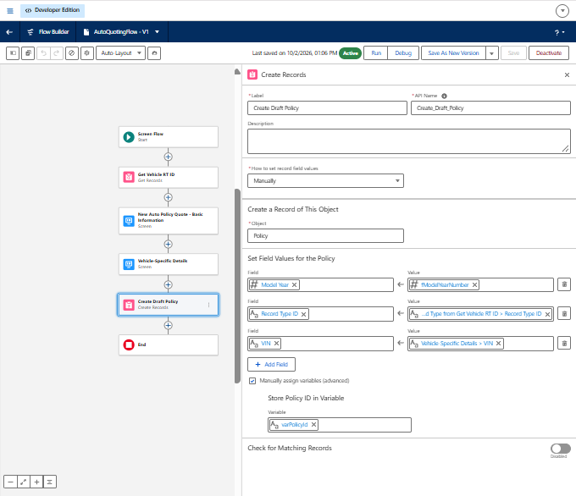
Figure: Create Draft Policy - manual field mapping and varPolicyId storage.
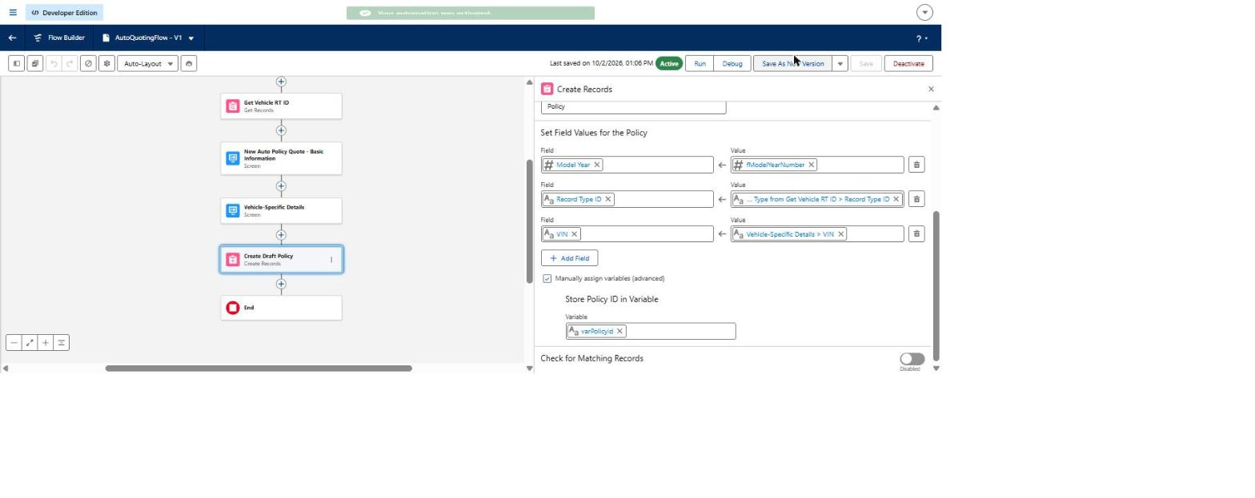
Figure: AutoQuotingFlow V1 saved and Active ('Your automation was activated').

3. Claims Automation and Environment Checks
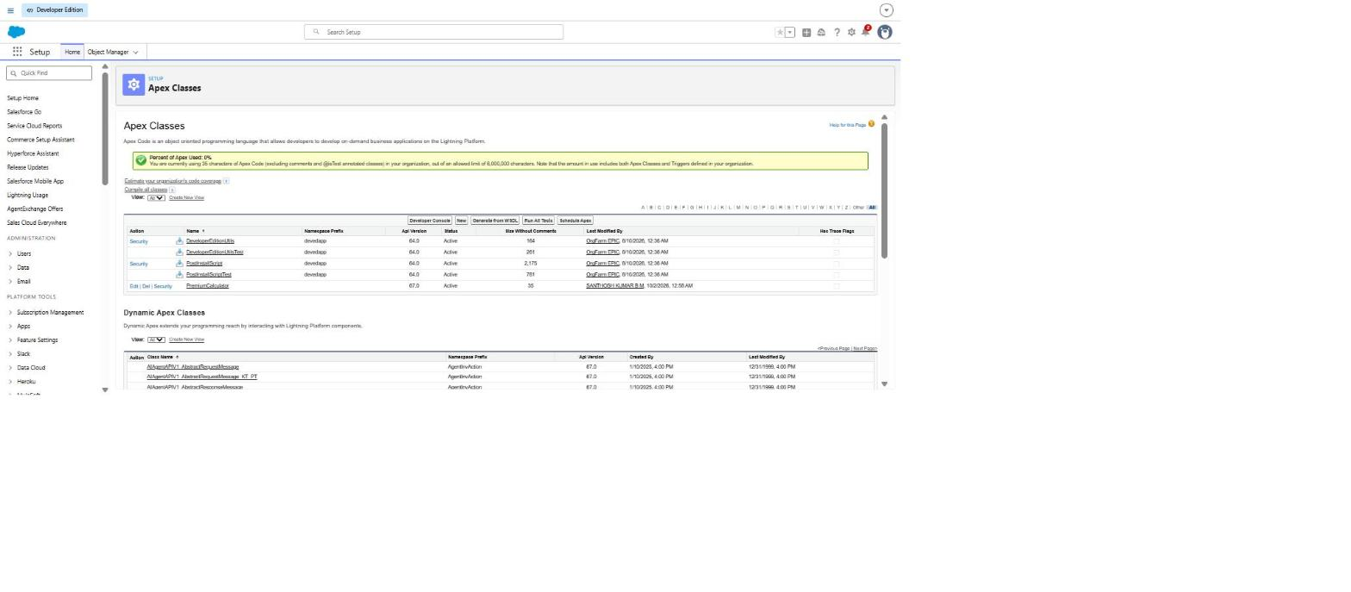
Figure: Apex Classes list - PremiumCalculator class is present in the org.
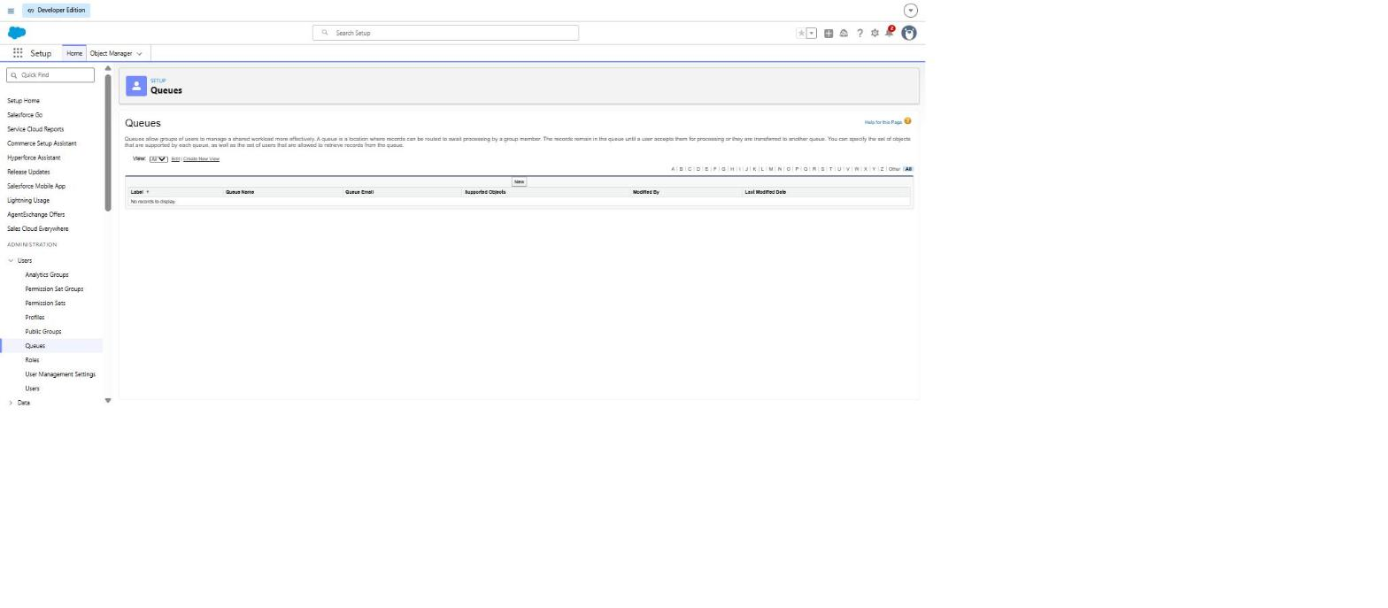
Figure: Queues page - no queues exist yet (needed for claim routing).
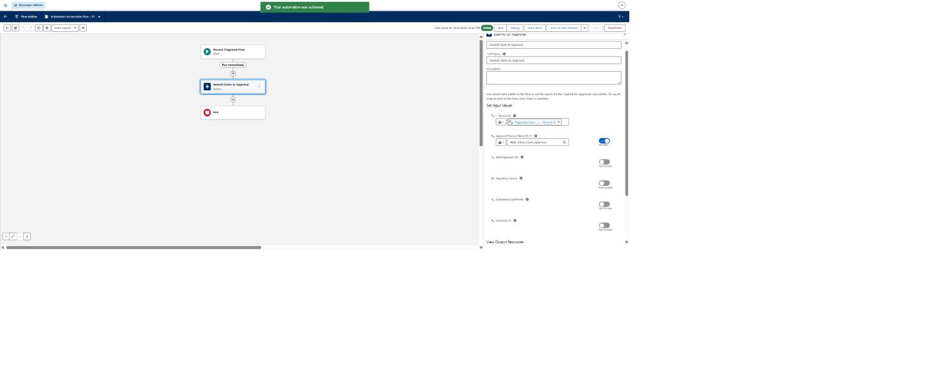
Figure: Submission Automation Flow (record-triggered on Claim) saved and Active, with the Submit Claim to Approval action.

