Week 1 Task: Data Cleaning and Preliminary Analysis with R
1. Dataset Selection:
I selected the publicly available Titanic dataset. It is ideal for this data cleaning task because it contains a mix of numerical variables (Age, Fare) and categorical variables (Sex, Ticket Class), along with missing values that require preprocessing.
2. Data Cleaning Process:
Handling Missing Values: The primary missing data issue occurred in the 'Age' column. To prevent statistical skewness, missing ages were imputed using the median age of the passengers (median_age).
Categorical Encoding: The attributes Sex, Survived, and Pclass were converted into R factors using the as.factor() function so that statistical models can process them correctly.
Outlier Handling: Fare values showed high variance, which was retained as authentic differences across ticket classes.
3. R Code and Summary Output:
# Load dataset
url <- "https://raw.githubusercontent.com/datasciencedojo/datasets/master/titanic.csv"
titanic <- read.csv(url)

# Impute missing numeric values (Age) using the median
titanic$Age[is.na(titanic$Age)] <- median(titanic$Age, na.rm = TRUE)

# Encode categorical variables into factors
titanic$Sex <- as.factor(titanic$Sex)
titanic$Survived <- as.factor(titanic$Survived)
titanic$Pclass <- as.factor(titanic$Pclass)

# View cleaned summary
summary(titanic[, c("Survived", "Pclass", "Sex", "Age", "Fare")])

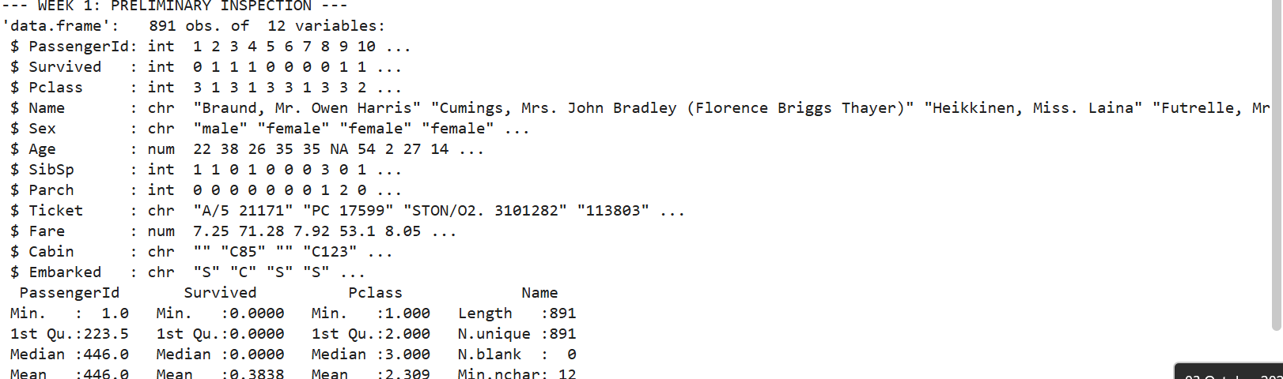
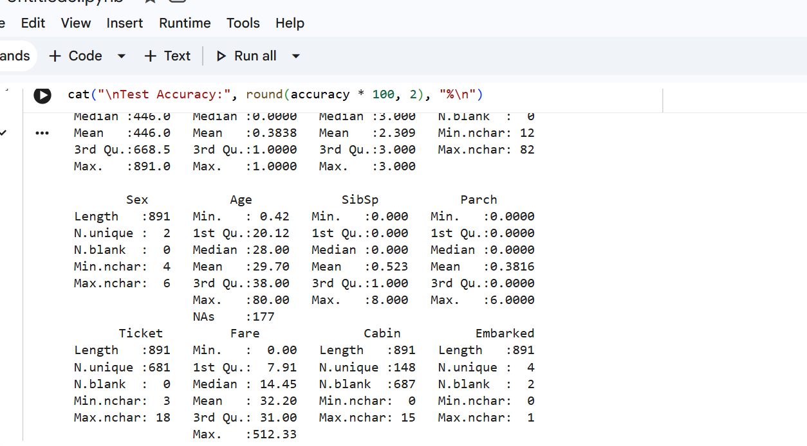
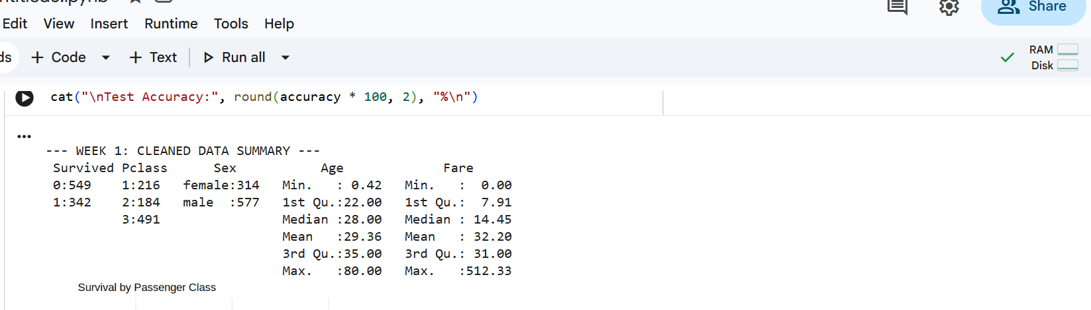
4. Initial Insights:
Imputation resolved all missing values in the core predictors without altering the distribution. The post-cleaning dataset is now fully structured for visualization and predictive evaluation.

