Week 2 Task: Data Visualization and Insight Communication using R
1. Overview:
Using R's ggplot2 library, four distinct visualizations were generated to analyze survival distributions, age demographics, ticket pricing patterns, and class differences.
2. Visualizations and Findings:
Figure 1: Bar Graph - Survival by Ticket Class
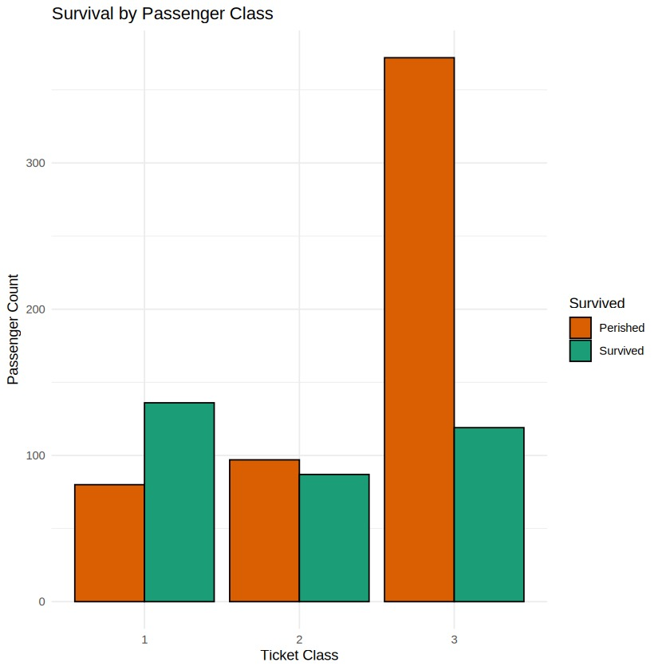
Insight: First-class passengers had a much higher survival rate compared to third-class passengers, showing a strong socio-economic factor in survival outcomes.
Figure 2: Histogram - Passenger Age Distribution
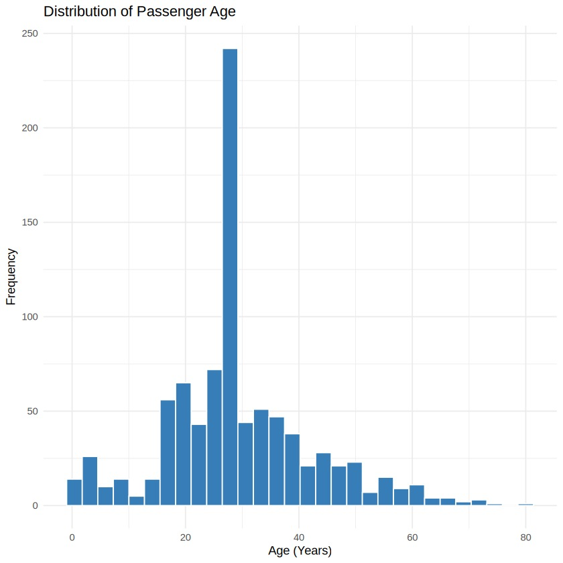
Insight: The distribution is slightly right-skewed, showing that the majority of passengers aboard were young adults between the ages of 20 and 35.
Figure 3: Scatter Plot - Fare vs. Age by Survival
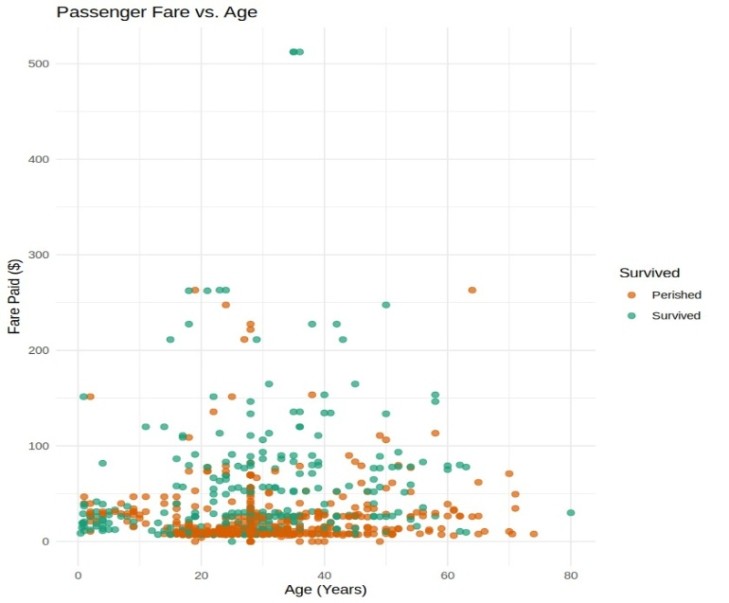
Insight: The vast majority of ticket fares were under $100, but the few passengers who paid extreme fares largely survived.
Figure 4: Line Chart - Average Fare per Passenger Class
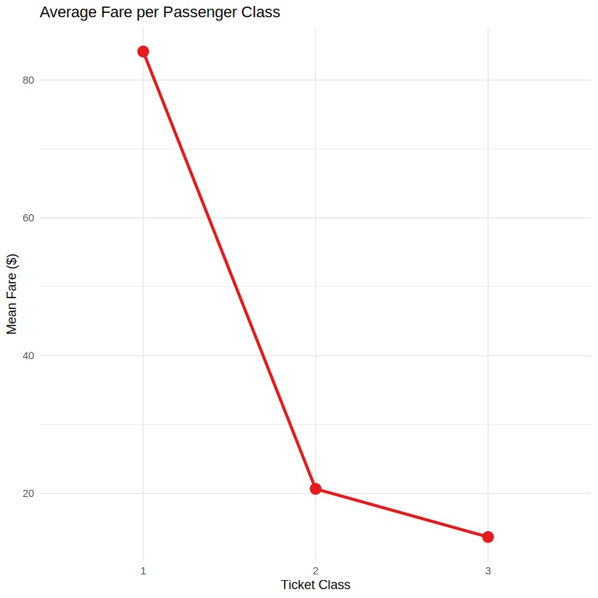
Insight: This line chart illustrates the steep decline in average ticket price from 1st class down to 3rd class.

