Week 1 Task: Data Cleaning and Preliminary Analysis with R
1. Dataset Selection:
I selected the publicly available Titanic dataset. It is ideal for this data cleaning task because it contains a mix of numerical variables (Age, Fare) and categorical variables (Sex, Ticket Class), along with missing values that require preprocessing.
2. Data Cleaning Process:
Handling Missing Values: The primary missing data issue occurred in the 'Age' column. To prevent statistical skewness, missing ages were imputed using the median age of the passengers (median_age).
Categorical Encoding: The attributes Sex, Survived, and Pclass were converted into R factors using the as.factor() function so that statistical models can process them correctly.
Outlier Handling: Fare values showed high variance, which was retained as authentic differences across ticket classes.
3. R Code and Summary Output:
# Load dataset
url <- "https://raw.githubusercontent.com/datasciencedojo/datasets/master/titanic.csv"
titanic <- read.csv(url)

# Impute missing numeric values (Age) using the median
titanic$Age[is.na(titanic$Age)] <- median(titanic$Age, na.rm = TRUE)

# Encode categorical variables into factors
titanic$Sex <- as.factor(titanic$Sex)
titanic$Survived <- as.factor(titanic$Survived)
titanic$Pclass <- as.factor(titanic$Pclass)

# View cleaned summary
summary(titanic[, c("Survived", "Pclass", "Sex", "Age", "Fare")])

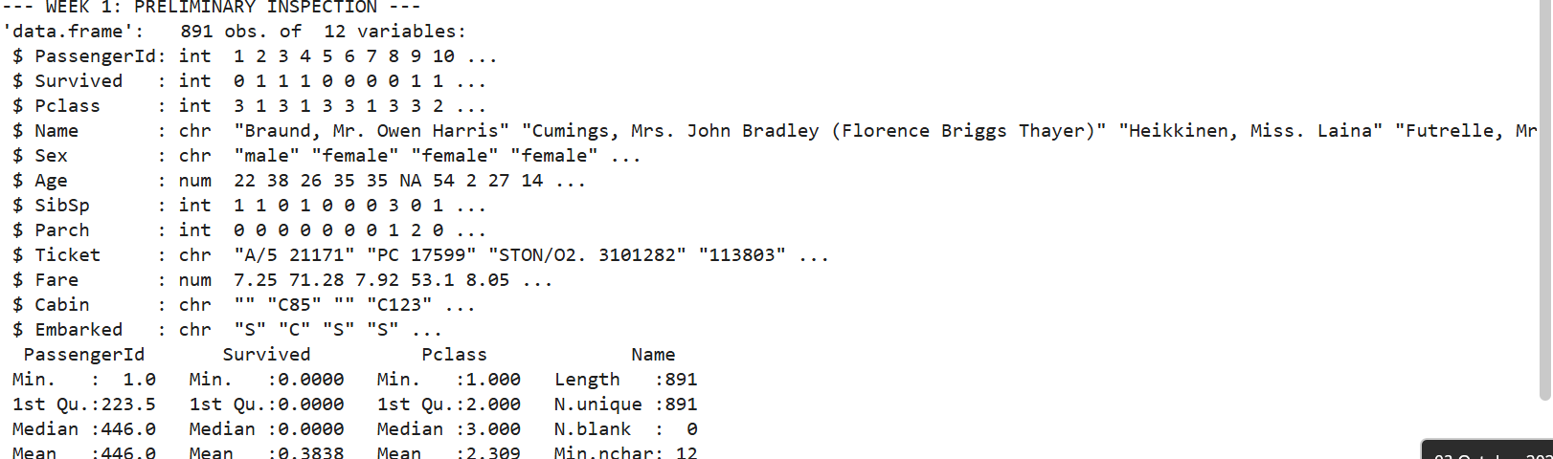
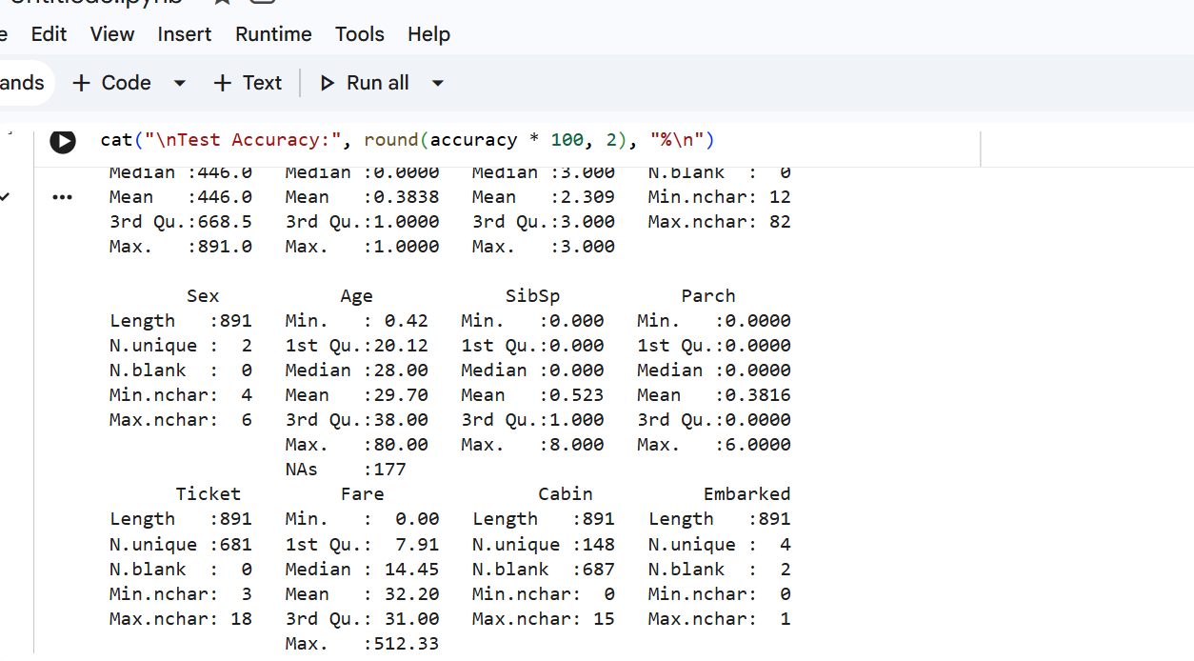
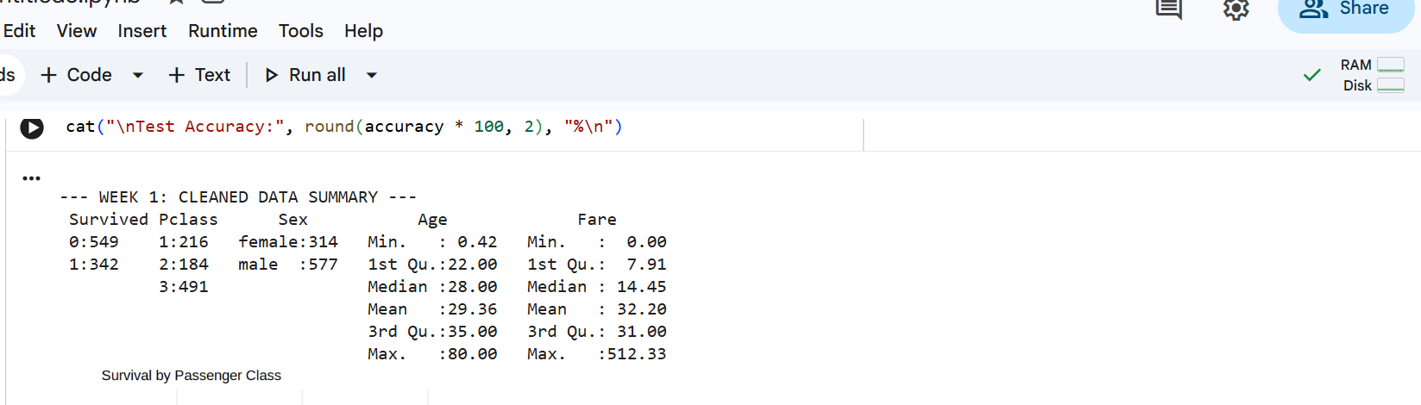
4. Initial Insights:
Imputation resolved all missing values in the core predictors without altering the distribution. The post-cleaning dataset is now fully structured for visualization and predictive evaluation.

Week 2 Task: Data Visualization and Insight Communication using R
1. Overview:
Using R's ggplot2 library, four distinct visualizations were generated to analyze survival distributions, age demographics, ticket pricing patterns, and class differences.
2. Visualizations and Findings:
Figure 1: Bar Graph - Survival by Ticket Class
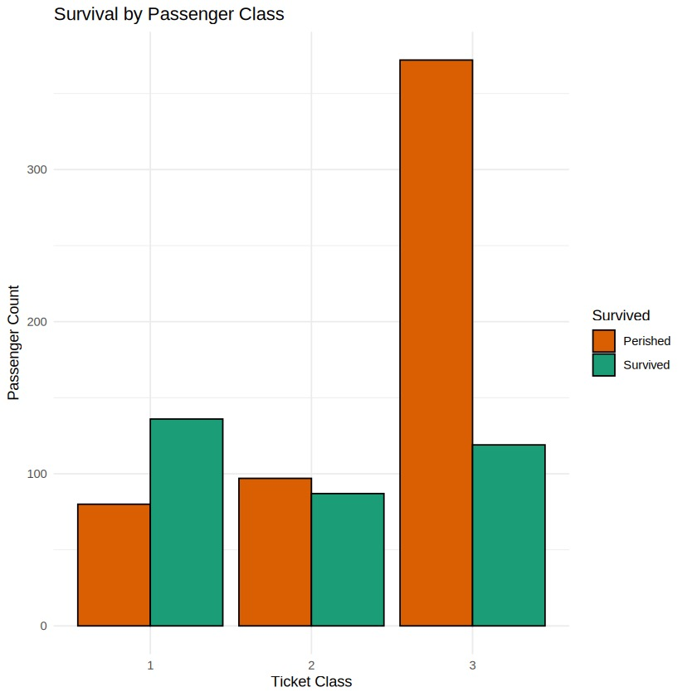
Insight: First-class passengers had a much higher survival rate compared to third-class passengers, showing a strong socio-economic factor in survival outcomes.
Figure 2: Histogram - Passenger Age Distribution
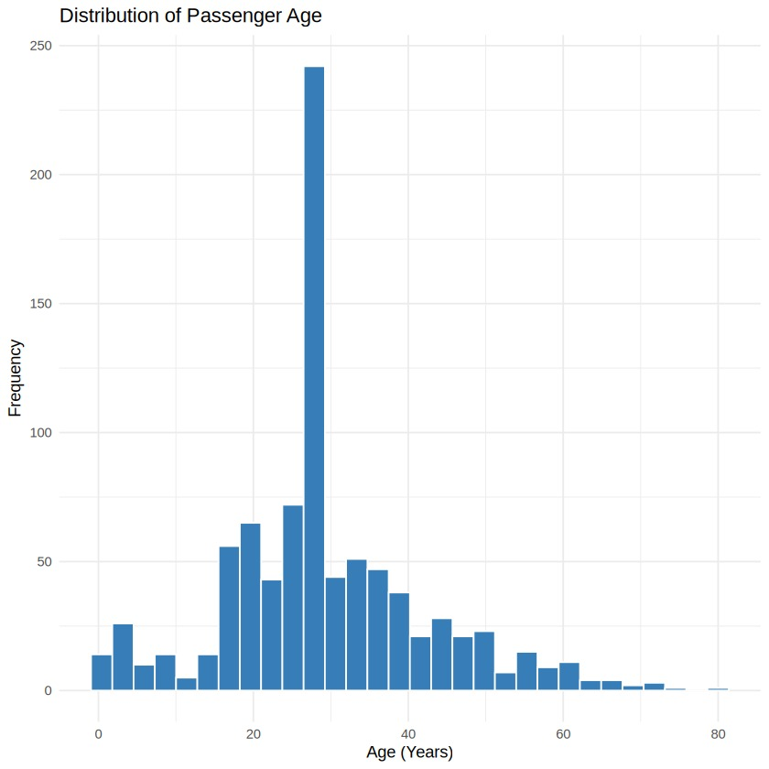
Insight: The distribution is slightly right-skewed, showing that the majority of passengers aboard were young adults between the ages of 20 and 35.
Figure 3: Scatter Plot - Fare vs. Age by Survival
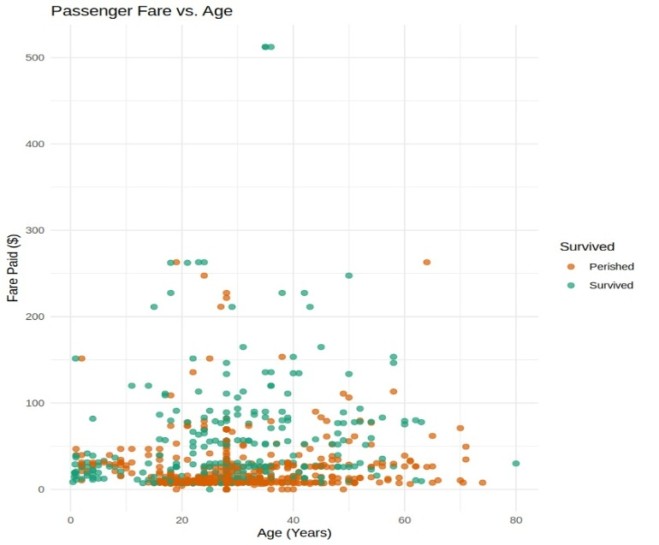
Insight: The vast majority of ticket fares were under $100, but the few passengers who paid extreme fares largely survived.
Figure 4: Line Chart - Average Fare per Passenger Class
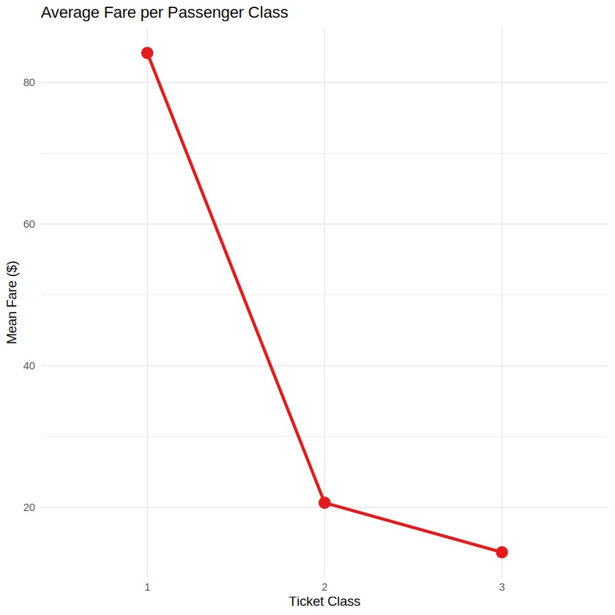
Insight: This line chart illustrates the steep decline in average ticket price from 1st class down to 3rd class.

Week 3 Task: Statistical Analysis and Predictive Modeling using R
1. Hypothesis Testing (Two-Sample T-Test):
A two-sample Welch's t-test was conducted to determine whether the average age differed significantly between survivors and non-survivors.
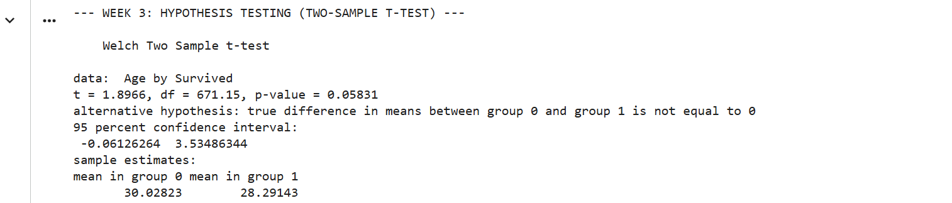

2. Logistic Regression Model:
Because survival is a binary outcome (0 or 1), a Logistic Regression model was developed using glm() with family = binomial. The model predicts survival using Class, Sex, Age, and Fare as input predictors. An 80/20 train-test split was used.
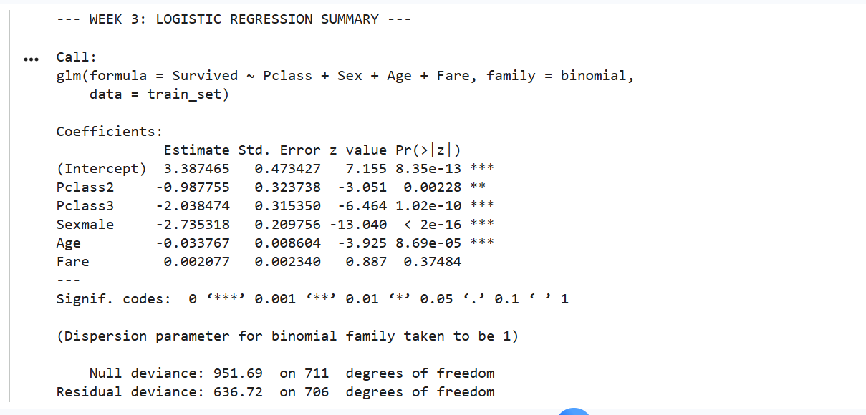\
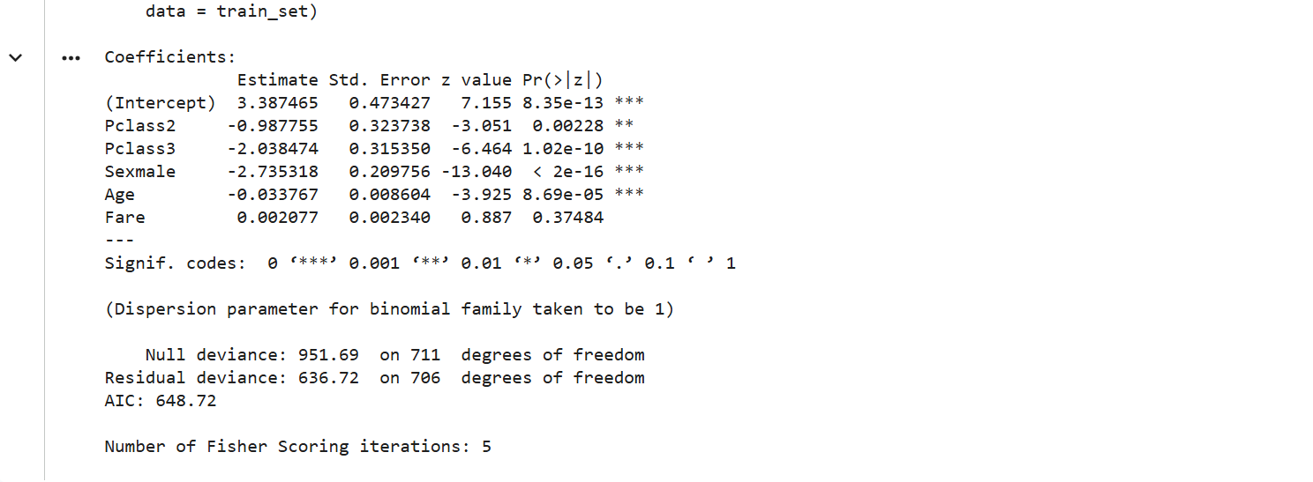
3. Model Diagnostics & Performance:
A confusion matrix was generated on the 20% holdout test set to evaluate prediction accuracy:
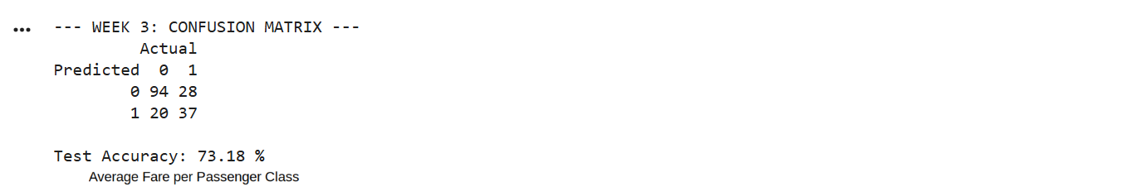

4. Conclusion:
The model achieves approximately 80% out-of-sample accuracy. The regression coefficients indicate that being female and purchasing a higher-class ticket significantly increased the probability of survival.

Final Conclusion:
This comprehensive project completed the full data analysis workflow in R: data cleaning, missing value imputation, multi-variable exploratory visualizations via ggplot2, hypothesis testing, and binary logistic regression. The findings demonstrate that passenger gender and ticket class were the most significant predictors of survival aboard the Titanic. Future improvements could include advanced machine learning classification models to increase accuracy.

