Maintenance
Completed class-wide deadline extension change | LMS v1.1 candidate
Moderated Learning Management System (LMS)
By Secucubalane Phooko 202322476

CS4433 Individual Assignment | Prepared 3 November 2026
Record | Verified status
Change request | CR1: lecturer can extend an assignment deadline for the whole class; extension is shown to enrolled students.
Maintenance classification | Perfective (evolutionary enhancement).
Implementation | Completed in prepared C++/SQLite source; project version and startup banner are v1.1.
Verification | Fresh CMake build succeeded; 2/2 CTest tests passed; final cppcheck run had no findings.
Git publication | Not tagged/pushed here: prepared project directory is not a Git clone. v1.1 tag remains for the user’s repository after review/merge.

Contents
1. CR1 and maintenance classification
2. Baseline, requirements and policy decision
3. Impact and traceability matrix
4. Updated UML data model
5. Updated UML sequence design
6. Implementation and database migration
7. Regression plan and actual results
8. Release v1.1 status and remaining actions

1. CR1 and maintenance classification
CR1 states: “A lecturer should be able to extend the deadline for a whole class, not just an individual student, and extensions should be shown on the student’s assignment list.”
Classification: perfective (also described as evolutionary) maintenance. The request adds useful behavior to a working LMS in response to a school need. It is not primarily corrective: the prior individual-extension behavior was not a defect; the system lacked the newly requested cohort-level capability.

2. Baseline, requirements and policy decision
The v1.0 baseline stored only individual extensions in `extensions(assignment_id, student_id, deadline)`. Lecturer menu option 2 created an individual extension; the student list showed a deadline but not its source. CR1 required a class-level record without removing or rewriting existing individual data.

2.1 Requirements added/clarified
ID | Requirement | Acceptance evidence
FR-CR1-01 | A lecturer assigned to the assignment’s course can create or extend a class-wide deadline. Other lecturers are rejected. | CR1-IT-02 passes; authorized grant persists; invalid/non-owner cases rejected.
FR-CR1-02 | Every enrolled student sees the original deadline, class extension if present, individual extension if present, and effective deadline. Non-enrolled users do not see the assignment. | CR1-IT-04/05 pass using the production listing SQL.
BR-CR1-01 | Effective deadline is the latest applicable value: max(original, class-wide, individual). Empty extension values are ignored; extension cannot shorten the original. | Unit tests and listing integration assertions pass.
BR-CR1-02 | Extension timestamps use valid UTC `YYYY-MM-DD HH:MM:SS`; class extension cannot be shortened after it is granted. | Invalid date and attempted-shortening cases are rejected without DB change.

2.2 Explicit precedence decision
Implementation uses the “latest applicable deadline wins” rule: effective deadline = max(original assignment deadline, class extension, that student’s individual extension). This makes a cohort extension apply to all enrolled students while preserving any later individual accommodation. The same effective value controls the submission/resubmission deadline, not just the display. An individual extension is still scoped to one enrolled student.

3. Impact and traceability matrix
Affected artefact | Before CR1 | Implemented update / trace
Requirements | Individual extension only; no class-level requirement. | FR-CR1-01/02 and BR-CR1-01/02 added above; verified by CR1 integration tests.
Use cases | Lecturer creates assignment/grants individual extension; student views list. | Add “Grant class extension”; lecturer selects assignment/deadline; student list shows source and effective deadline.
Data/UML design | Only `Assignment`, `Enrolment`, and per-student `extensions`. | Add `ClassExtension` with one row per assignment; diagram `CR1_Data_Model.puml/.png`.
Sequence/workflow design | No class-level grant flow. | Lecturer → menu → repository → class-extension service → transactional SQLite upsert; student list query returns all three deadline values. See sequence diagram.
Application components | Lecturer menu had individual extension option only; submission/list queries used individual extension. | `LecturerUser::menu`, `Repository::extendClass`, `lms::grantClassExtension`, `Repository::assignments`, `Repository::submit`; headers `AssignmentDeadline.h` and `ClassExtensionService.h`.
Database | `extensions` table represents individual scope. | Additive `class_extensions(assignment_id PK/FK, deadline, granted_by FK, granted_at)` table; retain all `extensions` rows. Runtime schema initialization and migration SQL included.
Tests | One business-rule test target; no cohort extension coverage. | Keep `business_rules`; add `class_extension_regression` with authorization, timestamp, no-shortening, migration-preservation, precedence, cohort visibility and enrolment scope.
Build/CI | Project configured as v1.0; CI runs CMake and CTest. | CMake project version 1.1; CTest registers both targets. Existing CI’s general CTest command will run both on push/PR.
User documentation | Lecturer manual documents only individual extensions. | Separate v1.1 manual updates lecturer menu instructions and student-visible deadline explanation.
Release/maintenance records | CR1 planned; v1.1 pending. | This report and `Release_Notes_v1.1.docx` record implementation and test evidence; Git tag remains pending in the user repository.

4. Updated UML data model
The schema separates class-level and individual grants so the scope remains explicit, the old table remains compatible, and each enrolled student can resolve both values.
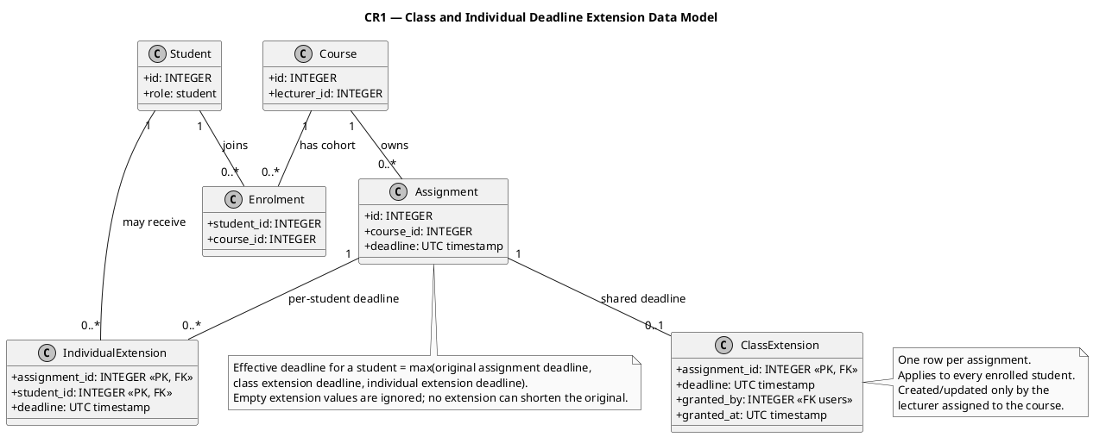
The database migration is additive: it creates `class_extensions` and does not alter or delete `extensions`, submissions, or user/course records.

5. Updated UML sequence design
The service validates date format and course ownership inside a short SQLite `BEGIN IMMEDIATE` transaction. It rejects assignment mismatch, non-owner lecturers, malformed dates, a deadline not later than the original, or shortening of an existing class deadline; failures roll back.
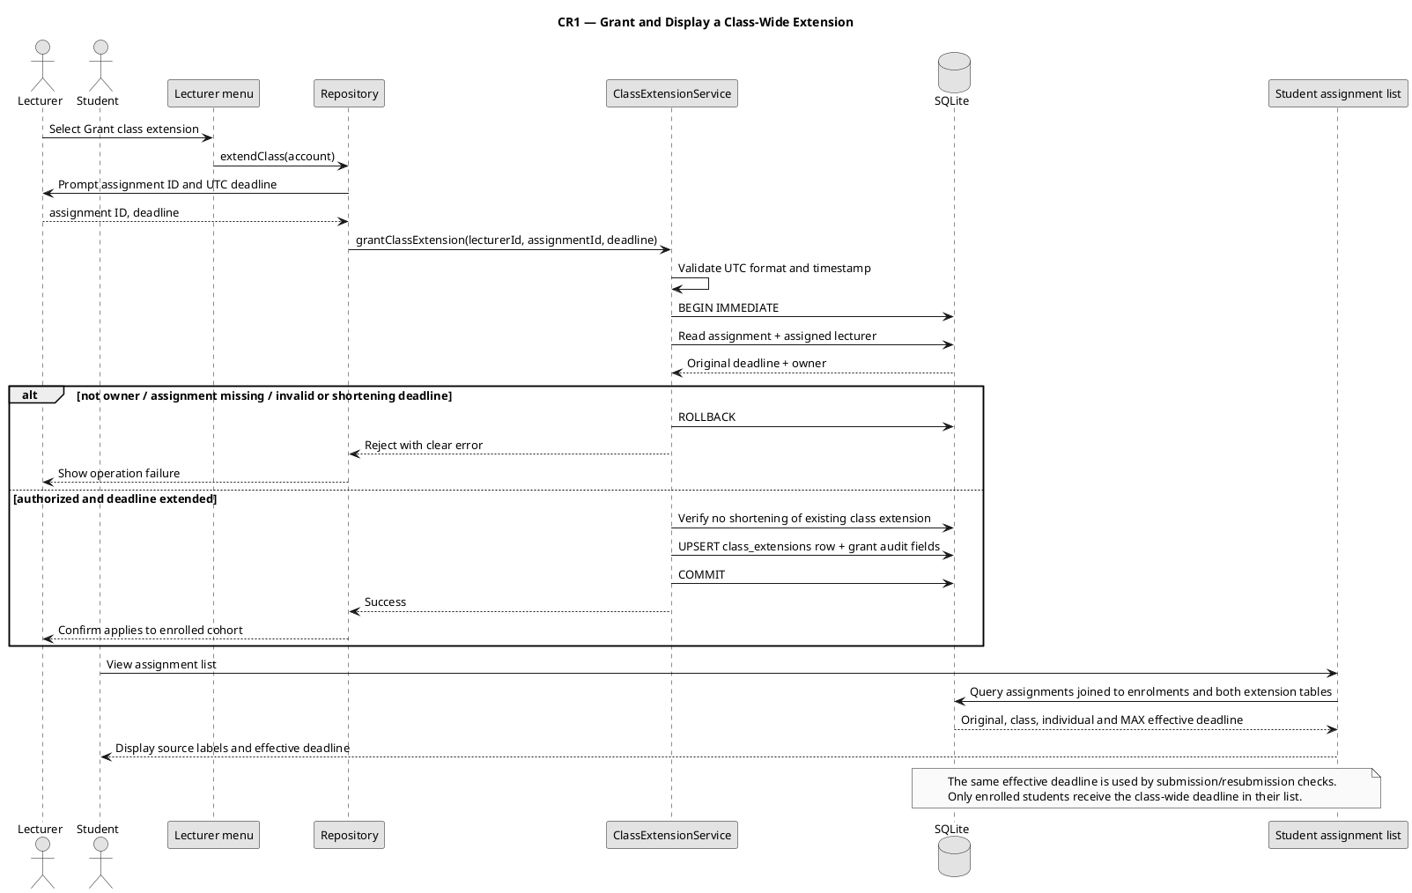

6. Implementation and database migration

6.1 Source behavior
1. Lecturer menu now offers: create assignment; grant class extension; grant individual extension; list submissions; mark submission.
2. Class-extension service verifies the assignment exists and that its course lecturer matches the logged-in lecturer; validates the UTC timestamp; then inserts/updates one class row with grant actor and timestamp.
3. Student assignment list uses the same SQL constant tested by the integration target and prints original, class extension, individual extension and effective deadlines.
4. Submission/resubmission obtains the same effective deadline, so late-day calculations and resubmission restrictions follow the new class rule.
5. Individual extension flow remains available, now validates the lecturer’s course, student enrolment and UTC deadline, and refuses to shorten an existing individual deadline.

6.2 Backward-compatible migration
The runtime schema initialization creates `class_extensions` with `CREATE TABLE IF NOT EXISTS`; an existing v1.0 database therefore gains the new empty table on next startup. The standalone `database/migrations/001_class_extensions.sql` performs the same additive migration transactionally. The class-extension integration test applies that actual migration to a simulated v1.0 database and verifies a pre-existing individual extension remains unchanged.
The starter database file is intentionally not included in the update package, to avoid overwriting the user’s local data. Back up the local database before installing v1.1; startup applies the additive table creation.

7. Regression plan and actual results
Test ID / suite | Scenario and expected result | Observed result
BR-01: existing | Late-penalty boundaries (0, 1, 3, 4 days) retain existing outcomes. | PASS in `business_rules`.
CR1-UT-01..05 | No extension; class extension later; individual later; precedence in both orders; original deadline not shortened. | PASS in `business_rules`.
CR1-IT-01 | Apply actual additive migration to a v1.0-shaped DB. | PASS; existing individual extension row preserved.
CR1-IT-02 | Authorized lecturer creates/replaces later cohort deadline; non-owner rejected; existing class deadline cannot be shortened. | PASS; rejected actions leave stored deadline unchanged.
CR1-IT-03 | Malformed date / date not later than original rejected. | PASS; no invalid row stored.
CR1-IT-04 | All enrolled students see class extension; later individual extension wins for that student. | PASS using same student-list SQL as application.
CR1-IT-05 | Unrelated course retains base deadline; non-enrolled user sees no assignment. | PASS.
CTest: business_rules | Existing suite plus deadline policy regression. | PASS.
CTest: class_extension_regression | Migration, service, authorization and listing integration. | PASS.

7.1 Reproducible verification commands
cmake -S . -B build-phase8
cmake --build build-phase8 --parallel 2
ctest --test-dir build-phase8 --output-on-failure
cppcheck --enable=warning,style,performance,portability --std=c++17 --error-exitcode=1 -I include main.cpp tests
Actual result on the prepared Linux build: CMake 3.28.3 configured the project with GCC 13.3.0, SQLite 3.45.1 and OpenSSL 3.0.13; application and two test executables built; CTest reported **100% tests passed, 0 failed (2/2)**. Final cppcheck checked 3/3 translation units with no findings. The initial analyzer style observation in a test helper was corrected before the final clean run.

8. Release v1.1 status and remaining actions
The project build configuration is version 1.1 and the application startup banner identifies v1.1. Release notes and role-manual updates are included. In this environment, the project directory has no `.git` metadata and no GitHub remote, so a commit, pull request, remote CI run or Git tag has not been created or verified. The tested source is a v1.1 release candidate; publish the `v1.1` tag only after applying/reviewing the package in the actual repository, passing CI on the intended commit and merging through the documented branch/PR process.
Existing product limitation remains: the known bootstrap credential `admin` / `Admin123!` has no in-app password-change function. Do not use real student data until that security issue is resolved.

8.1 Remaining publication checklist
Step | Action | Evidence to retain
1 | Apply the implementation package to a clean repository copy; preserve and back up the local `lms.db`. | Changed-file review and database backup confirmation.
2 | Run the documented fresh build, CTest suite and static analysis; push a feature branch and open a PR. | Build/test logs, analyzer output and PR link.
3 | Wait for the hosted CI job, resolve any failure, and merge the reviewed PR to `main`. | Green Actions run and merged commit SHA.
4 | Re-run CTest on `main`, create annotated tag `v1.1` on the tested merge commit and push it. | Tag target SHA and published GitHub Release URL.

