By: Secucubalane Phooko
Student Number: 202322476
Project Planning and Management

Learning Management System

Table of Content
Table of Content 2
Feasibility Study 3
Work Breakdown Structure 5
Gantt Chart 6
Risk Register 7

Feasibility Study
A feasibility study evaluates whether the proposed Moderated LMS is viable before significant resources are committed. The assessment covers five dimensions.

Technical Feasibility (Viable)
- The required technology stack is mature, open-source, and well-documented.
- SQLite provides reliable local persistence without a server, matching the offline / single-machine or local-network constraint.
- Role-based access, inheritance/polymorphism for user types, design patterns, salted password hashing, and an audit log are all standard and achievable in C++.
- Performance target is modest for a desktop/console application with local SQLite.
- Risk of technical novelty is low; the main challenge is correct modelling of the submission lifecycle and mark-moderation rules rather than exotic technology.

Operational Feasibility (Viable with careful UI design)
- Stakeholders (Principal, Lecturers, HoDs, Students, IT Officer) have clearly articulated needs. Conflicts can be resolved through prioritisation and explicit business rules.
- The system must be simple for non-IT users. A console interface or lightweight desktop GUI with clear menus and validation messages satisfies this.
- Offline operation is mandatory and is natively supported by local SQLite.
- Existing school computers are old, a lightweight C++ binary with minimal dependencies is appropriate.
- Training needs are limited because role-based menus can restrict each user to only the actions they are allowed to perform.

Economic Feasibility (Highly favourable)
- All required tools are free and open-source.
- No hardware purchases or cloud services are needed.
- Development is performed by a single student over 7 weeks as part of coursework, therefor no external labour cost.
- Long-term maintenance cost is low because the system is a self-contained local application.
- Benefits outweigh the development effort.

Legal / Ethical Feasibility (Viable provided privacy and fairness controls are implemented)
- Learner personal data and assessment records must be protected. Salted password hashes, role-based access, and an immutable audit log address confidentiality and integrity.
- Late-penalty rules must be applied consistently and transparently to avoid claims of unfairness.
- Accessibility for users with disabilities should be considered in the console/GUI design.
- No copyrighted third-party content or prohibited functionality is involved.

Schedule Feasibility (Tight but achievable)
- The 7-week Waterfall schedule with three formal gates is realistic for a single developer of final-year competence.
- Critical constraint: implementation may not begin until the design has passed Gate 2.
- Buffer exists in weeks 6–7 for deployment, the mandatory change request, and documentation.
- Risk of slippage is managed by the risk register and weekly progress tracking.

Work Breakdown Structure
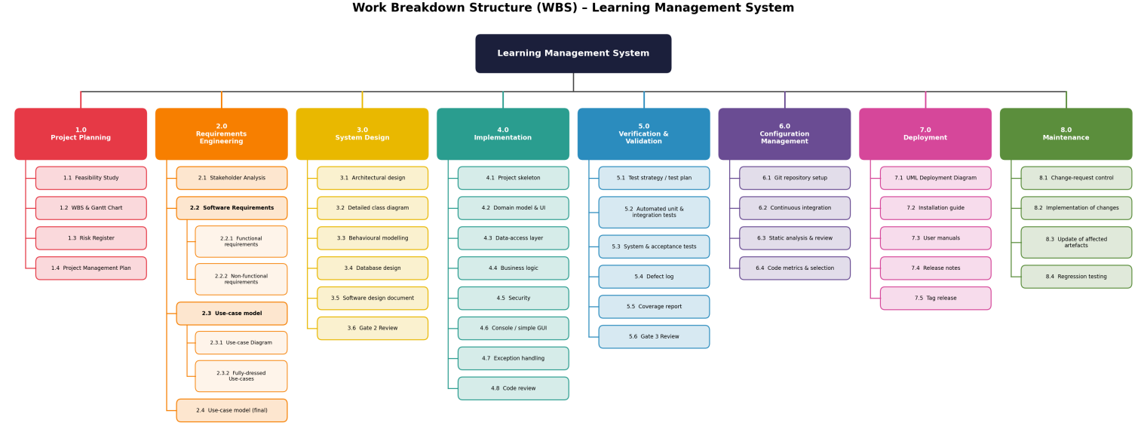

Gantt Chart
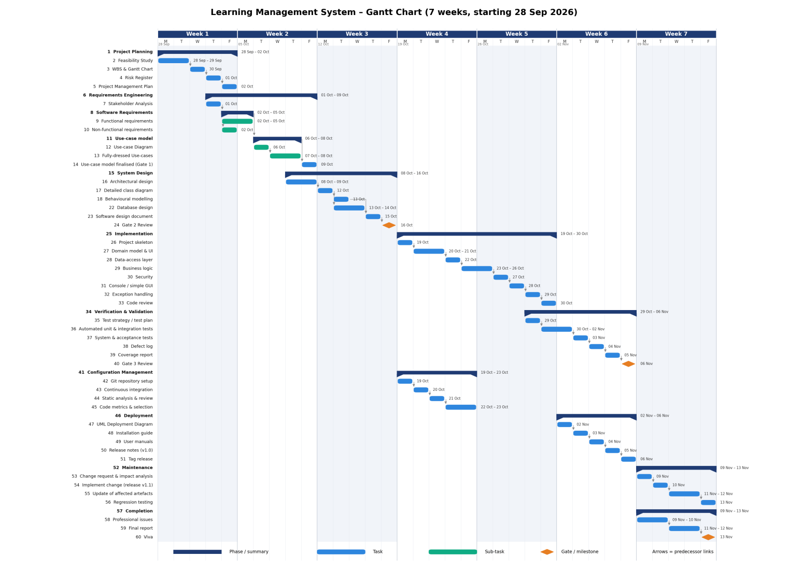

Risk Register
ID | Risk description | Category | Likelihood (1–5) | Impact (1–5) | Exposure (L×I) | Mitigation / Contingency | Owner | Status
R1 | Stakeholder requirement conflicts remain unresolved | Project | 4 | 4 | 16 | Early structured conflict-resolution workshop; document decisions in SRS with priorities (MoSCoW) | Student | Open
R2 | Schedule overrun because design Gate 2 is delayed | Project | 3 | 5 | 15 | Strict weekly progress checks; start Class Diagram as soon as use cases are stable. | Student | Open
R3 | Difficulty implementing secure password hashing + audit log correctly | Technical | 3 | 4 | 12 | Research and prototype hashing library early, unit-test security functions thoroughly | Student | Open
R4 | SQLite performance or concurrency issues with 800 users | Technical | 2 | 3 | 6 | Design for single-user or low-concurrency local use, index key tables, measure with representative data | Student | Open
R5 | Illness or personal circumstances reduce available effort | People | 2 | 5 | 10 | Maintain buffer tasks, keep repository and documentation up to date so progress is recoverable | Student | Open
R6 | Static analyser or CI pipeline configuration consumes excessive time | Technical | 3 | 2 | 6 | Allocate half day in Week 4 for CI setup, use proven GitHub Actions / GitLab CI templates | Student | Open
R7 | Design patterns or SOLID principles applied incorrectly leading to rework | Technical | 3 | 3 | 9 | Review pattern, peer/self design review at Gate 2 | Student | Open
R8 | Change request has larger impact than expected | Project | 2 | 3 | 6 | Perform thorough impact analysis before coding, keep design documents under version control | Student | Open

