
COMSATS University, Islamabad Pakistan

IRONWALL

By

Muhammad Zubair CIIT/FA22-BCT-046/ISB
Shahab Ishaq CIIT/FA22-BCT-029/ISB

Supervisor
Dr. Farhana Jabeen

Bachelor of Science in Cyber Security (2022-2026)

The candidate confirms that the work submitted is their own and appropriate credit has been given where reference has been made to the work of others.

COMSATS University, Islamabad Pakistan

IRONWALL

A project presented to
COMSATS University, Islamabad

In partial fulfillment
of the requirement for the degree of

Bachelor of Science in Cyber Security (2022-2026)

By

Muhammad Zubair CIIT/FA22-BCT-046/ISB
Shahab Ishaq CIIT/FA22-BCT-029/ISB

DECLARATION
We hereby declare that this software, neither whole nor as a part, has been copied out from any source. It is further declared that we have developed this software and accompanied report entirely on the basis of our personal efforts. If any part of this project is proved to be copied out from any source or found to be a reproduction of some other, we will stand by the consequences.
No Portion of the work presented has been submitted of any application for any other degree or qualification of this or any other university or institute of learning.

Muhammad Zubair Shahab Ishaq

CERTIFICATE OF APPROVAL
It is to certify that the final year project of BS(CYS) Ironwall was developed by
MUHAMMAD ZUBAIR (CIIT/FA22-BCT-046) and SHAHAB ISHAQ (CIIT/FA22-BCT-029)
under the supervision of DR. FARHANA JABEEN and that in her opinion; it is fully adequate, in scope and quality for the degree of Bachelor of Science in Cyber Security.

Supervisor

External Examiner

Head of Department
(Department of Computer Science)

Acknowledgement
All praise is to Almighty Allah who bestowed upon us a minute portion of His boundless knowledge by virtue of which we were able to accomplish this challenging task.

We are greatly indebted to our project supervisor Dr. Farhana Jabeen. Without her personal supervision, advice and valuable guidance, completion of this project would have been doubtful. We are grateful to her for her encouragement and continual help during this work.

And we are also thankful to our parents and family who have been a constant source of encouragement for us and brought us with the values of honesty & hard work.

Muhammad Zubair Shahab Ishaq

Table of Contents

Chapter 3: Design and Architecture 8
3.1 System Architecture Overview 8
3.1.1 Purpose 8
3.2 Conceptual Architecture Diagram 9
3.2.1 Technologies and Services 9
3.3 Architecture Style / Pattern 11
3.3.1 Chosen pattern 11
3.3.2 High-level rationale 12
3.3.3 How the microservices pattern supports ironwall’s key requirements 12
3.3.4 Quality attributes justification 13
3.3.5 Alternatives considered and why they were not chosen 13
3.3.6 Components mapped to architecture style 14
3.4 Design Model 16
3.4.1 Class Diagram 16
3.4.2 Sequence Diagrams 17
3.4.3 Activity Diagrams 26
3.4.4 State Transition Diagrams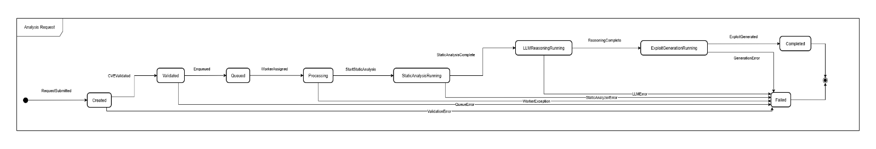 32
3.5 Data Design 33
4 Chapter 4: Implementation 37
4.1 Project Methodology & Algorithms 37
4.1.1 Project Methodology (Step-by-Step Approach) 37
4.1.2 Algorithm 42
4.2 User Interface 45
4.2.1 Landing page 46
4.2.2 Signup 46
4.2.3 Login 47
4.2.4 Dashboard 48
4.2.5 Campaign history 49
4.2.6 View report 49
4.2.7 Chatbot 50
4.2.8 User profile 51
4.2.9 Reports and governance 51
4.2.10 Settings 52
4.3 Deployment 52
Chapter 5: Testing and Evaluation 54

Table of Figures
Figure 3- 1: Conceptual Architecture Diagram 10
Figure 3- 2: Class Diagram IRONWALL 17
Figure 3- 3: Submit CVE analysis report 18
Figure 3- 4: Data fetch and sync 19
Figure 3- 5: Static analysis execution 20
Figure 3- 6: LLM Reasoning Workflow 21
Figure 3- 7: Exploit Generation 22
Figure 3- 8: view analysis results 23
Figure 3- 9: exploit validation on target 24
Figure 3- 10: System-wide Logging and audit trail 25
Figure 3- 11: Ironwall notification 26
Figure 3- 12: exploitation engine 27
Figure 3- 13:CVE Analysis 28
Figure 3- 14:Payload Generation 29
Figure 3- 15:PEntesting Execution 30
Figure 3- 16:Validation and verification 31
Figure 3- 17:preprocessing 32
Figure 3- 18:analysis request 33
Figure 3- 19:CVE entry enric 33
Figure 3- 20:exploit artifact 33
Figure 3- 21:landing page 47
Figure 3- 22:Signup and Register page 47
Figure 3- 23:Login page 48
Figure 3- 24:Dashboard page 49
Figure 3- 25:Campaign history 50
Figure 3- 26:View report 50
Figure 3- 27:CHatbot 51
Figure 3- 28:user profile 52
Figure 3- 29:reports and governance 53
Figure 3- 30:settings 53

Chapter 3: Design and Architecture

This chapter presents the high-level architectural design of Ironwall. It integrates the conceptual system architecture, architectural design patterns, and design models to provide a comprehensive understanding of how the system is structured and implemented. It also includes data design and a data dictionary for full system clarity.

System Architecture Overview
.
IRONWALL follows a microservices-based architecture where each major capability of the system is separated into its own independent service to ensure scalability, security, and clean domain boundaries. The user interacts through a Next.js frontend, which sends all requests to a centralized API Gateway. The gateway performs authentication, routing, and rate limiting before forwarding requests to backend services. Behind the gateway, IRONWALL is composed of specialized services: an authentication service for identity and access control, a CVE intelligence service for fetching and enriching vulnerability data, an analysis service for inspecting source code or binaries, a guidance service that merges CVE data with analysis results to produce structured penetration-testing steps, a validation service to verify environment readiness, and a logging service that stores centralized system logs. This architecture ensures that failure in one module does not affect the entire system and each component can scale or evolve independently.
All microservices communicate using lightweight REST APIs, and logs are funneled into a central MongoDB-backed log service. Redis is used for caching and short-lived data such as sessions and rate-limiting tokens. This design gives IRONWALL a clean separation of responsibilities, reduces coupling, and improves maintainability. It also aligns with the recommended architectural practices in your university’s design guidelines, which emphasize clear modular boundaries, layered data flow, and secure communication between system components.

Purpose

The purpose of IRONWALL’s architecture is to provide a secure, scalable, and modular foundation for automating cybersecurity analysis workflows such as CVE understanding, code/executable inspection, exploit-path reasoning, and validation of attack environments. By structuring the system into independent microservices behind a controlled API Gateway, the architecture ensures fault isolation, easier maintenance, and the ability to evolve each analytical component without affecting others. This approach supports high-performance processing for heavy tasks like static analysis, maintains strict security boundaries for sensitive operations, and delivers a smooth end-to-end workflow for analysts through a centralized, well-organized system design that aligns with formal architectural guidelines.

Conceptual Architecture Diagram
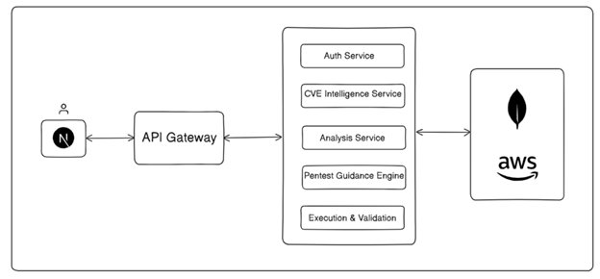
Figure 3- 1: Conceptual Architecture Diagram

Technologies and Services
Table Technologies, Components, and Security Mechanisms Used in the System Architecture

Component | Description | Technology Used | Security / Integration
Presentation Layer | Next.js web interface for CVE selection, code/binary upload, displaying analysis, and guided exploit workflow. Communicates only with API Gateway. | Next.js, React, TypeScript, REST APIs | HTTPS, JWT Token-Based Authentication
API Gateway & Core | Central entry point for all system traffic. Manages auth verification, routing, rate limiting, and request logging before forwarding to microservices. | Node.js (Fastify/Express), NGINX (optional), JWT Auth, TypeScript | Rate Limiting, JWT Verification, API Gateway Filtering
CVE Intelligence Layer | Fetches CVE records, enriches metadata, validates CVE IDs, and caches results for fast access. Provides structured vulnerability intelligence to downstream services. | Node.js Microservice, NVD API, Redis Cache, Axios, TypeScript | API Key Security, Cached Response Protection
Analysis Layer (Static Analysis + Preprocessing Tools) | Performs preprocessing and analysis of uploaded source code or binaries. Extracts features, detects patterns, identifies relevant functions/classes, and prepares structured analysis for reasoning engine. | Node.js Microservice, Python Bridge, Semgrep, Binwalk, Ghidra Headless Mode (optional), ClamAV (malware scan), File-Type Detectors, AST Parsers, Regex-Based Feature Extractors | File Sanitization, Antivirus Scan Before Processing, Upload Size Limits, Sandboxed Parsing
Guidance / Reasoning Layer | Combines CVE intelligence + analysis results to generate detailed pentesting guidance steps, environment setup instructions, payload placement strategies, and verification instructions. | Node.js Microservice, Python Microservices (optional), OpenAI LLM APIs | RBAC for service access, Audit Logging, Validation Policy Enforcement
Exploit Generation Layer (Code Llama) | Generates exploit code drafts using Code Llama based on guidance-layer reasoning. Converts conceptual payload design into structured exploit templates. Ensures safe output filtering and non-execution. | Code Llama Model, Python Microservice, Node.js Bridge, Prompt Templates | Output Safety Filters, Policy-Based Redaction, Execution Prevention, RBAC
Validation Layer | Validates exploit prerequisites: dependency compatibility, environment readiness, resource checks, and configuration correctness. Does not execute real exploits. | Node.js Microservice, Static Dependency Checkers, Containerized Validation Tools | Strict Input Validation, Non-Execution Security Model, Container Isolation
Data Management Layer | Stores analysis sessions, logs, CVE snapshots, exploit drafts, metadata, and user artifacts. Supports efficient querying and fast retrieval. | MongoDB, Redis Upstash, Mongoose ORM, JSON Storage | Encrypted Storage, Automatic Backups, Access Control Lists
Security & Monitoring Layer | Centralized monitoring for system events, failures, suspicious activity, and audit logs. Ensures full observability across services. | Node.js Logging Service, MongoDB, Winston Logger, Prometheus/Grafana (optional) | TLS 1.3, RBAC, Audit Logging, Secure Token Management
Sandbox Execution Control (No Real Exploit Execution) | Safely inspects uploaded files pre-analysis. Ensures zero execution of untrusted artifacts. Manages isolation and cleanup. | Docker Engine Sandbox, File Scanners, Resource Limits, Seccomp Profiles | Full Isolation, Snapshot Revert, No Execution Policy, Safe Sandbox Controls

Architecture Style / Pattern

Chosen pattern
Microservices Architecture (with layered internal structure inside each service).
IRONWALL is decomposed into independently deployable backend services—Auth, CVE Intelligence, Analysis, Guidance/LLM Reasoning, Exploit Generation, Validation, and Logging—exposed through a unified API Gateway. Each service has its own internal layering (Controller → Service Logic → Data Access → Utilities), and all inter-service communication occurs over secure REST calls. This hybrid pattern gives IRONWALL the correctness and clarity of layered design while achieving the modularity and scalability that the project's pipelines demand.

High-level rationale

The microservices pattern is the best fit for IRONWALL because the system contains multiple independent analytical pipelines—CVE parsing, static analysis, reasoning, exploit generation, validation—and each evolves at a different pace, uses different tooling (Node.js, Python, Code Llama), and may require different runtime environments. Forcing all of these into a single layered monolith would significantly reduce flexibility and make updates risky. Microservices allow heavy components (analysis, exploit generation) to scale independently, enable isolation of unsafe operations (file preprocessing), and support clean boundaries required for a cybersecurity platform. Unlike UI-driven apps, IRONWALL is a backend-heavy decision/analysis engine, where independent services reduce cognitive load and allow parallel development.
.

How the microservices pattern supports ironwall’s key requirements

- Separation of concerns / independent evolution
CVE logic, static analysis, reasoning, and exploit generation all change at different rates.
Microservices prevent one module’s updates (e.g., switching from Semgrep to Ghidra) from breaking other modules.
- Security isolation
File uploads are handled in a sandboxed analysis service.
Exploit generation (Code Llama) runs in its own controlled environment to prevent misuse.
API Gateway enforces access policies centrally.
- Scalability for heavy workloads
Analysis workloads (Semgrep, Binwalk, AST parsing) are CPU-intensive.
Exploit generation (LLMs) is GPU/latency intensive.
Each can scale horizontally without affecting lighter services like Auth or Logs.
- Fault containment
If exploit generation fails (API outage, model failure), CVE intelligence and static analysis still work.
If a file crashes analysis service, it does not bring down user authentication.
- Technology diversity
Some services use Node.js; others call Python tools; exploit generation uses Code Llama.
Microservices allow correct tools per function instead of forcing a single stack.
- Auditability & traceability
Logging is centralized; every service reports activity to logs-service.
Execution history is preserved per module for security review.

Quality attributes justification
- Reliability:
Failures are isolated. A faulty analysis run does not impact the rest of the system. Each service can degrade independently.
- Security:
Defense-in-depth: JWT at the gateway, RBAC in services, sandboxing for file handling, isolation for exploit generation.
- Performance:
Heavy services scale separately. Analysis-service and exploit-service receive more resources; others remain lightweight.
- Evolvability:
New services (e.g., runtime emulator, advanced exploit verifier) can be added without refactoring core logic.
- Testability:
Services can be tested independently using mocks for upstream/downstream dependencies.

Alternatives considered and why they were not chosen

- Layered Architecture (Monolithic)
Too restrictive for IRONWALL because analysis tools, LLM reasoning, and exploit generation use different stacks and resource profiles.
A monolith mixing Node.js + Python + LLM workflows becomes impossible to maintain.
Heavy workloads would slow the entire system rather than isolated components.
- MVC Architecture
Suitable for simple CRUD/web apps, not for a multi-engine cybersecurity automation pipeline.
Does not naturally represent asynchronous pipelines or complex backend logic.
- DDD (Domain-Driven Design) as Primary Architecture
IRONWALL’s complexity is technical, not business-domain driven.
DDD adds unnecessary modeling overhead without solving our performance/security needs.
Useful only inside certain services, not across the entire system.
- Event-Driven / Pub-Sub Architecture
Not suitable as the primary pattern because IRONWALL requires synchronous, deterministic interactions among services (e.g., analysis → guidance → exploit generation).
Pub/Sub is only useful for background tasks (logging, notifications), not the core pipeline.
- Monolithic Single-Service Architecture
Easier to start but impossible to scale once analysis tools and LLM workloads begin.
Security isolation breaks down because everything runs in one process.

Components mapped to architecture style
- Presentation Layer → API Gateway
The interaction begins when the analyst performs actions such as selecting a CVE, uploading source code/binaries, or requesting exploit-generation guidance.
The Presentation Layer (Next.js Web App) performs basic client-side validation and converts user actions into structured API requests forwarded to the API Gateway.
Key interactions:
User uploads, CVE selections, and analysis requests are translated into authenticated REST calls.
Results (CVE intelligence, analysis output, exploit templates, validation messages) are displayed after being processed by backend layers.
- API Gateway → Backend Service Layer
The API Gateway is the central entry point for all external requests and shields the internal microservices from direct exposure. It authenticates JWT tokens, rate-limits clients, and routes requests to the correct backend service (CVE Service, Analysis Service, Guidance Service, Exploit Service, Validation Service, Auth Service, Logs Service).
Key interactions:
Requests such as fetch CVE, static analysis, generate exploit, and validate environment are forwarded to their appropriate service.
The gateway ensures only authorized requests reach the business logic services.
Service responses (success/failure/errors) travel upward through the same secure path.
- Backend Service Layer → Business Logic Layer (Inside Each Microservice)
Each microservice contains its own internal business logic responsible for performing specialized analytic tasks.
For example:
CVE Service retrieves and enriches CVE metadata.
Analysis Service preprocesses code/binaries (Semgrep, Binwalk, AST parsers, malware scan) and extracts meaningful findings.
Guidance Service merges analysis + CVE to produce a step-by-step pentest workflow.
Exploit Generation Service (Code Llama) produces safe exploit templates.
Validation Service verifies environment readiness.
Each service interacts only with its own data access layer and remains independent from the persistence strategy used by others.
Key interactions:
Each microservice performs computation based on request context from the gateway.
Business rules, LLM reasoning, and static analysis pipelines operate in isolation.
Workflows involving multiple services are coordinated via synchronous API chaining.
- Business Logic Layer → Data Management Layer
Business logic requires persistent storage for logs, past analyses, exploit drafts, CVE snapshots, guidance history, and user artifacts.
The Data Management Layer provides centralized storage using MongoDB (logs, metadata), Redis (caching), and internal JSON artifacts.
Key interactions:
Analysis Service stores structured analysis results and file metadata.
Exploit Service stores generated exploit drafts and reasoning traces.
Logs Service writes audit logs, system metrics, and request histories.
All updates pass through the service’s repository layer, keeping logic decoupled from storage technology.
- Business Logic Layer → Sandbox / Preprocessing Isolation Layer
When the Analysis Service or Exploit Service requires handling potentially malicious files, the request is delegated to a sandboxed preprocessing subsystem. This layer does not execute exploits; it only ensures safe inspection and feature extraction.
Key interactions:
Uploaded files undergo antivirus scanning, type checking, and safe parsing.
AST extraction, Binwalk binary scanning, and metadata extraction are all performed inside isolated containers.
Processed outputs and extracted features are returned to the business logic layer for reasoning.
This ensures IRONWALL never executes an exploit or untrusted binary on the host system.
- Sandbox / Preprocessing Layer → Data Management Layer
Preprocessing outputs such as file fingerprints, extracted metadata, vulnerability indicators, and safe snapshots are stored in the Data Management Layer.
Key interactions:
Feature extraction results are persisted for later review or cross-service correlation.
Logs generated inside sandbox containers are forwarded to the Logs Service for auditing.
- Data Management Layer → Presentation Layer
After the backend completes analysis or exploit generation, the accumulated structured outputs are passed upward for display.
Key interactions:
Business Logic Layer retrieves final results from the Data Management Layer.
API Gateway applies security filtering and sends sanitized data to the frontend.
Presentation Layer displays CVE insights, analysis findings, exploit drafts, and environment validation steps.
Security & Monitoring Layer (Cross-Cutting Across All Layers)
The Security & Monitoring Layer spans the entire architecture and applies protection, policy enforcement, and auditing at every interaction point.
Key responsibilities:
JWT + RBAC: Ensures only authorized analysts can request sensitive operations such as exploit generation or file analysis.
TLS 1.3: Secures all communication between frontend, gateway, and services.
Audit Logging: Every action—file upload, CVE request, analysis run, exploit generation—is recorded centrally for forensic traceability.
Rate limiting & anomaly detection: Protects against brute-force, API abuse, and malformed payloads.
This layer ensures IRONWALL maintains compliance, confidentiality, and operational safety across all components.

Design Model

Class Diagram

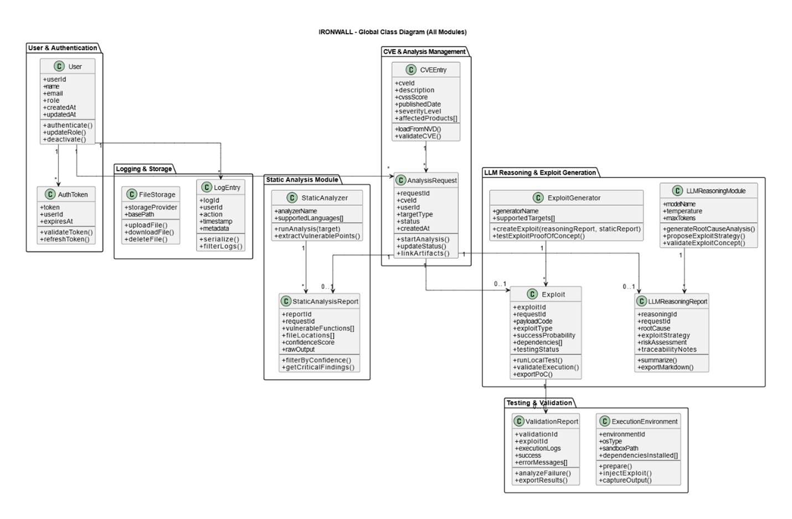
Figure 3- 2: Class Diagram IRONWALL

Sequence Diagrams

3.4.2.1 Submit CVE Analysis request
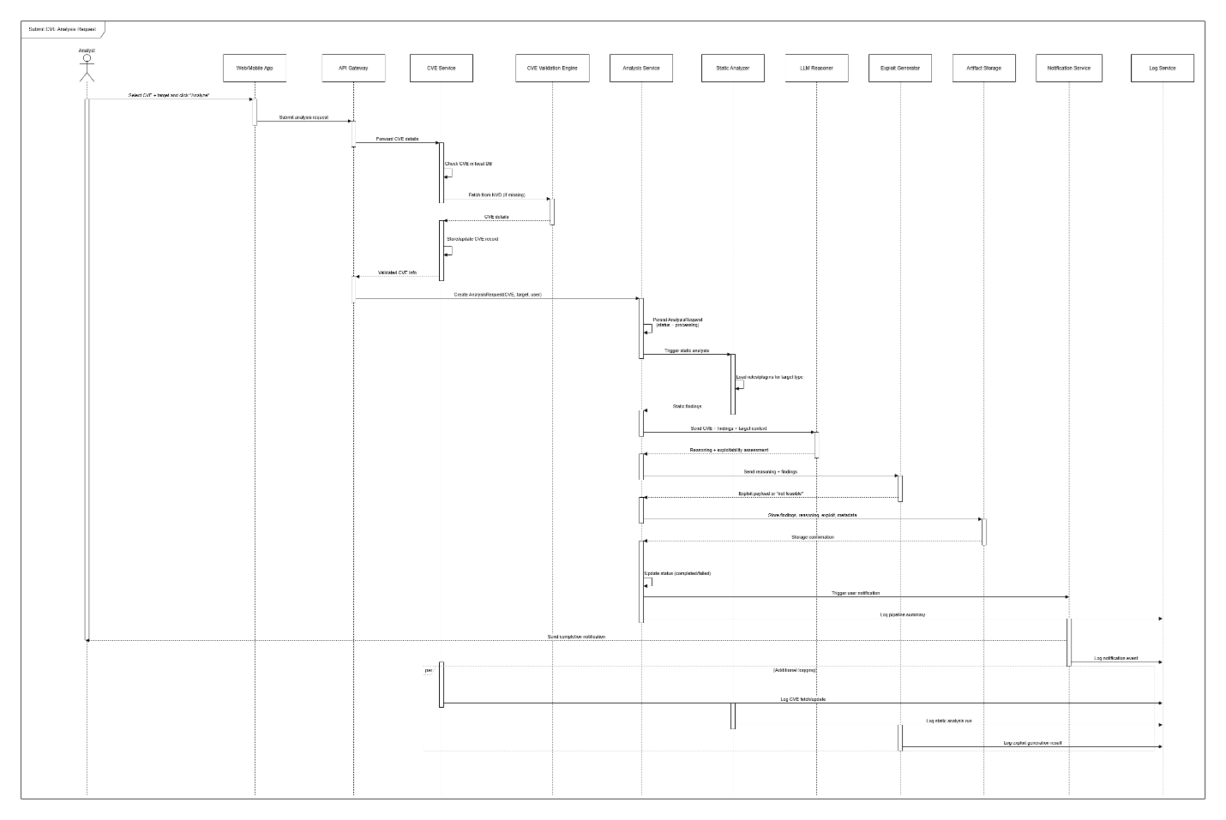
Figure 3- 3: Submit CVE analysis report
3.4.2.2 CVE Data fetch and synchronization
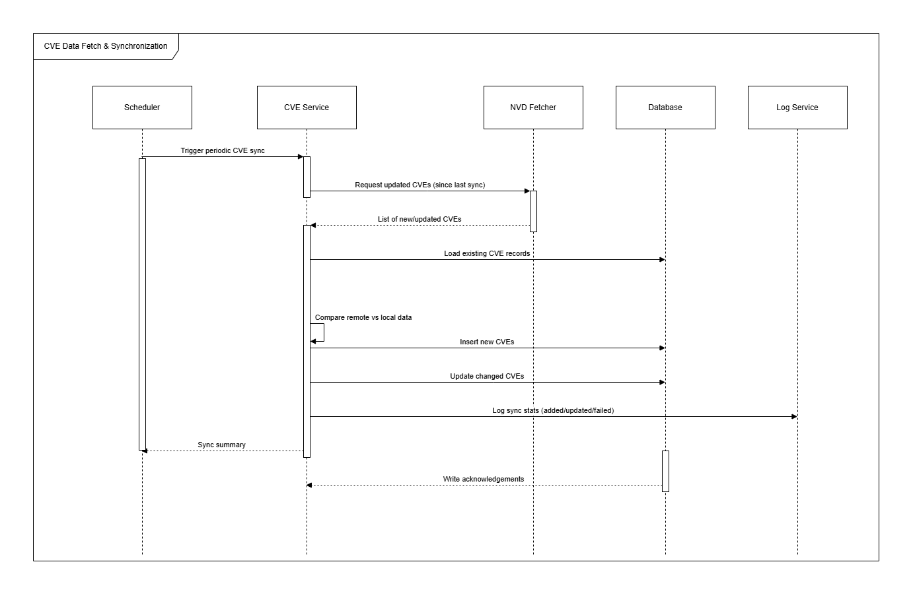
Figure 3- 4: Data fetch and sync

3.4.2.3 Static Analysis Execution (Source/Binary)

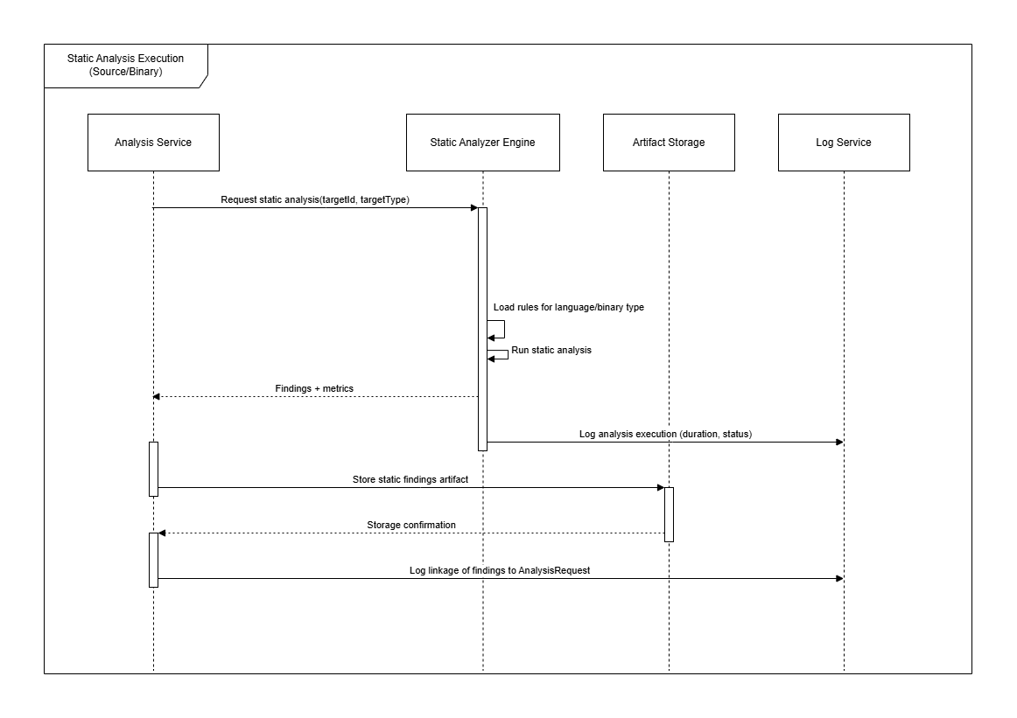
Figure 3- 5: Static analysis execution

3.4.2.4 LLM Reasoning Workflow
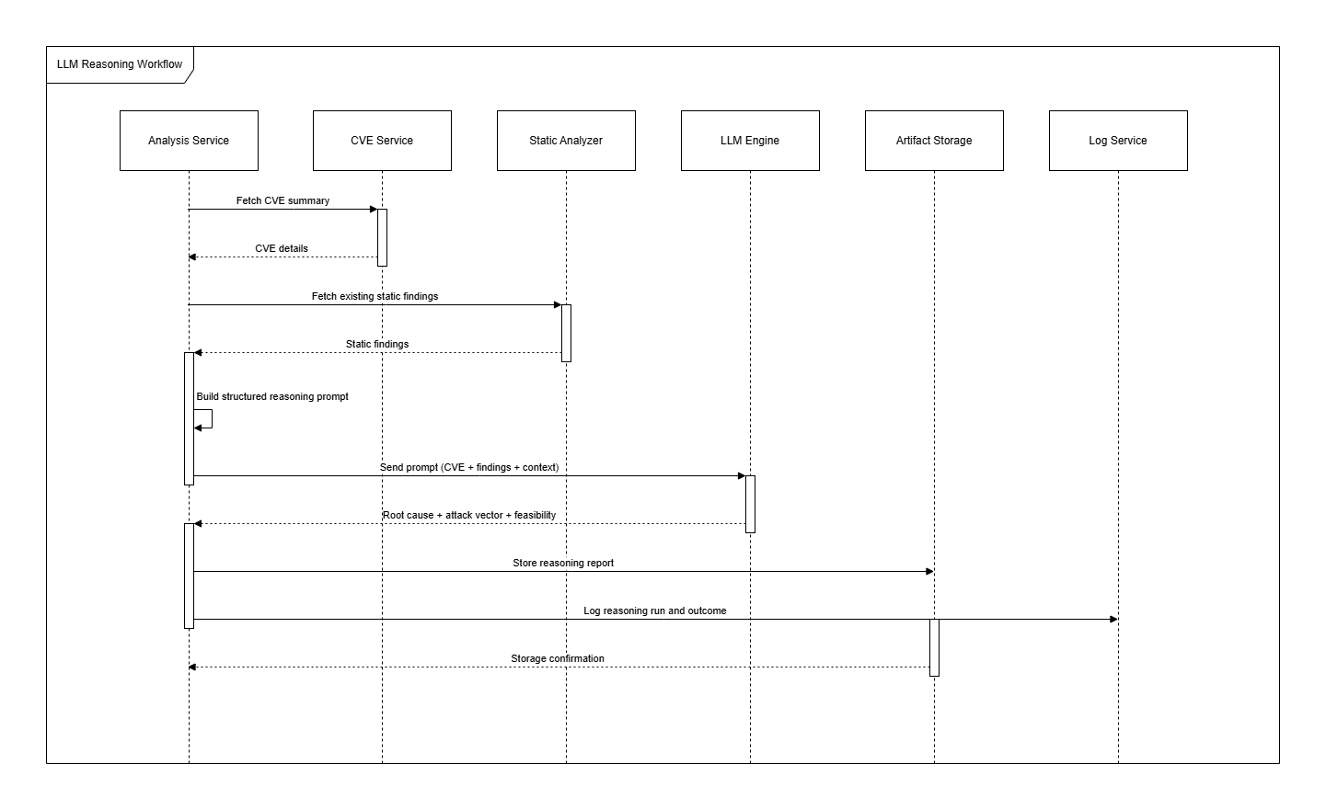
Figure 3- 6: LLM Reasoning Workflow

3.4.2.5 Exploit Generation
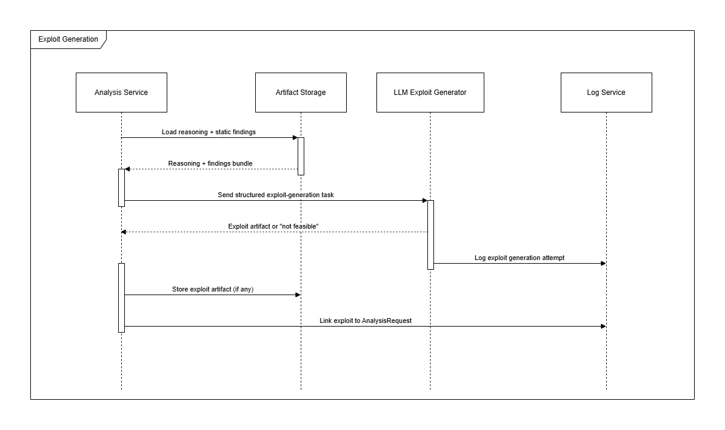
Figure 3- 7: Exploit Generation

3.4.2.6 View Analysis Results
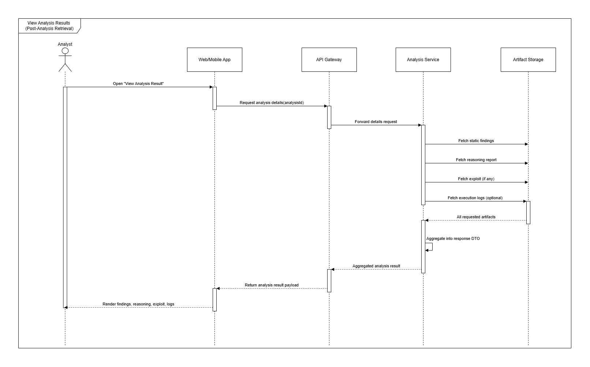
Figure 3- 8: view analysis results

3.4.2.7 Exploit validation on target
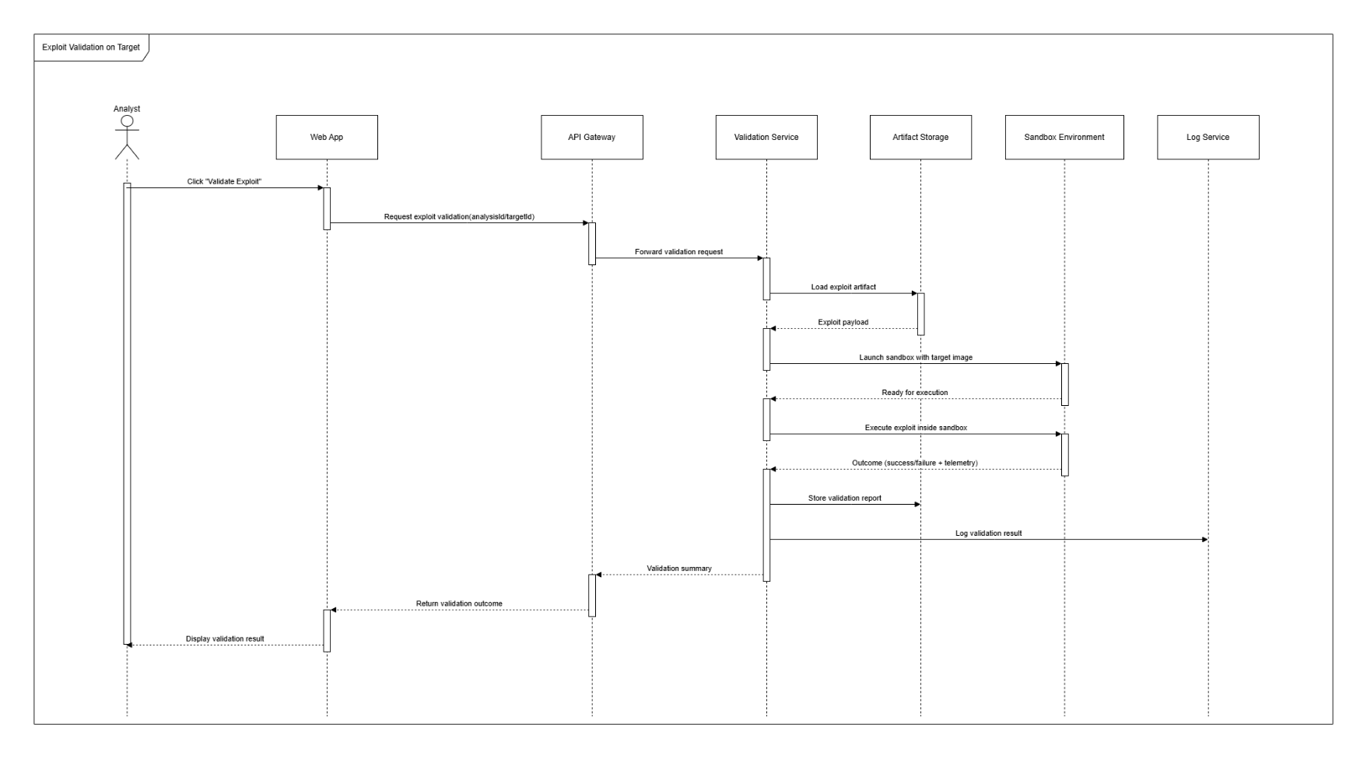
Figure 3- 9: exploit validation on target

3.4.2.8 System-wide Logging and audit trail
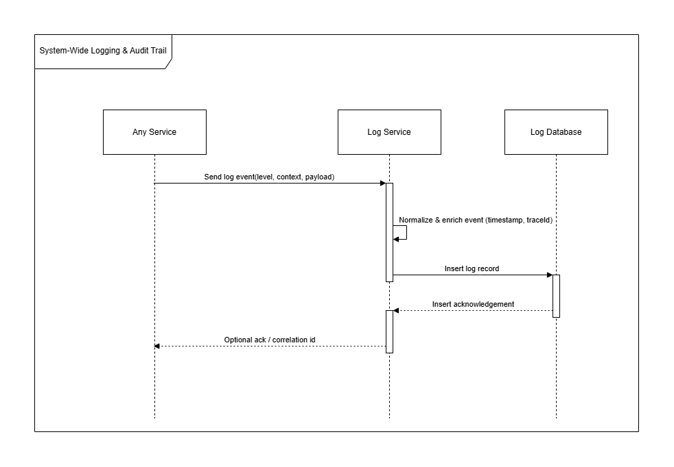
Figure 3- 10: System-wide Logging and audit trail

3.4.2.9 Ironwall Notification

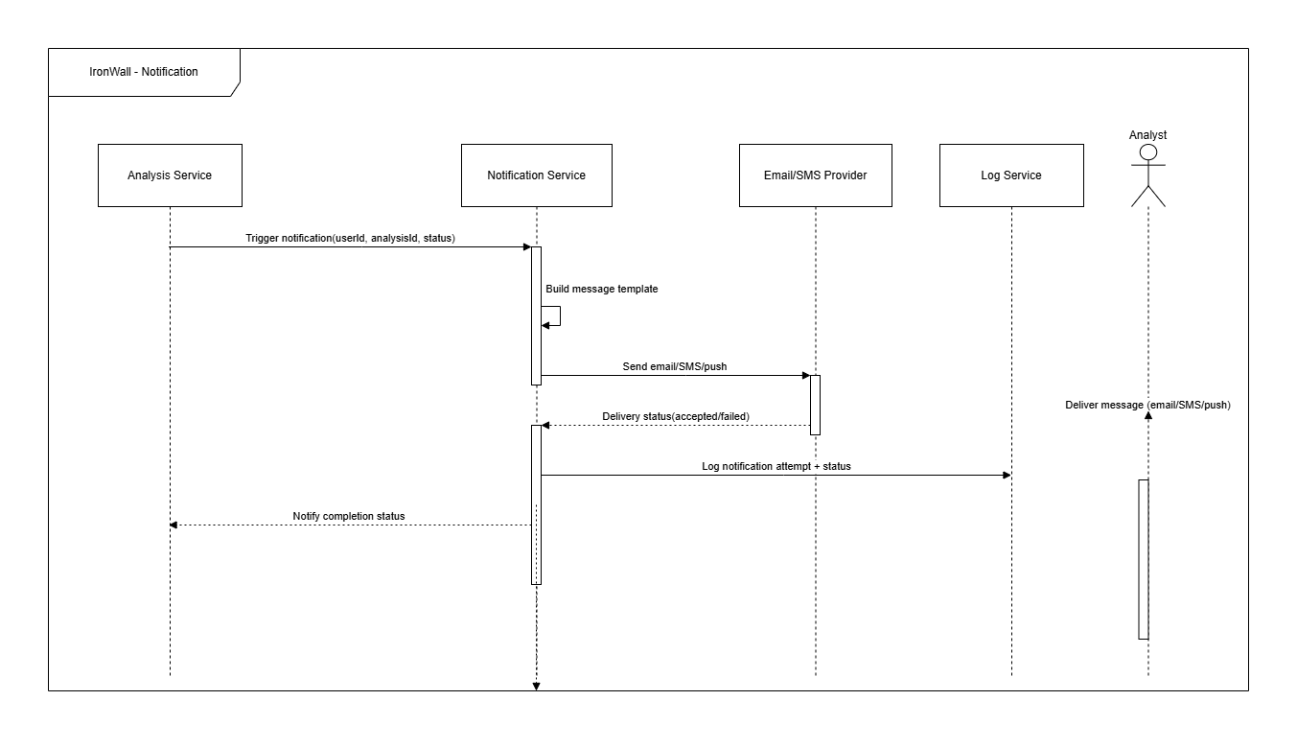
Figure 3- 11: Ironwall notification

Activity Diagrams

Exploitation Engine

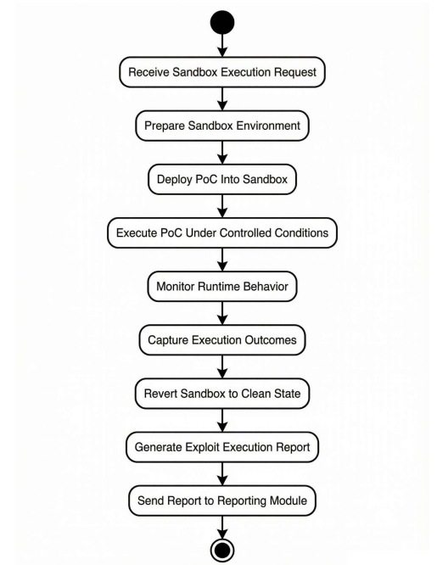
Figure 3- 12: exploitation engine

CVE analysis

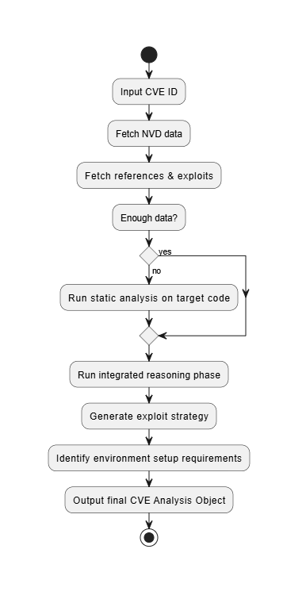
Figure 3- 13:CVE Analysis

Payload Generation

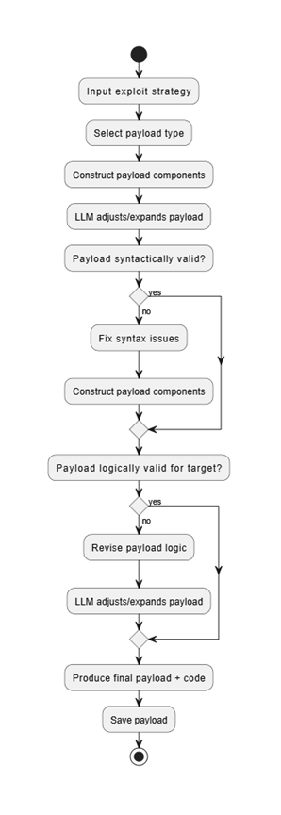
Figure 3- 14:Payload Generation

Pentesting Execution
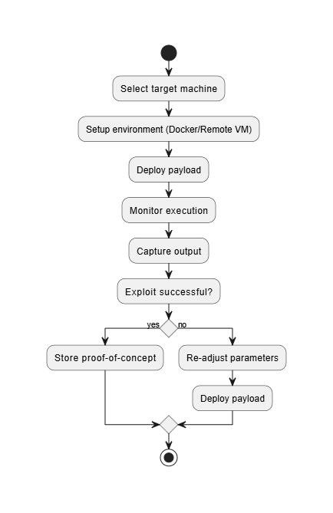
Figure 3- 15:PEntesting Execution

Validation and verification
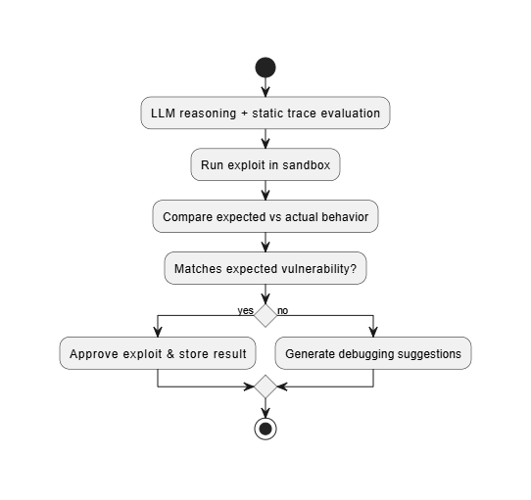
Figure 3- 16:Validation and verification

Preprocessing
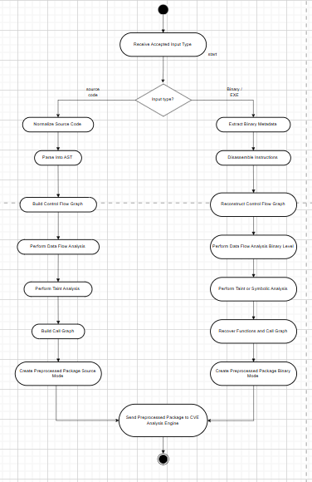
Figure 3- 17:preprocessing

State Transition Diagrams
Figure 3- 18:analysis request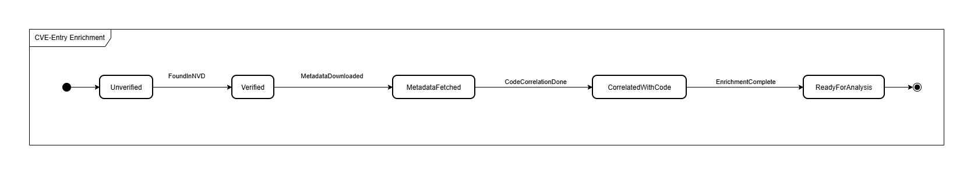
Figure 3- 19:CVE entry enric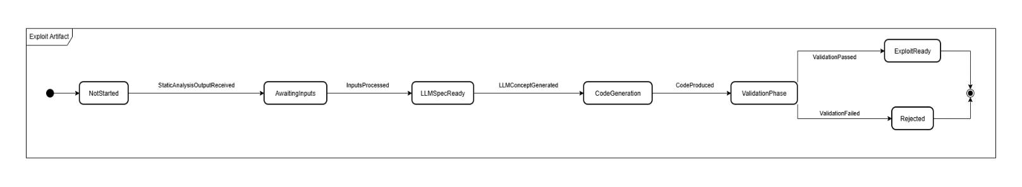
Figure 3- 20:exploit artifact

Data Design
This section explains how IRONWALL transforms cybersecurity analysis data into structured representations. It describes how the system stores, organizes, and processes information related to CVE intelligence, static analysis of source code/binaries, reasoning outputs, exploit-generation drafts, and validation results.
IRONWALL uses a combination of MongoDB for structured and semi-structured data, Redis for caching, and AWS S3 for large binary artifacts generated during preprocessing or exploit-generation workflows. This hybrid design supports flexibility, scalability, and secure handling of large technical assets.

1. Structured & Semi-Structured Storage (MongoDB)
MongoDB acts as the primary persistence layer for IRONWALL. It stores all information that benefits from flexible schema evolution and query efficiency.
Examples include:
CVE Intelligence Records
- CVE ID, severity, CVSS metrics
- Affected products
- Enriched metadata and external references
Analysis Sessions
- Session ID, timestamps, status
- Uploaded file metadata (name, size, hash, type)
- Preprocessing outputs (AST structures, Semgrep findings, fingerprints)
- Detected indicators and mapped weaknesses
Exploit Generation Outputs (Code Llama)
- Exploit drafts with safety annotations
- Reasoning context and prompt metadata
- Suggested payload structures
Guidance & Attack Workflow Data
- Step-by-step pentest guidance
- Environment setup requirements
- Validation conditions
System Activity Logs (Business-Level)
- User actions
- Service communication events
- Analysis failures and warnings
MongoDB is preferred because IRONWALL analysis outputs vary significantly in shape depending on file type and analysis tools.

2. High-Speed Cache Storage (Redis)
Redis stores temporary or frequently accessed data that improves performance and reduces latency.
Common cached items:
- CVE lookup caches
- JWT session tokens
- Rate-limit counters
- Temporary analysis indicators
- Partial LLM reasoning segments

3. Object Storage (AWS S3)
Large, binary, or unstructured items are stored in Amazon S3, which provides durable, scalable, and secure object storage suitable for a cybersecurity analysis pipeline.
Artifacts stored in S3 include:
- Uploaded source code archives
- Uploaded binaries (EXE, ELF, DLL, firmware)
- Decompiled code (if applicable)
- AST dumps
- Binwalk extraction results
- Malware scan logs
- Raw preprocessing outputs (Semgrep JSON, tool logs)
- Generated exploit templates / PoC drafts
- Final analysis reports (PDF, JSON, HTML)
Why S3 fits IRONWALL:
- Automatically scales with large files and high upload volumes
- Provides versioning and access control for sensitive artifacts
- Supports presigned URLs for secure uploads/downloads
- Integrates cleanly with containerized microservices
This ensures analysis tools have reliable access to artifacts without bloating the database or local filesystem.

4. Log Storage (Dual Format)
A. MongoDB Log Documents
Used for structured logs such as:
- User activity
- Audit events
- Error summaries
- Pipeline-level events
B. S3-Based Log Archives
Used for high-volume or tool-specific logs, including:
- Static analysis engine logs
- Sandbox preprocessing logs
- LLM reasoning debug logs (developer mode)
This dual structure enables fast query capability while still retaining rich diagnostic data.

Data Dictionary for IRONWALL:
Entity / Function | Attribute | Type | Description | Methods | Parameters | Return
CVERecord | cveID | String | CVE identifier (e.g., CVE-2021-44228) | fetchDetails() | cveID | JSON
 | severity | Enum | Low / Medium / High / Critical | enrichCVE() | cveID | JSON
 | cvssScore | Float | Standard CVSS score | validateID() | cveID | Boolean
 | description | String | Summary of the vulnerability | — | — | —
 | affectedProducts | List | List of impacted software/products | — | — | —
AnalysisSession | sessionID | UUID | Unique ID for each analysis run | startAnalysis() | fileID | Boolean
 | status | Enum | Pending / Processing / Completed / Failed | getResults() | sessionID | JSON
 | createdAt | DateTime | Session creation timestamp | listFindings() | sessionID | List
 | fileID | UUID | Reference to uploaded artifact | — | — | —
ArtifactInfo | fileID | UUID | Unique file reference | preprocess() | fileID | JSON
 | fileName | String | Name of uploaded source/binary | detectType() | fileID | String
 | fileHash | String | SHA-256 checksum | extractMetadata() | fileID | JSON
 | fileSize | Integer | Size of uploaded file | — | — | —
StaticFinding | findingID | UUID | Unique identifier for analysis finding | classifyFinding() | metadata | Enum
 | cveID | String | Mapped CVE (if applicable) | formatEvidence() | findingID | JSON
 | severity | Enum | Info / Low / Medium / High | — | — | —
 | filePath | String | Affected file or binary section | — | — | —
 | evidence | JSON | Code slice, AST snippet, binary signature | — | — | —
GuidanceRecord | guidanceID | UUID | Unique reasoning result | generateSteps() | sessionID | JSON
 | sessionID | UUID | Associated analysis session | mergeData() | sessionID, cveID | JSON
 | steps | JSON | Step-by-step pentest workflow | — | — | —
 | environmentNeeds | JSON | Required dependencies & setup | — | — | —
ExploitDraft | draftID | UUID | Generated exploit template ID | generateExploit() | guidanceID | String
 | cveID | String | CVE associated with exploit | refineDraft() | draftID | String
 | language | Enum | Python / Bash / C / Other | validateSafeOutput() | draftID | Boolean
 | codeSnippet | String | Exploit code generated by Code Llama | — | — | —
ValidationReport | validationID | UUID | Unique environment validation result | runChecks() | sessionID | JSON
 | sessionID | UUID | Linked analysis session | verifyDependencies() | sessionID | Boolean
 | issues | JSON | Missing packages, incompatible versions | — | — | —
 | status | Enum | Passed / Failed / Warnings | — | — | —
SystemLog | logID | UUID | Log entry reference | writeLog() | message | Void
 | service | String | Originating service (Analysis, CVE, etc.) | fetchLogs() | sessionID | List
 | message | String | Log message text | — | — | —
 | timestamp | DateTime | Logging timestamp | — | — | —
FinalReport | reportID | UUID | Consolidated output for user | exportPDF() | sessionID | File
 | sessionID | UUID | Linked analysis session | exportJSON() | sessionID | File
 | generatedAt | DateTime | Report generation time | summarize() | reportID | JSON

Chapter 4: Implementation
This chapter presents the implementation details of the IRONWALL Cybersecurity Automation Platform. It documents the core backend services, preprocessing pipelines, CVE intelligence ingestion, reasoning and exploit generation modules, as well as progress made on the frontend (≈35% complete). The backend implementation currently covers CVE ingestion, static analysis preprocessing for source code and binaries, guidance reasoning, and safe exploit template generation using Code Llama. Additional components such as environment validation and report generation have been implemented at a functional level.

Project Methodology & Algorithms
This section explains the step-by-step methodology and core algorithms implemented in IRONWALL. The implementation focuses on intelligent analysis of uploaded target artifacts, automated CVE intelligence retrieval, structured vulnerability reasoning, and controlled exploit template generation.

Project Methodology (Step-by-Step Approach)
The IRONWALL system implementation follows a structured analysis pipeline from CVE intake to automated exploit reasoning. The methodology is divided into stages, each addressing a required portion of the vulnerability analysis workflow.

CVE intake and vulnerability feed aggregation
Retrieval and normalization of external CVE intelligence used for matching uploaded artifacts and guiding exploit reasoning.
How:
1. CVE Data Ingestion
IRONWALL aggregates vulnerability data from multiple sources:
- NVD JSON Feeds
Parsed and cached for severity, affected products, CWE mappings, references.
- Vendor Advisories (Optional Future)
Allows manufacturer-specific exploit notes when available.
- Exploit Index Sources (Optional Future)
Used to enrich reasoning with known exploit primitives.
2. CVE Metadata Normalization
IRONWALL standardizes:
- CVSS values (0–10 scale)
- Severity classifications (Low/Medium/High/Critical)
- CWE mappings
- Affected product fingerprints for reasoning alignment
(e.g., language-specific issues, library version patterns, protocol misconfigurations)
Why:
Accurate and normalized CVE intelligence is required for meaningful reasoning, exploit guidance, and validation of vulnerability context.
Implementation Status:
- CVE ingestion microservice implemented.
- Normalization + caching through Redis completed.
- MongoDB storage schema validated.

Artifact preprocessing and static feature extraction
IRONWALL preprocesses uploaded source code or binary executables to extract relevant static features before reasoning.
How:
Source Code Preprocessing
- Language detection (extension + heuristic)
- Recursive file enumeration
- Semgrep scanning (--config auto)
- Optional AST parsing for JS/TS using Tree-sitter
- Hashing (SHA-256) and metadata extraction
Binary / Executable Preprocessing
- File type identification (file)
- Binary structure analysis (binwalk)
- Readable string extraction (strings)
- Optional malware scan (clamscan)
- Binary fingerprint metadata (size, hash, architecture hints)
Why:
Structured preprocessing is essential for:
- Identifying vulnerable regions
- Producing evidence for reasoning (file paths, code slices)
- Classifying weakness types before exploit guidance
Implementation Status:
- Python preprocessing module fully implemented.
- Integrated with analysis-service microservice.
- S3 storage enabled for all uploaded artifacts and generated metadata.

Data normalization and feature structuring
Cleans, combines, and prepares preprocessing outputs for the reasoning engine.
How:
- Missing feature fields flagged and surfaced to user.
- AST/semgrep/binary results standardized into a single schema.
- Duplicate signals removed (e.g., identical findings from multiple semgrep rules).
- Artifacts stored in MongoDB + S3 with compact references.
Implementation Status:
- Normalization layer implemented in Python.
- Schema enforcement via Pydantic models.
- Completeness indicators generated for each analysis session.

Reasoning engine and exploit guidance generation
This component provides structured human-readable exploit reasoning based on preprocessing outputs and CVE intelligence.
How:
- Correlation Stage:
  - Merge CVE metadata + analysis signals.
  - Identify likely vulnerable functions, logic branches, or input vectors.
- Guidance Reasoning (LLM-based):
  - Code Llama or OpenAI model used to produce step-by-step exploit paths.
  - Only conceptual and high-level reasoning (no malicious executable output).
- Safety Layer:
  - All generated exploit templates are validated against safe-output rules.
  - Removal/redaction of dangerous payloads (e.g., raw shellcode).
- Final Exploit Template Generation:
  - Code Llama generates a sanitized proof-of-concept skeleton.
  - Includes comments, placeholders, and nonfunctional payload structure.
Why:
This mechanism transforms raw analysis + CVEs into actionable guidance for security research while maintaining ethical safety controls.
Implementation Status:
- Reasoning-service microservice implemented.
- Exploit-generation microservice using Code Llama fully functional.
- Built-in safety filters enabled.

      - Environment validation

Validates whether the exploit prerequisites described by the reasoning engine are feasible.
- How:
- Dependency detection (runtime libraries, language versions)
- Environment mismatch detection
(e.g., binary requires 32-bit runtime, missing dependencies)
- Non-execution-based verification — purely static and configuration-level
- Implementation Status:
- Validation-service operational.
- Integrated into final reporting pipeline.

4.1.1.6 Reporting and Visualization
Provides clean UI and structured downloadable reports.
How:
- Next.js frontend panels for CVE insights, analysis summaries, exploit templates
- Reports generated in JSON/PDF format
- Evidence references include file paths, function contexts, and reasoning summaries
Implementation Status:
- UI ≈ 35% complete
- Dark mode implemented
- Analysis session dashboard functional
- PDF export module partially implemented

4.1.1.7 Deployment (Initial)
How:
- All backend services containerized using Docker
- Proposed deployment:
  - API Gateway → port 5000
  - Microservices → ports 5001+
- MongoDB and Redis managed via docker-compose
- S3 used for artifact storage
- Planned:
  - HTTPS via Nginx reverse proxy
  - JWT auth enforcement in gateway
  - Cloud deployment (AWS / Railway / Render)
Implementation Status:
- Base Docker deployment validated
- Service communication tested
- CI/CD integration planned

Algorithm

Algorithm Name | Details
PreprocessArtifact (Static Preprocessing Module) | Input: artifact_path  Output: preprocess_result (JSON)  Pseudocode:  1. Procedure PreprocessArtifact(artifact_path)  2. If path is directory Then  3. artifact_type ← "SOURCE_CODE"  4. Else If file_contains_binary_signatures(path) Then  5. artifact_type ← "BINARY"  6. Else  7. artifact_type ← "SOURCE_CODE"  8. End If  9. If artifact_type = "SOURCE_CODE" Then  10. files ← recursively_collect_files(path)  11. languages ← detect_languages(files)  12. semgrep_output ← run_semgrep(path)  13. ast_summary ← parse_js_ts_ast(files)  14. hash ← sha256(path)  15. Return {type, files, languages, semgrep_output, ast_summary, hash}  16. End If  17. If artifact_type = "BINARY" Then  18. file_meta ← run_file_command(path)  19. binwalk_output ← run_binwalk(path)  20. strings_output ← extract_strings(path)  21. clamav_result ← run_clamscan(path)  22. hash ← sha256(path)  23. Return {type, file_meta, binwalk_output, strings_output, clamav_result, hash}  24. End If  25. End Procedure
CVEMatching (Rule-Based + Feature-Based Detection) | Input: preprocess_result, cve_list  Output: matched_cves  Pseudocode:  1. Procedure CVEMatching(preprocess_result, cve_list)  2. matched ← Empty List  3. For each CVE in cve_list Do  4. score ← 0  5. If preprocess_result.languages contains language_from(CVE) Then  6. score ← score + 1  7. End If  8. If semgrep_output matches cve_signatures(CVE) Then  9. score ← score + 1  10. End If  11. If binary_metadata_matches(preprocess_result, CVE) Then  12. score ← score + 1  13. End If  14. If score ≥ 1 Then  15. Add CVE to matched  16. End If  17. End For  18. Return matched  19. End Procedure
PrioritizeCVEs (Optimization Module) | Input: matched_cves  Output: sorted_cves  Pseudocode:  1. Procedure PrioritizeCVEs(matched_cves)  2. Define severityRank: Critical=4, High=3, Medium=2, Low=1  3. Sort matched_cves by:  4. severityRank descending  5. CVSS_score descending  6. exploit_availability descending  7. Return sorted list  8. End Procedure
GenerateGuidance (LLM Reasoning Module) | Input: preprocess_result, selected_cve  Output: reasoning_steps  Pseudocode:  1. Procedure GenerateGuidance(preprocess_result, selected_cve)  2. context ← build_context(preprocess_result, selected_cve)  3. prompt ← create_reasoning_prompt(context)  4. llm_output ← call_llm(prompt)  5. structured_steps ← parse_llm_output(llm_output)  6. Return structured_steps  7. End Procedure
GenerateExploitDraft (Exploit Template Generator) | Input: reasoning_steps, selected_cve  Output: exploit_draft  Pseudocode:  1. Procedure GenerateExploitDraft(reasoning_steps, selected_cve)  2. prompt ← build_exploit_template_prompt(reasoning_steps, selected_cve)  3. draft ← call_code_llama(prompt)  4. If draft contains unsafe_patterns Then  5. draft ← sanitize(draft)  6. End If  7. Return draft  8. End Procedure
ValidateEnvironment (Static Validation Module) | Input: preprocess_result, reasoning_steps  Output: validation_report  Pseudocode:  1. Procedure ValidateEnvironment(preprocess_result, reasoning_steps)  2. required ← extract_dependencies(reasoning_steps)  3. found ← detect_dependencies(preprocess_result)  4. missing ← required - found  5. incompatible ← compare_versions(found, required)  6. Return {missing, incompatible}  7. End Procedure
ComprehensiveAnalysisPipeline (End-to-End Workflow) | Input: artifact_path, cve_list  Output: final_report  Pseudocode:  1. Procedure ComprehensiveAnalysisPipeline(artifact_path, cve_list)  2. preprocess ← PreprocessArtifact(artifact_path)  3. matched ← CVEMatching(preprocess, cve_list)  4. prioritized ← PrioritizeCVEs(matched)  5. reasoning ← GenerateGuidance(preprocess, prioritized[0])  6. exploit ← GenerateExploitDraft(reasoning, prioritized[0])  7. validation ← ValidateEnvironment(preprocess, reasoning)  8. final_report ← {preprocess, matched, prioritized, reasoning, exploit, validation}  9. Return final_report  10. End Procedure

User Interface

Landing page
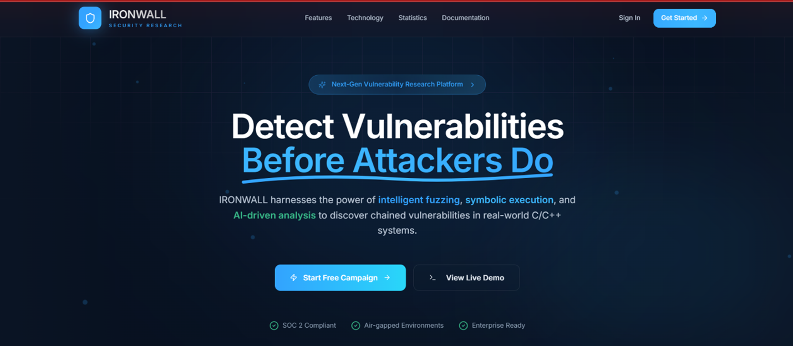
Figure 3- 21:landing page
The Landing Page introduces IRONWALL as an advanced vulnerability research platform, highlighting its AI-driven analysis and automated detection capabilities. It presents the core value proposition—discovering vulnerabilities before attackers can exploit them—through clear messaging and visual emphasis. The page also guides users toward key actions, such as starting a new campaign or exploring a live demo, making onboarding simple and intuitive.

Signup

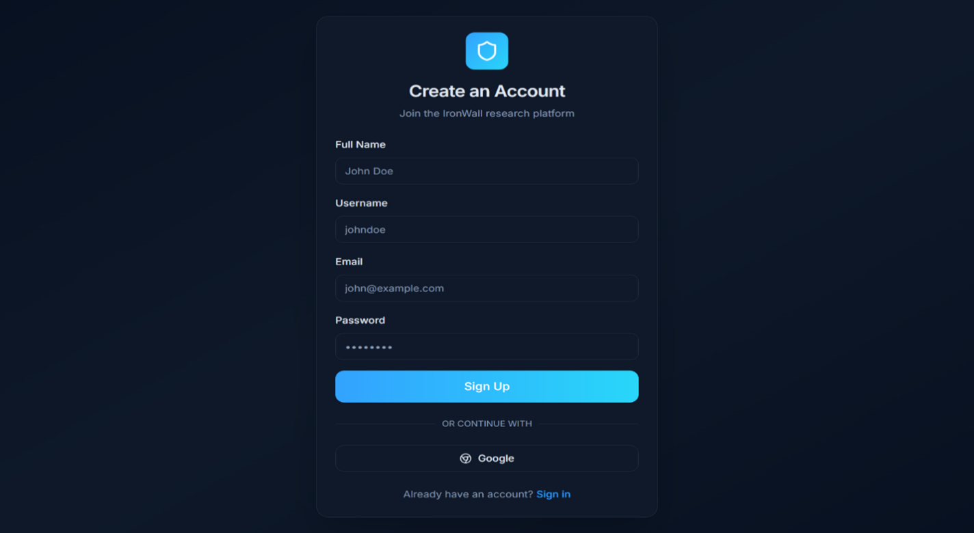
Figure 3- 22:Signup and Register page

The Register module allows new users to create accounts by providing required details. It validates inputs, ensures secure password storage, and integrates seamlessly with the authentication system to grant users appropriate access upon successful registration.
.

Login

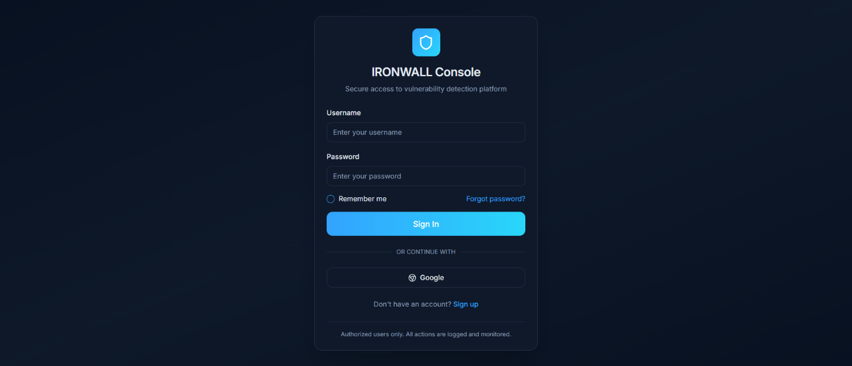
Figure 3- 23:Login page

The Login module handles secure authentication of users, verifying credentials and issuing session tokens. It ensures that only authorized users can access the system and protected routes, providing a secure entry point to all application functionalities.
.

Dashboard
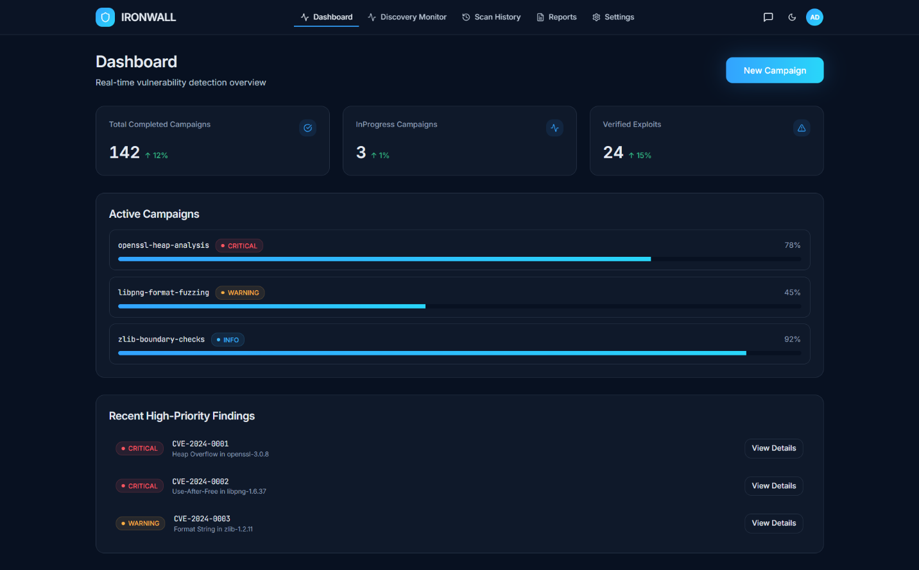
Figure 3- 24:Dashboard page

The Dashboard provides a real-time overview of all vulnerability analysis activities, showing completed campaigns, active scans, and verified exploits. It highlights ongoing campaigns with their progress and severity levels so analysts can quickly identify high-risk areas. The interface also presents recent critical findings, enabling fast navigation to detailed reports for deeper investigation.

Campaign history
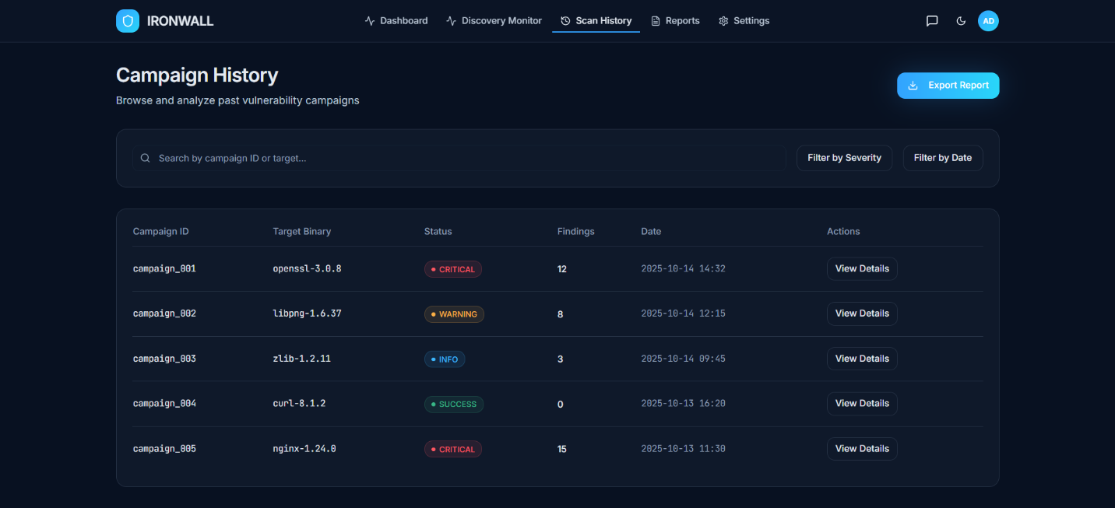
Figure 3- 25:Campaign history

The Campaign History page allows users to browse and review all past vulnerability analysis campaigns, displaying each campaign’s target binary, status, findings count, and completion date. It provides search and filtering options so analysts can quickly locate specific campaigns based on ID, severity, or time. The interface also offers direct access to detailed reports for deeper examination of previous analysis results.

View report
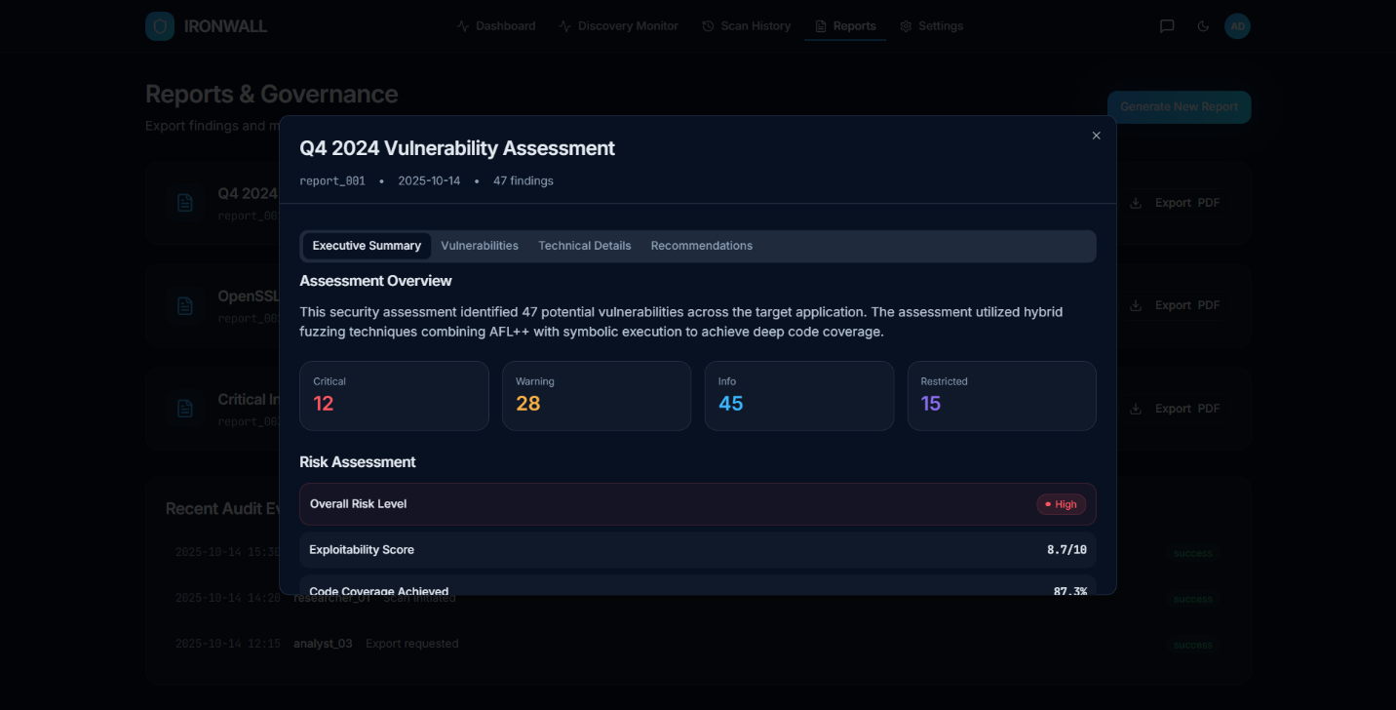
Figure 3- 26:View report

The Report View page presents a detailed vulnerability assessment for a completed campaign, summarizing all discovered issues and their severity levels. It provides structured sections—including executive summary, technical findings, and recommendations—so analysts can clearly understand the overall risk posture. The interface also highlights key metrics such as exploitability scores and coverage achieved, offering a comprehensive technical and managerial overview of the assessment.

Chatbot
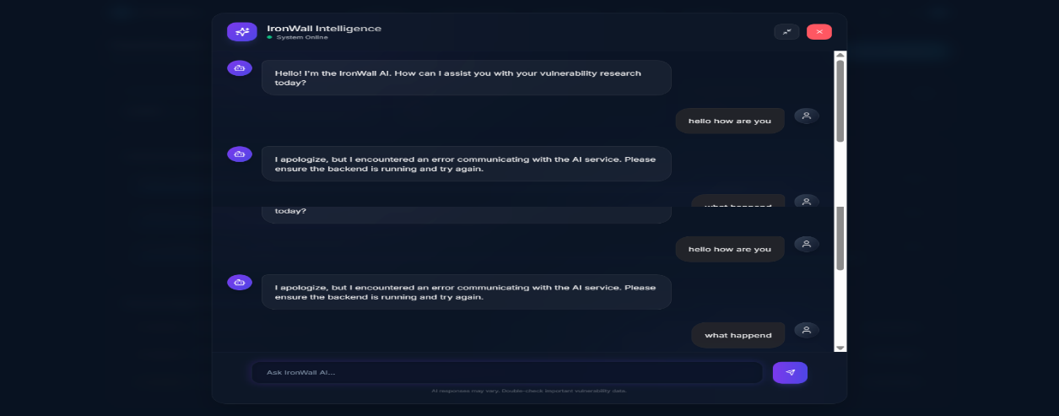
Figure 3- 27:CHatbot
The AI Assistance Chat Interface allows users to interact directly with IRONWALL’s intelligence module to ask questions, request guidance, or troubleshoot analysis workflows. It provides a conversational interface where analysts can receive contextual help, explanations, or vulnerability insights based on system data. When backend services are unavailable, the interface clearly displays system errors, helping users understand communication or processing issues.

User profile
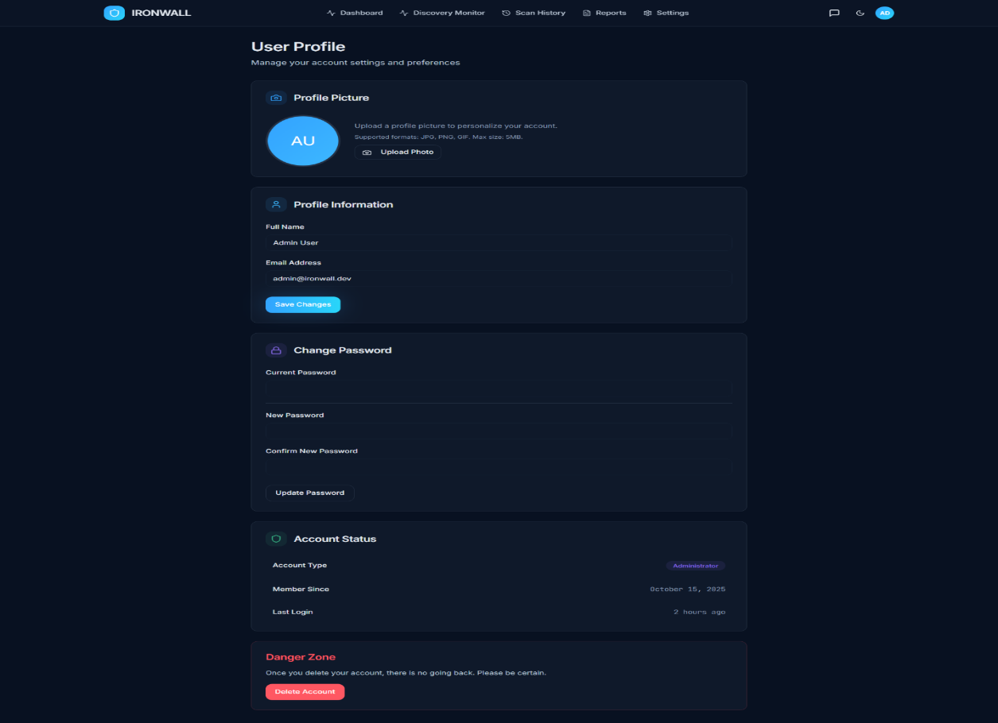
Figure 3- 28:user profile
The User Profile page allows users to manage their personal account information, including updating their profile picture and modifying their contact details. It provides secure options for changing passwords and reviewing account activity such as membership date and recent logins. The interface also includes a controlled “Danger Zone” section where users can delete their account, ensuring full account lifecycle management.

Reports and governance
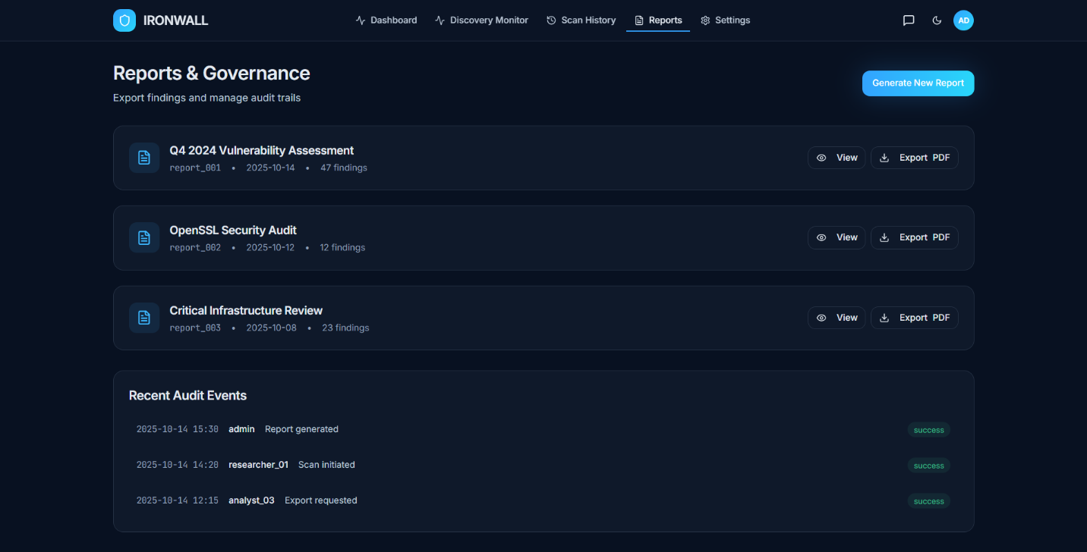
Figure 3- 29:reports and governance
The Reports & Governance page provides access to all generated vulnerability assessment reports, allowing users to view detailed findings or export them as PDFs. It organizes reports in a clear list format with metadata such as dates, severity counts, and report identifiers. The page also displays recent audit events, offering transparency and traceability for actions like report generation, scans, and exports,

Settings
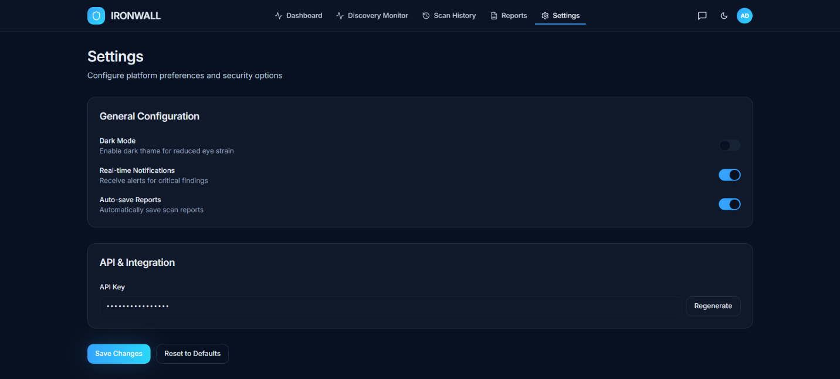
Figure 3- 30:settings
The Settings page allows users to configure their personal and system-wide preferences, such as enabling dark mode, activating real-time notifications, or turning on automatic report saving. It also provides secure API key management, giving users the ability to regenerate integration keys when needed. This interface helps customize the platform experience while maintaining strong control over security and integration settings.

Deployment

The deployment process for the partially implemented IRONWALL system ensures that the microservices, database layer, and frontend run in a stable environment suitable for testing, debugging, and demonstration. Since this implementation is still in progress, deployment is primarily focused on local development setups, VPS-ready configurations, and containerized environments. The system currently supports end-to-end deployment for preprocessing, CVE ingestion, reasoning, and reporting workflows.

4.5.1 Deployment Environment Overview
The IRONWALL system is deployed using the following environment setup:

Backend Deployment
- Frameworks:
  - Node.js 20+ (API Gateway, Auth, CVE Service, Guidance Service, Validation Service)
  - Python 3.10+ (Preprocessing & Exploit Generation Service)
- Application Servers:
  - Node.js Development Server (local)
  - Fastify/Express API server
  - Uvicorn/Gunicorn (optional for Python services on VPS)
- Runtime Environment:
  - Local machine
  - VPS / Cloud VM (Docker-based)
- Databases:
  - MongoDB (primary storage for CVE data, sessions, analysis results)
  - Redis (Upstash) (caching, rate limiting, session tokens)
  - AWS S3 (object storage for uploaded artifacts, preprocessing outputs, reports)
- Static & Vulnerability Analysis Engine:
  - Python preprocessing pipeline integrating Semgrep, Binwalk, strings, ClamAV, and AST parsing
  - CVE ingestion + normalization microservice
  - LLM-based reasoning + exploit generation
- Package Management:
  - npm / pnpm for Node.js services
  - pip + virtual environment (venv) for Python services

Frontend Deployment
- Framework: Next.js 14 (React-based)
- Build Tool: Next.js build + SWC compiler
- Runtime Environment: Node.js 20.x
- Hosting Method: Local development server (next dev)
- Backend Access: API calls routed to
http://localhost:5000/api (via API Gateway)

Containerization
Although full production deployment is not yet completed, the system structure already supports:
- Dockerfile for each Node.js microservice
- Dockerfile for Python preprocessing/exploit service
- Dockerfile for Next.js frontend build
- docker-compose structure for multi-service orchestration (API Gateway, microservices, MongoDB, Redis, MinIO/S3 optional)
These containerized components will be used in later phases once all modules, including automated CVE synchronization, continuous scanning, and full reporting workflows, are fully implemented.

Chapter 5: Testing and Evaluation

This chapter describes the testing strategy used to verify the correctness, reliability, performance, and security of the IRONWALL cybersecurity automation platform. The testing process ensures that all microservices, pipelines, frontend components, and integration points function according to the defined requirements. The evaluation covers unit testing, functional testing, business rules testing, and integration testing, followed by a summary of results.

5.1 Unit Testing
Unit testing focuses on validating the smallest executable components of each microservice in isolation. Given IRONWALL’s microservices-based design, each service was tested independently using mocks and stubs for external dependencies such as MongoDB, Redis, S3, and other services.
5.1.1 CVE Intelligence Service Tests
Objective: Ensure correct ingestion, normalization, caching, and retrieval of CVE records.
Test Cases:
Test Case | Description | Expected Output
TC-CVE-01 | Validate CVE JSON parsing | CVE stored with correct fields
TC-CVE-02 | Verify severity normalization | CVSS scaled 0–10, correct severity bucket
TC-CVE-03 | Redis caching test | Cached response fetched under 50ms
TC-CVE-04 | Invalid CVE ID handling | Return “Invalid/Not Found” error
5.1.2 Analysis Service Tests
Objective: Validate correctness of preprocessing and static analysis workflows.
Test Cases:
Test Case | Description | Expected Output
TC-ANL-01 | Source file enumeration | All files listed, correct extensions
TC-ANL-02 | Semgrep rule execution | Findings parsed into unified schema
TC-ANL-03 | Binwalk execution for binaries | Output parsed, fingerprints generated
TC-ANL-04 | ClamAV safety check | Malicious files blocked before analysis
5.1.3 Guidance/Reasoning Service Tests
Objective: Test reasoning logic that merges CVE metadata + analysis signals.
Test Case | Description | Expected Output
TC-GUID-01 | Merge analysis + CVE signals | Correct correlation JSON
TC-GUID-02 | LLM reasoning output validation | Well-structured guidance steps
TC-GUID-03 | Safety filter test | Dangerous payloads removed
5.1.4 Exploit Generation Service Tests
Test Case | Description | Expected Output
TC-EXP-01 | Valid exploitation guidance converted to template | Clean PoC template generated
TC-EXP-02 | Unsafe output redaction | No raw shellcode/unsafe code
TC-EXP-03 | Draft storage in MongoDB | Draft saved with correct metadata
5.1.5 Validation Service Tests
Test Case | Description | Expected Output
TC-VAL-01 | Dependency detection | Missing dependencies listed
TC-VAL-02 | Environment mismatch detection | Warning or fail status
TC-VAL-03 | Non-execution validation | No code is executed

5.2 Functional Testing
Functional testing verifies whether IRONWALL meets its functional requirements across the CVE pipeline, static/binary analysis, reasoning, exploit generation, validation, and reporting processes.
5.2.1 CVE Intake and Lookup
Goal: Validate complete CVE retrieval workflow.
Performed Tests:
- Fetch CVE by ID → Verified correct response, normalized fields.
- Bulk CVE ingestion from NVD feed → Stored correctly in MongoDB.
- Wrong CVE ID → Error handled gracefully.
5.2.2 Artifact Upload and Static Analysis
Goal: Ensure uploaded files are processed accurately and safely.
Performed Tests:
- Upload large source projects → Successfully processed and stored in S3.
- Upload binary executables → Correctly identified by file-type detection.
- Semgrep analysis → Vulnerable patterns detected and normalized.
- Antivirus scan → Malicious samples blocked.
5.2.3 Reasoning and Guidance Generation
Goal: Test ability to generate structured exploitation reasoning.
Performed Tests:
- Correct merging of analysis output and CVE metadata.
- Detailed reasoning steps produced (setup → trigger → validation).
- LLM responses sanitized by safety filters.
5.2.4 Exploit Template Generation
Goal: Validate Code Llama template generation workflow.
Performed Tests:
- Generate exploit skeletons for known vulnerabilities.
- Unsafe payloads removed.
- Draft stored and linked to session.
5.2.5 Validation and Environment Readiness
Goal: Confirm that exploitation prerequisites are correctly evaluated.
Performed Tests:
- Missing dependency detection.
- Platform mismatch flagged correctly.
- Validation reports displayed on UI.
5.2.6 Reporting
Goal: Validate generation of structured reports.
Performed Tests:
- JSON report generation.
- PDF export formatting.
- Evidence linking (file paths, code slices, metadata).

5.3 Business Rules Testing
Business rules testing ensures IRONWALL enforces its cybersecurity-driven logic consistently across all workflows.
5.3.1 CVE Severity & Prioritization Rules
Rule: Severity categories must map correctly from CVSS base scores.
Severity | CVSS Range
Critical | 9.0–10
High | 7.0–8.9
Medium | 4.0–6.9
Low | 0–3.9
Result: All tests passed; prioritization consistent across data sources.
5.3.2 File Safety and Sandbox Rules
Rule: No untrusted binary is executed.
- All binaries scanned before analysis.
- No runtime hooks or execution operations performed.
- Container-level isolation verified.
5.3.3 Reasoning Safety Rules
Rule: LLM must not output directly harmful exploit payloads.
- Shellcode removed.
- Reverse shells replaced with placeholders.
- Dangerous API calls redacted.
5.3.4 Authentication & Access Control Rules
Rule: Access controlled via JWT + RBAC.
- Unauthorized users blocked at gateway.
- Sensitive endpoints (exploit generation) require elevated roles.
- Session expiry enforced.

5.4 Integration Testing
Integration testing validates interactions between microservices and ensures the complete analysis workflow
functions seamlessly.
5.4.1 API Gateway → Microservices Integration
Tests performed:
- Routing correctness
- JWT validation
- Rate limiting and malformed payload handling
Gateway successfully forwarded requests to all services.
5.4.2 CVE Service → Analysis Service
Integration verified:
- Analysis-service consumes CVE intelligence correctly.
- Correlation logic matches CVE metadata with analysis findings.
5.4.3 Analysis Service → Reasoning Service
Integration validated:
- Preprocessing output passed without loss.
- Reasoning-service recognized vulnerable patterns and file paths.
5.4.4 Reasoning Service → Exploit Generation Service
Integration tested:
- Exploit template generated according to reasoning structure.
- Safety rules applied automatically.
5.4.5 Exploit Generation → Validation Service
Integration validated:
- Exploit templates accurately referenced in validation checks.
- Missing components correctly identified.
5.4.6 End-to-End UI → Backend Pipeline
A full workflow was executed:
- Upload file
- CVE selection
- Static analysis
- Reasoning
- Exploit generation
- Validation
- Reporting
All stages completed successfully with expected outputs.

