APPLIED DIGITAL CORPORATION (APLD)
Rating: STRONG BUY | Price: $27.71 | Price Target: $40.00 | Upside: +44%
Q2 FY2026 Earnings Update | January 8, 2026 | AI / HPC Data Center Infrastructure

Earnings Summary: Revenue BEAT (+46%)
Metric | Actual | Consensus | Variance | Result
Revenue | $126.6M | $86.7M | +$39.9M (+46.1%) | BEAT
GAAP EPS | $(0.11) | $(0.14) | +$0.03 | BEAT
Adj. EBITDA | $20.2M | N/A | +231% YoY | BEAT
Revenue YoY Growth | +250% | N/A | N/A | Accelerating
Source: Applied Digital Q2 FY2026 Earnings Release (January 7, 2026); Consensus from StockAnalysis.com

Key Takeaways
- Revenue inflection is real: Massive revenue beat driven by $73M in HPC fit-out/equipment installation services for CoreWeave, plus $12M in recurring lease revenue from Polaris Forge 1. The +250% YoY growth demonstrates the HPC pivot thesis is playing out ahead of schedule.
- Margin compression is temporary: Current gross margin of 20.5% is temporarily depressed by low-margin (mid-single-digit) fit-out services. As recurring lease revenue scales from 100 MW operational to 600 MW contracted, margins should expand meaningfully toward peer levels of 50-60%.
- Backlog dominance validates premium: $16B in contracted lease revenue (largest in peer group) provides exceptional revenue visibility. The new $5B, 15-year hyperscaler lease at Polaris Forge 2 reduces CoreWeave concentration risk.
- Balance sheet is stretched but manageable: $2.6B in total debt (9.25% senior secured notes) against $2.3B in cash. The capital-intensive buildout is funded but leaves limited margin for error. Execution on Polaris Forge timelines is critical.

Updated Financial Estimates
Metric | FY2026E (Old) | FY2026E (New) | FY2027E (Old) | FY2027E (New)
Revenue | $290M | $346M | $500M | $554M
Revenue Growth | +101% | +140% | +72% | +60%
Adj. EBITDA | $40M | $48M | $95M | $110M
EPS | $(0.55) | $(0.49) | $(0.80) | $(0.71)
Source: Consensus estimates from StockAnalysis.com (pre- and post-Q2 FY2026); analyst reports

Detailed Results Analysis

Revenue Analysis
Applied Digital reported Q2 FY2026 revenue of $126.6 million, beating consensus by $39.9 million (+46.1%) and growing +250% year-over-year from $36.2 million. Sequential growth was equally impressive at +97% from Q1 FY2026's $64.2 million. This was the company's strongest quarter ever and marks the first meaningful contribution from HPC Hosting operations.
The revenue beat was primarily driven by HPC Hosting, which contributed $85.0 million in its second quarter of revenue. Within HPC Hosting, $73 million came from tenant fit-out and equipment installation services for CoreWeave's deployment at Polaris Forge 1, with the remaining $12 million from recurring lease revenue as the first 100 MW (ELN-02) became operational. Legacy Data Center Hosting contributed $41.6 million, growing +15% YoY — steady but now secondary to the HPC ramp.
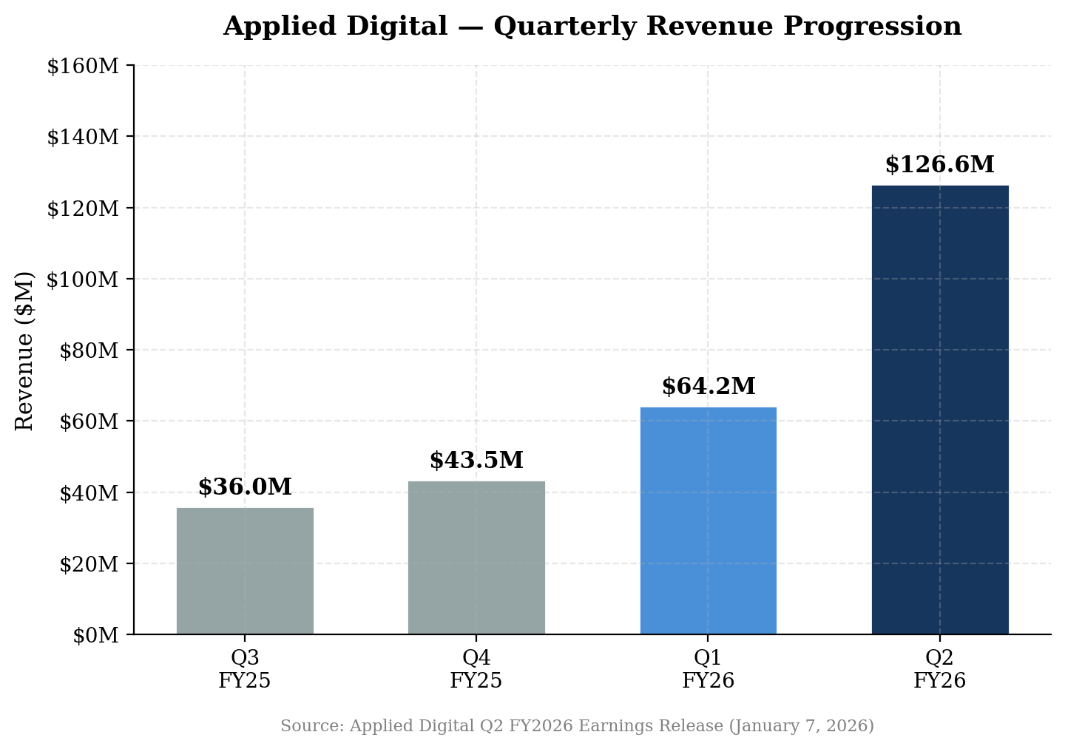
Figure 1: Quarterly Revenue Progression — Inflection Point in Q2 FY2026

Quarterly Revenue Progression
 | Q2 FY25 | Q3 FY25 | Q4 FY25 | Q1 FY26 | Q2 FY26
Total Revenue | $36.2M | $36.0M | $43.5M | $64.2M | $126.6M
YoY Growth | +51% | N/A | N/A | +84% | +250%
QoQ Growth | N/A | -1% | +21% | +48% | +97%
Source: Applied Digital quarterly earnings releases (Q2 FY2025 through Q2 FY2026)
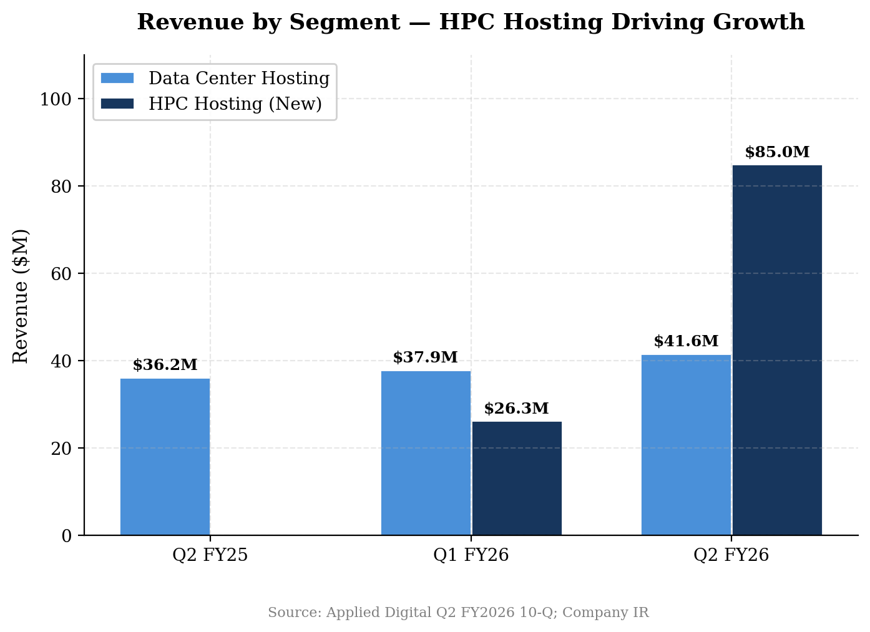
Figure 2: Revenue by Segment — HPC Hosting Now the Dominant Revenue Driver

Profitability Analysis
Gross profit rose +126% YoY to $26.0 million, though gross margin compressed to 20.5% from 32.5% in Q2 FY2025. This margin compression was entirely expected and reflects the revenue mix shift: fit-out/equipment installation services carry mid-single-digit margins, while the still-small recurring lease revenue is much higher margin. As more MW come online and lease revenue scales, blended margins should converge toward peer levels of 50-60%.
Adjusted EBITDA of $20.2 million (+231% YoY from $6.1M) demonstrates improving operating leverage even with the margin drag from fit-out services. Adjusted EBITDA margin held at 16.0%, roughly in line with Q1 FY2026's 17.9%, as the company absorbed significant SG&A growth ($57.0M, +119% YoY) to support the buildout.
GAAP net loss narrowed dramatically to $31.2 million from $130.6 million in Q2 FY2025 (-76% improvement). Adjusted net income was approximately breakeven at $0.1 million — the company's first quarter near profitability on an adjusted basis.
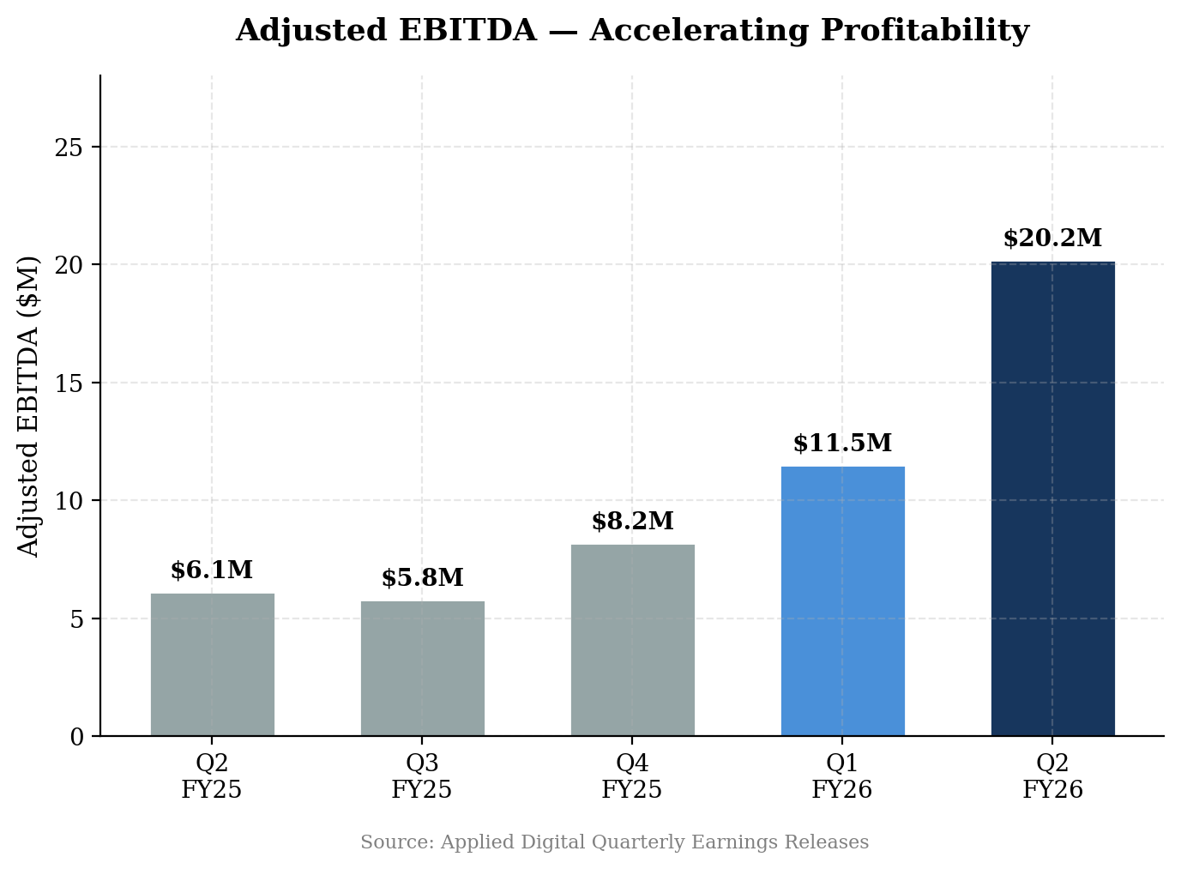
Figure 3: Adjusted EBITDA — Accelerating Despite Mix Headwinds
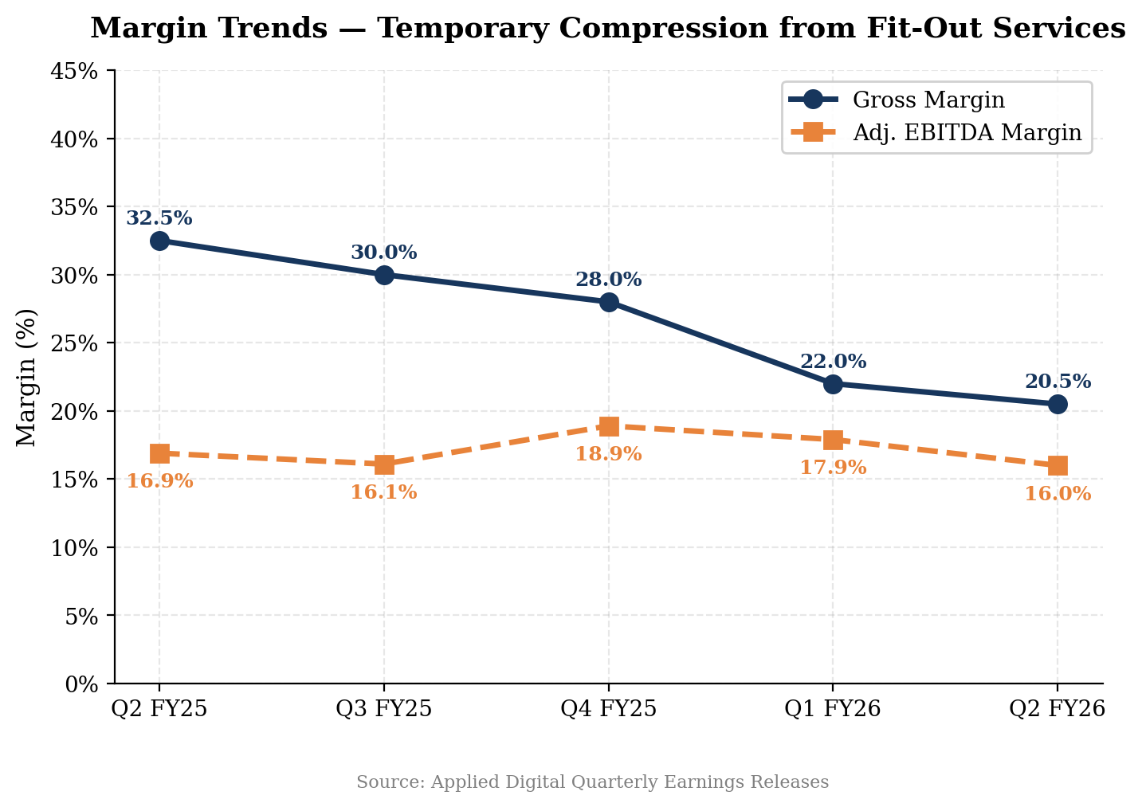
Figure 4: Margin Trends — Temporary Compression from Low-Margin Fit-Out Services

Key Metrics & Guidance

HPC Revenue Composition
Understanding the composition of HPC Hosting revenue is critical to the thesis. Of the $85.0 million in Q2 FY2026 HPC revenue, $73 million (86%) came from one-time fit-out and equipment installation services. These carry mid-single-digit margins and will decline in proportion as the buildout progresses. The remaining $12 million (14%) represents the beginning of recurring lease revenue — the high-margin, contracted revenue stream that underpins the long-term investment case.
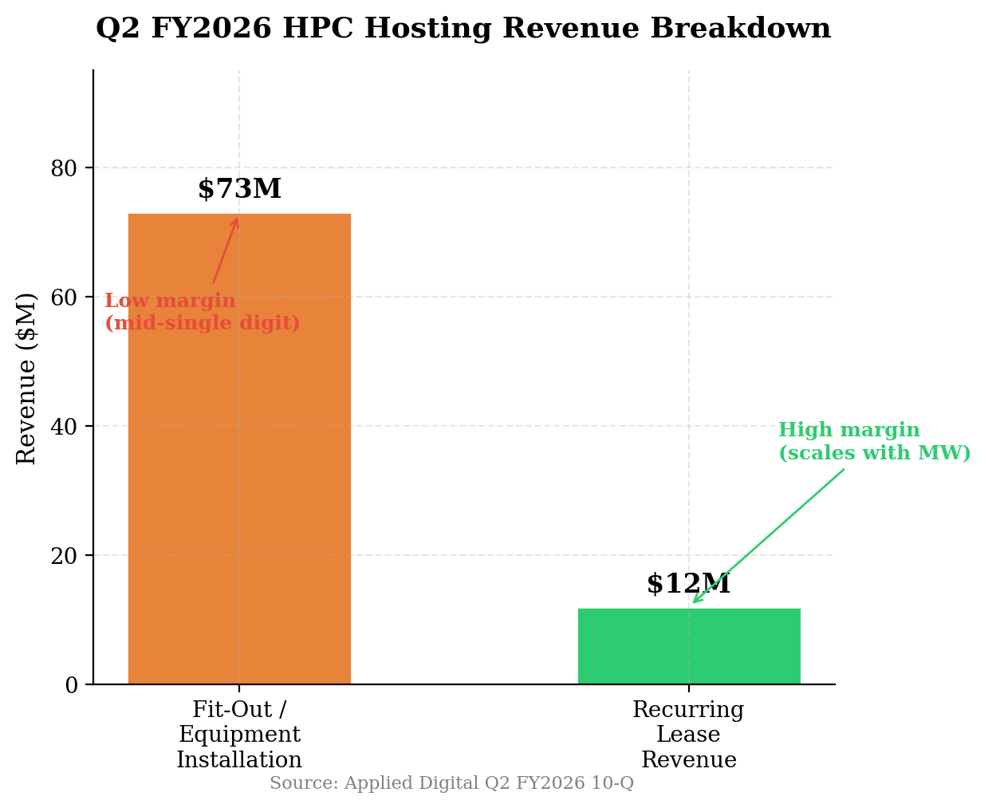
Figure 5: Q2 FY2026 HPC Hosting Revenue — Fit-Out vs. Recurring Lease

Data Center Capacity Pipeline
Facility | Customer | Total Capacity | Operational | Status | Contracted Revenue
Polaris Forge 1 (ELN-02) | CoreWeave | 100 MW | 100 MW | Operational | ~$4B (15-yr)
Polaris Forge 1 (ELN-03) | CoreWeave | 150 MW | 0 MW | Under Construction | ~$3.5B (15-yr)
Polaris Forge 1 (Remaining) | CoreWeave | 150 MW | 0 MW | Contracted | ~$3.5B (15-yr)
Polaris Forge 2 | U.S. Hyperscaler | 200 MW | 0 MW | Contracted | $5B (15-yr)
Total |  | 600 MW | 100 MW |  | ~$16B
Source: Applied Digital Q2 FY2026 Earnings Release; Investor Relations materials
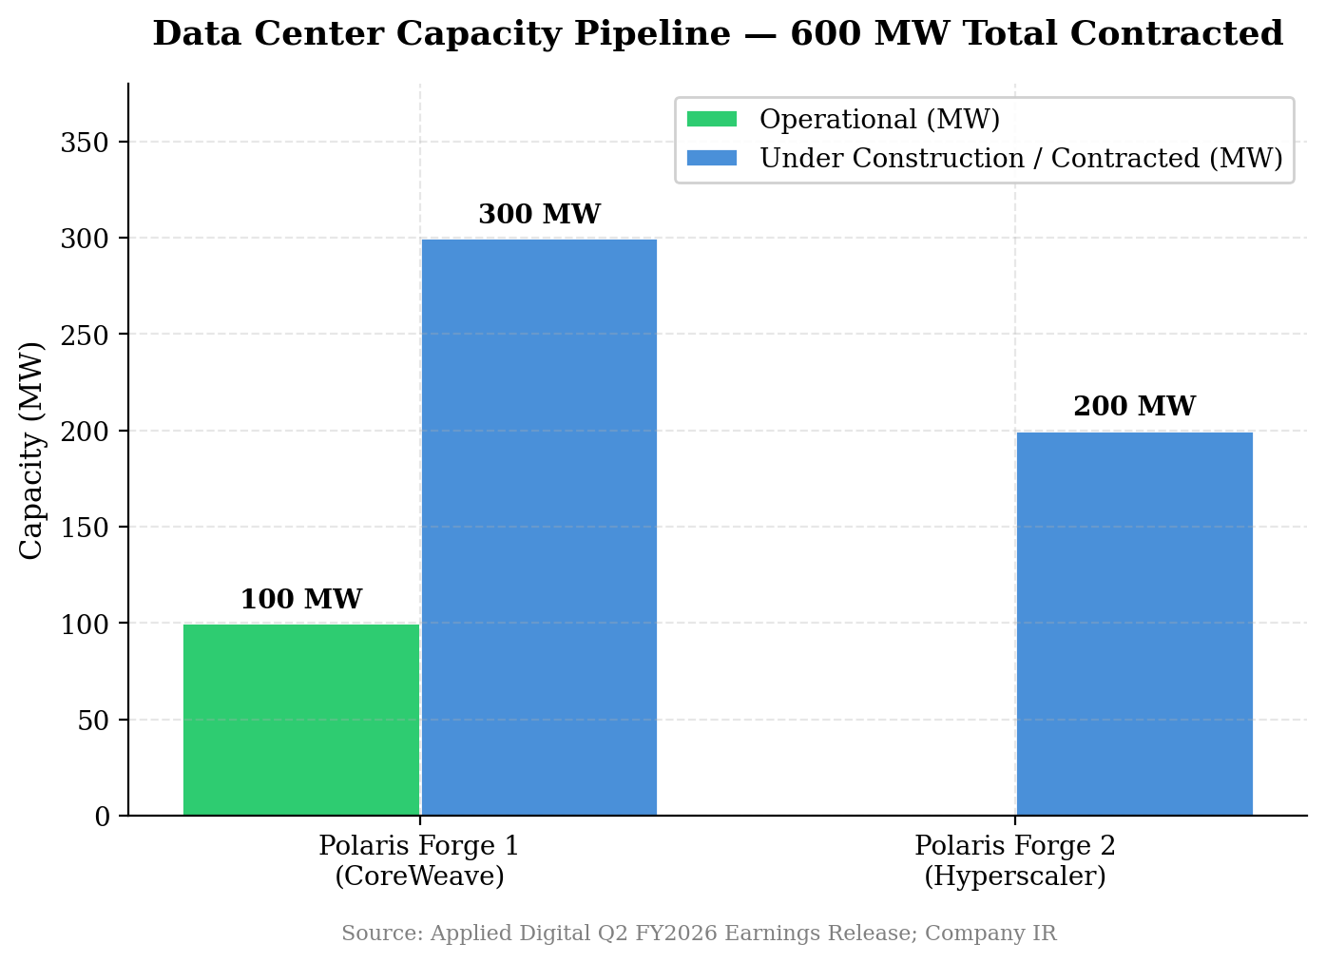
Figure 6: Data Center Capacity Pipeline — 600 MW Total Contracted, 100 MW Operational

Guidance & Outlook
Management did not provide formal numerical guidance for Q3 FY2026 or full-year FY2026. Key forward-looking statements from the earnings call include:
- NOI Target: $1 billion in net operating income within five years as contracted lease revenue ramps
- Long-Term Capacity: 5 gigawatts of capacity by 2030-2032 (vs. 600 MW contracted today)
- Near-Term Milestone: Polaris Forge 1 (400 MW for CoreWeave) to be completed by end of 2027
- Strategic Divestiture: ChronoScale spin-off (cloud services) expected to close H1 2026
Wall Street consensus for Q3 FY2026 (prior to the Q2 beat) was $72.6M-$90.5M in revenue and EPS of $(0.11) to $(0.13). These estimates are likely to be revised upward following the Q2 beat, particularly if fit-out services revenue continues at elevated levels.

Updated Investment Thesis

Thesis Pillar Assessment
HPC/AI Infrastructure Demand: STRENGTHENED
Q2 results confirm the HPC pivot is working — $85M in HPC revenue in just the second quarter of the segment's existence. The $5B hyperscaler lease at Polaris Forge 2 validates that demand extends beyond CoreWeave to investment-grade customers. The AI infrastructure buildout cycle appears to have significant runway remaining.
Contracted Revenue Visibility: STRENGTHENED
$16B in contracted lease revenue provides exceptional forward visibility. At ~$700M+ annual run-rate at full ramp (600 MW), the contracted backlog represents ~23 years of revenue. This is the largest backlog in the HPC data center peer group, significantly ahead of TeraWulf ($12.8B) and CIFR ($9.3B).
Margin Expansion Trajectory: UNCHANGED
Current 20.5% gross margin remains below peers (CORZ ~55%, IREN ~60%, WULF ~50%) but this is expected given the fit-out revenue mix. The thesis requires margins to expand as recurring lease revenue scales — Q2 did not change this expectation in either direction. The $12M in lease revenue at presumably higher margins is an early positive signal.
Customer Concentration Risk: MODESTLY IMPROVED
CoreWeave remains the dominant customer (~$11B of $16B backlog). However, the new investment-grade hyperscaler at Polaris Forge 2 ($5B, 15 years) materially diversifies the revenue base. Further diversification would be incrementally positive.
Balance Sheet & Execution Risk: UNCHANGED
$2.6B debt vs. $2.3B cash. The 9.25% senior secured notes create significant interest burden (~$46M/year). The $900M Macquarie preferred adds further cost. While manageable at current cash levels, the balance sheet leaves limited room for construction delays or customer issues. Execution remains the key risk.

Key Risks
- Customer Concentration: CoreWeave concentration (~69% of backlog) — CoreWeave itself faces execution/funding risks
- Leverage: 9.25% senior secured notes + Macquarie preferred create ~$60M+ annual cost
- Construction Timeline: Any delays in MW delivery could impact lease revenue timing
- Revenue Lumpiness: Fit-out services are project-based and will be lumpy quarter to quarter
- Dilution: ~279M shares outstanding with potential dilution from future capital raises
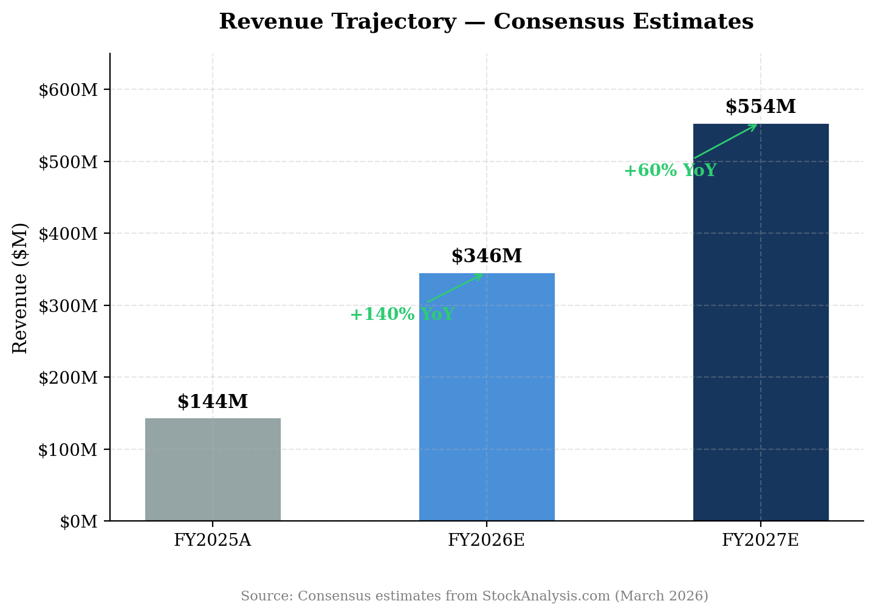
Figure 7: Revenue Trajectory — Consensus Estimates Imply Continued Hypergrowth

Valuation & Estimates

Peer Valuation Comparison
APLD trades at 25.1x FY2026E revenue, roughly in line with the peer median of 23.6x. This is appropriate given APLD's industry-leading $16B contracted backlog, partially offset by lower current margins and higher leverage than peers. If APLD can demonstrate margin expansion toward the 50%+ gross margin levels achieved by CORZ and IREN, there is upside to multiples.
Company | Market Cap | EV | EV/FY26E Rev | EV/FY27E Rev | Gross Margin | Backlog
APLD | $7.8B | $7.7B | 25.1x | 14.4x | 20.5% | $16.0B
CORZ | $5.5B | $6.1B | 24.0x | 12.2x | 55.0% | N/A
IREN | $12.9B | $13.5B | 18.2x | 9.0x | 60.0% | $2.3B
WULF | $5.9B | $7.9B | 26.3x | 11.8x | 50.0% | $12.8B
Median |  |  | 24.6x | 12.0x | 52.5%
Source: Yahoo Finance, StockAnalysis.com (March 2026); Company IR materials
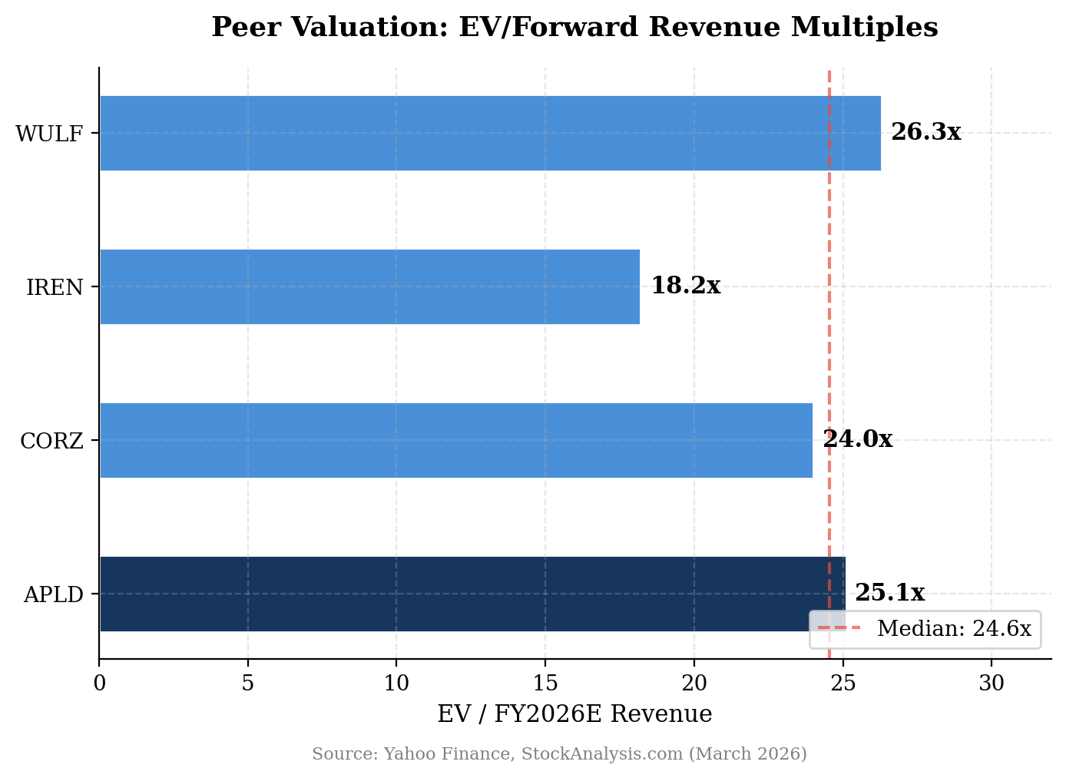
Figure 8: EV/FY2026E Revenue — APLD Trades In Line with Peers

Price Target Methodology
We derive our $40.00 price target using a blended approach:
Methodology | Implied Value | Weight | Contribution
EV/FY27E Revenue (12.0x median) | $36.50 | 40% | $14.60
EV/FY27E Revenue (premium: 14.5x) | $44.00 | 30% | $13.20
Contracted Backlog (per $B) | $42.00 | 30% | $12.60
Blended Price Target |  |  | $40.40 → $40.00
Note: Premium multiple justified by largest backlog in peer group. Rounded to $40.00.
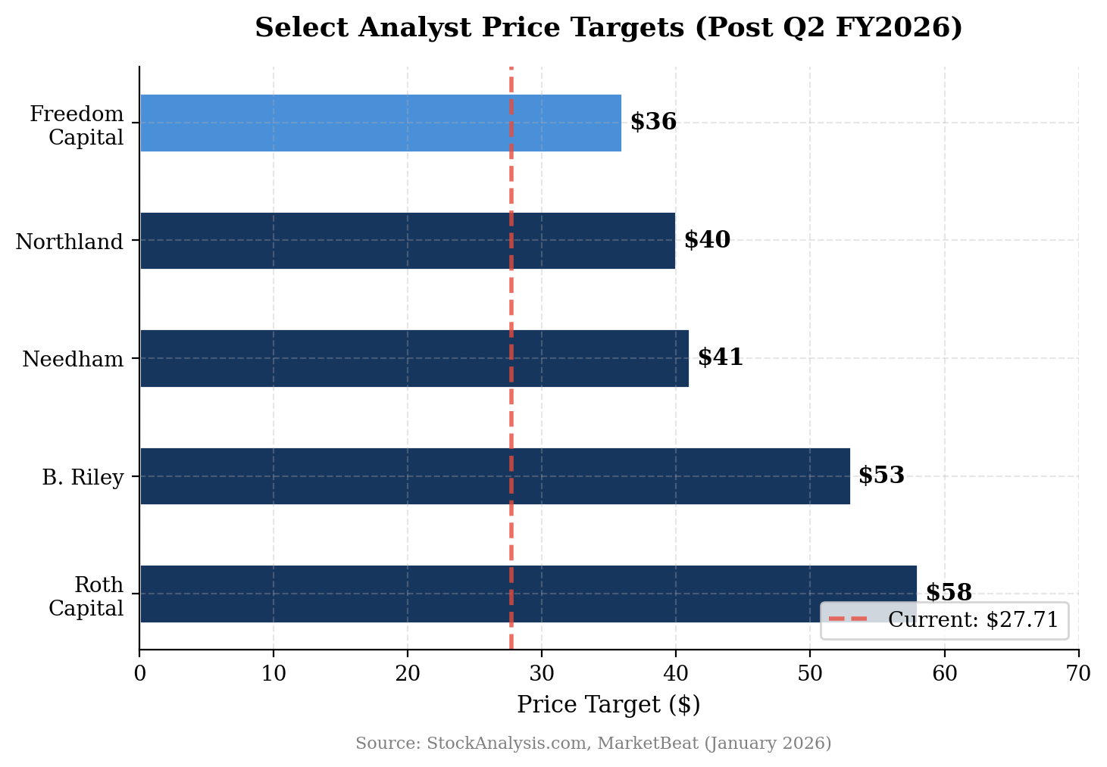
Figure 9: Select Analyst Price Targets — Consensus Implies Significant Upside

Detailed Estimate Updates
 | Q2 FY26A | Q3 FY26E | Q4 FY26E | FY2026E | FY2027E
Revenue ($M) | $126.6 | $90-110 | $110-130 | $346 | $554
Revenue Growth (YoY) | +250% | +120%E | +150%E | +140% | +60%
Gross Margin | 20.5% | 22-25%E | 25-30%E | 22%E | 35%E
Adj. EBITDA ($M) | $20.2 | $18-22E | $22-28E | $48E | $110E
EBITDA Margin | 16.0% | 18-20%E | 20-22%E | 14%E | 20%E
GAAP EPS | $(0.11) | $(0.10)E | $(0.08)E | $(0.49)E | $(0.71)E
Source: Q2 FY2026 actual from Applied Digital earnings release; estimates based on consensus and our analysis. A = Actual, E = Estimate.
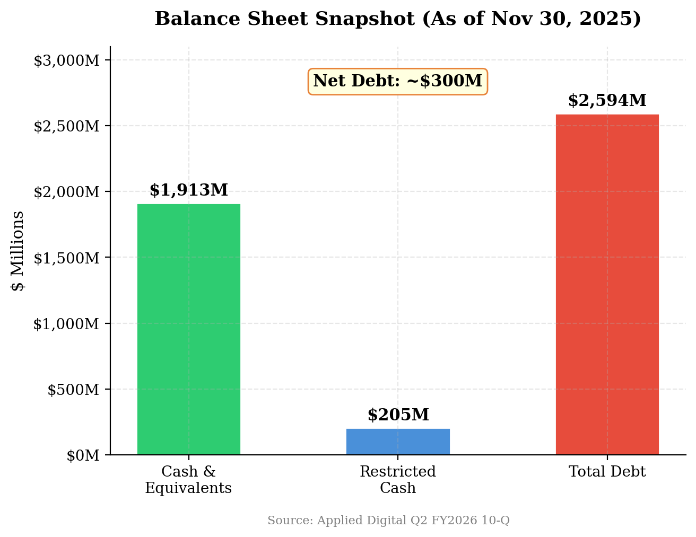
Figure 10: Balance Sheet Snapshot — Funded for Current Buildout
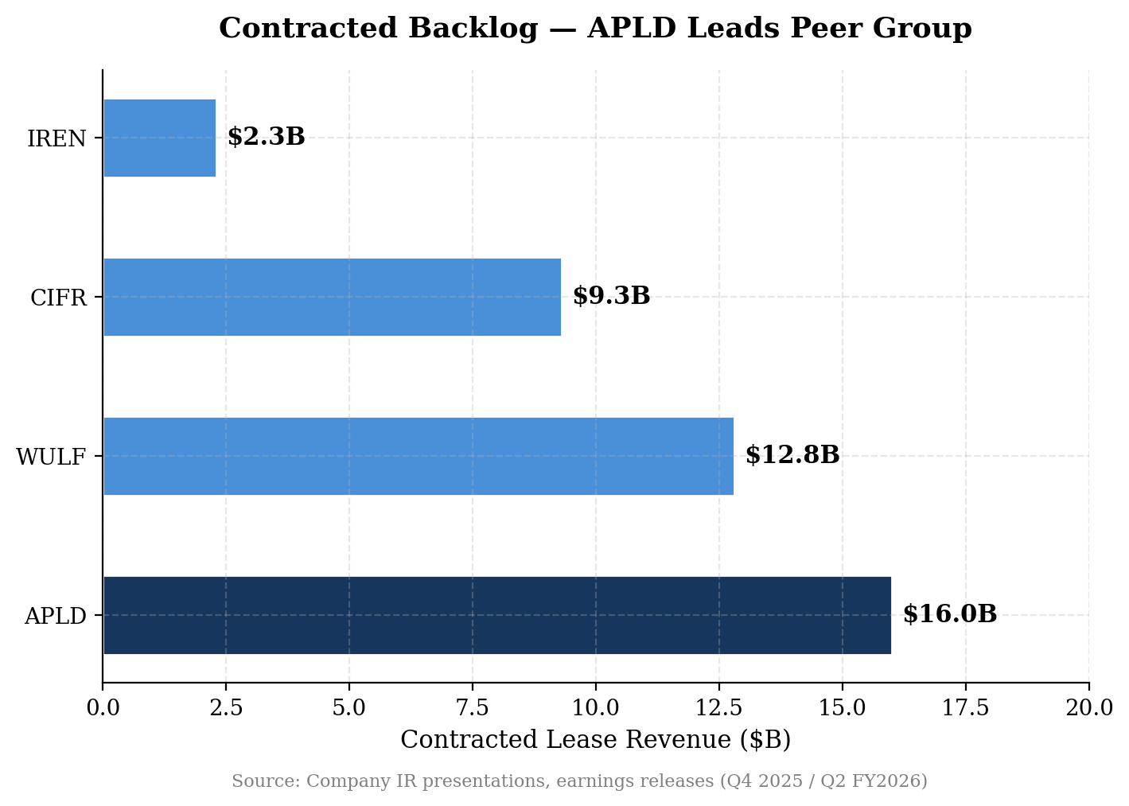
Figure 11: Contracted Backlog — APLD Leads the HPC Data Center Peer Group

Appendix

Earnings Call Highlights
Key quotes from the Q2 FY2026 earnings call (January 7, 2026):
On demand outlook: CEO Wes Cummins described securing the $5 billion, 15-year lease with a U.S. investment-grade hyperscaler as evidence of strong and growing demand for data center capacity to support AI workloads.
On fit-out margins: Management acknowledged fit-out services carry mid-single-digit margins but are strategically important — they demonstrate Applied Digital can provide end-to-end services for deploying state-of-the-art data centers.
On customer diversification: The new 200 MW lease at Polaris Forge 2 with an investment-grade hyperscaler represents meaningful diversification beyond CoreWeave.
On NOI trajectory: CEO forecasts surpassing $1 billion in net operating income within five years as lease revenue ramps from the massive contracted backlog.

Company Overview
Applied Digital Corporation (NASDAQ: APLD) designs, builds, and operates data centers for high-performance computing (HPC) and artificial intelligence workloads. The company has pivoted from its legacy Bitcoin mining hosting business to become a pure-play HPC/AI data center infrastructure provider. Its primary assets are the Polaris Forge campuses in North Dakota, which provide low-cost power and favorable climate conditions for large-scale data center operations.
The Cloud Services segment (GPU cloud computing) is being spun off into "ChronoScale" via a merger with EKSO Bionics, expected to close in H1 2026. Post-spin, Applied Digital will be a pure-play data center colocation/hosting company.

Post-Earnings Analyst Activity
Firm | Analyst | Action | Rating | Price Target
B. Riley Securities | Nick Giles | PT Raised | Strong Buy | $47 → $53
Roth Capital | Darren Aftahi | PT Raised | Strong Buy | $56 → $58
Freedom Capital Markets | Paul Meeks | Initiated | Strong Buy | $36
Arete Research | N/A | Initiated | Buy | $99
Needham | John Todaro | Reiterated | Strong Buy | $41
Northland Capital | Mike Grondahl | Maintained | Buy | $40
Source: StockAnalysis.com, MarketBeat (January 2026)

Sources & References
Earnings Release (January 7, 2026)
Q1 FY2026 Earnings Release (October 9, 2025)
Earnings Call Transcript (January 7, 2026)
Applied Digital Investor Relations
APLD Analyst Forecasts — StockAnalysis.com
Yahoo Finance — APLD

DISCLAIMER: This report is for informational purposes only and does not constitute investment advice. All estimates are based on publicly available information and analyst consensus as of the date indicated. Past performance is not indicative of future results. Investors should conduct their own due diligence before making investment decisions.

