COLGATE-PALMOLIVE COMPANY (CL)
Rating: BUY | Price: $93.56 | Price Target: $100.00 | Upside: +7%
Q4 2025 & Full-Year Earnings Update | January 31, 2026 | Consumer Staples / Household & Personal Care

Earnings Summary: Revenue & EPS BEAT
Metric | Actual | Consensus | Variance | Result
Revenue | $5,230M | $5,120M | +$110M (+2.1%) | BEAT
Base Business EPS | $0.95 | $0.91 | +$0.04 (+4.4%) | BEAT
GAAP EPS | $(0.05) | $0.91 | N/M (Impairment) | MISS*
Organic Sales Growth | +2.2% | N/A | vs. +0.4% in Q3 | Accelerating
*GAAP miss driven by $794M after-tax non-cash Filorga impairment charge; not indicative of operating performance.

Key Takeaways
- Sequential acceleration is the headline: Q4 organic growth accelerated to +2.2% from Q3's +0.4%, led by emerging markets strength in Africa/Eurasia (+10.3%) and Latin America (+6.5%). Underlying organic growth was ~3.1% excluding the private label pet food exit. The sequential improvement signals Colgate is navigating the soft category backdrop better than feared.
- Cash machine firing on all cylinders: Record operating cash flow of $4.2B and free cash flow of $3.6B enabled $2.9B in shareholder returns (dividends + buybacks). The 63-year consecutive dividend increase streak continues. This cash generation consistency is the core of the Colgate investment case.
- Filorga write-down is a one-time event: The $794M after-tax non-cash impairment of Filorga skin health goodwill and intangibles caused a GAAP loss of $(0.05). This is a write-down of the 2019 acquisition and signals Colgate may be reassessing its premium skin care strategy. No operational impact.
- FY2026 guidance is credible: Organic sales guidance of +1% to +4% with gross margin expansion, base business EPS growth of low-to-mid-single digits, and increased advertising investment. Conservative but achievable, with scenario-based framing reflecting management's candor about category uncertainty.

Updated Financial Estimates
Metric | FY2025A | FY2026E (Old) | FY2026E (New) | FY2027E
Revenue | $20,382M | $21,500M | $21,940M | $22,660M
Revenue Growth | +1.4% | +5.5% | +7.6% | +3.3%
Base Business EPS | $3.69 | $3.90 | $3.99 | $4.26
EPS Growth (Base) | +2.5% | +5.7% | +8.1% | +6.8%
Gross Margin | 60.1% | 60.5% | 60.8% | 61.2%
Source: FY2025 actual from Colgate-Palmolive earnings release; consensus from StockAnalysis.com. A = Actual, E = Estimate.

Detailed Results Analysis

Revenue Analysis
Colgate-Palmolive reported Q4 2025 net sales of $5,230 million, up +5.8% year-over-year and beating consensus by $110 million (+2.1%). Organic sales grew +2.2%, a meaningful acceleration from Q3's +0.4%, though decelerating from Q4 2024's +4.3% in a softer category environment. FX provided a +3.1% tailwind, the first positive currency quarter in several years.
Full-year 2025 net sales reached a record $20,382 million (+1.4%), with organic growth of +1.4%. Excluding the strategic exit from private label pet food manufacturing, underlying organic growth was approximately +2.1% for the year and ~3.1% in Q4.
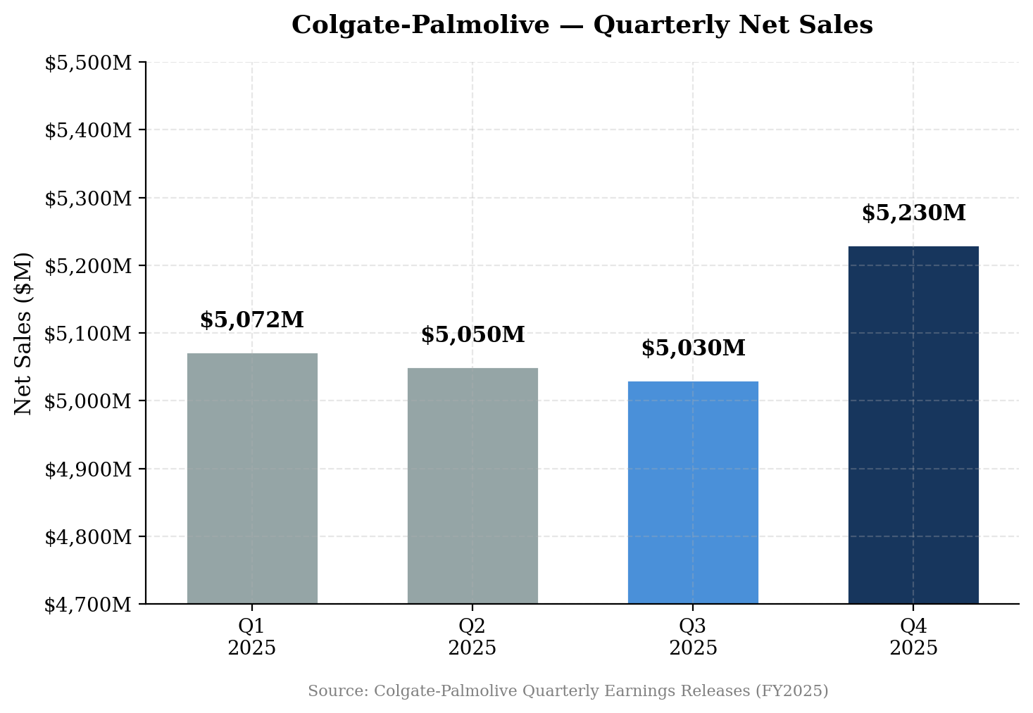
Figure 1: Quarterly Net Sales — Q4 Acceleration on FX Tailwind and Organic Improvement

Geographic Performance
Emerging markets were the clear growth engine in Q4. Africa/Eurasia delivered +10.3% organic growth (+9.1% pricing, +1.1% volume), reflecting strong pricing power in high-inflation markets. Latin America grew +6.5% organic (+4.2% pricing, +2.3% volume) with Mexico and Brazil as standouts. Europe posted +1.8% organic on modest volume and pricing gains.
North America remained the soft spot at -1.8% organic, with negative volumes across 9-10 categories. Management cited soft category trends rather than share loss, noting Colgate's global toothpaste share held at 41.3%. Asia Pacific was flat at +0.1% organic, with pricing offsetting volume declines.
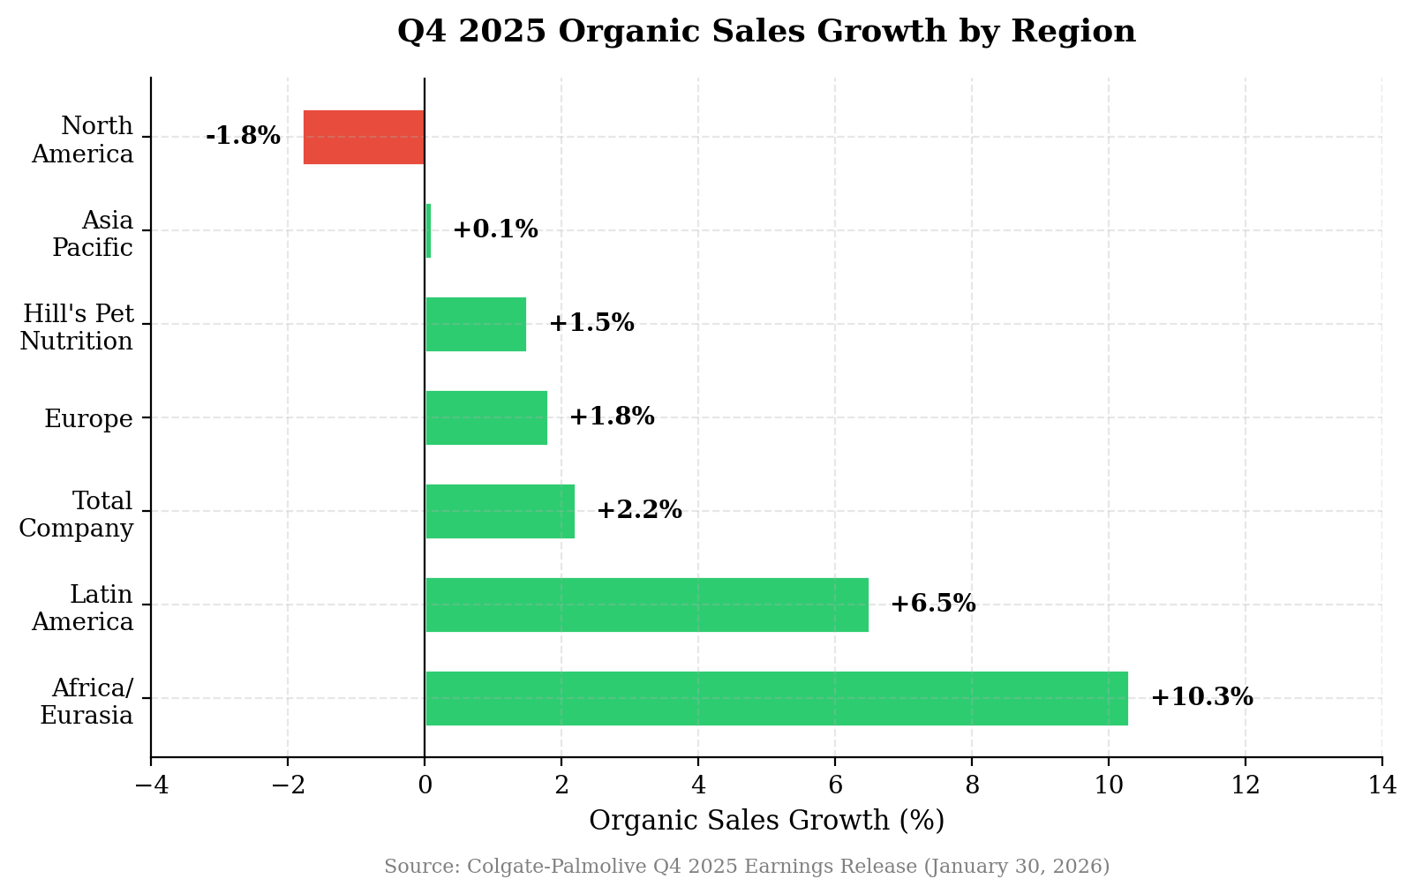
Figure 2: Q4 2025 Organic Sales Growth by Region — Emerging Markets Lead
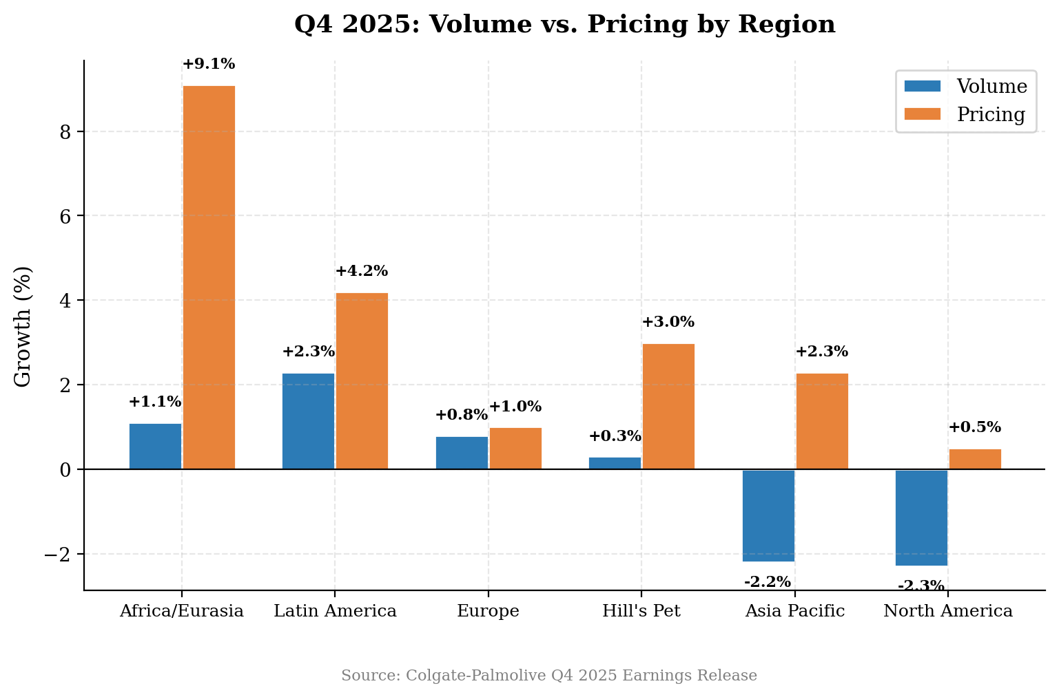
Figure 3: Volume vs. Pricing Decomposition — Pricing Dominates in EM, Volume Weak in DM

Profitability Analysis
Q4 2025 gross margin of 60.2% was essentially flat versus Q4 2024's 60.3% (-10 bps), but improved +80 bps sequentially from Q3's 59.4%. Management highlighted that raw material inflation and tariffs were headwinds, offset by Revenue Growth Management (pricing, promotion, and mix optimization) and productivity savings.
Base Business operating margin of 21.2% compressed -50 bps YoY from 21.7%, driven by increased advertising investment (+5% in Q4 on a dollar basis). This is a deliberate choice — management is investing behind the innovation pipeline for 2026. GAAP operating margin was distorted by the $794M Filorga impairment.
Base Business EPS of $0.95 grew +4.4% YoY from $0.91, beating consensus by $0.04. Full-year Base Business EPS of $3.69 grew +2.5% from $3.60, reflecting margin discipline and share buybacks partially offset by currency headwinds.
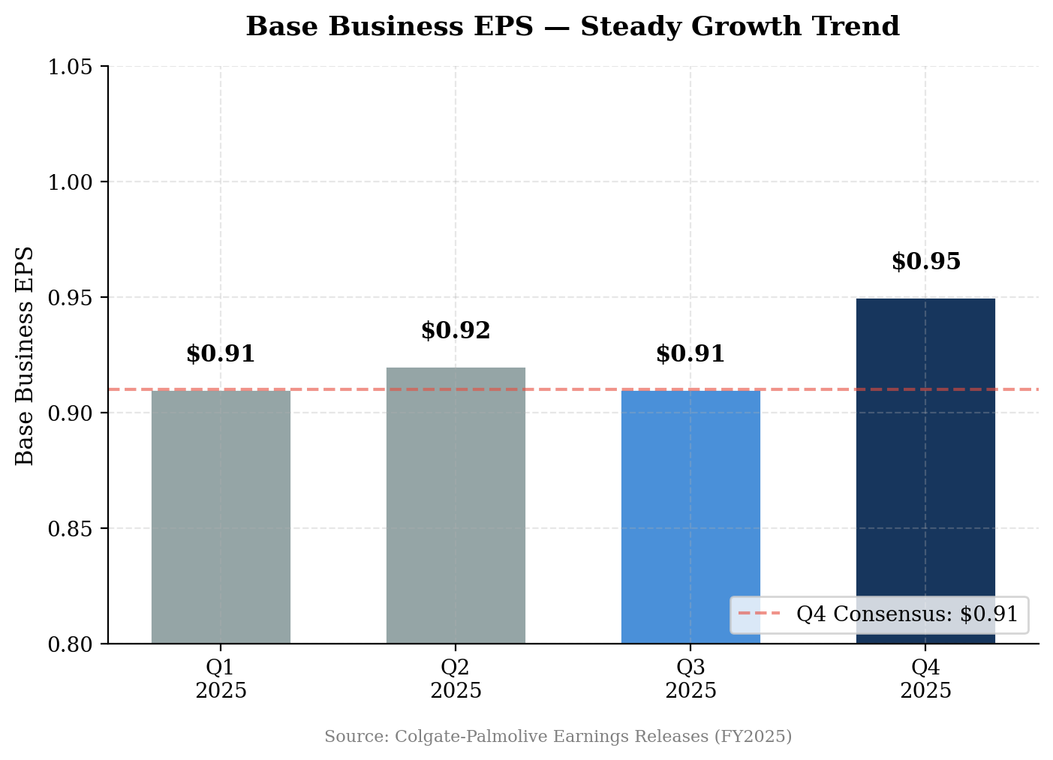
Figure 4: Base Business EPS — Steady Growth, Q4 Beat
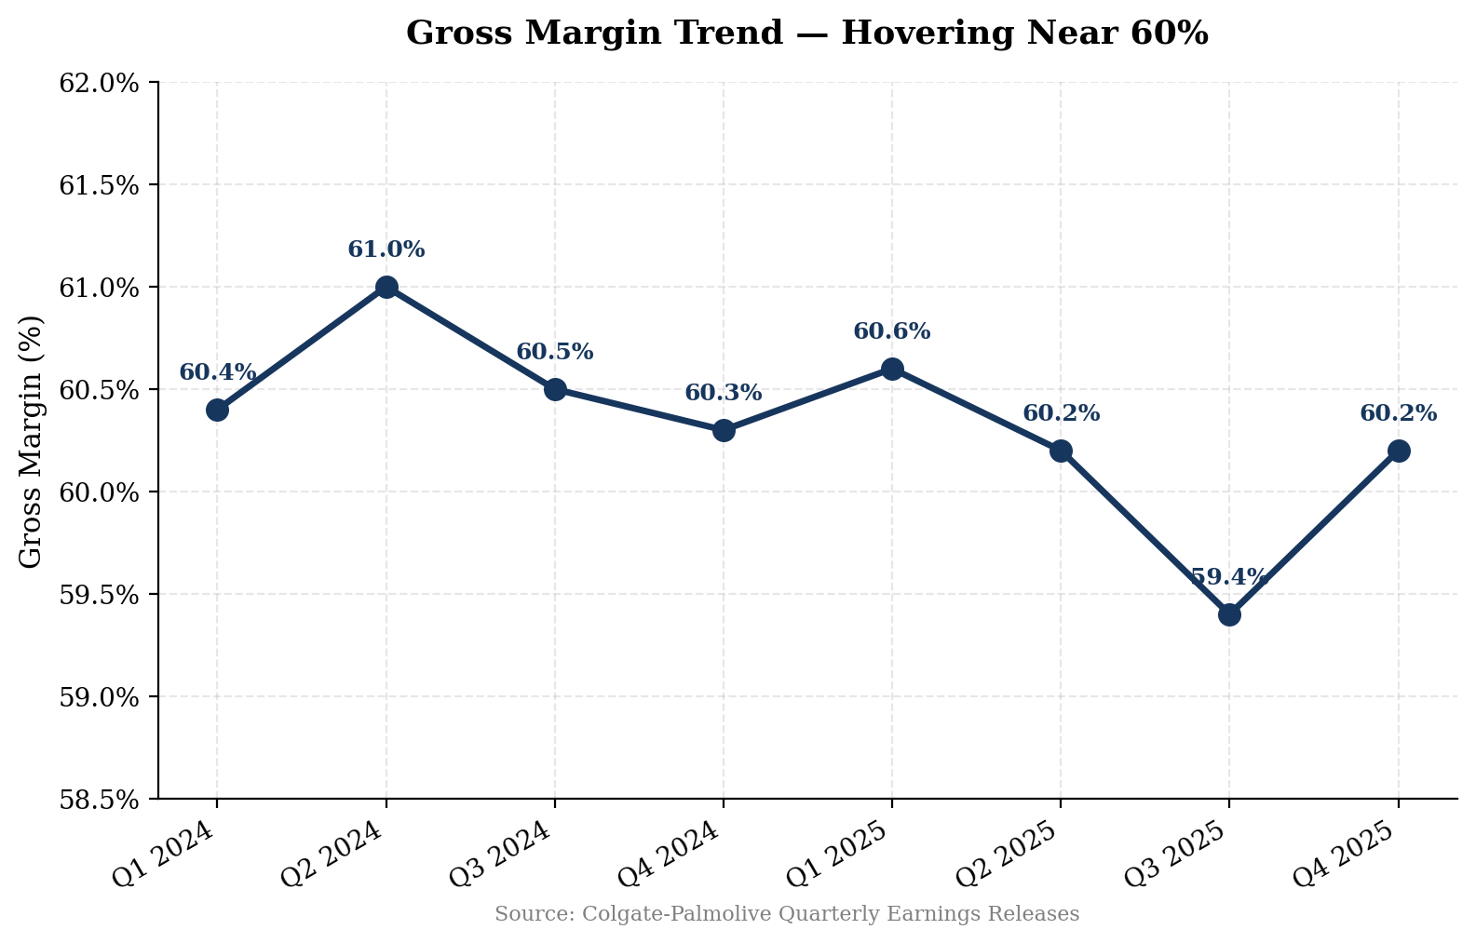
Figure 5: Gross Margin Trend — Hovering Near 60%, Sequential Recovery in Q4

Key Metrics & Guidance

Operating Highlights
Metric | Q4 2025 | FY2025 | FY2024 | YoY Change
Net Sales | $5,230M | $20,382M | $20,101M | +1.4%
Organic Growth | +2.2% | +1.4% | +4.3% | Decelerated
Gross Margin | 60.2% | 60.1% | 60.5% | -40 bps
Base Business Op. Margin | 21.2% | 21.3% | 21.7% | -40 bps
Base Business EPS | $0.95 | $3.69 | $3.60 | +2.5%
Operating Cash Flow | N/A | $4,198M | $3,900M* | Record
Free Cash Flow | N/A | $3,634M | $3,500M | Record
Toothpaste Market Share | 41.3% | 41.3% | 41.4% | -10 bps
Advertising Spend | +5% ($ basis) | $2,703M | $2,720M | -0.6%
Source: Colgate-Palmolive Q4 & FY2025 Earnings Release (January 30, 2026). *Estimated.
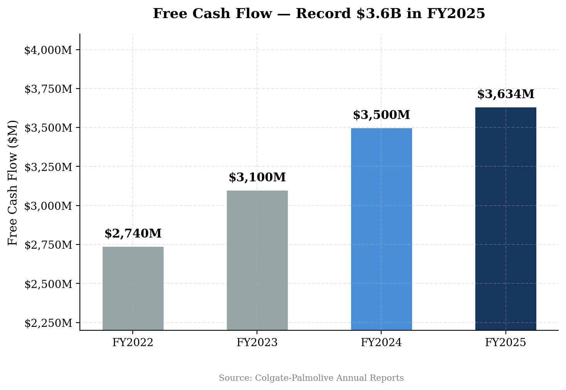
Figure 6: Free Cash Flow — Record $3.6B Supports Dividend Growth and Buybacks
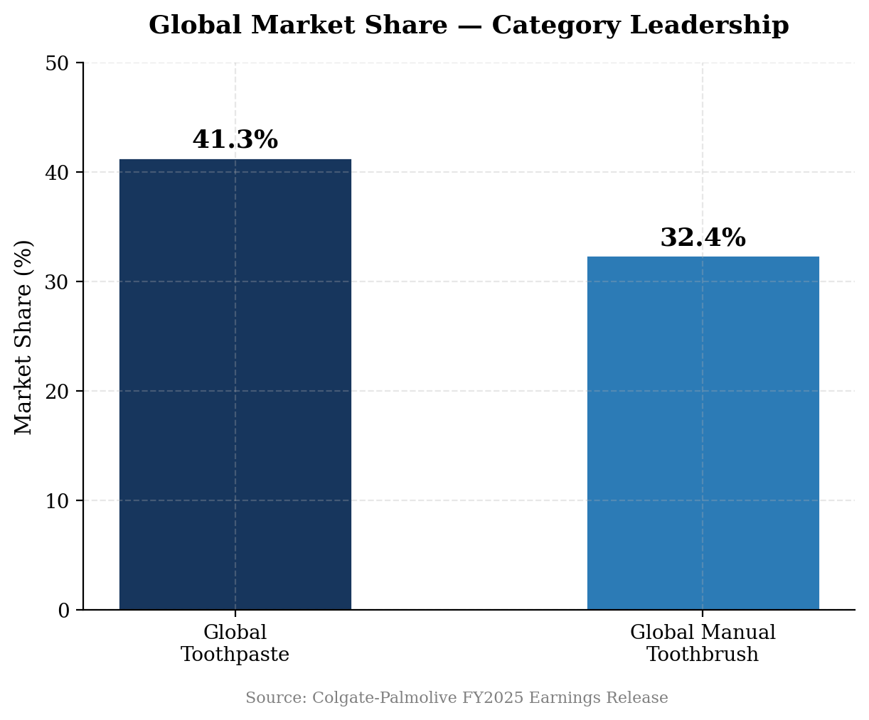
Figure 7: Global Market Share — Dominant Oral Care Position Maintained

Hill's Pet Nutrition
Hill's delivered +4.9% net sales growth in Q4 (organic +1.5%), with currency providing a +1.6% tailwind and the private label exit a -2.2% drag. Excluding private label, Hill's grew >5%. Prescription Diet continues to gain market share, and management described it as 'growing very, very nicely.' Volume was slightly positive (+0.3%) with pricing of +3.0%.
For the full year, Hill's generated approximately $4.6 billion in revenue, making it roughly 23% of total Colgate sales. The segment's science-led positioning in veterinary-recommended pet nutrition provides a structural growth tailwind as pet humanization trends continue.

FY2026 Guidance
Metric | FY2026 Guidance | Scenario Framework
Net Sales Growth | +2% to +6% | FX low-single-digit positive (H1 weighted)
Organic Sales Growth | +1% to +4% | Low end if categories worsen; high end if strengthen
Gross Margin | Expansion (GAAP & Base) | Funded productivity + RGM offsetting inflation
GAAP EPS Growth | Double-digit | Non-recurrence of Filorga impairment
Base Business EPS Growth | Low-to-mid single digit | Increased advertising investment
Advertising | Up ($ and % of sales) | Stronger innovation pipeline backing spend
Source: Colgate-Palmolive FY2026 Guidance (January 30, 2026 Earnings Call)
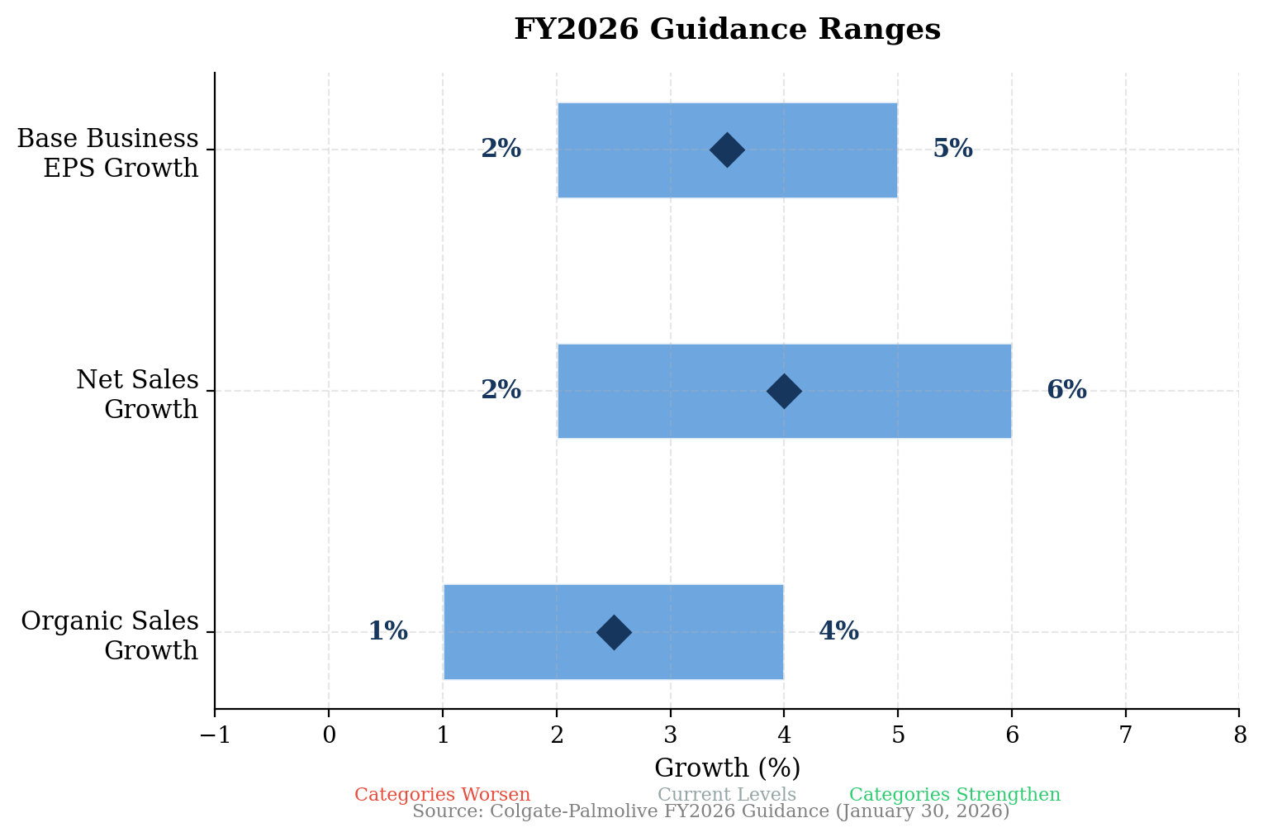
Figure 8: FY2026 Guidance Ranges — Scenario-Based Framework

Updated Investment Thesis

Thesis Pillar Assessment
Global Oral Care Leadership: UNCHANGED
41.3% global toothpaste share maintained. The category remains resilient — oral care is non-discretionary with pricing power. Innovation pipeline for 2026 described as "much stronger" with aggressive new products planned for North America and India. The core franchise is intact.
Emerging Markets Growth Engine: STRENGTHENED
Q4 demonstrated the portfolio's geographic diversification value. Africa/Eurasia (+10.3%), Latin America (+6.5%) delivered outsized growth that offset developed market softness. Emerging markets grew ~4.5% organic with balanced volume/pricing — healthier than pure inflationary pricing. This is exactly what the thesis depends on.
Gross Margin Expansion: MODESTLY WEAKENED
Full-year gross margin compressed 40 bps to 60.1% despite RGM efforts, as raw material inflation and tariffs offset productivity gains. However, Q4 showed +80 bps sequential improvement, and management guided to expansion in 2026. The trajectory is recovering but the magnitude of expansion may be more modest than previously expected.
Hill's Pet Nutrition as Growth Driver: UNCHANGED
Hill's grew >5% organically excluding private label — solid but not outstanding. Prescription Diet share gains are encouraging. The pet humanization and premiumization thesis remains intact, though the broader pet food category showed some softness. Hill's represents ~23% of revenue and likely a higher share of profit.
Cash Generation & Capital Allocation: STRENGTHENED
Record $3.6B FCF and $4.2B operating cash flow. $2.9B returned to shareholders via dividends ($1.8B) and buybacks ($1.2B). The 63-year dividend increase streak continues. FCF conversion is excellent and provides a durable floor for the stock.

Key Risks
- Category Softness: 9-10 categories with negative volumes in North America; soft global category growth (~1.5-2.5% vs. historical 4-5%)
- Input Cost Inflation: Tariffs and raw material inflation could pressure gross margins despite productivity efforts
- Filorga Overhang: $794M Filorga write-down raises questions about the skin health strategy and M&A discipline
- EM Currency/Pricing Risk: Emerging market growth depends on continued pricing power in inflationary environments
- Valuation: Stock has rallied ~11% post-earnings; forward P/E of 23.5x is in line with PG but above KMB/HENKY
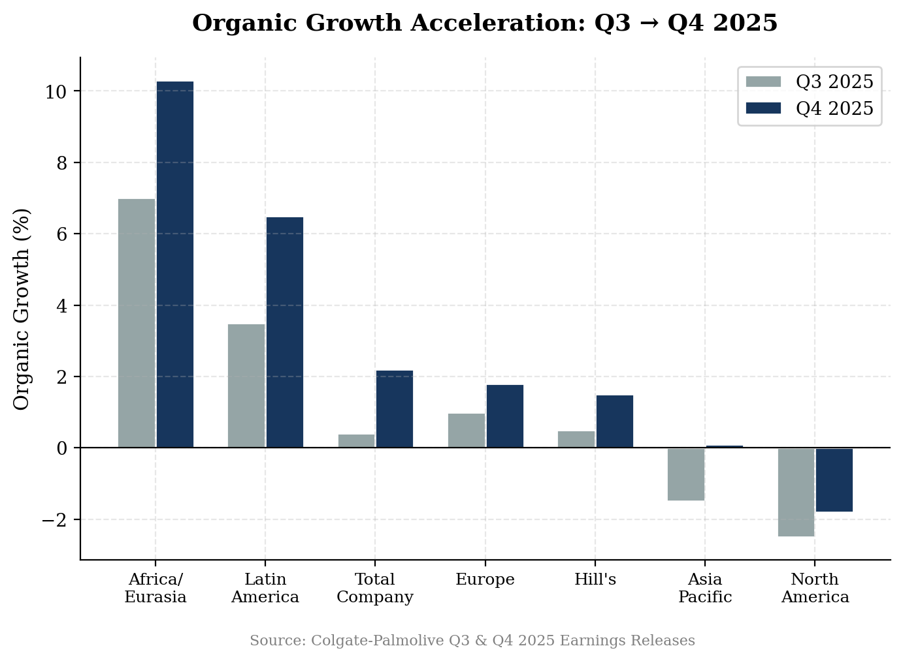
Figure 9: Organic Growth Acceleration Q3 → Q4 — Broad-Based Improvement

Valuation & Estimates

Peer Valuation Comparison
CL trades at 23.5x forward P/E, roughly in line with Procter & Gamble (22.0x) and below Church & Dwight (27.6x). This represents a premium to European peers Henkel (13.0x) and Kimberly-Clark (12.6x), justified by CL's superior organic growth profile, global scale, and category leadership in oral care. The premium appears reasonable but not cheap at these levels.
Company | Market Cap | Forward P/E | EV/EBITDA | Organic Growth | Gross Margin
Colgate-Palmolive (CL) | $75.0B | 23.5x | 15.6x | +2.2% | 60.2%
Procter & Gamble (PG) | $390.7B | 22.0x | 14.7x | +3.0%* | 51.5%*
Church & Dwight (CHD) | $24.5B | 27.6x | 19.2x | +4.5%* | 46.0%*
Kimberly-Clark (KMB) | $34.5B | 12.6x | 10.1x | +1.5%* | 37.0%*
Henkel (HENKY) | $34.5B | 13.0x | 8.7x | +2.0%* | 48.0%*
Peer Median |  | 17.3x | 12.4x
Source: Yahoo Finance, StockAnalysis.com (March 2026). *Estimated from most recent reported quarter.
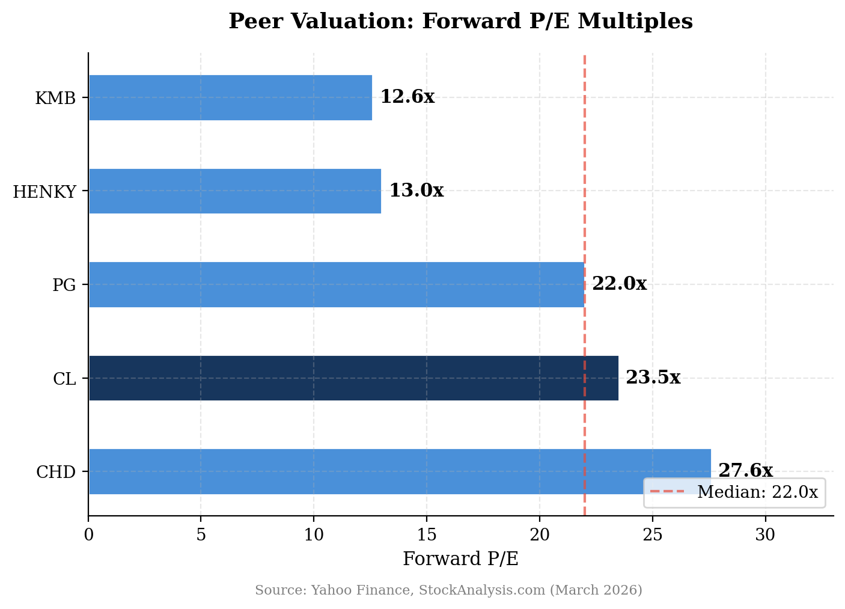
Figure 10: Forward P/E — CL Trades at a Premium, Justified by Growth and Category Position

Price Target Methodology
Our $100 price target is derived from a blended approach:
Methodology | Implied Value | Weight | Contribution
Forward P/E (25x FY2026E EPS of $3.99) | $99.75 | 50% | $49.88
EV/EBITDA (16x, slight premium to peers) | $98.00 | 25% | $24.50
DCF (WACC 8.5%, terminal growth 2.5%) | $103.00 | 25% | $25.75
Blended Price Target |  |  | $100.13 → $100.00

Detailed Estimate Updates
 | Q4 2025A | FY2025A | FY2026E | FY2027E
Net Sales ($M) | $5,230 | $20,382 | $21,940 | $22,660
Net Sales Growth | +5.8% | +1.4% | +7.6% | +3.3%
Organic Growth | +2.2% | +1.4% | +2.5%E | +3.0%E
Gross Margin | 60.2% | 60.1% | 60.8%E | 61.2%E
Base Business Op. Margin | 21.2% | 21.3% | 21.5%E | 22.0%E
Base Business EPS | $0.95 | $3.69 | $3.99E | $4.26E
Free Cash Flow ($M) | N/A | $3,634 | $3,800E | $4,000E
Dividend/Share (Annual) | $2.08 | $2.08 | $2.16E | $2.24E
Source: FY2025 actual from Colgate-Palmolive; estimates from StockAnalysis.com consensus and our analysis. A = Actual, E = Estimate.
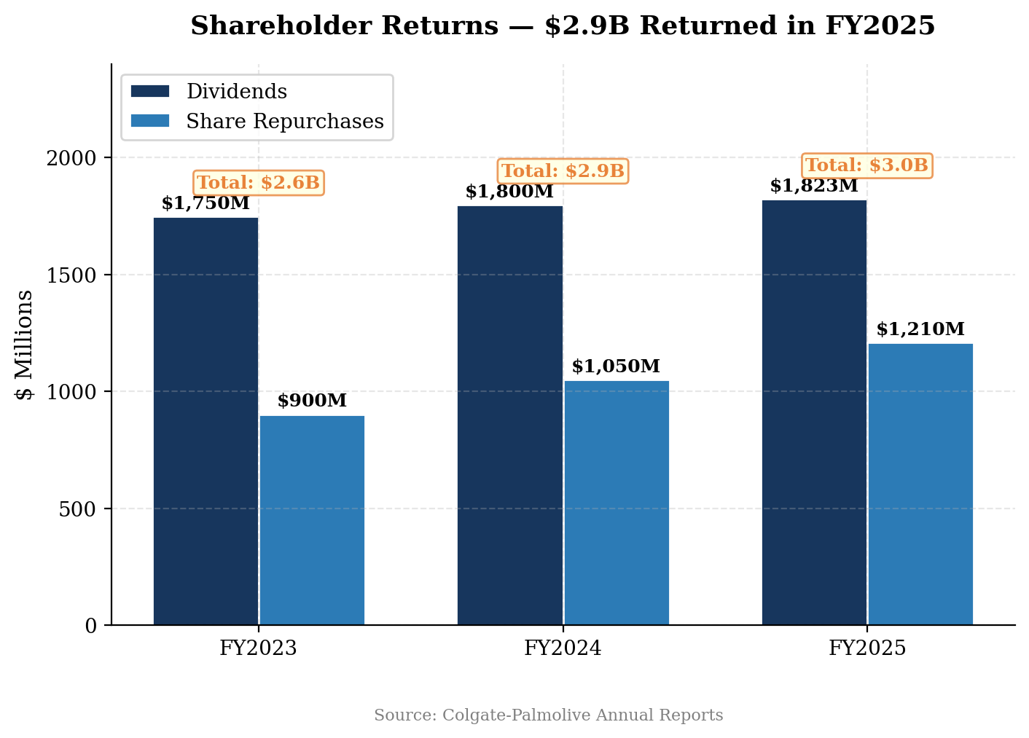
Figure 11: Shareholder Returns — Consistent and Growing Capital Return
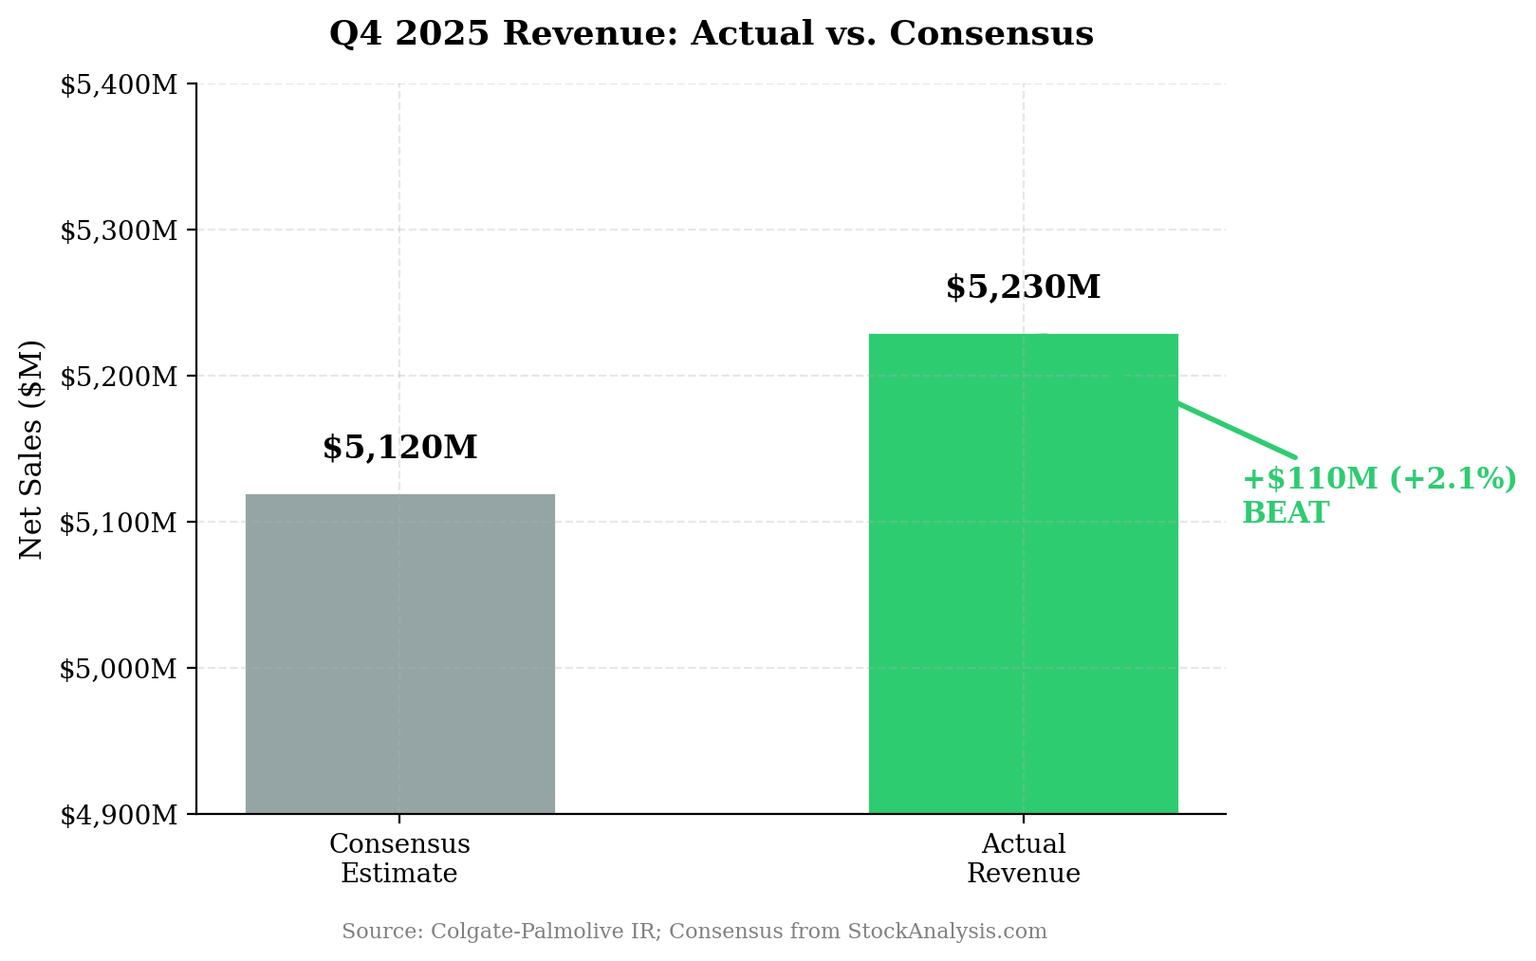
Figure 12: Q4 2025 Revenue Beat — Strongest Quarter of the Year

Appendix

Earnings Call Highlights
Key quotes from the Q4 2025 earnings call (January 30, 2026):
On category environment: Global product categories remain soft at ~1.5-2.5% growth versus the historical 4-5% level. Management framed 2026 guidance around three scenarios depending on whether categories worsen, hold, or strengthen.
On North America: Management acknowledged 9-10 categories with negative volume in October-November but emphasized this reflects category-wide softness rather than Colgate-specific share loss. Innovation pipeline for 2026 is "much stronger" with aggressive new product introductions.
On emerging markets: "Emerging markets grew at about 4.5% organic in the quarter with a good balance between price and volume." Mexico and Brazil contributed high single-digit growth.
On Hill's Pet Nutrition: "Prescription Diet business growing very, very nicely" with market share gains. Hill's achieved >5% growth excluding the private label exit.
On pricing power: "We need to get some pricing in that category" — management emphasizing Revenue Growth Management to balance price, promotion, mix, and innovation.
On 2030 strategy: New long-term strategy announced focusing on brand leverage, science-driven innovation, omnichannel demand generation, digital/AI capabilities, and supply chain optimization.

Filorga Impairment Detail
Colgate recorded a $794 million after-tax non-cash impairment charge in Q4 2025 related to the Filorga skin health business (goodwill and intangible asset write-downs). Filorga was acquired in 2019 for approximately $1.7 billion as part of Colgate's premium skin care strategy. The impairment reflects lower-than-expected growth and a reassessment of long-term prospects for the brand. This charge had no impact on cash flow, operating performance, or the Base Business earnings metric.

Post-Earnings Analyst Activity
Firm | Action | New Price Target | Previous
Bank of America | PT Raised | $105 | $100
Citi | PT Raised | $105 | $95
Goldman Sachs | PT Raised | $100 | $94
JPMorgan | PT Raised | $97 | $93
Piper Sandler | PT Raised | $96 | $88
UBS | PT Raised | $93 | $90
Consensus: 12 Buy / 6 Hold / 1 Sell (19 analysts). Average PT: $96.87.

Sources & References
Colgate-Palmolive Q4 & FY2025 Earnings Release (January 30, 2026)
Q4 2025 Earnings Call Transcript — Motley Fool
Q3 2025 Earnings Release
Colgate-Palmolive Investor Relations
CL Analyst Forecasts — StockAnalysis.com
Yahoo Finance — CL

DISCLAIMER: This report is for informational purposes only and does not constitute investment advice. All estimates are based on publicly available information and analyst consensus as of the date indicated. Past performance is not indicative of future results. Investors should conduct their own due diligence before making investment decisions.

