Rare Pyramid Bookstore Management System (BMS)
Group C
Created by: Phillip Cook, Regina Cleveland, Robert Campbell, Kalder Morgan
10 May 2026

Table of Contents
1. Project Vision and Description 3
2. Team Roles 3
3. Collaboration Methodology 4
4. The Definition of “Done” 4
5. Product Design 5
High-Level System Design 5
6. Sprint 1 Retrospective Summary Report 14
7. Sprint 2 Retrospective Summary Report (TBD) 15
8. References 16

Project Vision and Description

BMS (Bookstore Management System) is an automated management system that provides accounting, inventory, ordering, and sales functionality. The main system capabilities include the following:

- Keeping track of inventory
- Keeping track of sales records
- Providing the ability to place orders with manufacturers
- Providing the ability for customers to place orders

Team Roles

Product Owner: Robert Campbell, according to Neudecker (n.d.), responsibilities include
- Manage the product backlog
- Prioritize work
- Ensure understanding of items in the product backlog
Scrum Master: Phillip Cook, according to Neudecker (n.d.), responsibilities include
- Ensures Scrum is understood and enacted by everyone
- Facilitates the Scrum ceremonies as needed (stand-up, sprint planning, retrospective, sprint review)
- Removes blockers
Developers: Kalder Morgan and Regina Cleveland, according to Neudecker (n.d.), responsibilities include
- Deliver increments of value
- Create a plan for the sprint
- Instilling quality by adhering to the Definition of Done

Collaboration Methodology

The team will utilize an Agile/Scrum framework to allow for flexibility as the bookstore owner discovers new needs during the transition.
- Stand-ups twice a week to discuss progress.
- Communication Tools: Zoom and group text

The Definition of “Done”

- Code Review: The code has been reviewed and approved by at least one other team member.
- Testing: The story has passed all unit testing
- Zero Critical Bugs: No high-priority bugs are outstanding in the current build.
- Product Owner Approval: The product owner has reviewed the story and confirmed it meets the acceptance criteria

Product Design

High-Level System Design
The Bookstore Management System (BMS) will use a 3-tier architecture consisting of the Presentation Layer, Application Layer, and Data Layer. This design supports maintainability, security, and future scalability.
Presentation Layer
This layer provides the user interface for employees, managers, and customers.
Components:
Employee dashboard
Inventory management screens
Customer ordering portal
Reports and sales screens
Application Layer
This layer contains business logic and processing.
Modules:
User Authentication Module
Inventory Management Module
Sales Processing Module
Order Management Module
Reporting Module

Data Layer
Stores all persistent data in a relational database.
Tables:
Users
Books
Inventory
Orders
Order Items
Sales Transactions
Suppliers
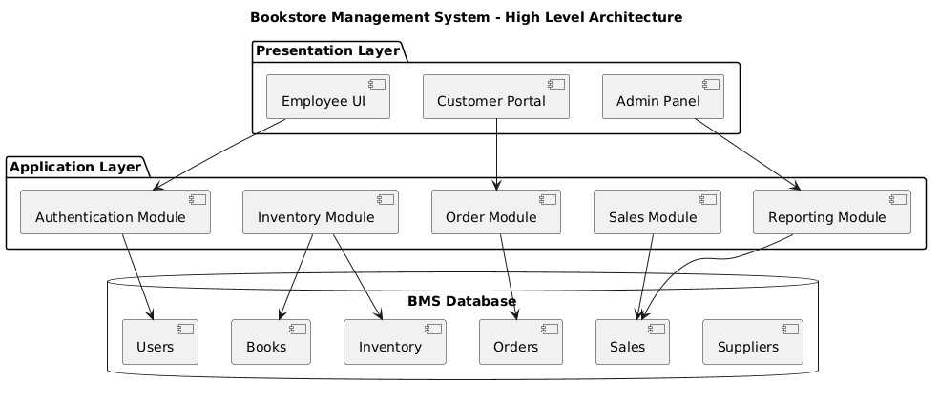

Sprint 1 Detailed Design
Sprint 1 Goal:
Build core inventory and user login functionality.
Sprint 1 Use Cases
Use Case 1: User Login
Actor: Employee/Admin
Steps:
- User enters username and password
- System validates credentials
- Access granted based on role
Use Case 2: Add New Book
Actor: Employee
Steps:
- User selects Add Book
- Enters ISBN, title, author, price, quantity
- System validates data
- Book saved to database
Use Case 3: Update Inventory
Actor: Employee
Steps:
- Search for book
- Modify quantity
- Save changes
- Inventory updated
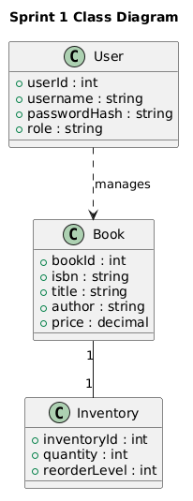

Sprint 2 Detailed Design
Sprint 2 Goal:
Implement customer ordering and sales tracking.
Sprint 2 Use Cases
Use Case 1: Customer Places Order
Actor: Customer
Steps:
- Customer browses books
- Adds items to cart
- Confirms purchase
- Order stored in system
Use Case 2: Process Sale
Actor: Employee
Steps:
- Select customer order
- Accept payment
- Generate receipt
- Reduce inventory automatically
Use Case 3: View Sales Report
Actor: Manager
Steps:
- Select date range
- System calculates totals
- Display revenue and top-selling books
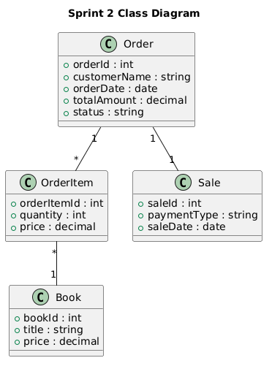
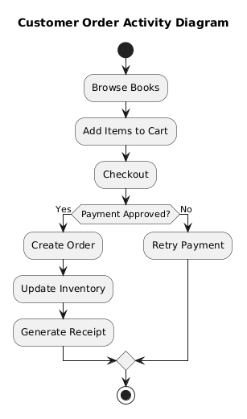
Security and Nonfunctional Requirements
Security
Passwords stored using hashed encryption
Role-based access control for Admin, Employee, Customer
Input validation to prevent SQL injection
Session timeout after inactivity
Audit logs for inventory and sales changes
Performance
Search results returned in under 3 seconds
Support multiple concurrent users
Reliability
Daily automated database backups
Error logging and recovery procedures
Scalability
Modular architecture allows future addition of:
Online payments
Loyalty rewards
Mobile app support
Usability
Simple navigation for non-technical bookstore staff
Clean dashboards and readable reports

Legal and Ethical Principles Considered During Sprint Planning
Legal and ethical considerations were reviewed while breaking epic stories into sprint-sized tasks so that the Bookstore Management System supports trustworthy operations and avoids preventable harm.
•Customer privacy. Special-order tasks were written to capture only the information needed to fulfill an order, such as customer name and contact details, and to avoid unnecessary exposure of personal data.
•Least-privilege access. Authentication and role-based tasks were included so employees, managers, and administrators only see or change information appropriate to their responsibilities.
Data integrity and accountability. Validation and audit logging tasks were planned to reduce inaccurate records, support traceability, and provide a reliable history of key inventory, order, and sales changes.
Secure handling of transactions. Because the project scenario assumes credit-card payments, the system design avoids unnecessary storage of sensitive payment details inside the bookstore application.
Honest customer communication. Search, inventory, and order-status tasks were designed to support accurate availability and order updates so customers are not misled about stock or fulfillment status.
Error prevention and fairness. Validation rules, clear error messages, and review tasks were included to reduce operational mistakes that could affect staff decisions or customer service quality.
These principles influenced both the order of work and the structure of the sprint tasks. Features that protect records, control access, validate input, and preserve auditability were treated as essential project work rather than optional cleanup items.

Sprint 1 Retrospective Summary Report
Things That Went Well
- Team established strong communication early on through Discord with regular meetings throughout the week.
- GitHub branching helped organize work and reduce conflicts between members
- SQLite database integration worked better than we expected once it was setup.
- Godot made it easy to separate between scenes, scripts, and database logic which made the project feel organized.
- Sprint Planning documents helped the team focus on the right tasks, keeping us on target to complete necessary goals.
- Each team member contributed to the group using their personal strengths, which helped us work efficiently.
- The project structure in Godot stayed organized even when more features were being added.

Things That Could Have Gone Better
- Some testing was delayed until after features were already nearing completion instead of being done continuously.

Things That Surprised Us
- GitHub collaboration became easier once everyone better understood branches and pushing changes regularly.
- We were surprised by how much functionality could be created quickly once the database structure was connected properly.
Lessons Learned
- Smaller commits in GitHub and frequent pushes make collaboration much safer and easier to manage.
- Testing features incrementally is more effective than waiting until the end of the sprint.
- Building functional core systems first is more important than focusing on visual polish early in development.
- Separating UI logic from database logic improves maintainability and organization.
- Sprint retrospectives help identify workflow problems before they become larger project issues.

Sprint 2 Retrospective Summary Report (TBD)
Things That Went Well
Things That Could Have Gone Better
Things That Surprised Us
Lessons Learned

References
Neudecker, J. (n.d.). Scrum team (accountabilities). Agile Academy. https://www.agile-academy.com/en/agile-dictionary/scrum-team/

