Insulated Gate Bipolar Transistors
James Ryan, Power Electronics, Spring 2026

Physical Overview
Insulated Gate Bipolar Transistors (IGBTs) are a type of transistor which can be considered a hybrid between a Bipolar Junction Transistor (BJT) and a Field Effect Transistor (FET).

BJTs
To review, a BJT consists of three p- or n- doped regions stacked in an alternating style. The outer layers are the collector and emitter, and the center is the base.
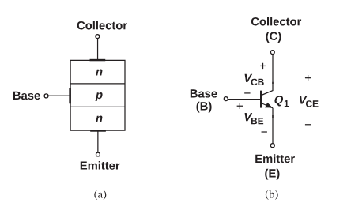Figure 1: (a) structure and (b) symbol of a BJT (source: Razavi)
In normal operation, current will flow from the collector to the emitter of a BJT, and this flow is controlled by the base. This happens when the base-emitter region is forward biased (V_be > 0) and the base-collector region is reversed biased (V_bc < 0). In other terms, the voltage at the collector should be higher than the voltage at the base, which should be higher than the voltage at the emitter (relative to ground, assuming threshold voltage is met). When a small current is provided to the base, it flows into the base and out of the emitter. A much larger current is induced from collector to emitter, which can be measured by multiplicative factor β.
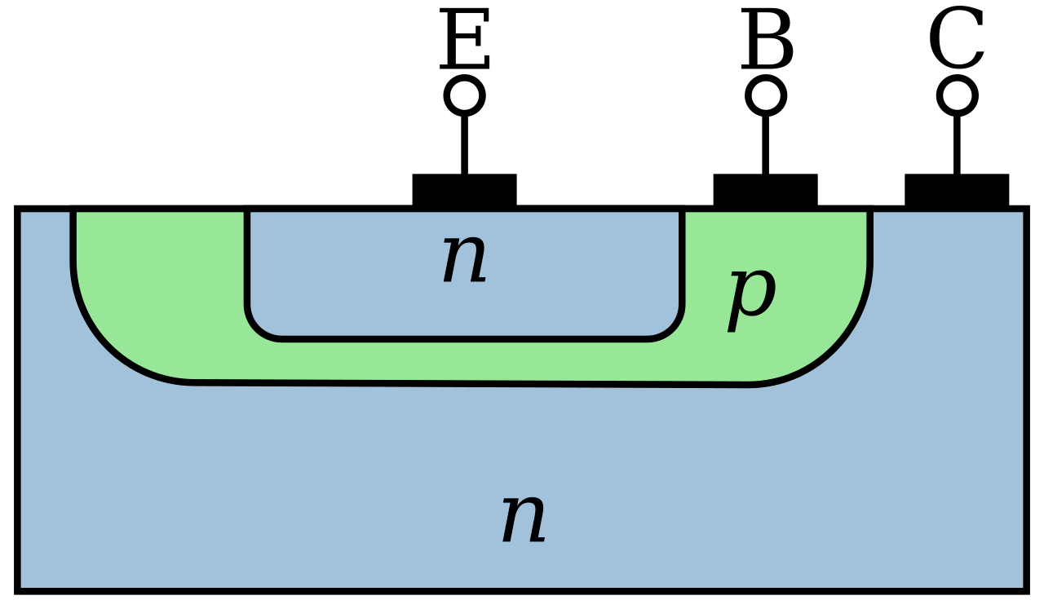Figure 2: Cross section of an npn BJT (Wikipedia)
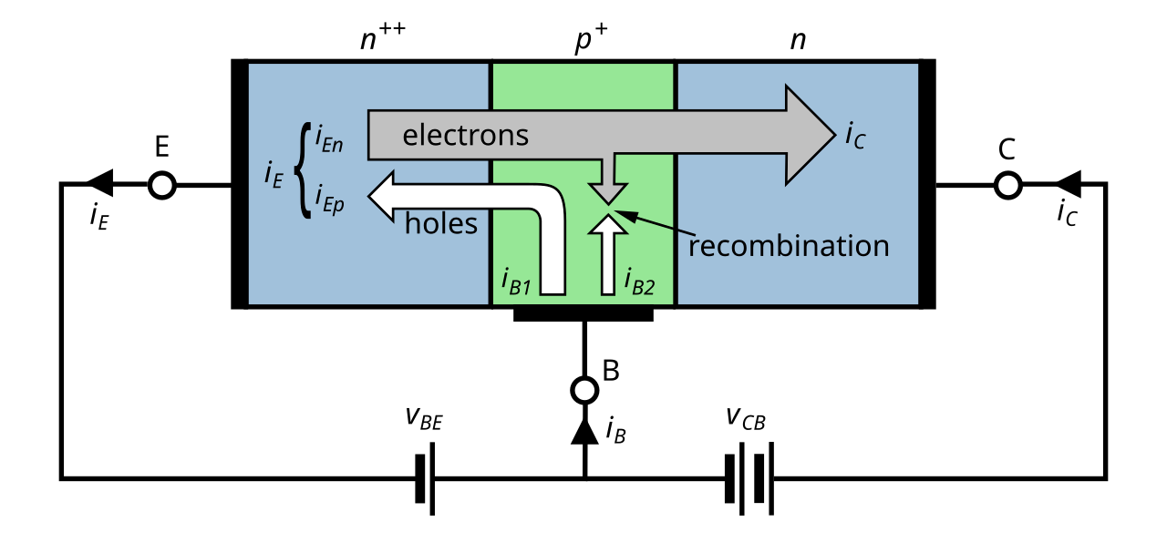Figure 3: NPN BJT in active mode (Wikipedia)
In typical (conventional) operation, the flow of charge is due to a diffusion of charge carriers across the junctions in our BJT. In active mode, our base-emitter junction is forward biased, so our potential barrier is lowered on that region: holes from the p region come to the n region, and electrons go from the n to p region, creating a current. Typically, this base region is thin, so electrons reach the collector-base junction and are swept into the collector region by the potential barrier’s E field. This induces a conventional current from the collector to emitter. (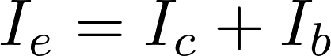)

MOSFETs
Recall that a capacitor is a two plate device, where, when a voltage difference is applied across it, a charge buildup is formed in between the two plates (). FETs take advantage of this physical phenomenon: as opposed to a BJT, where there is a non-negligible current which flows into the device from the base, a FET, or field-effect transistor, attempts to isolate it’s control terminal from the active device.
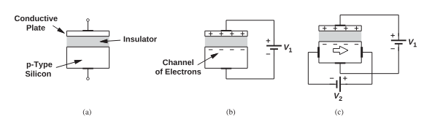Figure 4: (a) hypothetical semiconductor device, (b) operation as a capacitor, (c) current flow as a result of the electron difference (Razavi)
This isolation is achieved by taking advantage of the electric field produced by a capacitor. Looking at figure 4(c), we can control the current through the material by adjusting V_1, which in effect, adjusts the resistance through the device.
A common type of FET is the MOSFET (Metal-oxide Semiconductor FET).
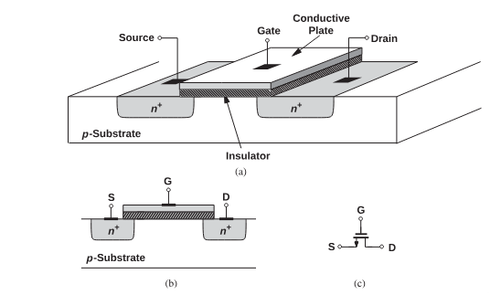Figure 5: (a) structure of MOSFET, (b) cross section, (c) schematic symbol (Razavi)
When a voltage is applied to the gate, a large negative charge buildup forms across the channel (from Source to Drain), and if the voltage difference from Gate to Source exceeds our device’s inherent threshold voltage, a conventional current from Drain to Source is formed. It should be noted that, implied by the capacitave nature of the device, the width to length ratio of the channel is directly proportional to the current that this device can conduct through it.

IGBTs
The IGBT can be thought of as a combination of the two technologies briefly discussed above.
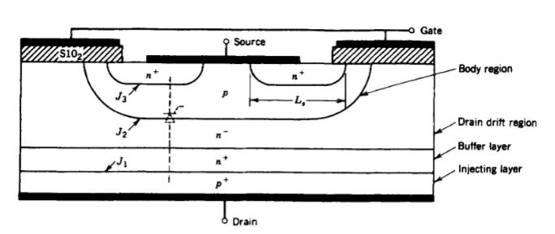Figure 6: Cross section of an IGBT (Mohan)
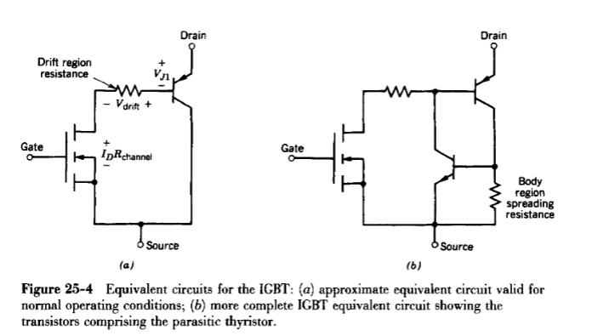Figure 7: IGBT Equivalent Circuit
From a high level, our cross section (figure 6) is laid similarly to a MOSFET, noting the isolated gate. When we correctly apply a gate-source voltage, a channel forms across the p region (our body region), and “connects” our n+ source region to our drain. However, our drain is not one region, its multiple: a drain drift region (n-), a buffer (n+), and an injecting layer (p+). So, within the drain region, we have formed a pn junction.
This buffer layer is not explicitly necessary. The presence of it indicates that this is a punch-through IGBT. Including this region means that we have a thinner potential barrier, which drops our on-state losses. However, this means our reverse-blocking ability is diminished, and our device will only work in forward biased mode (Vds > 0). Removing this layer creates a symmetric (non punch-through) IGBT, and can block both forward and reverse voltages.
Once the gate-source voltage passes the threshold, our channel forms beneath the gate, allowing current to flow. Our n- drain drift region is essentially shorted to the n+ source region (exactly like a MOSFET), and
Considering the physical construction, we can see that the IGBT can be equivalently modeled as a Darlington pair, with a MOSFET as the driver and a pnp transistor as our main device. Note that our

The structure in figure 6 is quite similar to the structure of a MOSFET, specifically, when we apply a voltage to the gate, we form a channel from the source n+ region to the “drain drift” n- region. But, compared to a FET, there is a key difference: the p+ layer which forms our drain creates a pn junction which allows us to inject minority carriers into the drain of what would be our MOSFET. The construction of an IGBT can vary a bit: it can either be a punch-through or non-punch-through structure. A punch-through structure has a drift region that is about half the thickness of a non-punch-through structure, which has the benefit of incurring lower losses in the on-state, but due to the buffer layer, we greatly diminish the reverse-blocking capability of our structure.
In the equilibrium (or, “off”) state, there is no voltage applied on the gate, so neither channel forms, and a small leakage current is present. This is close to how our MOSFET operates at equilibrium.
In the “on” state, our gate-source voltage is large enough to sufficiently form the channel, inducing a current flow, shorting our drift region and our n+ source region. As a result of this, holes in our p+ drain region are induced to flow into our drift region via charge carrier drift and diffusion, and recombine in the p body region. Essentially, the junction between the body region and the drift region collects the attracted holes, and the device operates like a pnp BJT, if it had a disproportionately thick collector region.

Benefits

Example: Usage in an Induction Heating Circuit
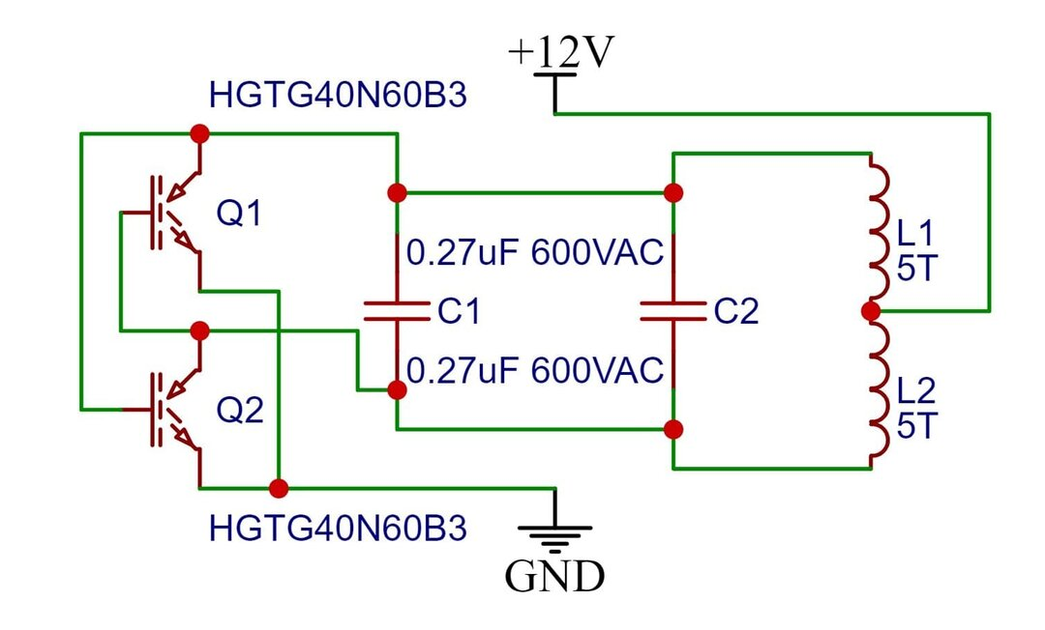Figure 8: IGBT-based induction heater circuit (hackatronic.com)
In an induction heater, our main goal is to induce heat into another piece of metal using some kind of coil. Conceptually, the goal is to harness an AC power source to induce a magnetic field around our coil. This alternating magnetic field then generates current in metal which is in proximity to it, which in turn induces a circulating current in that metal. These currents are called eddy currents. Metal is imperfect, so this current encounters resistance as it circulates, and as we learned in circuit analysis, this generates energy, which in our case becomes thermal heat. So, our main goal is to create a circuit which can generate a lot of circulating currents, in order to produce a lot of heat in our neighboring metal very quickly
We have a sample circuit shown in figure 8, an IGBT-based induction heater. Our main coil (L1 and L2) is connected to a driver circuit. This driver controls the flow of our current from the 12-volt power supply, where our IGBTs (Q1 and Q2, SKU HGTG40N60B3) act as an automatic switch. We have two large capacitors (C1 and C2) for two reasons: adding capacitors will offset our large power factor, which is a result of having a large inductance in our circuit, and we can take advantage of this to produce a resonant LC tank circuit, to produce an oscillating current in our circuit. Our IGBTs are set up in a multivibrator configuration: as our capacitors charge to a threshold, our center-tapped transformer has current going down it in one direction. When we reach the threshold, the polarity across the coil reverses, and our current also reverses. This change in current induces the magnetic field. We specifically use IGBTs in this configuration since they are well-suited for the large alternating currents we are experiencing in the control circuitry.

