Asynchronous Buck Converter Lab
James Ryan, Power Electronics, Spring 2026

Specifications
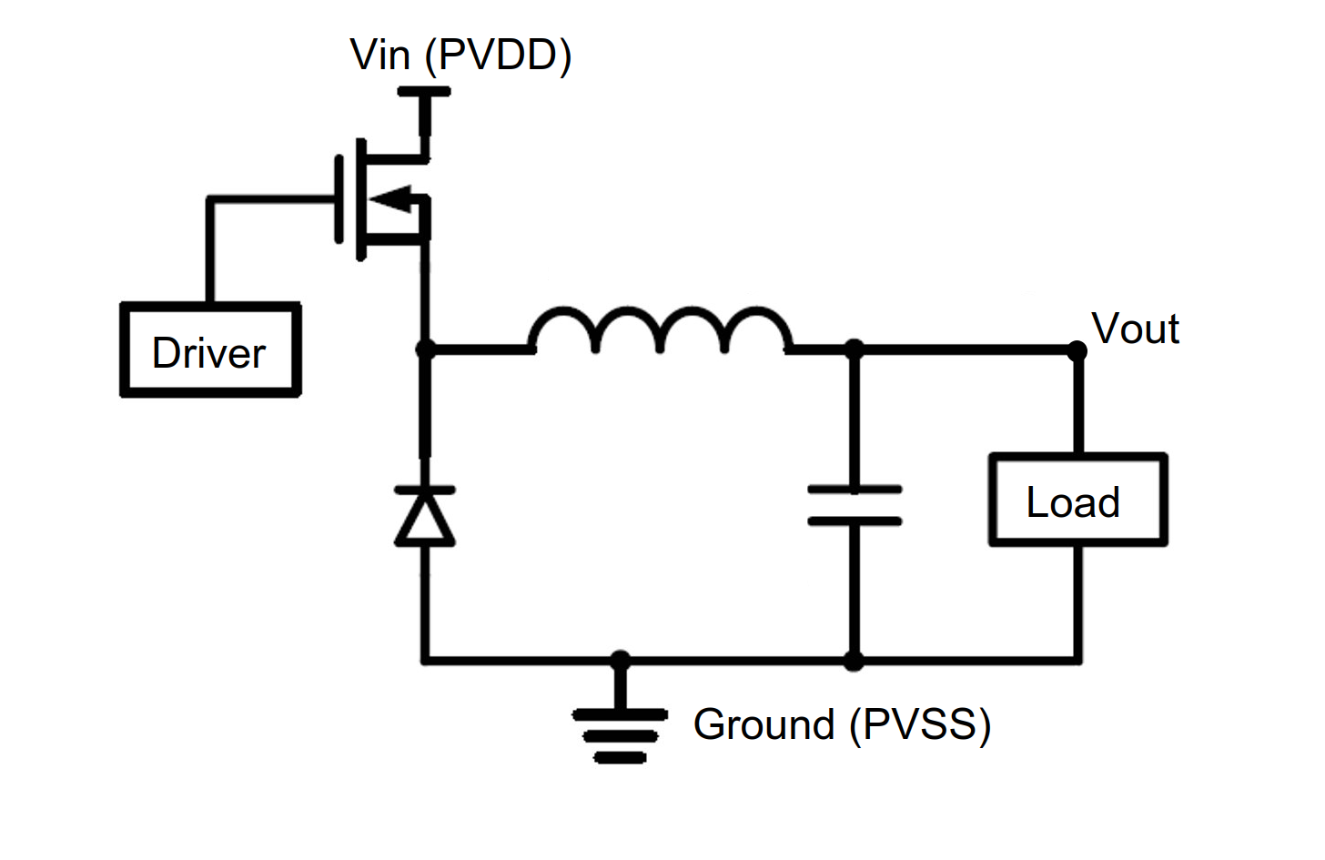Figure 1: Block diagram for an async buck converter
This converter is designed to step down a 10V input to a 5V output, while maintaining 1A current delivery to the load. The inductor current should have a peak to peak ripple which is within 20%-40% of its DC value, and the output voltage should have a peak to peak ripple which is at most 1% of its DC value.
Following TI SLVA477B, we can calculate what our inductance and capacitance should be in this circuit, matching what is available in the lab.

Simulation

Simulation Performance

Physical Prototype

Part Selection
Include a table of measured components

Prototype Performance

Appendix I – LTSpice models
Below are the models which I sourced from the Internet. For each model, copy and paste the contents of each file to their own file, in the same location as your project, and create an include directive to import the file to your project. Then, hold control and click on the device, and update the `Value` field to reflect the correct device (e.g., for a PMOS, change `Value` to `irf9530`; for the Diode, change `Value` to `1N4004`).

IRF9530 PMOS
.SUBCKT irf9530 1 2 3
**************************************
* Model Generated by MODPEX *
*Copyright(c) Symmetry Design Systems*
* All Rights Reserved *
* UNPUBLISHED LICENSED SOFTWARE *
* Contains Proprietary Information *
* Which is The Property of *
* SYMMETRY OR ITS LICENSORS *
*Commercial Use or Resale Restricted *
* by Symmetry License Agreement *
**************************************
* Model generated on Apr 23, 96
* Model format: SPICE3
* Symmetry POWER MOS Model (Version 1.0)
* External Node Designations
* Node 1 -> Drain
* Node 2 -> Gate
* Node 3 -> Source
M1 9 7 8 8 MM L=100u W=100u
* Default values used in MM:
* The voltage-dependent capacitances are
* not included. Other default values are:
* RS=0 RD=0 LD=0 CBD=0 CBS=0 CGBO=0
.MODEL MM PMOS LEVEL=1 IS=1e-32
+VTO=-3.29858 LAMBDA=0.00943157 KP=5.81678
+CGSO=4e-05 CGDO=5e-08
RS 8 3 0.0732334
D1 1 3 MD
.MODEL MD D IS=1e-17 RS=0.150832 N=1.5 BV=100
+IBV=0.00025 EG=1.2 XTI=4 TT=1e-07
+CJO=3e-09 VJ=3 M=0.8 FC=0.1
RDS 3 1 1e+06
RD 9 1 0.107379
RG 2 7 6
D2 5 4 MD1
* Default values used in MD1:
* RS=0 EG=1.11 XTI=3.0 TT=0
* BV=infinite IBV=1mA
.MODEL MD1 D IS=1e-32 N=50
+CJO=1e-09 VJ=0.85 M=0.8 FC=1e-08
D3 5 0 MD2
* Default values used in MD2:
* EG=1.11 XTI=3.0 TT=0 CJO=0
* BV=infinite IBV=1mA
.MODEL MD2 D IS=1e-10 N=0.4 RS=3e-06
RL 5 10 1
FI2 7 9 VFI2 -1
VFI2 4 0 0
EV16 10 0 9 7 1
CAP 11 10 3e-09
FI1 7 9 VFI1 -1
VFI1 11 6 0
RCAP 6 10 1
D4 6 0 MD3
* Default values used in MD3:
* EG=1.11 XTI=3.0 TT=0 CJO=0
* RS=0 BV=infinite IBV=1mA
.MODEL MD3 D IS=1e-10 N=0.4
.ENDS

1N4004 Diode
.MODEL 1N4004 D(IS=2.55E-9 RS=0.042 N=1.75 TT=5.76E-6 CJO=1.85E-11 VJ=0.75 M=0.333 BV=400 IBV=3.95E-5 Iave=1A Vpk=400 type=silicon)

