**Mobile Application for Site Monitoring**

[CHANNEL MANAGER DOCUMENT]

**Background**

ATMs have become face of the Bank. More than 60% of eligible cash transactions are now happening on ATMs. The maintenance and upkeep of ATM is the immediate priority next to keeping the ATM alive for customer transactions. There is a monitoring tool to capture technical faults in an ATM and help the Channel Managers in monitoring vendors/ taking corrective actions on their own to resolve the issues. However, there has been no mechanism to record and follow site related issues viz. cleaning and general condition of ATM site.

There was an urgent requirement to provide a tool to Channel Managers which enables them to log tickets on service providers in real time thus eliminating manual calls or noting in the register. The mobile application is an effort to log the tickets online from the site itself, track the life of the ticket till closure, calculate TAT and apply penalties on the vendor for resolutions beyond agreed time as per SLA (service level agreements). This is another step towards empowering Channel Managers for effective and efficient discharge of their duties.

**Introduction**

The mobile application has been developed by M/S SecureT concepts private limited led by a group of young and dynamic professionals, as an initiative of SBI. The application currently works on android operating system and requires basic data connectivity on the mobile phone. The acronym ASM used for the application stands for ATM service management. ASM is a mobile based SAAS model for Field Service management, helpdesk / Ticket management Solution capable of handling real time allocation / managing of assignment to service provider and raising Tickets through Multiple Channels. ASM application can be downloaded from Google play store on Channel Manager’s mobile phone and accessed through the user ID and password specially created by the Bank for individual Channel Manager.

The application has two main parts:

1. **Submit new tickets**: This allows the Channel Manager to raise new tickets on the vendors for deficiencies in services.
2. **View existing tickets**: This allows Channel Managers to track, follow and close the tickets raised by them.

The detailed steps are explained later in the ‘How to’ section.

**How to**

1. Download the application

The application can be downloaded from Google play store on the android based mobile phone. The pre-registration to play store with Gmail ID is a must for downloading as for other software/application downloads. The user may go to play store and type the key word –‘ASM secureT’ in the search bar and select the application with icon similar to the writing pad as under (in blue) named as ‘Secure T Service Management’ from all the applications displayed.

[](https://www.google.co.in/search?biw=1524&bih=767&tbm=isch&q=writing+pad+clipart&revid=1729100361&sa=X&ei=7KjtVISsAYurogSNo4CoBA&ved=0CB8Q1QIoAA)

Secure T Service Management

**SecureT concepts**

Install the application by accepting the terms displayed by the application.

1. Submit new ticket

After you login using the pre-created user ID and password provided by the solution provider, two small boxes will be displayed for new tickets and existing tickets, each. For raising a new ticket, submit new ticket box has to be clicked. The form for submitting new tickets will open with various drop down menus for selecting ATMID, vendor, fault, severity of fault, etc. will be available for registering a complaint and submitting the ticket.

**ATMID**🡪 The top most drop down will show the ATMIDs associated with the particular Channel Manager ID for selecting the ATMID for which ticket has to be submitted.

**Vendor**🡪 The next dropdown allows you to select the concerned vendor out of all vendors associated with the particular ATM.

**Fault Category** 🡪 This dropdown allows you to select the correct option out of the option list which represents the fault/ deficiency for which ticket is to be submitted.

**Severity**🡪 The severity of the fault may be selected out of ‘major’ and ‘minor’. All faults deficiencies affecting the availability / operation of the ATM should be categorised as ‘major’.

**Attach the picture** 🡪 this allows you to click a picture showing the deficiency/ fault and attach to the ticket for information of the vendor. This functionality is very useful as it records date, time and geo coordinates of the picture.

**Comments** 🡪 The fault may be briefly described to help vendor understand the requirement and take suitable action in the quickest possible time.

Once the information is selected, press ‘submit’ button to submit the ticket. The ticket is created in real time and vendor is updated through SMS/e-mail to his registered e-mail ID.

1. View existing ticket

Once a ticket is submitted by Channel Manager it automatically moves to open status. The other categories are ‘works in progress’, ‘resolved’ and ‘closed’.

|  |  |
| --- | --- |
| **Category** | **What it represents** |
| Open | The ticket has been generated by Channel Manager but not seen/accepted by the vendor. |
| Work in progress | The ticket moves to this category as soon as vendor acknowledges the ticket. |
| Resolved | The vendor can change the status to ‘resolved’ after resolving the issue. |
| Closed | After the vendor has changed the status of ticket to resolved, Channel Manager has the option to accept the resolution and ‘close’ the ticket or to reject it and re-open the ticket. |

On clicking the ‘view existing ticket’ tab, all existing tickets will be displayed in the application with the latest ticket on top of the list. The ticket status is also displayed against each ticket number. The Channel Manager can view the details of any ticket simply by tapping on it. The ticket may be modified by adding comments, if required and saved again. Each time any modification is done, the update is shared with the vendor.

The facility of sorting tickets based on category is also available.

**Geo location tagging**

The application is capable of recording the coordinates of location from where the ticket has been raised; thus making it useful to track and record the visits by Channel Manager at ATM sites. Channel Manager has to ensure that the option ‘All OK’ under MS vendor is selected from the ATM site in case no deficiency is observed during the visit.

**Web interface**

The web interface has also made available to Channel Manager for monitoring and follow up the status of tickets raised on different vendors. To access the web interface, Channel Manager has to type the URL ‘www.asm.securet.in’ in the address bar of the internet explorer or any other browser being used by the user. The following page will be displayed:-

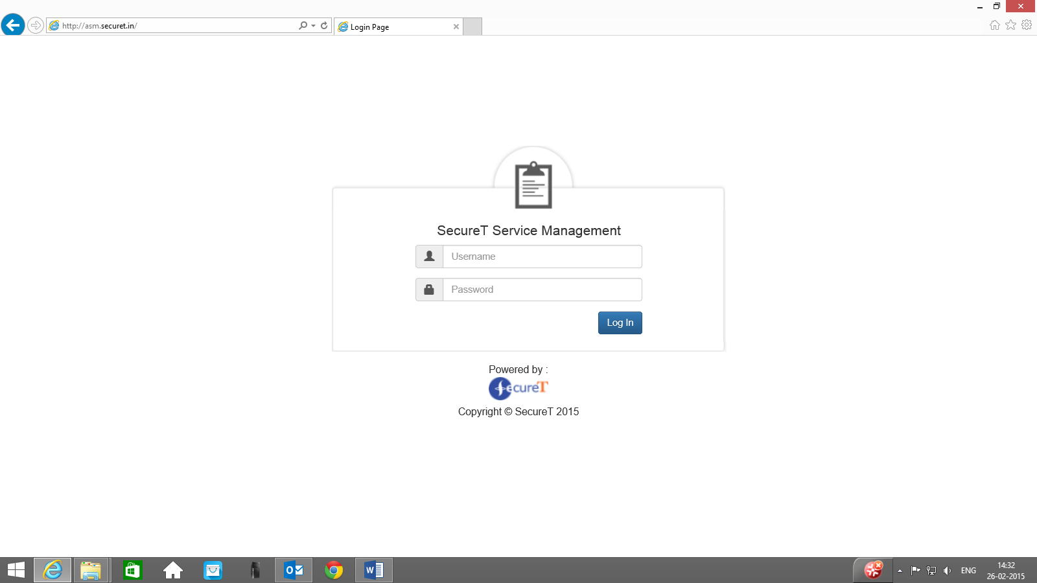

[Picture1]

The Channel Manager will be able to login using the same user ID and PW which is being used at mobile for accessing the application. After login, the Channel Manager will be able to see individual tickets as well as dashboard showing the total tickets under each category.

The ‘Dashboard’ link on the left side will provide the following view:-

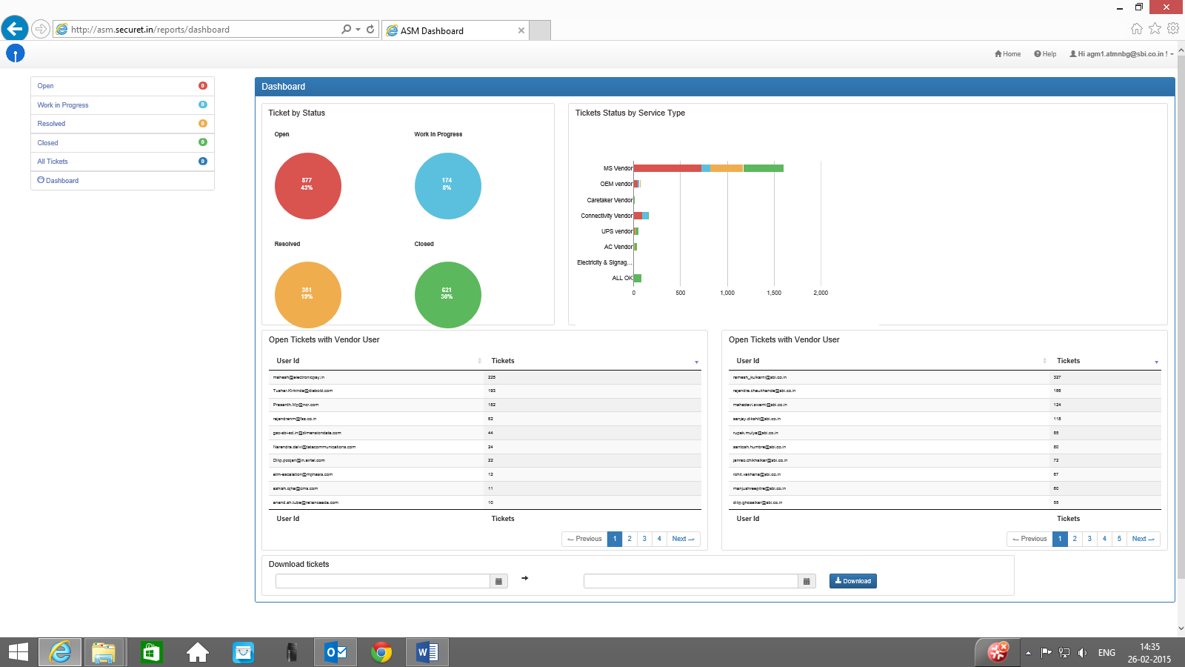

[Picture2]

The right hand panel also shows vendor-wise tickets. The web interface allows Channel Manager to download the ticket details in excel format for review and analysis.

**Guidelines for Channel Manager**

Channel Manager has to visit ATMs as per the stipulated periodicity and make record of the visits by using the ASM application. Since the application records geo coordinates also, tickets should preferably be raised from the ATM site itself. However, in case of mobile data connectivity issues, Channel Manager may make note of the deficiencies, click the picture if required and raise the ticket later when data connectivity is available.

ASM application may be used for both raising new tickets and viewing/ modifying the existing tickets. The web interface allows the facility of downloading the date for review and analysis.

The video links explaining download from Google play store and for raising a ticket are available under ‘help’ link in the web interface.