**Mobile Application for Site Monitoring**

[VENDOR DOCUMENT]

**Background**

ATMs have become face of the Bank. More than 60% of eligible cash transactions are now happening on ATMs. The maintenance and upkeep of ATM is the immediate priority next to keeping the ATM alive for customer transactions. The Bank has entered into separate agreements for maintenance of AC, UPS, ATM site, ATM and other peripherals at central level as well as local level for upkeep and maintenance. While Channel Manager has been monitoring with individual vendors on the basis of deficiencies observed during site visits, there has neither been any documentation nor structured tracking system for such site related complaints.

The Bank has therefore decided to introduce a software solution in form of mobile application for registering, tracking and monitoring tickets for deficiencies at the ATM site/ATM. The basic features of the application are described in the subsequent paragraphs.

**Introduction**

The mobile application (ASM) has been developed by M/S SecureT concepts private limited led by a group of young and dynamic professionals, as an initiative of SBI. The acronym ASM used for the application stands for ATM service management. ASM is a mobile based SAAS model for Field Service management, helpdesk / Ticket management Solution capable of handling real time allocation / managing of assignment to service provider and raising Tickets through Multiple Channels viz. mobile phone, tablets or web interface.

The solution has three major components:-

1. Mobile application for use of Channel Manager
2. Web interface for vendors to acknowledge and update the status of tickets
3. Controllers view

The mobile application allows Channel Managers to raise tickets which are sent immediately to the vendors’ mailbox as an e-mail and to the mobile number as SMS. The vendor is required to resolve the issue mentioned in the ticket within agreed TAT (Turnaround time) and change the status of ticket to ‘resolved’ after incorporating necessary comments.

**Web Interface**

The vendor can access the interface by typing URL ‘www.asm.securet.in’ in the address bar of the browser. The following screen appears:-

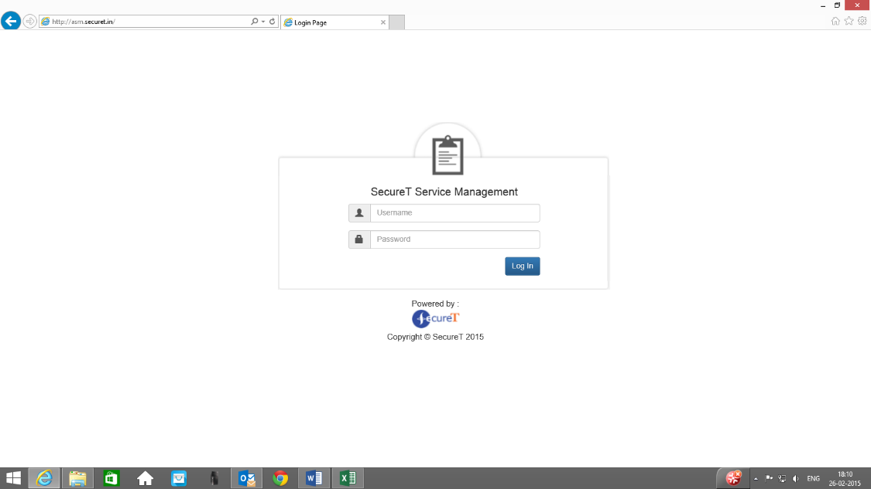

The vendor will access the interface using pre-defined user ID and password advised by the solution provider.

Post login screen has two sections:-

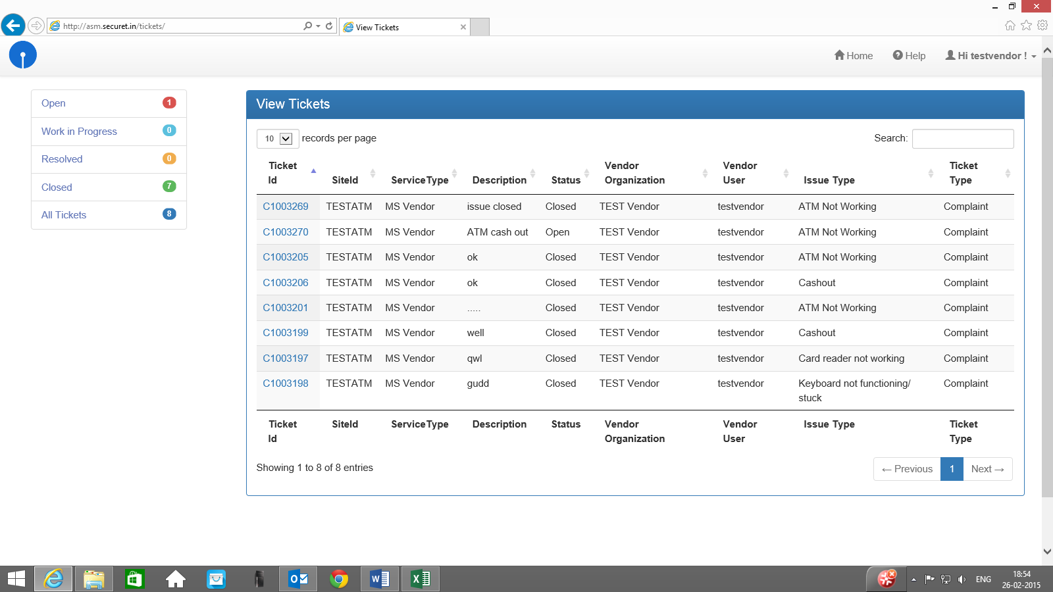

The left section displays summary of tickets under each category viz. open, work-in progress, resolved and closed category. The description of categories is as under:-

|  |  |
| --- | --- |
| **Category** | **What it represents** |
| Open | The ticket has been generated by Channel Manager but not seen/accepted by the vendor. |
| Work in progress | The ticket moves to this category as soon as vendor acknowledges the ticket. |
| Resolved | The vendor can change the status to ‘resolved’ after resolving the issue. |
| Closed | After the vendor has changed the status of ticket to resolved, Channel Manager has the option to accept the resolution and ‘close’ the ticket or to reject it and re-open the ticket. |

The right section of the screen shows list of tickets raised on the vendor with latest ticket on the top as below:

**View Tickets**

records per page

Search:

loading

|  |  |  |  |  |  |  |  |  |
| --- | --- | --- | --- | --- | --- | --- | --- | --- |
| **Ticket Id** | **SiteId** | **ServiceType** | **Description** | **Status** | **Vendor Organization** | **Vendor User** | **Issue Type** | **Ticket Type** |
| [C1003270](http://asm.securet.in/tickets/modifyTicket?id=C1003270) | TESTATM | MS Vendor | Work in progress | Work in Progress | TEST Vendor | testvendor | ATM Not Working | Complaint |
| [C1003269](http://asm.securet.in/tickets/modifyTicket?id=C1003269) | TESTATM | MS Vendor | issue closed | Closed | TEST Vendor | testvendor | ATM Not Working | Complaint |
| [C1003205](http://asm.securet.in/tickets/modifyTicket?id=C1003205) | TESTATM | MS Vendor | ok | Closed | TEST Vendor | testvendor | ATM Not Working | Complaint |
| [C1003206](http://asm.securet.in/tickets/modifyTicket?id=C1003206) | TESTATM | MS Vendor | ok | Closed | TEST Vendor | testvendor | Cashout | Complaint |
| [C1003201](http://asm.securet.in/tickets/modifyTicket?id=C1003201) | TESTATM | MS Vendor | ..... | Closed | TEST Vendor | testvendor | ATM Not Working | Complaint |
| [C1003199](http://asm.securet.in/tickets/modifyTicket?id=C1003199) | TESTATM | MS Vendor | well | Closed | TEST Vendor | testvendor | Cashout | Complaint |
| [C1003197](http://asm.securet.in/tickets/modifyTicket?id=C1003197) | TESTATM | MS Vendor | qwl | Closed | TEST Vendor | testvendor | Card reader not working | Complaint |
| [C1003198](http://asm.securet.in/tickets/modifyTicket?id=C1003198) | TESTATM | MS Vendor | gudd | Closed | TEST Vendor | testvendor | Keyboard not functioning/ stuck | Complaint |

The details of the ticket may be seen by clicking on the respective ticket number. The tickets in a particular category can be viewed by clicking the respective category on the left section of the screen.

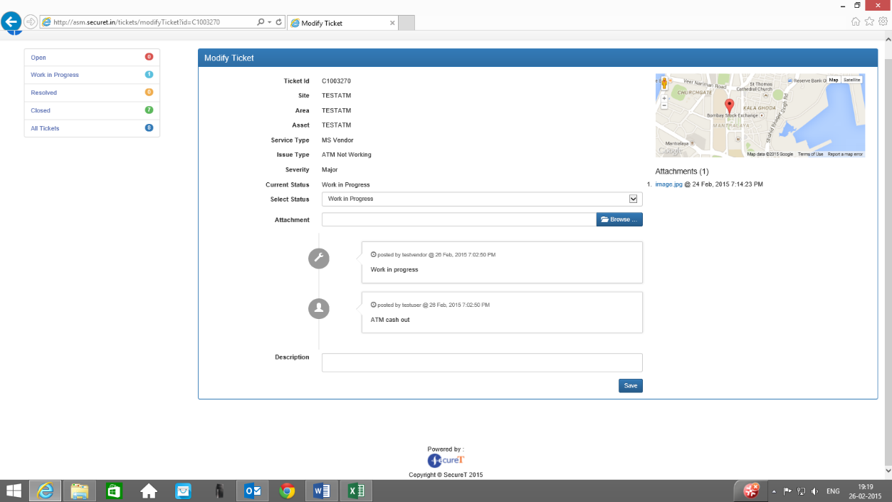The following screen appears on clicking an individual ticket number:-

The undernoted details will be available in respect of the individual ticket:-

1. The geo location where ticket was raised,
2. Image, if any attached with the ticket,
3. Ticket ID
4. ATM ID & Location
5. Area
6. Service Type
7. Issue Type
8. Severity
9. Current status of the ticket
10. Drop down for selecting the status (for change by the vendor)
11. Attachment box (for attaching the document/ image)
12. Comments box

The status of ticket will automatically change to ‘work in progress from ‘open’ on clicking the ticket number and a comments box will open for vendor’s comments. The vendor will arrange to resolve the issue and change the status of ticket from ‘work in progress’ to ‘resolved’ with suitable comments. An image conforming to the resolution of issue may be attached by vendor in attachment box for information of Channel Manager, if need be.

The vendor does not have permission to close the ticket. The Channel Manager will review the position and accept the resolution to close the ticket. In case, however, Channel Manager finds that the issue has not been resolved, he may reject the resolution and the ticket will be reopened for resolution by the vendor.

Resolution time will be calculated from the time ticket is initiated to the time when vendor has changed the status to ‘resolved’. The resolution time will be compared with the TAT (turnaround time) and penalty will be levied as per agreement for overshooting the TAT.

In case, Channel Manager rejects the resolution by vendor, TAT will include the earlier resolution time also.

**Guidelines for Vendor**

Vendor is required to login the web interface and take corrective actions based on the issues raised in the tickets. It would be beneficial for both the Bank and the vendor if issues are promptly resolved and tickets closed in time.