# Integrating a PHP Web Application with Amazon DynamoDB Using AWS SDK

#Objective
The objective of this project was to integrate a PHP-based web application with Amazon DynamoDB and understand how a serverless NoSQL database can be used to store and retrieve application data. The project demonstrates how an EC2-hosted PHP website communicates with DynamoDB using the AWS SDK for PHP.

#Architecture Overview
The architecture of this project includes the following AWS services:
- Amazon EC2
  - Hosts the PHP website.
  - Runs Ubuntu Linux, Nginx web server, and PHP-FPM.
  - Executes PHP code responsible for communicating with DynamoDB.
- Amazon DynamoDB
  - Used as the backend NoSQL database.
  - Stores website data in a scalable and highly available manner.
  - Provides low-latency access without managing database servers.
- AWS SDK for PHP
  - Provides libraries required for PHP applications to interact with AWS services.
  - Used to send API requests from the website to DynamoDB.
- Amazon S3
  - Used to store and download the project package during EC2 instance configuration.
1# Create DynamoDB:
I Created a DynamoDB there i give primary this key ( id ) for unique then i configure my php code. Here i had to give TableName and Region name.I used default RCU and WCU because it just for practice so didn’t focus here.
<?php

require 'vendor/autoload.php';

use Aws\DynamoDb\DynamoDbClient;

$message = "";

$dynamodb = new DynamoDbClient([
'version' => 'latest',
'region' => 'eu-north-1'
]);

if ($_SERVER["REQUEST_METHOD"] == "POST") {

$name = $_POST['name'];
$email = $_POST['email'];
$msg = $_POST['message'];

try {

$dynamodb->putItem([
'TableName' => 'prakash_dyanamo_table',
'Item' => [
'id' => ['S' => uniqid()],
'name' => ['S' => $name],
'email' => ['S' => $email],
'message' => ['S' => $msg],
'created_at' => ['S' => date('Y-m-d H:i:s')]
]
]);

echo "Submitted Successfully!";
exit();

} catch (Exception $e) {

echo $e->getMessage();
exit();

}

}

?>
2# Create S3 Bucket to store project zip file:
I created a bucket then i made it public then i wrapped my all project in zip file then i uploaded it in bucket for EC2 instance user data script.
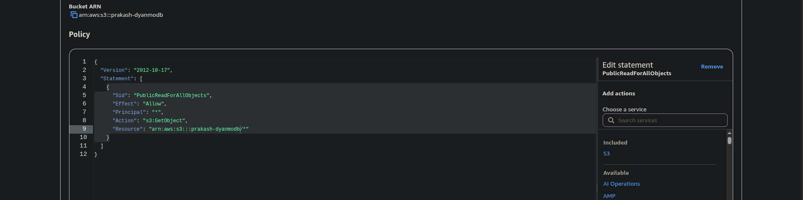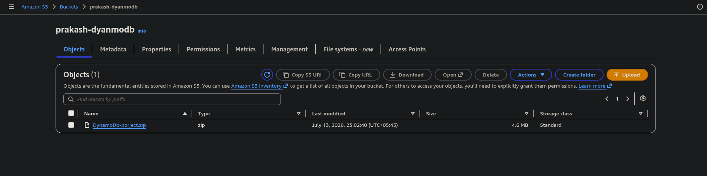
3# Lunch EC2 instance :
I lunched a EC2 instance . i used ubuntu server and instance type is t3.micro then i add security group where i allowed ssh and http ( note : for dynamodb no need to allow any port), then i write user data script. After lunched my instance i attached role fullaccessDynamoDB to my instance for write data.
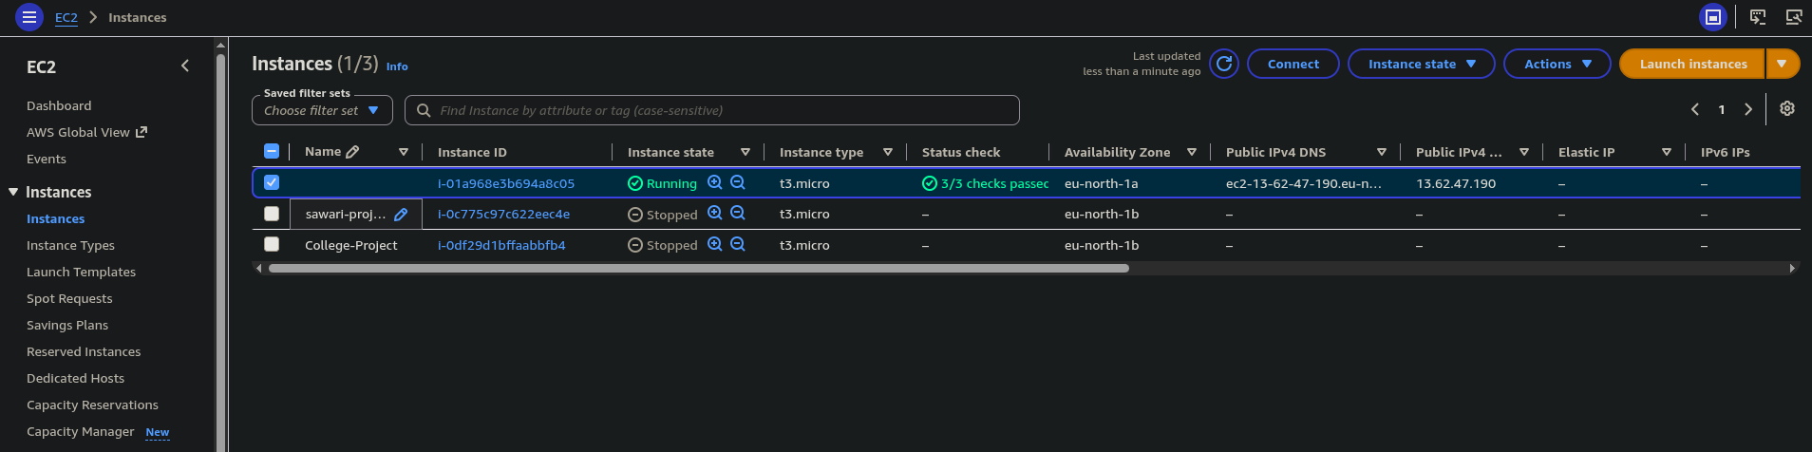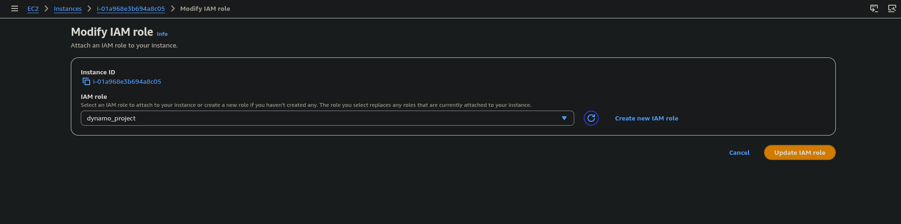
4# Check connectivity with web to DynamoDB:
Finally i successfully lunched my web then i access it then i manually filled my contact form , then i checked my DynamoDB table there successfully store data what i filled in my contact form.
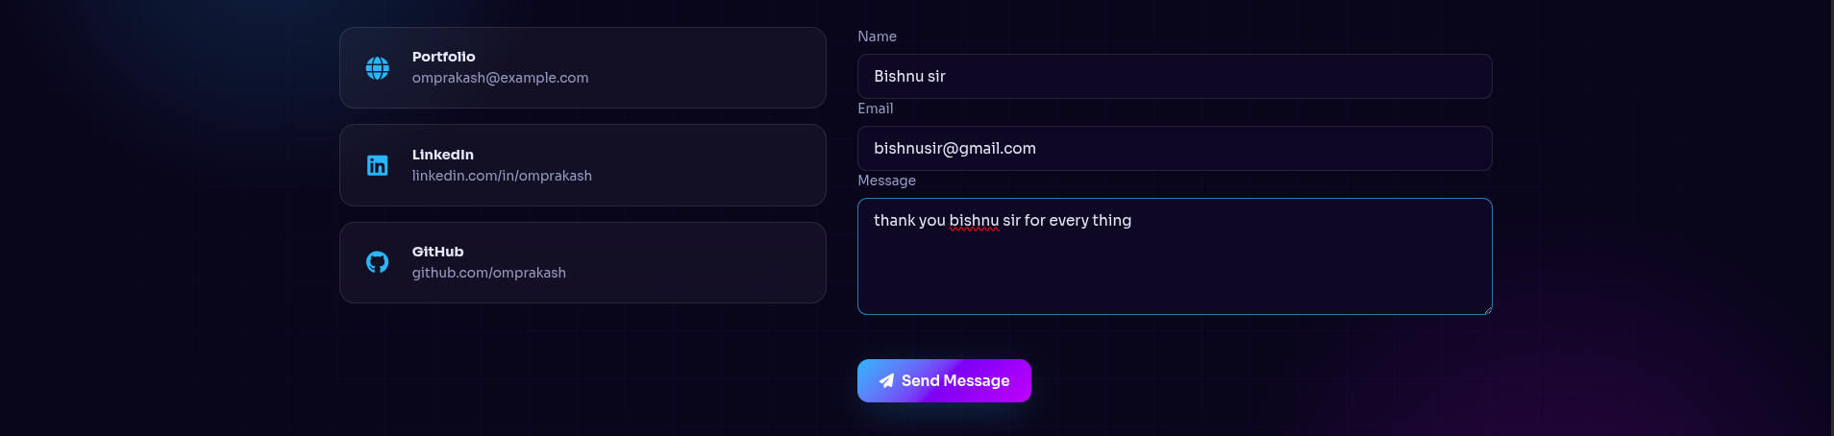
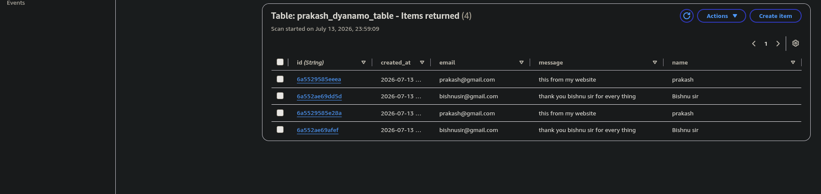

#Conclusion
This project successfully implemented a PHP web application integrated with Amazon DynamoDB. The solution provides a scalable and reliable architecture where the application layer runs on EC2 while DynamoDB handles database operations. This approach reduces database management overhead and allows applications to scale efficiently using AWS managed services.

# User Data Script
#!/bin/bash

apt-get update -y

apt-get install -y nginx php-fpm php-cli unzip wget composer php-curl php-xml php-mbstring

rm -f /var/www/html/index.nginx-debian.html

cd /tmp
wget https://prakash-dyanmodb.s3.eu-north-1.amazonaws.com/DynamoDb-porject.zip

if [ ! -f DynamoDb-porject.zip ]; then
echo "Project download failed."
exit 1
fi

unzip -o DynamoDb-porject.zip -d s3project

cp -r /tmp/s3project/DyanmoDB_web_site/* /var/www/html/

chown -R www-data:www-data /var/www/html
chmod -R 755 /var/www/html

# Only if vendor is NOT included in the ZIP
cd /var/www/html
if [ ! -d "vendor" ]; then
composer require aws/aws-sdk-php --no-interaction
fi

PHP_VERSION=$(php -r "echo PHP_MAJOR_VERSION.'.'.PHP_MINOR_VERSION;")

cat >/etc/nginx/sites-available/default <<EOF
server {
listen 80;
server_name _;

root /var/www/html;
index index.php index.html;

location / {
try_files \$uri \$uri/ /index.php?\$query_string;
}

location ~ \.php\$ {
include snippets/fastcgi-php.conf;
fastcgi_pass unix:/run/php/php${PHP_VERSION}-fpm.sock;
}
}
EOF

if nginx -t; then
systemctl restart php${PHP_VERSION}-fpm
systemctl restart nginx
systemctl enable nginx
systemctl enable php${PHP_VERSION}-fpm
else
echo "Nginx configuration failed."
exit 1
fi

# Run this command manually in ec2 instance /var/www/html/
sudo composer require aws/aws-sdk-php

