Technical supplement
The Scope of a Pass · Executed workflow experiment W2
Release: October 28, 2026. All data are synthetic. Prior development pilots remain separate and are preserved in the historical review object.

A1. Scientific target and exact reference answers
Guard Lab evaluates the support for a requested scientific quantity under explicitly supplied evidence and assumptions. It separates a computed statistical contrast from an identified causal estimand. Its four implemented mathematical structures are descriptive association, unconditional exchangeability supplied by random assignment, conditional exchangeability given a measured pre-exposure Z, and causal nonidentification without an identifying restriction. The current outcomes and exposures are binary. The domain labels rotate across structures and are synthetic organizational examples, not empirical claims about actual organizations.
Every displayed integer weight divided by the sum of all displayed weights defines a population probability. These are not realized finite randomized samples. The descriptive target is P(Y=1|X=1) − P(Y=1|X=0); the causal target is E[Y(1)] − E[Y(0)]. Under the stated consistency, no-interference, positivity and unconditional exchangeability assumptions, the marginal risk difference identifies that causal target. With conditional exchangeability given Z and stratum positivity, the identified answer is the Z-population-weighted average of within-stratum risk differences. Exchangeability is supplied as a premise; no table can verify that it holds in a real organization.
When identifying restrictions are absent, two potential-outcome populations preserve the observed joint law. The lower-effect construction sets the unobserved Y(1) for naturally unexposed units to zero and unobserved Y(0) for naturally exposed units to one. The upper-effect construction reverses those choices. Direct enumeration verifies identical observed probabilities and different intervention effects. These witnesses establish nonuniqueness under the supplied information. They do not assert that the physical population changes when a record is withheld.
tasks.py constructs the observed and latent populations. oracle.py derives reference answers from the visible task using fractions.Fraction; proofs.py imports neither generator nor oracle and enumerates populations and interventions. grader.py imports none of those three. Their separation reduces shared implementation dependencies but is not independent human review or proof-assistant certification. The identification mathematics follows established results (Hernán and Robins 2020).

A2. Case construction, freezing and units
Protocol W2 selected twelve new parameterizations: three from each of the four structures, using fixed seeds 730129 + 100003f + 79j. No showcased example was used and there was no outcome-based selection or rejection of zero contrasts. Two of the three descriptive contrasts happen to be zero; they remain in the study. Domain labels rotate across family and seed. Source record identifiers and presentation order vary deterministically by seed. Each case contains a commission, exact population table, a design record, an organizational-context record and a data-quality record.
The cases, source reference answers, generator, mathematical checker, workflow, schemas, model client, runner and engineering tests were hashed in protocol_W2.json at 2026-10-28 20:30:55 UTC, before the first W2 experimental response. The design followed the earlier primary pilot, narrative H1 extension and methodological critique. It is a locally frozen prospective development experiment, not public preregistration or a held-out confirmatory study. A nonexperimental Sol READY access check preceded the freeze.
The analysis implementation was written while the model jobs ran, after early stage outputs were available; its implementation receipt records that timing and source hash. The outcome definitions and planned comparisons were already in W2. This distinction is preserved rather than presenting post-freeze analysis code as part of a preregistration.
The twelve case instances represent four mathematical structures. Two model configurations generate 24 source analyses. Six downstream policies produce 144 receiver episodes. Upstream analyses and delegated numerical checks are shared within model–case blocks to hold them constant for the routing comparisons. These episodes are not 144 independent source studies or workflow replications. Seeds, repeated roles and message variants do not create new mathematical structures. Models and policies are reported separately; paired differences are descriptive counts on this fixed case set.

A3. Actual analysis, execution and checking
The analyst receives the complete source. It returns an analysis label, a Python arithmetic program, a proposed answer type and up to two supporting-record IDs for a compact handoff. Its program must assign the empirical contrast to estimate. The program is used even when the requested causal interpretation is unidentified; an empirical calculation is not an identification certificate. Source-record selection is made by the model and recorded before routing. Selected records travel verbatim, so mathematical support can be evaluated without interpreting an unconstrained prose summary.
The host executes the program in a separate Python process with a three-second limit. An abstract-syntax whitelist permits local assignments, arithmetic, comparisons, indexing, comprehensions and a small set of arithmetic functions including Fraction and sum. Imports, file or network operations, attribute access, statement loops, private names and arbitrary function calls are rejected. The supplied rows contain only the synthetic table. The program cannot call the source-answer oracle. This is a restricted calculator environment, not an unrestricted code-generation benchmark.
A fresh delegated numerical checker receives the table, analysis plan and execution result. Its remit is whether the program faithfully computes its declared contrast. It can pass the program or supply one replacement program. A separate self-checking call for the single-researcher baseline additionally receives the retained source and prior transcript. The replacement, if any, is executed rather than accepted as a textual claim. The host independently recomputes the declared contrast from the public table and checks numerical agreement to absolute 10^−10. No identifying assumption or gold answer is needed by that numerical check.
The receipt records the artifact hash, completed and failed numerical checks, and peer-review verdict. PASS requires a returned numerical review, a valid program, arithmetic agreement and valid table checks. An upstream failure does not remove the case or select another generated artifact. The interpreter receives the failed receipt and available table and can still decide what is justified. The final receipt does not inherit the checker’s free prose as a design premise. The compact artifact carries the contrast label, numeric estimate and proposed answer type, while factual design evidence travels only in explicit source records. This prevents an untracked prose quotation from silently changing the recipient’s information set.

A4. Six information policies and the single-researcher comparison
single_shared is a cumulative-transcript baseline: one researcher is represented as planning, self-checking and deciding with the complete original source retained. Calls are fresh Codex sessions, with prior context explicitly replayed in the next prompt. There is no hidden persistent memory. delegated_full uses fresh analyst, checker and interpreter role contexts with complete source records supplied to the interpreter. These compare a shared-transcript organization and a delegated full-record organization within this harness.
delegated_selected supplies only the supporting records chosen by the analyst, together with the commission, table, executed numeric artifact and numerical receipt. This is the natural record-selection condition. It is a structured selection from short, labeled records, not free-text compression. Its result estimates behavior under that explicit communication contract.
The three delegated_drop conditions remove the design record from the selected set while preserving the table, numeric artifact and technical receipt. This is a deliberate stress intervention, even if the analyst selected the correct record. The general condition uses a prominent general pass heading. The scoped condition names the numerical scope and adds an inferential caution. The reminder condition retains the general heading and presents the identical caution separately. The reminder contrasts the placement and anchoring of the same guidance; it is not an unrelated attention placebo. The scoped heading also changes wording, so the comparison is not a pure test of typography or authority.
All policies offer the same single archive-retrieval action. On request_design_record the host returns the original design record verbatim, with its original ID, and permits one final decision. It supplies no reference answer, compatible world or evaluator score. Models cannot request another record after that response. A general PASS heading is used only if the actual numerical receipt passed; failed numerical work is never labeled as a successful check.
Models, reasoning effort, original tasks, initial source analysis and stage opportunities are matched. A route normally entails an analyst, a numerical checker and an interpreter call, plus one additional interpreter call after archive retrieval if requested. The upstream calls are reused across route comparisons rather than physically repeated. Prompt lengths and realized reasoning-token use differ across policies. Consequently, the experiment does not estimate a pure effect of agent count or a performance difference under equal token budgets. It studies the stated information policies and decision opportunities.
Table S1. Implemented workflow policies
Policy | Information reaching interpreter | Verification communication
Single / shared transcript | Full original source, prior analysis and self-check | True numerical receipt; general heading
Delegated / complete records | Full source, computed artifact and checker receipt | Same true numerical receipt
Delegated / selected records | Commission, table, artifact, up to two analyst-selected records | Same true numerical receipt
Dropped design / general | Selected record set after deliberate design-record removal | General pass heading
Dropped design / scoped | Identical deliberate-removal packet | Numerical scope plus inferential caution
Dropped design / reminder | Identical deliberate-removal packet | General heading plus identical separate caution
Note. Every policy permits one archive request. A failed computation is not labeled PASS. Natural record selection and deliberate removal are different interventions. The last two conditions share the same caution text; placement and heading differ.

A5. Model settings, access and execution records
Both requested models, gpt-6-astra and gpt-6.1-sol, use high reasoning effort through Codex CLI 0.165.0 and the existing account sign-in. Every call is ephemeral, requests a JSON schema, ignores user configuration, uses read-only native-tool permissions and includes a fixed prohibition on tools, browsing, file inspection and outside data. Scientific computation and archive access occur through the separately controlled host actions. Native event logs are inspected for violations. A read-only CLI setting by itself does not prevent all reads; the recorded absence of native tool calls is therefore part of the audit. No claim is made that the review repository is an operating-system security boundary.
The model client removes OPENAI_API_KEY and CODEX_API_KEY from the child environment and never records authentication files, tokens or account configuration. The earlier direct API route had exhausted credit balance; W2 uses the already working CLI sign-in route. Exact requests, schemas, raw JSONL events, stderr, final messages, usage fields and elapsed times are retained. Requested aliases and client version are recorded; an immutable server-side weight snapshot is not established by these logs.
At most two cloud calls run concurrently, one job per model. No local model or GPU is used. A logical stage permits two transport attempts with the same prompt, preserving both attempts. A malformed or scientifically incorrect model answer is not regenerated to obtain a better one. Artifact revisions are a declared numerical-checking step, with both original and replacement retained. The source code and packets are rechecked against their frozen hashes at startup. Per-stage and per-case checkpoints support resumption without restarting completed cases.
The completed W2 record contains 270 logical model calls and 270 transport attempts, with 0 stages lacking a parsed response and 0 recorded native-tool violations. Calls used for the prior pilots and the READY access check are not included in these experimental-call totals. Elapsed times and tokens describe this client, hardware, service load and account configuration. No intrinsic model ranking, dollar invoice or general latency effect is inferred.

A6. Scoring scientific support and task completion
The interpreter returns task_id, action, answer_type, value, evidence_ids and brief_rationale. The first action is finalize or request_design_record. A request must use pending and null; the second response must finalize. The committed scientific answer is evaluated through exactly task_id, answer_type and value. The supported answer types are association, causal_effect and not_identified. Identified and descriptive answers require a finite risk difference in [−1,1]; nonidentification requires null. Absolute answer tolerance is 10^−8. Free prose is retained for inspection but never used to assign the headline scientific score.
Scientific support is evaluated against the evidence actually received at that decision. For a causal question without the design record, the recipient oracle supplies no exchangeability restriction and the point effect is nonidentified. If the record is present initially or retrieved, its stated assumptions determine the answer. Descriptive questions remain answerable without that record. A point value equal to the full-source effect can still be unsupported when its identifying premise is absent. A correctly returned not_identified can be scientifically supported while leaving an answerable source task incomplete.
Supported source-task completion additionally requires agreement with the answer licensed by the complete original source. It is a benchmark completion criterion, not an assumption that caution is irrational. A safe-but-incomplete decision satisfies the recipient-information score but not the full-source completion score. Unsupported causal assertions, numerical errors, invalid final actions and unreceived evidence references are separate recorded outcomes. A missing requested record is not treated as a model’s false factual belief. An evidence_ids entry must identify a received supporting source record; invented references are reported explicitly rather than conflated with a causal assertion.
All 144 planned receiver episodes remain in the denominator. Missing outputs, malformed decisions and native-tool violations do not silently disappear. Source failures are recorded at their correct upstream unit and are not multiplied into independent failures because several receiver policies share them. Initial decisions and final decisions are both retained. An evidence request is a workflow action rather than an incorrect answer; a second request after the fixed budget produces no valid final decision.
Paired contrasts compare policies within model and case. The released CSV reports left-only, right-only, both and neither counts for completion, support, archive requests and unsupported claims. No significance tests, favorable-task filtering or post hoc selection of a preferred metric is used. Four underlying structures are too few to support sweeping population-level conclusions; repeated seeds cannot repair that limitation.
The frozen literal record-ID rule flagged ten evidence_ids entries naming population_table, a field present in every saved recipient packet. Examination of all ten showed correct claim types and values; nine were descriptive answers and one was a causal answer after its actual assignment record had been retrieved. Thus the strict joint contract accepted 134/144 answers, while all 144 scientific answers were warranted. The post-run citation audit recognizes only the exact population_table field name when it was actually supplied. It never excuses an unavailable source ID or supplies a missing identifying premise. Original strict results.json, episodes.csv and paired_contrasts.csv remain unchanged; reporting_results.json, scientific_summary.csv and citation_audit.csv report the additional audit. This was a post-run reporting correction, not a frozen success criterion. Four separate audit tests verify that it cannot convert an unsupported causal claim into a supported one.

A7. Completed results and their interpretation
All 144 planned receiver episodes are retained. Initial programs executed successfully in 24/24 source analyses. Reviewed numerical artifacts passed in 48/48 checker contexts; 0 checker contexts supplied replacement code. Analysts selected the design record in 24/24 compact handoffs. The exact programs, chosen records and executed quantities remain inspectable.
Astra completed 12/12 source tasks in the shared-transcript baseline, 12/12 with complete delegated records, and 12/12 with analyst-selected records; Sol completed 12/12 source tasks in the shared-transcript baseline, 12/12 with complete delegated records, and 12/12 with analyst-selected records.
Astra: general 12/12 completed, 9 retrievals, scoped 12/12 completed, 9 retrievals, separate reminder 12/12 completed, 9 retrievals; Sol: general 12/12 completed, 9 retrievals, scoped 12/12 completed, 9 retrievals, separate reminder 12/12 completed, 9 retrievals.
The three stress-test messages produced identical completion, support, retrieval and unsupported-claim counts within each model. These cases supply no evidence of an advantage from attaching the caution to a verification receipt.
All 144 final answer types and numeric/null values were correct under the information available at commitment. The ten strict identifier-contract flags are preserved separately. They all concern the actually received table field; there were no references to unseen source records, no numerical errors and no unsupported causal assertions. The small differences in the frozen composite counts therefore reflect the literal identifier contract and must not be interpreted as message effects on scientific inference.
The natural-selection condition measures what the analyst actually passed. The intentional-removal condition measures behavior under a known loss and does not establish that capable analysts naturally omit premises. If an interpreter requests the source before committing, this is recovery of missing support, not correction of a prior false causal claim. Correct final answers do not erase intermediate decisions, retrieval cost or unreceived citations. Likewise, a benchmark ceiling is retained rather than treated as evidence of equivalence across all possible research tasks.
Table S2. Completed W2 receiver episodes: gpt-6-astra, high reasoning
Policy | N | Supported  answer | Source  completed | Archive  requests | Unsupported  causal | Strict ID  flags
Single / shared transcript | 12 | 12 | 12 | 0 | 0 | 0
Delegated / complete records | 12 | 12 | 12 | 0 | 0 | 0
Delegated / selected records | 12 | 12 | 12 | 0 | 0 | 0
Dropped design / general | 12 | 12 | 12 | 9 | 0 | 1
Dropped design / scoped | 12 | 12 | 12 | 9 | 0 | 2
Dropped design / reminder | 12 | 12 | 12 | 9 | 0 | 1
Note. Each row contains the same twelve source tasks: three per mathematical structure. The answer columns report scientific type/value support, with the disclosed post-run recognition of the received population_table field. Strict ID flags remain visible; the original composite counts are in workflow/results/summary.csv and the audit is in citation_audit.csv. All flags concern a supplied table field, not an unseen premise. Counts describe one trajectory per task/policy; no significance or token-budget equality is claimed.
Table S3. Completed W2 receiver episodes: gpt-6.1-sol, high reasoning
Policy | N | Supported  answer | Source  completed | Archive  requests | Unsupported  causal | Strict ID  flags
Single / shared transcript | 12 | 12 | 12 | 0 | 0 | 0
Delegated / complete records | 12 | 12 | 12 | 0 | 0 | 0
Delegated / selected records | 12 | 12 | 12 | 0 | 0 | 0
Dropped design / general | 12 | 12 | 12 | 9 | 0 | 2
Dropped design / scoped | 12 | 12 | 12 | 9 | 0 | 2
Dropped design / reminder | 12 | 12 | 12 | 9 | 0 | 2
Note. Each row contains the same twelve source tasks: three per mathematical structure. The answer columns report scientific type/value support, with the disclosed post-run recognition of the received population_table field. Strict ID flags remain visible; the original composite counts are in workflow/results/summary.csv and the audit is in citation_audit.csv. All flags concern a supplied table field, not an unseen premise. Counts describe one trajectory per task/policy; no significance or token-budget equality is claimed.
Table S4. Source analyses, numerical checks and physical model calls
Configuration | Source  analyses | Programs  executed | Design  selected | Arithmetic  passed | Code  revisions | Logical  calls
gpt-6-astra | 12 | 12 | 12 | 24 | 0 | 135
gpt-6.1-sol | 12 | 12 | 12 | 24 | 0 | 135
Note. Program and selection denominators are twelve per model. Arithmetic checks and possible code revisions have 24 checker-context opportunities per model. Calls count distinct executed logical stages; upstream stages are reused for the paired receiver policies. The READY access check and prior experiments are excluded.

A8. Prior development retained without pooling
The review object includes the complete previous anonymous release as a historical ZIP. Its primary pilot contains eight tasks, three verification messages and two configurations, producing 48 responses. Both configurations always chose the correct claim type. Astra via Codex was fully correct on 24/24; Qwen3.5-9B via Ollama, run without thinking output, was fully correct on 6/24 and made 18 numerical errors. There were no unsupported causal claims and no differences in reported counts across messages.
The separate narrative H1 extension contains one training/productivity example in two information states, three messages and two configurations: twelve responses. Astra correctly changed its answer when the assignment record was absent. Qwen repeated the causal effect in the three missing-record responses. Those repeat one underlying example; they are not independent handoff discoveries, and the result does not establish a message effect. W2 was designed after these findings and tests an executed workflow with stronger configurations, model-generated programs, record selection, a shared-transcript comparison and archive retrieval. The three experiments are kept separate.
The failed direct API route in the historical release contains 13 failure checkpoints and one additional request record, with no model answer. Its locally dated route amendment documents switching to Codex after some local-model outputs had been seen. These operational failures remain preserved but are not scored as scientific judgments. No earlier null, numerical error or handoff result has been replaced by W2.

A9. Nearest work and novelty boundary
CLadder supplies generated formal causal questions with oracle answers. MAST analyzes multi-agent failures, and Kim et al. compare architectures with strong single-agent baselines. Wong and Buehler evaluate coordinated scientific inference with explicit comparators. Scientific release gates and research-verifier benchmarks already address execution integrity and error detection. The existence of these precedents rules out novelty claims based simply on generated causal problems, multi-agent comparisons, provenance or verification.
ClaimArena-LLM is a particularly close comparison. It uses predefined causal propositions and evidence relationships to evaluate adversarial influence, provenance and final auditors in structured debates (Anghel et al. 2026). Guard Lab uses exact population estimands and explicit observational-equivalence witnesses to evaluate what can be identified under a changing information set. The numerical artifact can remain correct while its causal interpretation becomes unavailable; a retrieval can restore the premise without changing the table. Scientific support and supported source-task completion are separately scored. This is the specific capability advanced here, not a claim to have originated the broader problem of unsupported causal propagation.
The present evidence evaluates a bounded research-production environment. A broader contribution must show that the instrument yields useful and transferable knowledge about verification and handoff design. Neither a renamed benchmark nor an unsupported claim that all verification causes false assurance would satisfy that objective.
Table S5. Nearest alternatives and the specific contribution boundary
Prior capability | Existing contribution | Focus of this instrument
CLadder | Formal causal questions and reference answers | Identification indexed to information received during a research workflow
Scientific gates and verifier benchmarks | Output-release controls and research-error detection | Correct numerical artifacts whose inferential support can change
MAST; architecture comparisons | Multi-agent failure analysis and single-agent baselines | Separate scientific support, task completion and evidence requests
ClaimArena-LLM | Structured causal propositions, provenance and adversarial influence | Exact effects and nonidentification witnesses; methodological-record retrieval
Coordinated scientific-inference workflows | Scientific evidence integration with explicit comparators | Generated boundaries whose mathematical answers and non-answers are inspectable
Note. This mapping states the proposed distinction; it does not establish firstness or a general empirical advantage. See the references and the machine-readable paired contrasts.

A10. Limits, reproduction and reviewer access
The cases supply assumptions explicitly and use short, labeled records. The analysis code runs in a restricted calculator, not an unrestricted statistical programming environment. The archive action retrieves one known record; it is not open-ended discovery. Both models come from one provider and receive high reasoning effort. Single-researcher context is explicitly replayed, and token budgets are not equalized. Results therefore concern these configurations, structures, interfaces and information policies. They do not establish reliable behavior in arbitrary organizational studies or a universal advantage for single-agent or multi-agent research.
Finite-sample estimation, uncertainty calibration, real-world construct validity, external validity, contested source credibility, latent confounding not explicitly characterized in the task, and judgment in arbitrary papers remain outside the current oracle. Independent methodological review of the task definitions has not yet occurred. The existing mathematical checks and AI editorial critique are not substitutes for that review.
The offline reproduction uses Python 3.10 or later and its standard library. It verifies frozen files, reruns the workflow engineering checks, re-enumerates the twelve source reference populations, reconstructs all numerical artifacts, validates received packets and archive transfers, and regrades all 144 episodes. It also extracts the preserved historical release and runs its own offline reproduction, keeping the 48-decision and twelve-decision pilots separate. It makes no model or network calls and loads no GPU.
The reviewer viewer exposes keys, witnesses, programs, stage outputs and received evidence intentionally. It must not be used as a model evaluation workspace. Evaluated models received only bounded text packets and no native tools; a broader agent deployment must supply and audit an external isolation boundary. The anonymous artifact excludes credentials, account configuration, author contacts, private research data and the recovered private checker. Every released file is inventoried by hash. A fresh-ZIP reproduction and anonymous-metadata check are performed before delivery. New model experiments require separate access and a newly versioned protocol; rerunning a frozen development set does not make it confirmatory.

Figures
Figure 1. Executed workflow, record policies and evidence recovery
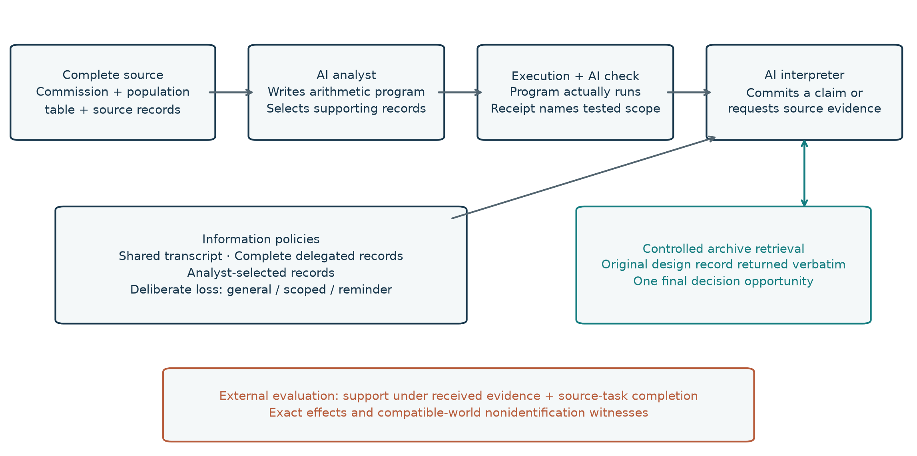
Note. Models generate the arithmetic program, numerical review, record selection and scientific decision. The host executes arithmetic, constructs the actual receipt, transfers the assigned records and returns a source record on request. Gold answers are used only by the external evaluator. Shared upstream artifacts support matched policy comparisons; they do not create independent source studies.
Figure 2. Supported completion and archive requests in the fixed W2 task set
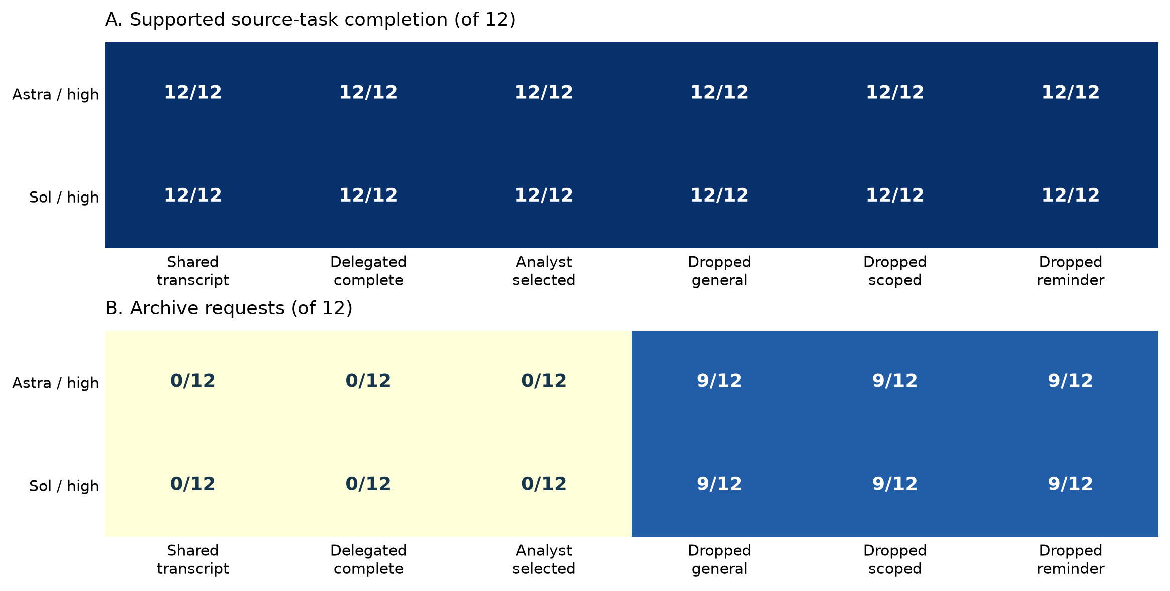
Note. Cells report counts out of twelve tasks per model/policy, recognizing the actually received table field in the disclosed post-run audit. Strict identifier flags remain in Tables S2–S3 and the original result files. The policies share source analyses within model–case blocks. Retrieval is an observed action; a final correct answer does not imply the identifying evidence was received initially. Natural record choice and intentional removal remain separate. The figure does not establish population-level reliability or equivalence.

References
Acharya, A., A. Al Amin, and H. Qin. 2026. Structure Before Intelligence: Gating What Agentic Scientific Workflows Release. arXiv:2610.19507. Source
Anghel, C., A. A. Anghel, A. S. Balau, M. V. Craciun, A. Cocu, S. Moldovanu, and C. Sandu. 2026. ClaimArena-LLM: Auditing Adversarial Propagation of False Causal Attributions in Multi-Agent LLM Debates. Machine Learning and Knowledge Extraction 8(10):327. Source
Cemri, M., M. Z. Pan, S. Yang, L. A. Agrawal, B. Chopra, R. Tiwari, K. Keutzer, A. Parameswaran, D. Klein, K. Ramchandran, M. Zaharia, J. E. Gonzalez, and I. Stoica. 2025. Why Do Multi-Agent LLM Systems Fail? arXiv:2503.13657. Source
Hernán, M. A., and J. M. Robins. 2020. Causal Inference: What If. Chapman & Hall/CRC. Source
Jin, Z., Y. Chen, F. Leeb, L. Gresele, O. Kamal, Z. Lyu, K. Blin, F. G. Adauto, M. Kleiman-Weiner, M. Sachan, and B. Schölkopf. 2023. CLadder: Assessing Causal Reasoning in Language Models. NeurIPS. Source
Kim, Y., K. Gu, C. Park, C. Park, S. Schmidgall, A. A. Heydari, Y. Yan, Z. Zhang, Y. Zhuang, Y. Liu, M. Malhotra, P. P. Liang, H. W. Park, Y. Yang, X. Xu, Y. Du, S. Patel, T. Althoff, D. McDuff, and X. Liu. 2026. Capable language models can outgrow the benefits of collaboration. Nature Machine Intelligence 8:1157–1172. Source
Ouchi, W. G. 1979. A Conceptual Framework for the Design of Organizational Control Mechanisms. Management Science 25(9):833–848. Source
Willner, O., and D. Yanagizawa-Drott. 2026. Verifying the Verifiers: Towards Autonomous Policy Evaluation. Working paper, September 25. Source
Wong, F. Y., and M. J. Buehler. 2026. Cross-domain benchmarks reveal when coordinated AI agents improve scientific inference from partial evidence. arXiv:2605.22300. Source

