***Assignment – 1***

**Name : Hem Gabhawala**

**Id : 23000858**

Q1

(a) Accept file name from the user and read text from the given file. Find the

frequency of each letter.

(b) Given the above information and a cipher text, which has been encrypted by

Caesar Cipher encryption algorithm, decrypt the given cipher text to get back the

plain text

Code : def letter_frequency(file_name):

try:

with open(file_name, 'r') as file:

text = file.read()

except FileNotFoundError:

print("File not founf. please provide a value")

return

frequency = {}

for char in text:

char = char.lower()

if char in frequency:

frequency[char] += 1

else:

frequency[char] = 1

for letter, count in sorted(frequency.items()):

print(f"{letter}: {count}")

if __name__== "__main__":

file_name = input("Enter the file name : ")

letter_frequency(file_name)

Output: 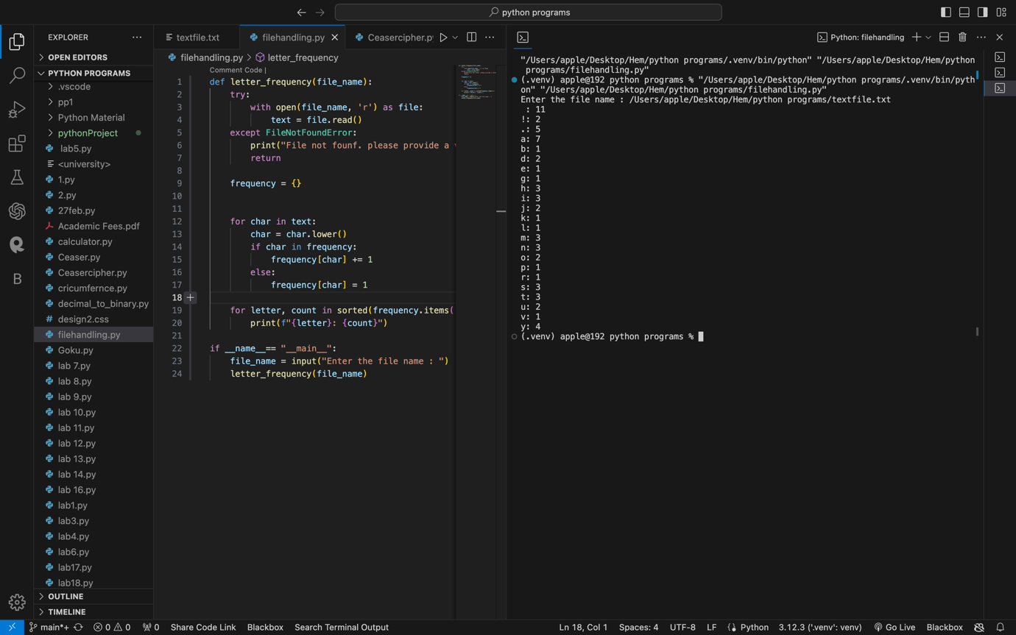

Code :

Method:1

from typing import Counter

string_input = input("Enter a string: ").lower()

list = list(string_input)

print(list)

shifted_chars = []

for char in list:

if char == ' ':

shifted_chars.append(' ')

else:

unicode_value = ord(char)

shifted_unicode = ((unicode_value + 3) - 26) if unicode_value + 3 > 122 else unicode_value + 3

shifted_char = chr(shifted_unicode)

shifted_chars.append(shifted_char)

print(shifted_chars)

shifted_string = ''.join(shifted_chars)

print(shifted_string)

frequency = Counter(shifted_string)

print(frequency)

frequency_dict = dict(frequency)

print(frequency_dict)

sorted_dict = dict(sorted(frequency_dict.items(), key=lambda item: item[1], reverse=True))

print(sorted_dict)

keys_list = []

for key in sorted_dict.keys():

keys_list.append(key)

print(keys_list)

Letter_frequencies = ['e','t','a','o','i','n','s','r','h','d','l','u','c','m','f','y','w','g','p','b','v','k','x','q','j','z']

keys_list = [key for key in sorted_dict.keys() if key != ' ']

print(keys_list)

first_key = keys_list[0]

first_frequency = Letter_frequencies[0]

for i in range(1, len(keys_list)):

current_key = keys_list[i]

current_frequency = Letter_frequencies[i]

difference = ord(current_key) - ord(current_frequency)

print(abs(difference))

unshifted_chars = []

for char in shifted_chars:

if char == ' ':

unshifted_chars.append(' ')

else:

unicode_value = ord(char)

reversed_unicode = ((unicode_value - abs(difference)) + 26) if unicode_value - abs(difference) < 97 else unicode_value - abs(difference);

reversed_char = chr(reversed_unicode)

unshifted_chars.append(reversed_char)

reversed_string = ''.join(unshifted_chars)

print(reversed_string)

user_input = input("Continue to the next frequency? (yes/no): ")

if user_input.lower() == "no":

break

Output:

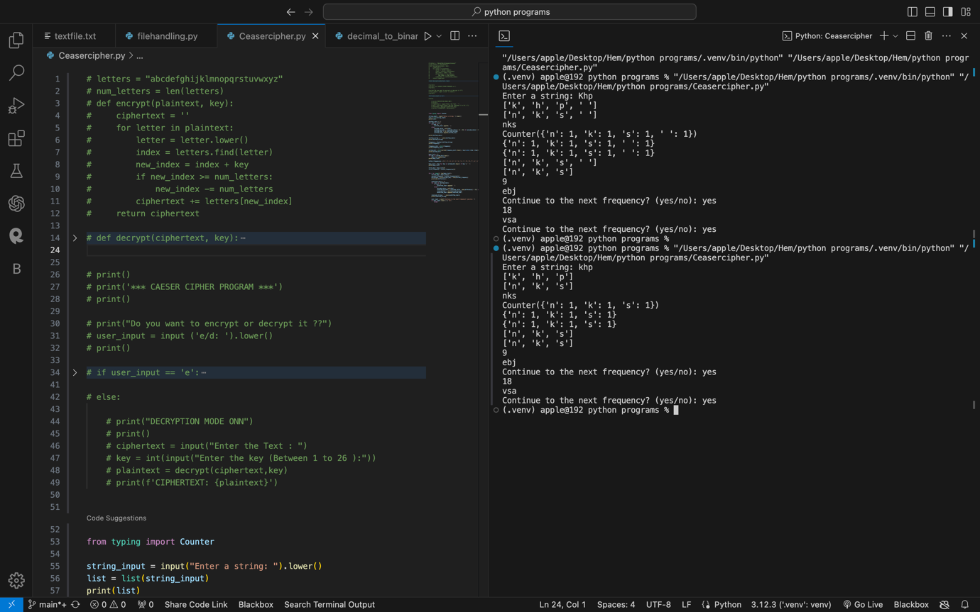

Method 2:

Code:

letters = "abcdefghijklmnopqrstuvwxyz"

num_letters = len(letters)

def encrypt(plaintext, key):

ciphertext = ''

for letter in plaintext:

letter = letter.lower()

index = letters.find(letter)

new_index = index + key

if new_index >= num_letters:

new_index -= num_letters

ciphertext += letters[new_index]

return ciphertext

def decrypt(ciphertext, key):

plaintext = ''

for letter in ciphertext:

letter = letter.lower()

index = letters.find(letter)

new_index = index - key

if new_index < 0 :

new_index += num_letters

plaintext += letters[new_index]

return plaintext

print()

print('*** CAESER CIPHER PROGRAM ***')

print()

print("Do you want to encrypt or decrypt it ??")

user_input = input ('e/d: ').lower()

print()

if user_input == 'e':

print("ENCRYPTION MODE ONN")

print()

plaintext = input("Enter the Text : ")

key = int(input("Enter the key (Between 1 to 26 ):"))

ciphertext = encrypt(plaintext,key)

print(f'CIPHERTEXT: {ciphertext}')

else:

print("DECRYPTION MODE ONN")

print()

ciphertext = input("Enter the Text : ")

key = int(input("Enter the key (Between 1 to 26 ):"))

plaintext = decrypt(ciphertext,key)

print(f'CIPHERTEXT: {plaintext}')

Output :

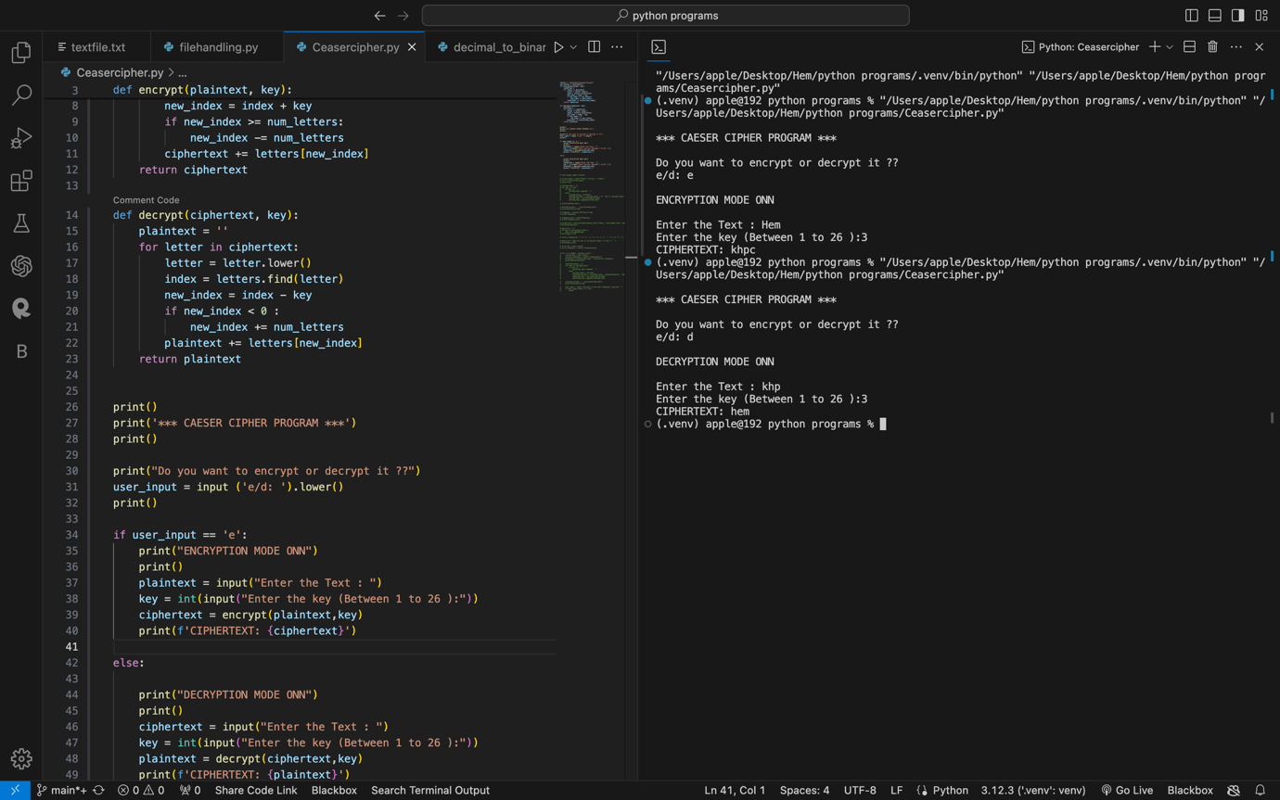

Q2:

(a) Accept a Decimal number from the user, the number may be positive or

negative and it may have 0 or more decimal digits. Convert the given number into the

corresponding Binary number.

(b) Accept a positive Binary number from the user. The number may have integral as

well as fractional parts. Convert the given Binary number into the corresponding

Octal number.

Code:

def binarytodecimal(binary):

return int(binary, 2)

if __name__ == '__main__':

# print(binarytodecimal('100'))

# print(binarytodecimal('101'))

# print(binarytodecimal('1001'))

binary = input("Enter your binary Number : ")

decimal = binarytodecimal(binary)

print(f'DECIMALNUMBER : {decimal}')

def decimaltobinary(decimal):

return bin(decimal).replace("0b","")

if __name__ == '__main__':

decimal = int(input("Enter your Decimal Number : "))

binary = decimaltobinary(decimal)

print(f'BINARYNUMBER : {binary}')

Output :

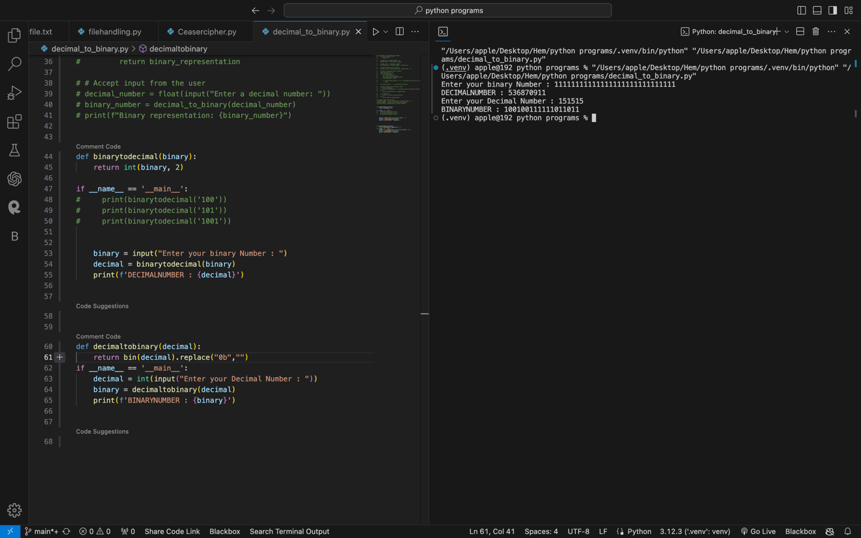

Code : def binary_to_octal():

binary_num = input("Enter a positive binary number: ")

# Check if the input is a valid binary number

if not set(binary_num).issubset({'0', '1', '.'}):

print("Invalid binary number. Please enter a number consisting of 0s, 1s, and an optional decimal point.")

return

# Split the binary number into integral and fractional parts

parts = binary_num.split('.')

# Convert the integral part to decimal

integral_part = int(parts[0], 2)

# Convert the fractional part to decimal

fractional_part = 0

if len(parts) > 1:

fractional_part = sum([int(bit) * 2**(-i) for i, bit in enumerate(parts[1], start=1)])

# Combine the integral and fractional parts to get the decimal number

decimal_num = integral_part + fractional_part

# Convert the decimal number to octal

octal_num = oct(int(decimal_num)).replace("0o", "")

print("The corresponding octal number is:", octal_num)

binary_to_octal()

Output:

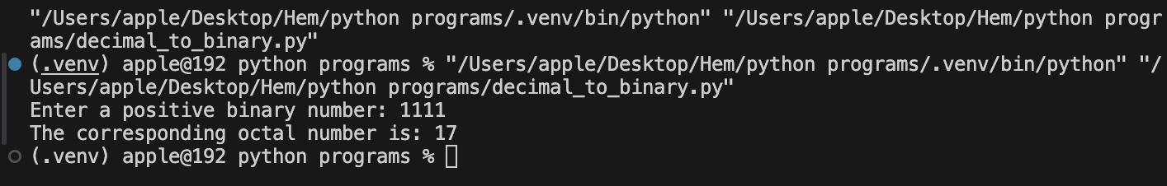

Q3 –

Accept an amount (from the user) having at least one integral digit and zero or two

decimal digits. Convert the given amount in words: (a) Each digit is converted to

corresponding word, (b) Entire integral part of the number is converted to words and

entire decimal part is also converted to words.

Code : def number_to_words(n):

ones = ["", "one", "two", "three", "four", "five", "six", "seven", "eight", "nine"]

tens = ["", "ten", "twenty", "thirty", "forty", "fifty", "sixty", "seventy", "eighty", "ninety"]

teens = ["eleven", "twelve", "thirteen", "fourteen", "fifteen", "sixteen", "seventeen", "eighteen", "nineteen"]

def one(num):

return ones[num]

def two_less_20(num):

if num < 10:

return one(num)

elif 10 < num < 20:

return teens[num - 11]

return tens[num // 10] + ('' if num % 10 == 0 else ' ' + one(num % 10))

def two(num):

if num < 10:

return one(num)

elif num < 20:

return two_less_20(num)

else:

return tens[num // 10] + ('' if num % 10 == 0 else ' ' + one(num % 10))

def three(num):

hundred = num // 100

rest = num % 100

if hundred == 0:

return two(rest)

else:

if rest == 0:

return one(hundred) + ' hundred'

else:

return one(hundred) + ' hundred and ' + two(rest)

def convert_number(num):

if num == 0:

return 'zero'

elif num < 100:

return two(num)

elif num < 1000:

return three(num)

return convert_number(n)

def amount_to_words(amount):

integral, decimal = str(amount).split('.')

integral = int(integral)

decimal = int(decimal) if decimal else 0

integral_words = number_to_words(integral)

decimal_words = ' '.join([number_to_words(int(d)) for d in decimal])

return integral_words + ' point ' + decimal_words if decimal else integral_words

def digit_to_word(amount):

digits = {'0': 'zero', '1': 'one', '2': 'two', '3': 'three', '4': 'four', '5': 'five', '6': 'six', '7': 'seven', '8': 'eight', '9': 'nine'}

amount_str = str(amount)

return ' '.join(digits[d] for d in amount_str)

def main():

amount = input("Enter an amount with at least one integral digit and zero or two decimal digits: ")

try:

amount = float(amount)

if not (amount % 1 == 0 or (len(str(amount).split('.')[1]) in [0, 2])):

raise ValueError("Amount must have zero or two decimal digits.")

print("Each digit in words:", digit_to_word(amount))

print("Amount in words:", amount_to_words(amount))

except ValueError as e:

print("Invalid input:", e)

if __name__ == "__main__":

main()

Output:

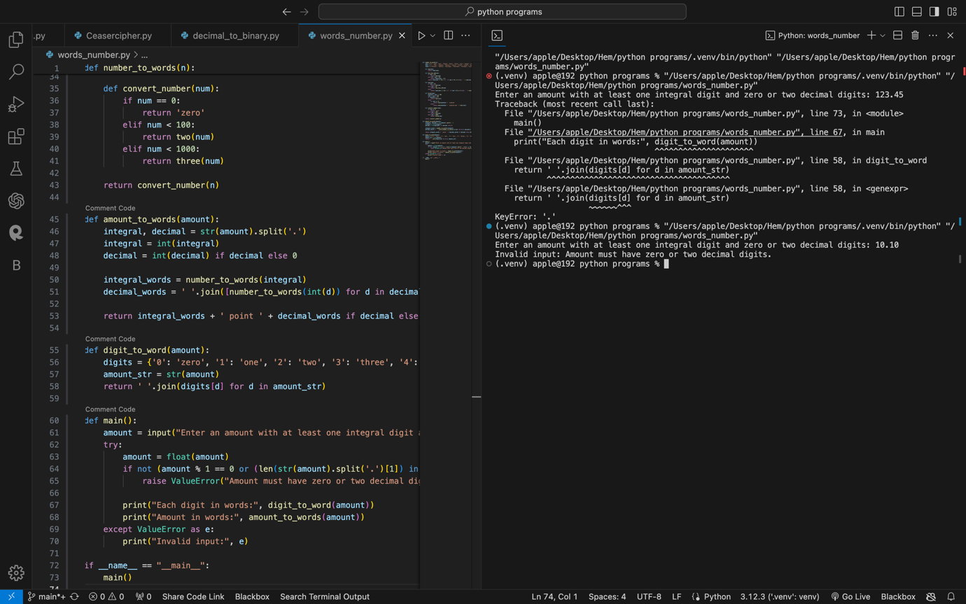

Q4 –

For a given positive integer, (a) find its divisors, (b) find its prime factors, and (c)

find the 5 co-prime numbers of the given integer.

Code : def find_divisors(n):

divisors = [i for i in range(1, n + 1) if n % i == 0]

return divisors

def find_prime_factors(n):

i = 2

prime_factors = []

while i * i <= n:

if n % i:

i += 1

else:

n //= i

prime_factors.append(i)

if n > 1:

prime_factors.append(n)

return prime_factors

def find_co_primes(n):

co_primes = []

for i in range(1, n * 2):

if gcd(i, n) == 1:

co_primes.append(i)

if len(co_primes) == 5:

break

return co_primes

def gcd(a, b):

while b:

a, b = b, a % b

return a

n = int(input("Enter the Number : "))

Divisors = find_divisors(n)

PrimeFactors = find_prime_factors(n)

CoPrimeNumbers = find_co_primes(n)

print(f'DIVISORS : {Divisors}')

print(f'PRIMEFACTORS : {PrimeFactors}')

print(f'CO-PRIME NUMBERS : {CoPrimeNumbers}')

Output :

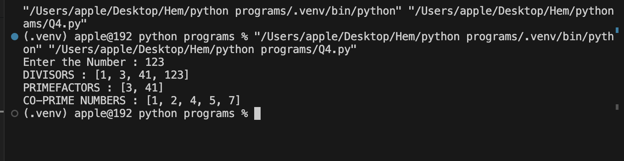

Q5 –

(a)In a 3 x 3 matrix arrange numbers 1, 2, 3 such that each row and each column

has different numbers.

(b) Make it general for n x n list for the given n unique numbers.

(c) First write a solution for 9 x 9 matrix with above-mentioned conditions. Each set

of 3 rows will have three 3 x 3 matrices, resulting in a total of nine 3 x 3 matrices.

Check whether each of nine 3 x 3 matrices have different numbers in each row and

each column.

Code :

# matrix = [[1, 2, 3], [3, 1, 2], [2, 3, 1]]

# for row in matrix:

# print(row)

#Qa

def matrix_find(i,j,k):

matrix = [[i,j,k],[k,i,j],[j,k,i]]

for row in matrix:

print(row)

i = int(input("Enter the Frist Number : "))

j = int(input("Enter the second Number : "))

k = int(input("Enter the third Number : "))

result = matrix_find(i,j,k)

print(f'FinalMAtrix : {result}')

#Qb

import numpy as np

def arrange_numbers(n, numbers):

# Create an empty matrix

matrix = np.zeros((n, n), dtype=int)

# Fill the matrix in a cyclic manner

for i in range(n):

for j in range(n):

matrix[i, j] = numbers[(i + j) % n]

return matrix

# Example usage

n = 5

numbers = list(range(1, n+1)) # [1, 2, 3, 4, 5]

matrix = arrange_numbers(n, numbers)

print(matrix)

#Qc

import numpy as np

def create_9x9_matrix():

# Define the 9 unique numbers

numbers = list(range(1, 10))

# Create the 9x9 matrix

matrix = np.zeros((9, 9), dtype=int)

# Fill the matrix in a cyclic manner

for i in range(9):

for j in range(9):

matrix[i, j] = numbers[(i + j) % 9]

return matrix

def check_3x3_matrices(matrix):

# Split the 9x9 matrix into 9 3x3 matrices

matrices = []

for i in range(0, 9, 3):

for j in range(0, 9, 3):

matrices.append(matrix[i:i+3, j:j+3])

# Check each 3x3 matrix

for mat in matrices:

if not (len(set(mat[:, 0])) == 3 and len(set(mat[:, 1])) == 3 and len(set(mat[:, 2])) == 3):

return False

if not (len(set(mat[0, :])) == 3 and len(set(mat[1, :])) == 3 and len(set(mat[2, :])) == 3):

return False

return True

# Create the 9x9 matrix

matrix = create_9x9_matrix()

# Check the 3x3 matrices

if check_3x3_matrices(matrix):

print("Each 3x3 matrix has different numbers in each row and each column")

else:

print("Not all 3x3 matrices have different numbers in each row and each column")

Output:

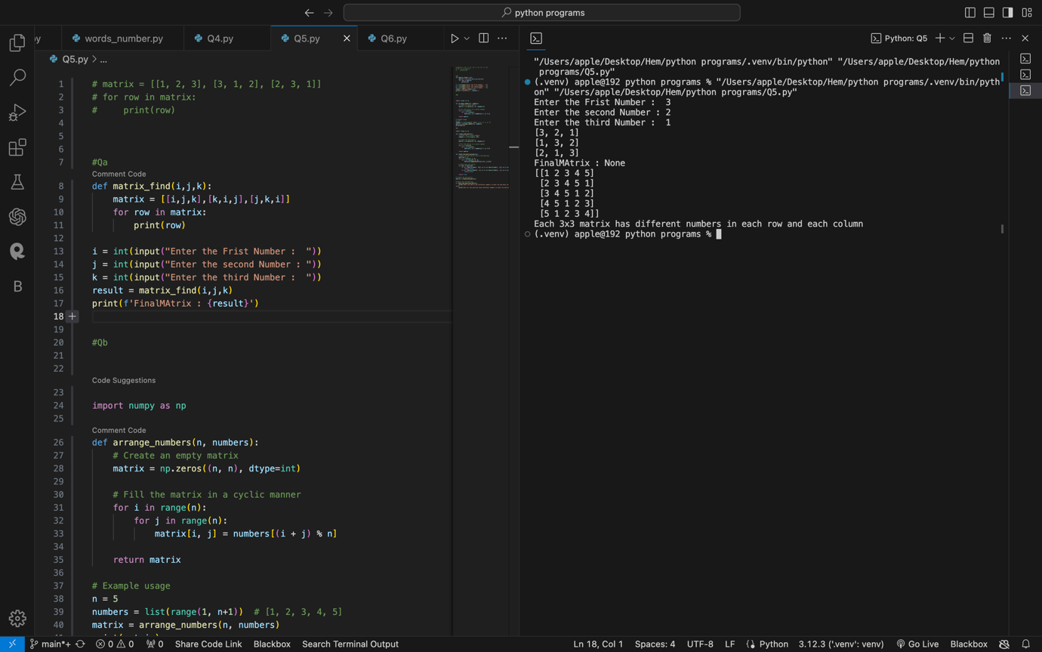

Q6-

(a) Convert each word (for a digit) to its corresponding digit and find frequency of

each digit.

(b) Draw two histograms using ‘*’ symbols – one horizontal and one vertical.

Code :

#Qa

import collections

# Define a dictionary to map words to digits

word_to_digit = {

'zero': 0, 'one': 1, 'two': 2, 'three': 3, 'four': 4,

'five': 5, 'six': 6, 'seven': 7, 'eight': 8, 'nine': 9

}

# Define a list of words

words = ['one', 'two', 'three', 'four', 'five', 'six', 'seven', 'eight', 'nine', 'zero']

# Convert each word to its corresponding digit

digits = [word_to_digit[word] for word in words]

# Find the frequency of each digit

frequency = collections.Counter(digits)

# Print the frequency of each digit

for digit, count in frequency.items():

print(f"Digit {digit}: {count}")

#Qb

def draw_horizontal_histogram(values):

max_value = max(values)

for value in values:

print("*" * value + " " * (max_value - value))

def draw_vertical_histogram(values):

max_value = max(values)

for i in range(max_value, 0, -1):

for value in values:

if value >= i:

print("*", end=" ")

else:

print(" ", end=" ")

print()

# Example usage

values = [3, 5, 2, 7, 1, 4]

print("Horizontal Histogram:")

draw_horizontal_histogram(values)

print("Vertical Histogram:")

draw_vertical_histogram(values)

Output:

