DATABASE MANAGEMENT AND DESIGN
A Practical Learning Series
Notebook 1
The Database Is the Heart of Information Systems
Introduction
By Amin Amirkhalili
Business & Data Analyst
Based on Chapter 1 (Sections 1-1 to 1-7) of:
Database Management and Design
Gove Allen, PhD · Gary Hansen, PhD · Robert Jackson, PhD

About This Series
This notebook is part of a practical learning series on database management and design. The series follows a logical progression — from understanding business needs, through conceptual modelling, all the way to writing SQL code on real databases.
1 — Fundamentals
Notebook 1 | Introduction: The Database Is the Heart of Information Systems ◀ You are here
2 — Database Management
Notebook 2.1 | Conceptual Data Model: From Conceptual Design to a Relational Model
Notebook 2.2 | Database Design: From Schema Creation to Data Management
3 — SQL & Data Analysis
Notebook 3.1 | Beginner Level: SELECT, FROM, WHERE, ORDER BY
Notebook 3.2 | Intermediate Level: Functions, GROUP BY, HAVING
Notebook 3.3 | Advanced Level I: Joining Tables — Inner & Outer Joins
Notebook 3.4 | Advanced Level II: Subqueries, Views, Temp Tables, CTEs
Notebook 3.5 | Data Cleaning with SQL (coming soon)
4 — Data Mining
Notebook 4.1 | SQL in Data Mining (coming soon)

📌 What This Notebook Covers
Notebook 1 introduces the big picture: why databases matter from a business point of view, what an information system is, what a database really is, and the main database architectures you will meet in practice.

1. Why Is Knowing About Databases a Good Skill? (From a Business Point of View)
In most business systems, the database provides the underlying foundation for the business applications that support the daily operations and activities of the business. Most business systems are created to support either direct business processes, such as taking orders and making sales, or indirect business processes, such as payroll and human resources. Since both types of business processes capture and store information, a database is required.
The ability to understand, design, build, maintain, and administer databases is an important and powerful skill.

But first, let’s see: what is an information system?
A Business Information System is best defined as a unified framework designed to capture, store, and process data to support business operations.

What are the components of an information system?
Information systems include three major parts working together: the database (organized data), the DBMS, and the front-end application.
Ah — that is why the database is so important.
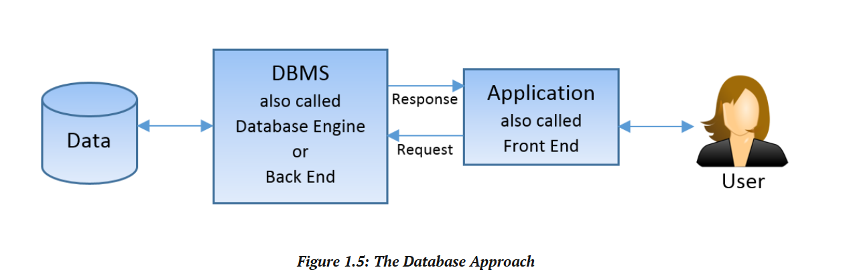
Before we define the components, let’s look at the types of information systems:
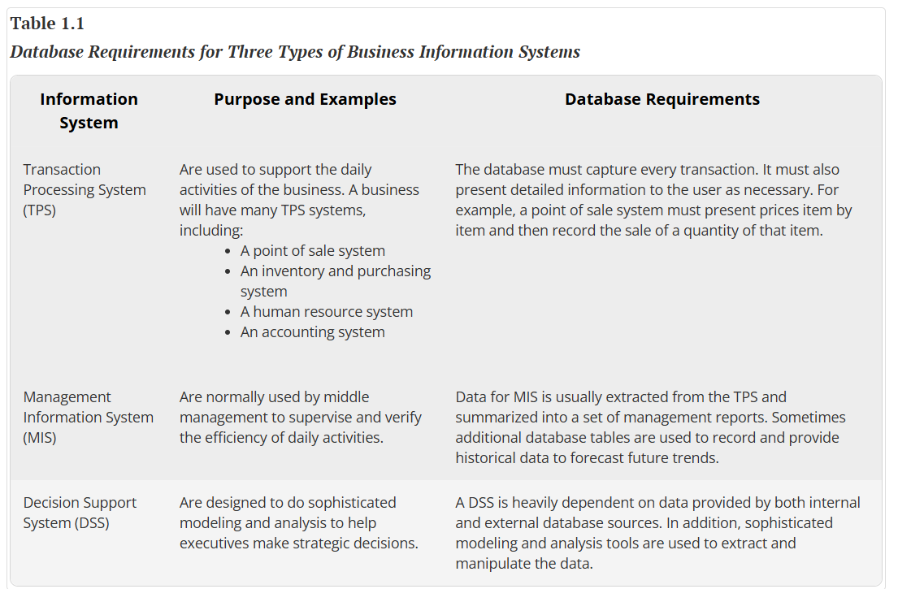

Which type of database is good for these information systems?
We have mainly two types of databases to support the different types of information systems: Online Transaction Processing (OLTP) databases and Online Analytical Processing (OLAP) databases. Usually, OLTP is good for TPSs and MISs, while OLAP is good for DSSs.
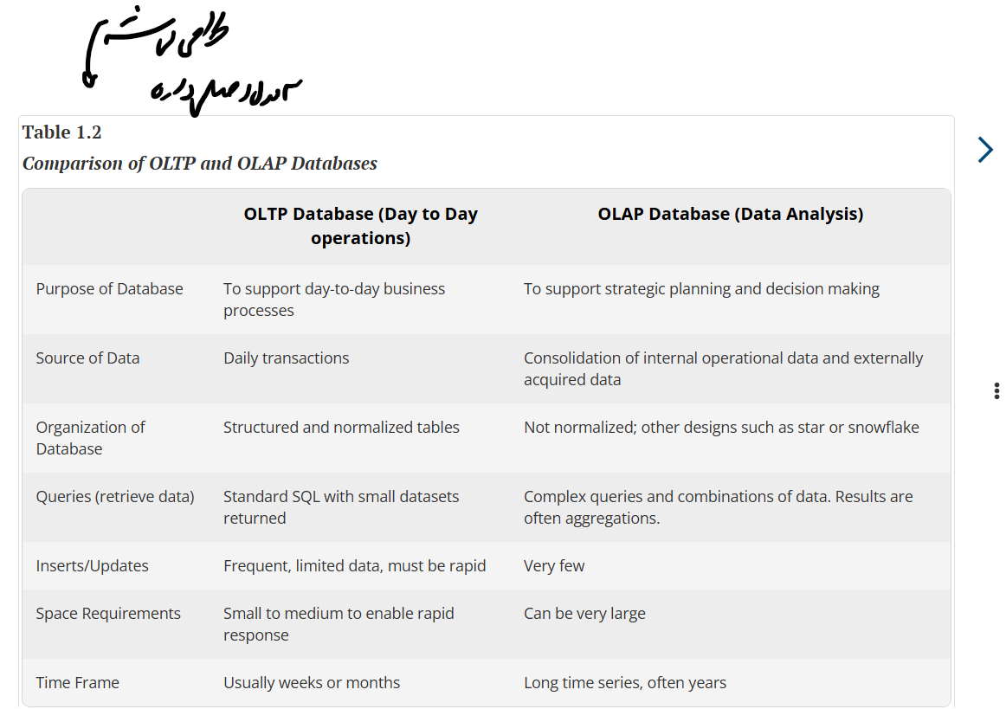

Now, let’s define each information system component:
- Front-end application
- DBMS
- Database

2. What Is a Database?
First, we need to explain what data is.
Data is a set of values.
Then:
A database is a collection of organized data.

Why a database?
A database, in fact, turns data into information. Because information is a set of data facts that (1) can be labeled, (2) are identified within a larger context, and (3) have identified relationships with other facts.
So, by entering data into a database, we turn data into information.

Database schema
Every database has a database schema. The database schema describes the structure of the database. This means:
- The purpose of the database.
- The subjects it intends to know about — the entities (in UML, called classes).
- The properties of each subject included in the database — the attributes (in UML, called associations).
How it looks: tables, which can be either classes or associations.

3. Database Architecture
Database architecture is about whether we use all three components of an information system in one place or not. This means the same information system can have different database architectures. Based on where the front application, the DBMS, and the data sit, we have different architectures:

Desktop architecture
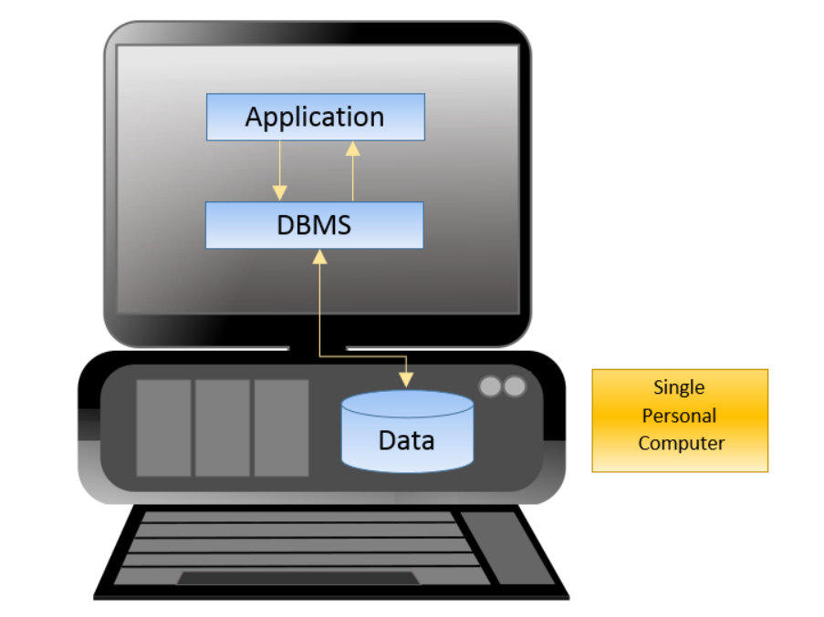
This is what I personally use.

File server architecture
Let’s expand it a little bit. Imagine keeping the data on one computer (the server) and giving each user a DBMS and a front app.
Example: small companies.
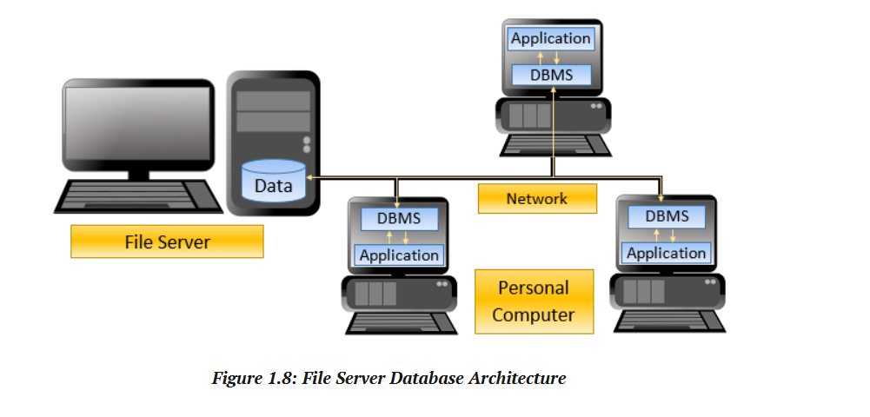

Benefits
- Ability to work on the same data.
- Easy to set up.

Drawbacks
- The network becomes a bottleneck.
- Needs a DBMS for every single user.

Client/server architecture
Now, let’s move the DBMS to the server.
Example: a hospital.
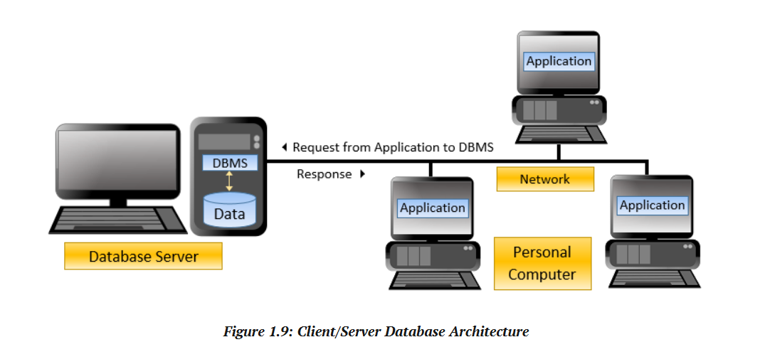

Benefits
- Ability to work on the same data.
- Faster processing, because the data and the DBMS are in one place.

Drawbacks
- A database server can be expensive.
- Version mismatches across front applications.

Web server architecture
Now let’s move the application to the cloud. We add one more layer: a web server.
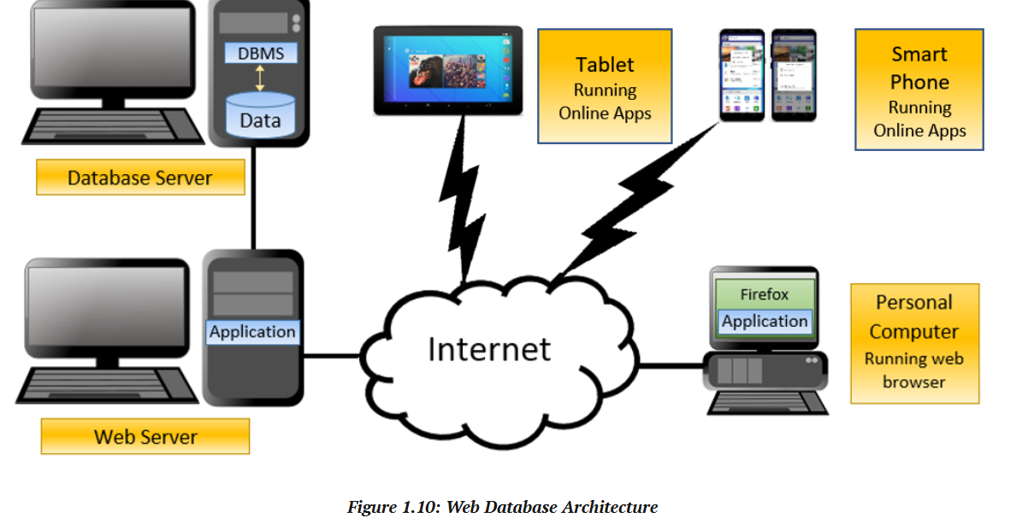

Benefits
- All the benefits of client/server architecture.
- All types of users, with various devices, can use the system.
- Ease of version updates.

Drawbacks
- One more layer is added.
- Security.

Example: one information system, two architectures
Power BI Desktop vs. Power BI Server:
- Power BI Desktop is a desktop architecture: the data is on the desktop, the front software is on the desktop, and the PBI engine is on the desktop.
- Power BI Server is a client/server architecture: the data is on a server, the PBI engine is on a server, and the front-end software (the browser) is on people’s own desktops.

Making a customised information system
As an example, Power BI is a company-designed information system (made by Microsoft). It has all three parts. But we can build our own information system if we can create and connect all three parts. I can create a database. But technically, it is too complicated and expensive to create a DBMS and a front app, so I use ones that are designed by companies like Microsoft. I use SQL Server (the DBMS) and SSMS (its front-end app) to make my own information system. If I know Python, I can even make my own front app.
As an example, I use:
- The application (front end): SQL Server Management Studio (SSMS)
- It talks to the DBMS (back end): Microsoft SQL Server
- With what language? When I write a query in SSMS, I am using Structured Query Language (SQL) to talk to the SQL Server engine.
⏭️ Coming up in Notebook 2.1
Conceptual Data Model — how business requirements become a conceptual model, and how that model becomes relational tables.

