DATABASE MANAGEMENT AND DESIGN
A Practical Learning Series
Notebook 2.1
From Conceptual Database Design to an Implemented Relational Database
Conceptual Data Model
By Amin Amirkhalili
Business & Data Analyst
Based on Chapters 3, 4 and 5 (Sections 3-1 to 3-4, Chapter 4, and Section 5-2) of:
Database Management and Design
Gove Allen, PhD · Gary Hansen, PhD · Robert Jackson, PhD

About This Series
This notebook is part of a practical learning series on database management and design. The series follows a logical progression — from understanding business needs, through conceptual modelling, all the way to writing SQL code on real databases.
1 — Fundamentals
Notebook 1 | Introduction: The Database Is the Heart of Information Systems
2 — Database Management
Notebook 2.1 | Conceptual Data Model: From Conceptual Design to a Relational Model ◀ You are here
Notebook 2.2 | Database Design: From Schema Creation to Data Management
3 — SQL & Data Analysis
Notebook 3.1 | Beginner Level: SELECT, FROM, WHERE, ORDER BY
Notebook 3.2 | Intermediate Level: Functions, GROUP BY, HAVING
Notebook 3.3 | Advanced Level I: Joining Tables — Inner & Outer Joins
Notebook 3.4 | Advanced Level II: Subqueries, Views, Temp Tables, CTEs
Notebook 3.5 | Data Cleaning with SQL (coming soon)
4 — Data Mining
Notebook 4.1 | SQL in Data Mining (coming soon)

📌 What This Notebook Covers
Notebook 2.1 walks the full path from business requirements to a relational data model. It is organised in five parts: (1) the two approaches to database design, (2) principles of conceptual data modelling with UML, (3) the logical relational data model, (4) transforming a conceptual model into a relational model, and (5) integrity constraints and normalization.

Part 1 — Two Approaches to Database Design
We are taking the role of the data architect. So, we suppose that the business analyst has already extracted the business requirements.
There are two approaches to database design:
- Relational data model directly from business requirements (there is no conceptual data model).
- Business requirements → conceptual data model → relational data model (the new approach).
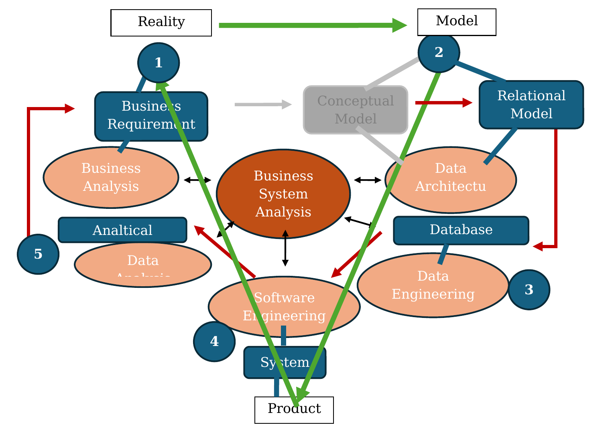
Fig. 1 — Conceptual model of data architecture

Approach 1 — Direct relational table design
- This approach was commonly used before the introduction of conceptual data models.
- In this approach, the analyst works directly with user requirements and designs the relational tables.
- The tables are then refined through a process called normalization to eliminate redundancy and reduce data anomalies. (We will discuss this in Part 5.)

How reality transforms into a system
- Reality → user requirements, by the business analyst.
- User requirements → relational model, by the data architect.
- Relational model → physical database (DBMS), by the data engineer.
- Physical database + front app → system (product), by the software engineer.
- Now, data analysts work on the data managed by information systems (a business analyst could do the same job).
- Business system analysts evaluate information systems for updates.

Approach 2 — Through a conceptual data model
- This approach is typically used for large, complex enterprise systems.
- First, a conceptual model is created.
- The conceptual model is then systematically transformed into a relational model (database tables).
- As a result, the generated tables are automatically well-structured and, in most cases, already normalized.
We focus on Approach 2 first.
To transform business requirements into a database, we need to go: business requirements → conceptual model → relational model → database.
In the following parts, we explain:
- The conceptual model (Part 2)
- The relational model (Part 3)
- How to transform the conceptual model into the relational model (Part 4)

Part 2 — Principles of Conceptual Database Design

Conceptual models
Definition: a conceptual model is a tool to model reality (business requirements).
There are two main conceptual data modeling approaches:
- Entity-Relationship (ER) modeling
- Object-Oriented modeling
In this course, we focus on Object-Oriented modeling.
Conceptual models are first built in our minds. When we want to bring them down to earth — onto paper, for example — we need a graphical tool to do so. In other words, we present our model with a graphical tool/chart. So, here we use UML (Unified Modeling Language) to design our conceptual model (which, of course, is based on object orientation).
[ER is modeled with another modeling language, the Entity-Relationship Diagram or ERD, which we will discuss later.]

How is an object-oriented model designed with UML?
Based on OO, facts can be grouped into classes and relationships:
- Class / object class (nouns)
- Relationship (verbs)

2.1 Class / Object Class
Each class has instances, which we call objects.
Class: Student
Objects: Mike James, Ali Ryan, ...

Various examples of classes (we can also name them object classes):
- Tools/objects: vehicle, ...
- People/roles: employees, customers, ...
- Places: departments, classrooms, warehouses, ...
- Events: sale, order, ...
- Concepts: skill, bank account, ...

Class types
All of the above classes could be:
- Abstract classes [student, class, ...]
- Lexical classes [attributes like name, age, ...]
An abstract class usually owns lexical classes (attributes).

2.2 Relationships
The other part of a fact is relationships. Classes may have relationships with each other.

Types of relationships

a) Generalization–specification relationships (the “is a” relationship)
Class A is a Class B. Class B is the father; Class A is a child.
- Example: students are (part of) people. People is the father; Student is a child.
- Example: a public college is a (type of) college. College is the father; Public College is a child.
We have four types of status between two or more child classes:
- Incomplete
- Complete
- Overlapping
- Disjoint
- Example: Employee and Student are overlapping, incomplete classes. [It means a person can be both an employee and a student at the same time (overlapping), and there are people other than employees or students (incomplete).]
- Example: Public College and Private College are disjoint, complete classes. [A college can only be private or public (disjoint), and there is no type of college other than public or private (complete).]

b) Association relationships / links
Class A does Class B. Example: Student takes Course.
As we mentioned, attributes are lexical classes and link to their abstract class. So we can also show them as an association.

c) A mix of association and “is a” relationships

2.3 Cardinality
There can be different cardinalities between the objects of two classes. In other words, we want to see, for each object of one class, how many objects of the other class are possible.
Cardinality depends on the way we define the relationships between classes, based on business requirements and rules.
We have three types of cardinality:
- One to one
- One to many
- Many to many

One to one
A person has a SIN number. For each person, only one SIN number exists. [This is what we defined in the business rules. On another planet, each person might have more than one SIN number — but here on Earth there is only one.]
More specifically, cardinality has a minimum and a maximum. In the example above, a person (a tourist) may not have a SIN number at all, and some SIN numbers may not be assigned to anyone yet (like web domains that exist but no one has taken them).
Class A (min, max) —— Class B (min, max)

The maximum cardinalities determine whether the relationship is one-to-one, one-to-many, or many-to-many.
(The minimums can differ: a person may have no SIN number (as a tourist, min = 0) and at most one (as a citizen, max = 1).)

Cardinality between a class and its attributes
Note: the relationship between a class and its attributes (which are themselves classes) must be one to one. We also call this a functional relationship.
Student (StudentID, FirstName, LastName, ...)

Student —— StudentID (1, 1)
Student —— FirstName (1, 1)
Student —— LastName (1, 1)

If a class does not have a functional relationship with its attributes, we need to normalize it (see Part 5).
Example: Student (StudentID, Tel#1, Tel#2, FirstName, LastName, ...). Because some people may have more than one telephone number, we need to normalize this relationship.
So far, we know that a class and its attributes must always have a one-to-one relationship. Also, a generalization–specification relationship is a one-to-one relationship.

One to many
For each one-to-many relationship, we may or may not need an extra class (or table).
Person —— Car (0, ∞)

Each person can have no car, or many cars.

Many to many
Class —— Students (∞, ∞)

Each class can have many students (or no students), and each student can be registered in a class or in no class. We will see that a many-to-many relationship must be changed into two one-to-many relationships.

How to deal with many-to-many relationships
We must transform many-to-many relationships into one-to-many relationships, because otherwise tracking the data is not possible.
For example, if the relationship between Loan and Book is many to many, we have to add an intermediary class (LoanItem).
⚠️ Attention
If, as a business rule (coming from the business requirements), we define that each loan can have only one book, then we no longer need the LoanItem class. (But in reality, a loan may have more than one book/loan item.)

2.4 Attributes
As we said before, attributes are also a type of class — lexical classes, like name, age, and so on.
For attributes (lexical classes), we only need to fill the table cell with values.
But in some cases, we can use a base/object class as its own attribute. We call that a relational attribute, meaning the attribute refers to the same table.
Person (PersonID, FirstName, LastName, Age, FatherName, ...)

FatherName is a relational attribute, because the father is himself a person and has a row in the same table:
Person 1: (PersonID, FirstName, LastName, FatherName, Age, ...)
Person 2: (PersonID, FirstName, LastName, FatherName, Age, ...)

-- Person 2 is Person 1’s father.

As mentioned before:
- All attributes are related to their class functionally.
- No attribute should have a functional relationship with another attribute in a class. [See normalization, Part 5.]
Example: Person (PersonID, FirstName, LastName, Age, BirthDate, ...). Age and BirthDate are related — one can be deleted.
In the generalization–specification relationship, the child class has all of its father class’s attributes plus its own attributes. A child class also inherits all of the father’s behavior.
Person (father class)
MarriedPerson (child class)

Person (PersonID, Age, FirstName, LastName)
MarriedPerson (PersonID, SpouseName, MarriageDate)

2.5 Keys
We can use an attribute as a key — in other words, to refer to a specific row in a table/class. A key can be any attribute.
Person (SinNumber, FirstName, LastName, Age, ...)

-- SinNumber is a key.

Primary keys are attributes that have a unique value for each object (or class instance). It means that no two rows of a table can have the same key value. [No two people can have the same SIN number.]
We have learned how an object-oriented conceptual model models reality (classes, attributes, keys, and relationships). Now let’s evaluate some conceptual data models.

2.6 Let’s design a simple conceptual data model
Example: suppose we are a bank. We define that each client can have only one savings account and one checking account. (Remember, a bank could allow you to have more than one savings and checking account — it depends on their business requirements.)
Now, with this business rule, we can answer questions such as:
What percentage of personal customers at Bank A have an average balance of more than $1,000 in their checking accounts?
- First, we define our classes, which are Client and Accounts.
- Second, we define their relationships: customers have/own accounts.
- Third, we define cardinalities.
- Fourth, attributes, keys, etc. come after.
Now, suppose each customer can have more than one savings and checking account (another business rule set). Could we answer the same question?
The answer is no.
If each customer could have multiple checking accounts, the question would become ambiguous. We would first need to specify whether we mean the total balance, the average balance, the largest account balance, or the balance of the most recent account (because each customer may have more than one checking account).

How can we evaluate a conceptual model?
- A model is judged by how accurately it represents the real-world domain of interest.
- The more information a model captures, the more sophisticated the queries it can support. But a more complex model is not necessarily a more effective one.
Now we have a conceptual data model. Next, we need to know what a relational data model is.

Part 3 — The Logical Relational Data Model

When did the logical relational data model start?
- The early database structures were classified as either network database structures or hierarchical database structures.
- These early databases had issues.
To solve those issues, in 1970 E. F. Codd developed the relational data model.
- The relational model, based on logical instead of physical relationships in data, overcame these problems.
- He also developed SQL.
Reference: Codd, E.F. 1970. “A Relational Model of Data for Large Shared Data Banks.” Communications of the ACM 13, no. 6 (June).

What is a relational data model?
In this model, data is seen as tables (relations — a term that comes from mathematics and represents a simple, two-dimensional table consisting of rows and columns of data).
Similar to the conceptual model, we need to model the relations (tables) and their relationships.

3.1 Modeling tables
Each table looks like:
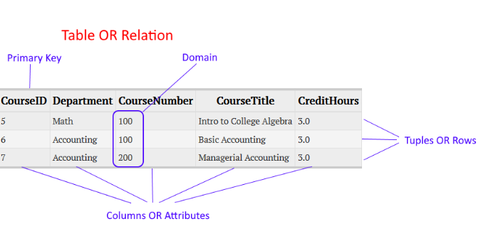
We have columns (attributes), rows/tuples (records), a primary key (attributes that have a unique value for each row), and a domain (the range of data for each attribute).
- No two rows of the table can be the same.
- Each table must have a primary key.
Primary key:
- Unique.
- Can be single or composite (more than one attribute).
- Can be internal or external (internal is preferred).
There is also a textual format:
Course (CourseID, Department, CourseName, CourseTitle, CreditHours)

Sometimes the primary key is composite — it includes more than one attribute. The reason is that sometimes one attribute is not enough to identify a row of data. In the example above, when we say CourseID = 1, we know everything about the course.
But in ClassEnrollment, where students’ grades are kept, we cannot identify a student’s grade by just one attribute such as CourseID. We also need to know which student (StudentID) took that class. So:
Student (StudentID, StudentNumber, FirstName, LastName, StreetAddress, City, CellPhone)
Course (CourseID, Department, CourseNumber, CourseTitle, CreditHours)
Enrollment (CourseID, StudentID, MidtermGrade, FinalGrade, ...)

3.2 Modeling relationships (among tables)
We link the tables with foreign keys (attributes that repeat in both tables).
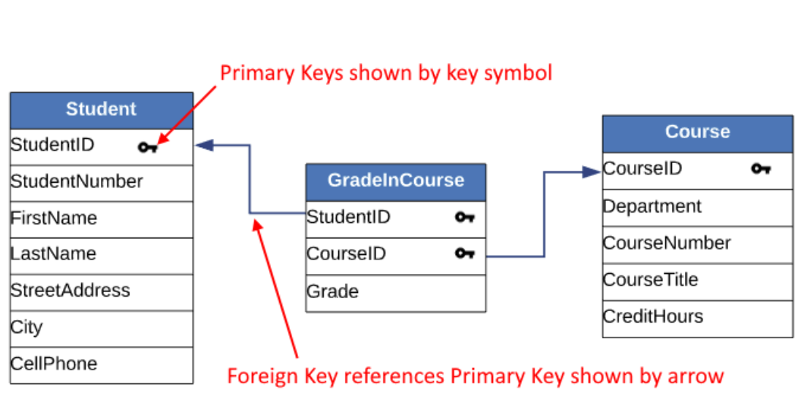
Example:
Student (StudentID, StudentNumber, FirstName, LastName, StreetAddress, City, CellPhone)
Course (CourseID, Department, CourseNumber, CourseTitle, CreditHours)
GradeInCourse (StudentID, CourseID, Grade)
Foreign key: StudentID → Student
Foreign key: CourseID → Course

So, tables that have one-to-one or one-to-many relationships are modeled easily by adding a foreign key. But for tables with many-to-many relationships, we first need to change them into one-to-many relationships. Then everything else is the same.
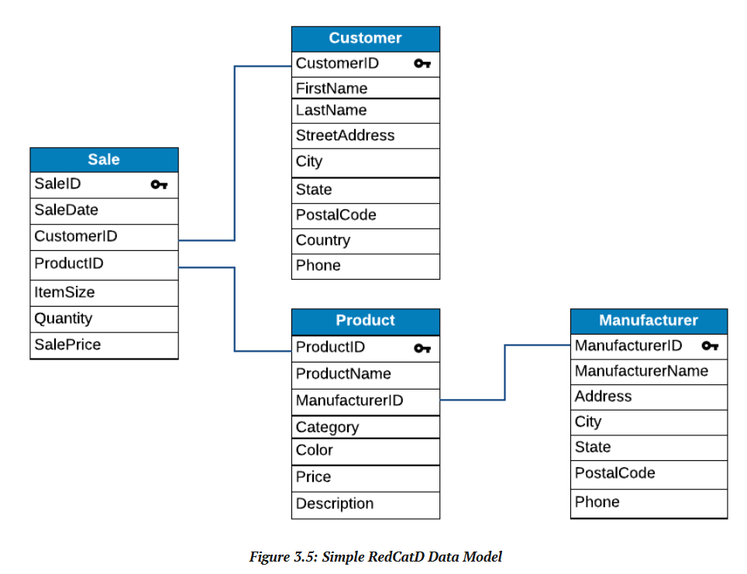
Example:
Sale (SaleID, SaleDate, CustomerID, ProductID, ItemSize, Quantity, SalePrice)
Foreign key: CustomerID → Customer
Foreign key: ProductID → Product

Customer (CustomerID, FirstName, LastName, StreetAddress, City, State, PostalCode, Country, Phone)

Product (ProductID, ProductName, ManufacturerID, Category, Color, Price, Description)
Foreign key: ManufacturerID → Manufacturer

Manufacturer (ManufacturerID, ManufacturerName, Address, City, State, PostalCode, Phone)

Recursive relationships
A recursive relationship is when a table is linked to itself.
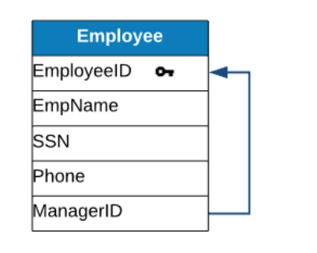
Employee (EmployeeID, EmpName, SSN, Phone, ManagerID)
Foreign key: ManagerID → Employee

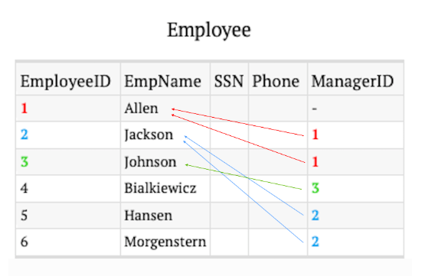

Part 4 — Transforming a Conceptual Model into a Relational Model
At this stage, we suppose we already have a conceptual data model (a UML or ERD diagram) that shows the entities and relationships. In Part 2, we showed how to create a conceptual model (using the UML language).
Now, we need to do four main steps:
- Deal with the base classes first (those that are neither generalization–specification nor association classes) and define primary keys.
- Deal with all generalization–specification classes (add their foreign keys in step 3).
- Deal with all relationships: (a) one-to-one, (b) one-to-many, (c) many-to-many.
- Deal with recursive tables.
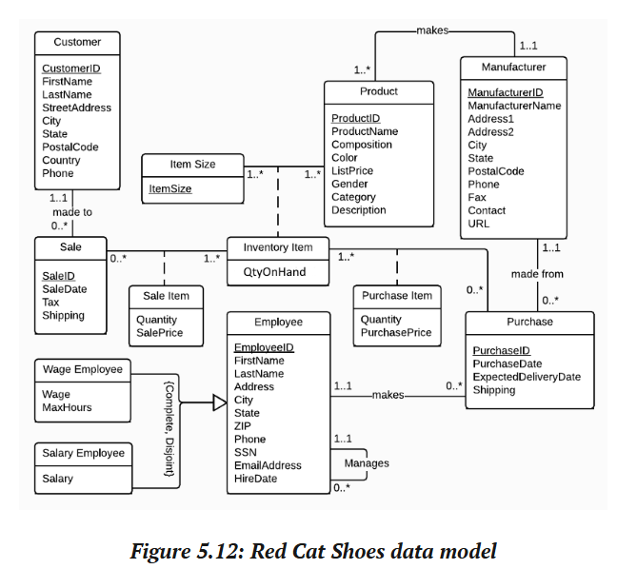
A conceptual data model (UML)

Step 1 — Dealing with base classes
Base classes: Customer, Sale, Employee, Product, Manufacturer, Purchase.
We model them:
Customer (CustomerID, FirstName, ...)
Sale (SaleID, SaleDate, ...)
Product (ProductID, ProductName, ...)
Manufacturer (ManufacturerID, ...)
Purchase (PurchaseID, PurchaseDate, ...)
Employee (EmployeeID, FirstName, LastName, ...)
-- (we define foreign keys for these tables in steps 3 and 4)

Step 2 — Generalization–specification relationships
There are three ways to model a G–S relationship. We define them and choose the most efficient one:

Way 1
Person (PersonID, FirstName, LastName, SinNumber, DOB, ...)
MarriedPerson (PersonID, FirstName, LastName, SinNumber, DOB, SpouseName)

Way 2
Person (PersonID, FirstName, LastName, SinNumber, DOB, SpouseName, ...)

Way 3
Person (PersonID, FirstName, LastName, SinNumber, DOB, ...)
MarriedPerson (PersonID, SpouseName)
Foreign key: PersonID → Person

Way 3 is the most efficient one. So, in this example:
Employee → WageEmployee, SalaryEmployee

Employee (EmployeeID, FirstName, LastName, ...) -- generalization
WageEmployee (EmployeeID, Wage, MaxHours, ...) -- specification
SalaryEmployee (EmployeeID, Salary) -- specification
-- (we add the foreign keys for SalaryEmployee and WageEmployee in step 3)

Step 3 — Dealing with association relationships

One-to-one
The only one-to-one relationships here are the G–S ones (WageEmployee → Employee, SalaryEmployee → Employee). We only need to add a key in WageEmployee and SalaryEmployee pointing to Employee:
WageEmployee (EmployeeID, Wage, MaxHours, ...)
Foreign key: EmployeeID → Employee

SalaryEmployee (EmployeeID, Salary)
Foreign key: EmployeeID → Employee

One-to-many
Customer — Sale: we put a foreign key into Sale.
Customer (CustomerID, FirstName, ...)
Sale (SaleID, CustomerID, ...)
Foreign key: CustomerID → Customer

Employee — Purchase:
Purchase (PurchaseID, PurchaseDate, EmployeeID, ...)
Foreign key: EmployeeID → Employee
Employee (EmployeeID, FirstName, LastName, ...)

Manufacturer — Purchase:
Purchase (PurchaseID, PurchaseDate, ManufacturerID, ...)
Foreign key: ManufacturerID → Manufacturer
Manufacturer (ManufacturerID, ManufacturerName, ...)

Remember, Purchase therefore has two foreign keys to two tables:
Purchase (PurchaseID, PurchaseDate, EmployeeID, ManufacturerID, ...)
Foreign key: ManufacturerID → Manufacturer
Foreign key: EmployeeID → Employee

Manufacturer — Product:
Manufacturer (ManufacturerID, ManufacturerName, ...)
Product (ProductID, ManufacturerID, ...)
Foreign key: ManufacturerID → Manufacturer

Many-to-many
We add an intermediate table inheriting the keys from the parent tables.

1) ItemSize — Product
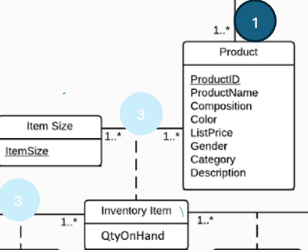
ItemSize (ItemSizeID, ItemSize, ...)
Product (ProductID, ProductName, Composition, ...)
InventoryItem (ProductID, ItemSizeID, QtyOnHand, ...)
Foreign key: ProductID → Product
Foreign key: ItemSizeID → ItemSize

2) Sale — InventoryItem
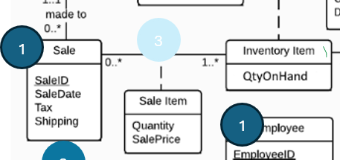
We create SaleItem:
Sale (SaleID, SaleDate, Tax, Shipping)
InventoryItem (ProductID, ItemSizeID, QtyOnHand, ...)
-- InventoryItem is the parent here; in the previous relationship it was the child.

SaleItem (ProductID, ItemSizeID, SaleID, Quantity, SalePrice, ...)
Foreign key: ProductID → Product
Foreign key: ItemSizeID → ItemSize
Foreign key: SaleID → Sale

3) InventoryItem — Purchase
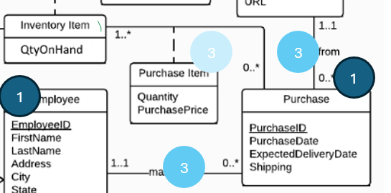
InventoryItem (ProductID, ItemSizeID, QtyOnHand, ...)
Purchase (PurchaseID, PurchaseDate, ...)
PurchaseItem (ProductID, ItemSizeID, PurchaseID, Quantity, PurchasePrice, ...)
Foreign key: ProductID → Product
Foreign key: ItemSizeID → ItemSize
Foreign key: PurchaseID → Purchase

Look at this part of the diagram (all three intermediary tables in one shot):
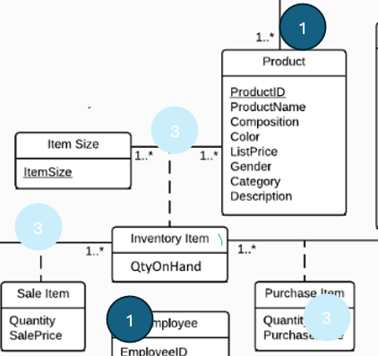
We have InventoryItem between ItemSize and Product, SaleItem between InventoryItem and Sale, and PurchaseItem between InventoryItem and Purchase.
It is always better to start from the one that is central. Here, InventoryItem is central. So we model it first, then use it for the other relationships. Because InventoryItem has two keys, when we want to model SaleItem or PurchaseItem, we need the keys from InventoryItem — we must use whatever keys it has. Therefore, in total, SaleItem and PurchaseItem each have three keys (two from InventoryItem and one from Sale or Purchase).

Step 4 — Recursive relationships
Employee → Employee

Employee (EmployeeID, FirstName, LastName, ManagerID, ...)
Foreign key: ManagerID → Employee
-- (make sure you add this key to the version of Employee from step 1)

In fact, a recursive relationship is a one-to-many relationship:
Employee (0, 1) —— Manager (1, *)

Each employee has no manager or exactly one manager (the top manager is also an employee and has no manager; everyone else has exactly one). Each manager manages one or many employees.
Conceptually, we could think of it as two tables — Employee and Manager — but we merge them into one table:
Employee (EmployeeID, FirstName, LastName, ManagerID, ...)
Foreign key: ManagerID → Employee

The relational data model, all together
Employee (EmployeeID, FirstName, LastName, ManagerID, ...)
Foreign key: ManagerID → Employee

WageEmployee (EmployeeID, Wage, MaxHours, ...)
Foreign key: EmployeeID → Employee

SalaryEmployee (EmployeeID, Salary)
Foreign key: EmployeeID → Employee

Sale (SaleID, CustomerID, ...)
Foreign key: CustomerID → Customer

Purchase (PurchaseID, PurchaseDate, EmployeeID, ManufacturerID, ...)
Foreign key: EmployeeID → Employee
Foreign key: ManufacturerID → Manufacturer

Product (ProductID, ManufacturerID, ...)
Foreign key: ManufacturerID → Manufacturer

Customer (CustomerID, FirstName, ...)

Manufacturer (ManufacturerID, ...)

ItemSize (ItemSizeID, ItemSize, ...)

InventoryItem (ProductID, ItemSizeID, QtyOnHand, ...)
Foreign key: ProductID → Product
Foreign key: ItemSizeID → ItemSize

SaleItem (ProductID, ItemSizeID, SaleID, Quantity, SalePrice, ...)
Foreign key: ProductID → Product
Foreign key: ItemSizeID → ItemSize
Foreign key: SaleID → Sale

PurchaseItem (ProductID, ItemSizeID, PurchaseID, Quantity, PurchasePrice, ...)
Foreign key: ProductID → Product
Foreign key: ItemSizeID → ItemSize
Foreign key: PurchaseID → Purchase

What we achieve by transforming the conceptual model into a relational data model is ready for building the database. It means there is no need to encounter anomalies or ineffectiveness in the model — in other words, there is no need to normalize the model.
In the next part, we talk about normalization. With this result, we could move on to the next notebook, which is database design. But before that, let’s look at one more example, and then talk about the first approach to data modeling.

Another example
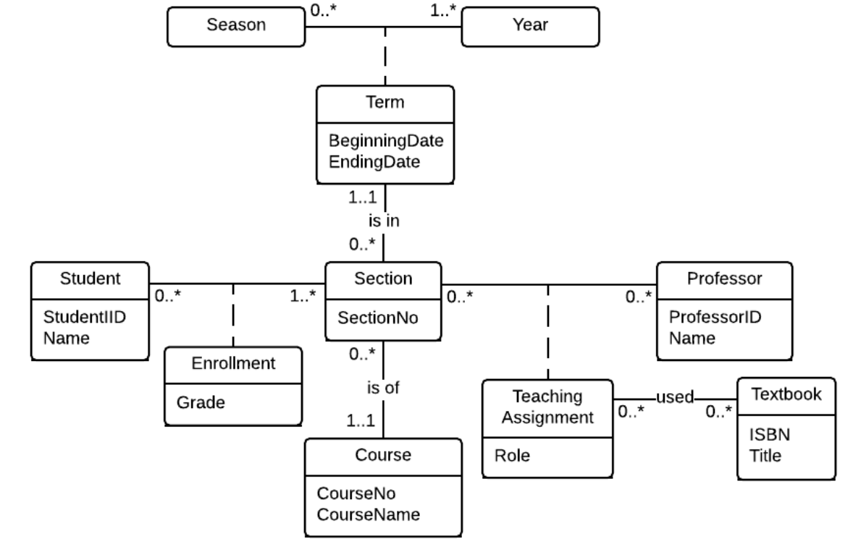
Season (Season)
Year (Year)

Term (Season, Year, StartDate, EndDate)
Foreign key: Year → Year
Foreign key: Season → Season

Course (CourseNo, CourseName)

Section (CourseNo, SectionNo, Season, Year)
Foreign key: CourseNo → Course
Foreign key: Season, Year → Term

Enrollment (StudentID, CourseNo, SectionNo, Season, Year, Grade)
Foreign key: StudentID → Student
Foreign key: CourseNo, SectionNo, Season, Year → Section

TeachingAssignment (ProfessorID, CourseNo, SectionNo, Season, Year, Role)
Foreign key: ProfessorID → Professor
Foreign key: CourseNo, SectionNo, Season, Year → Section

TeachingAssignment_Textbook (ProfessorID, CourseNo, Year, Season, SectionNo, ISBN)
Foreign key: ISBN → Textbook
Foreign key: CourseNo, SectionNo, Season, Year, ProfessorID → TeachingAssignment

Professor (ProfessorID, Name)
Textbook (ISBN, Title)

Part 5 — Integrity Constraints and Normalization
🔸 Remember — Approach 1: Direct Relational Table Design
This approach was commonly used before the introduction of conceptual data models.
It is still practical and efficient for small and relatively simple projects.
In this approach, the analyst works directly with user requirements and designs the relational tables.
The tables are then refined through a process called normalization to eliminate redundancy and reduce data anomalies.

So, if we want to go directly from business requirements to a relational database, we need to make sure our database has the highest efficiency and data integrity. Therefore, we discuss integrity and normalization to achieve this goal.

5.1 Integrity Constraints
- Entity integrity
- Referential integrity
- Functional dependencies

Entity integrity
The Entity Integrity Rule says: “No key attribute of any row in a relation may be null.”
Entity integrity only applies to primary keys. It simply says that every primary key must have a complete value, and it must be unique for that row. Obviously, if we did not have a value as the row identifier, how could we find that row?

Referential integrity
The rule says: “Every foreign key must either be null, or its value must be the actual value of a key in the referenced relation.”
What does referential integrity really mean? It only applies to foreign keys. It simply says that the value in a foreign key field must point to an actual row in the referenced table — or it must be empty. It cannot point to something non-existent.
Example:
TableA_ID | Name | ...
1 | A
2 | ...
3

TableB_ID | Name | TableA_ID (FK) | Valid?
01 | A | 1 | ✓ points to an existing row
02 | C | NULL | ✓ null is allowed
03 |  | 10 | ✗ row 10 does not exist

5.2 Normalization
Normalization is a process in relational data modeling — used with the old approach, which has no conceptual model — to remove anomalies from data tables.
Our goal is to stop having entry, delete, or update anomalies.
Normalization means breaking big tables down into smaller ones and connecting them with foreign keys (this is what makes us join tables in SQL queries later). That is why normalization = decomposition.
We need normalization when the data is not normal. (If we have already transformed a conceptual data model into a relational data design, it is already normal and we do not need normalization.)

First, what is a functional dependency?
When two or more attributes have a functional connection — meaning that by knowing one, we can know the other — we have a functional relationship.
As we mentioned before, in a relation all non-key attributes are functionally related to the primary key.
Customer (CustomerID, FirstName, LastName, Address, ...)

This is important because normalization is about certain conditions in the functional relationships between attributes.

The Four Forms of Normality

First Normal Form (1NF)
A relation is in First Normal Form (1NF) if the values in the relation are atomic for every attribute in the relation.
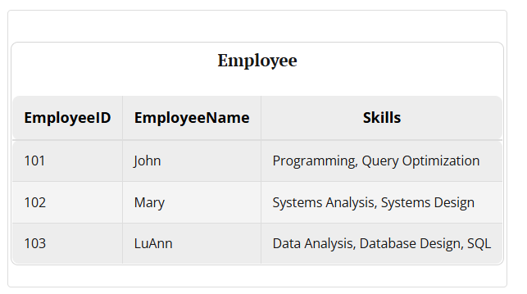
The solution:
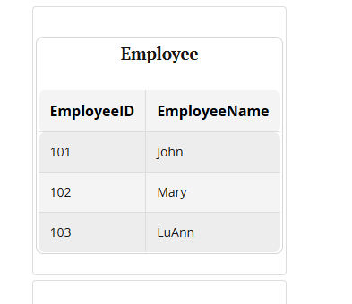
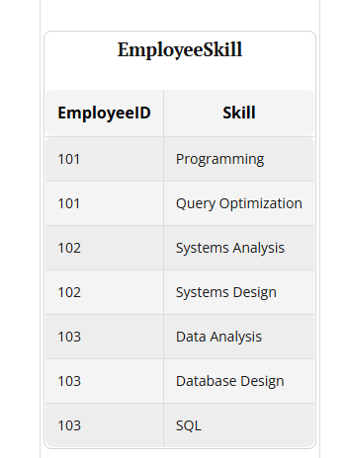
If a relation is not in 1NF, we will have two anomalies: insertion and deletion anomalies. For example, if a row is deleted, some skills may be lost.

Second Normal Form (2NF)
A relation is in Second Normal Form (2NF) if:
- It has a composite key, and
- None of the attributes in the composite key is functionally related to any other attribute in the table.
Example:
GradeInClass (ClassID, StudentID, Name, Grade, CreditHours)

Analysis: the relation is in 1NF, but it is not in 2NF. It has a composite key (ClassID, StudentID). But: StudentID → Name, and ClassID → CreditHours.
Solution:
- Keep the composite key.
- Make two tables containing the functional relationships: ClassID → CreditHours and StudentID → Name.
- Delete the related attributes (CreditHours, Name) from the original table.
Class (ClassID, CreditHours)
Student (StudentID, Name)
GradeInClass (ClassID, StudentID, Grade)
Foreign key: ClassID → Class
Foreign key: StudentID → Student


If a relation is not in 2NF, we will have insertion and deletion anomalies. For example, we may not be able to add a student’s name if that student does not have any class (because adding a row to the table requires a ClassID). Or, if we delete a student (a row), a course — or the credit hours of a course — may be lost (suppose one student is the only one taking a class, and we delete that student).

Third Normal Form (3NF)
A relation is in Third Normal Form (3NF) if there is no functional relationship between two non-key attributes.
Example:
Employee (EmployeeID, SkillType, BonusRate)

As usual: EmployeeID → SkillType, BonusRate. But also: SkillType → BonusRate — and SkillType and BonusRate are not primary keys.
Solution: create a table for SkillType → BonusRate, and delete BonusRate from the Employee table.
Employee (EmployeeID, SkillType)
Foreign key: SkillType → Skill

Skill (SkillType, BonusRate)

Fourth Normal Form (4NF)
A relation is in Fourth Normal Form (4NF) if, when we have two groups of information about the same objects and those groups are not related to each other at all, they are kept separate.
Example: Doctor → English, French (languages) and Doctor → Eye Specialist, General (specialties).
DoctorID | Name | Language | Specialty
01 | A | English | General
01 | A | French | General
02 | B | English | Eye Specialist

Here, we have to repeat rows 1 and 2 to show that Doctor A knows two languages.
Solution — separate the two groups:
DoctorID | Language
01 | English
01 | French
02 | English

DoctorID | Name | Specialty
01 | A | General
02 | B | Eye Specialist

📎 Note
If a relation is in 3NF, it is for sure in 2NF. And if it is in 2NF, it is for sure in 1NF. But if a relation is in 1NF, it is not necessarily in 2NF; and if it is in 2NF, it is not necessarily in 3NF.

5.3 A Full Example (Normalization + Data Modeling Together)
Suppose we come up with the idea of a database using business requirements, and it looks like this [we usually come up with the attributes after evaluating the business requirements]:
OrderDate, CustomerName, CustomerCity, CustomerPhones, ProductName,
Category, SupplierName, SupplierCity, UnitPrice, Quantity

Step 1 — Identify the possible entities
Order → OrderDate, Quantity, UnitPrice
Customer → CustomerName, CustomerCity, CustomerPhones
Product → ProductName, Category
Supplier → SupplierName, SupplierCity, UnitPrice

Step 2 — Add a primary key for each entity
Order (OrderID, OrderDate, Quantity, UnitPrice)
Customer (CustomerID, CustomerName, CustomerCity, CustomerPhones)
Product (ProductID, ProductName, Category)
Supplier (SupplierID, SupplierName, SupplierCity)

Step 3 — Create the relationships
-- Customer → Order
Order (OrderID, OrderDate, UnitPrice, CustomerID)
Foreign key: CustomerID → Customer
Customer (CustomerID, CustomerName, CustomerCity, CustomerPhones)

-- Product → Supplier
Product (ProductName, Category, SupplierID)
Foreign key: SupplierID → Supplier
Supplier (SupplierID, SupplierName, SupplierCity)

-- OrderItem → Order and Product
OrderItem (OrderID, ProductID, Quantity, UnitPrice)
Foreign key: OrderID → Order
Foreign key: ProductID → Product

Step 4 — Check for normality
1NF: Customer (CustomerID, CustomerName, CustomerCity, CustomerPhones) — CustomerPhones is not atomic. So we have to create a table for it:
Customer (CustomerID, CustomerName, CustomerCity)
Telephone (CustomerID, CustomerPhone)
Foreign key: CustomerID → Customer

2NF, 3NF, and 4NF are met.

Result
Customer (CustomerID, CustomerName, CustomerCity)

CustomerPhone (CustomerID, CustomerPhone)
Foreign key: CustomerID → Customer

Supplier (SupplierID, SupplierName, SupplierCity)

Category (CategoryID, CategoryName)

Product (ProductID, ProductName, CategoryID, SupplierID)
Foreign key: CategoryID → Category
Foreign key: SupplierID → Supplier

Order (OrderID, OrderDate, CustomerID)
Foreign key: CustomerID → Customer

OrderItem (OrderID, ProductID, Quantity, UnitPrice)
Foreign key: OrderID → Order
Foreign key: ProductID → Product

If we do not separate Category, it is still fine.
📎 Note
A one-to-many relationship can sometimes be two relations, and sometimes not. Example: Class (ClassID, ClassName, Capacity) and Department (DepartmentID, DepartmentName, ...) with Class *—1 Department. We can put all the info in one relation: Class (ClassID, ClassName, Capacity, DepartmentID, DepartmentName). But if we need more information about a department, it is better to separate it.

⏭️ Coming up in Notebook 2.2
Database Design — turning the relational model into a real, working database: creating schemas, managing table structures, and manipulating data with SQL.

