DATABASE MANAGEMENT AND DESIGN
A Practical Learning Series
Notebook 3.1
SQL and Data Analysis — Beginner Level
SELECT, FROM, WHERE, and ORDER BY
By Amin Amirkhalili
Business & Data Analyst
Based on Chapter 2 (Sections 2-1 & 2-2) and Chapter 6 (Sections 6-2 & 6-3) of:
Database Management and Design
Gove Allen, PhD · Gary Hansen, PhD · Robert Jackson, PhD

About This Series
This notebook is part of a practical learning series on database management and design. The series follows a logical progression — from understanding business needs, through conceptual modelling, all the way to writing SQL code on real databases.
1 — Fundamentals
Notebook 1 | Introduction: The Database Is the Heart of Information Systems
2 — Database Management
Notebook 2.1 | Conceptual Data Model: From Conceptual Design to a Relational Model
Notebook 2.2 | Database Design: From Schema Creation to Data Management
3 — SQL & Data Analysis
Notebook 3.1 | Beginner Level: SELECT, FROM, WHERE, ORDER BY ◀ You are here
Notebook 3.2 | Intermediate Level: Functions, GROUP BY, HAVING
Notebook 3.3 | Advanced Level I: Joining Tables — Inner & Outer Joins
Notebook 3.4 | Advanced Level II: Subqueries, Views, Temp Tables, CTEs
Notebook 3.5 | Data Cleaning with SQL (coming soon)
4 — Data Mining
Notebook 4.1 | SQL in Data Mining (coming soon)

📌 What This Notebook Covers
Notebook 3.1 introduces the SQL SELECT statement — the foundation of every query. You will learn to select columns, filter rows with WHERE, and sort results with ORDER BY. A practice version of this notebook with runnable code is available on Google Colab.

Intro
The job started when your boss asked:
- Which products sell best? Which products sell the worst? When are sales of these products best?
- Which manufacturers make the most popular products, and which the least popular products?
- Who are our best customers? What kinds of products do they tend to buy? Which brands do they prefer? How often do they purchase: monthly, yearly, twice a year? Do they buy at the beginning of each month, in the middle, or at the end?
To answer these types of questions, we need the SQL SELECT statement.
A SQL SELECT statement is the basic SQL language statement that is used to extract data from a table or a set of tables.

Before we can run SQL code:
- We must know the fundamentals, including data, databases, and database management systems. [If you don’t know these, go back to Notebook 1.]
- There must already be a DBMS and a front application, so that we can build a database and its tables and run SQL code. [If not, go and download one — I use Microsoft SQL Server and SSMS.]
- There must already be a database including tables, attributes, primary and foreign keys, and rows of information. [If not, go back to Notebooks 2.1 and 2.2.]
- Data entry must already be done, and the data must be standard. [If not, you either need to enter the data manually or insert a dataset into the database.]

The 6 main basic commands
In SQL, we have six main basic commands:
- SELECT
- FROM [JOIN]
- WHERE
- ORDER BY
- GROUP BY
- HAVING
Generally, the order in which the commands are written is:
SELECT ...
FROM ...
[JOIN ... -- if we need to join tables (advanced level)]
WHERE ...
GROUP BY ...
HAVING ...
ORDER BY ...

The logic is always like this: you first SELECT the columns FROM the table (of a database), filter them (WHERE) if needed, group the output if needed, and finally order the result by different criteria.
Now let’s dive in.

1 & 2 — SELECT and FROM

What I want to do: show me all attributes from a table.
How do I do it:
SELECT * FROM Table_Name

Examples:
SELECT * FROM Customer

-- Show me the top 50 rows of everything from the table:
SELECT TOP 50 * FROM Customer

What I want to do: show me some attributes from a table.
How do I do it:
SELECT Attribute_Names FROM Table_Name

-- Example:
SELECT FirstName, LastName FROM Student

-- I can name the columns however I like:
SELECT Attribute_Name AS Name_I_Like FROM Table_Name

DISTINCT
SELECT DISTINCT Attribute_Names FROM Table_Name

It only shows unique data for each attribute.
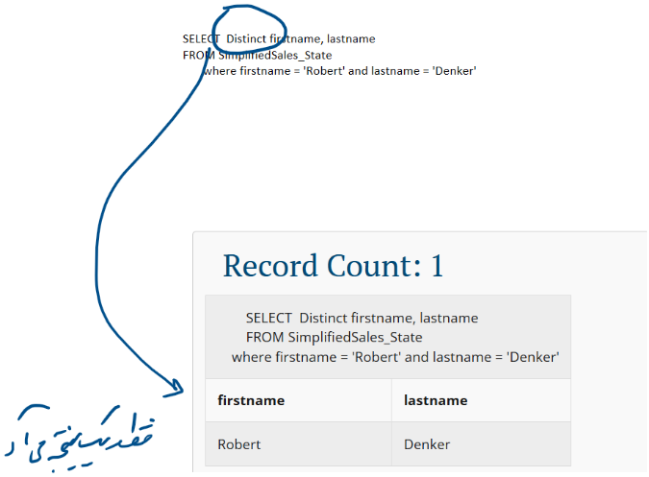
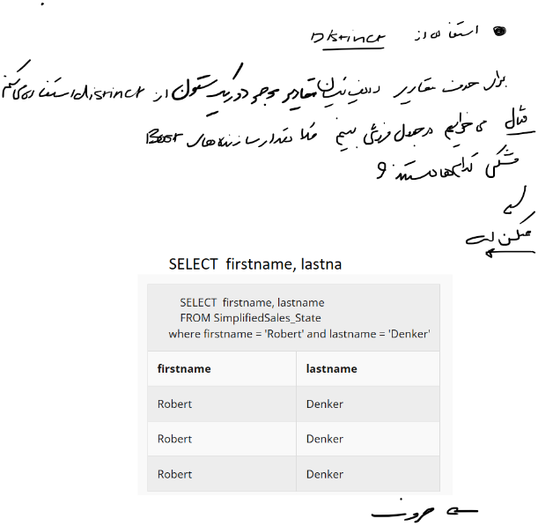
Note that the DISTINCT keyword does not eliminate duplicate values from individual columns, but rather duplicate rows from the query result.
It means that if the table contains:
FirstName | LastName | Age
Amin | Amirkhalili | 30
Amin | Amirkhalili | 50

and you say:
SELECT DISTINCT FirstName, LastName, Age FROM Amin

it shows both rows — because rows are compared as a whole, not only by name or last name.

3 — WHERE
We limit the result by adding more specifications.

What I want to do: show me all attributes from a table that have this speciality.
How do I do it:
SELECT * FROM Table_Name
WHERE [a condition that is True/False]

Using = or LIKE for string variables
SELECT * FROM Customer
WHERE State = 'VA'
-- (or: WHERE State LIKE 'VA')

Using =, >, <, <>, <=, >= for numbers
SELECT * FROM Product
WHERE ListPrice = 150

Adding AND, OR, AND NOT, OR NOT to add limitations
Using parentheses is important and can change the query result.
SELECT * FROM SimplifiedSales
WHERE Category = 'Sandals'
AND Color <> 'Gold'

Example — with parentheses:
SELECT * FROM Product
WHERE (Category = 'Sandals' OR Category = 'Sneakers')
AND Manufacturer = 'Nike'

Result:
Sandal A – Nike
Sandal B – Nike
Sneaker A – Nike
Sneaker B – Nike
...

Now the same query without parentheses:
SELECT * FROM Product
WHERE Category = 'Sandals' OR Category = 'Sneakers'
AND Manufacturer = 'Nike'

Result:
Sandal A – Adidas
Sandal B – Nike
Sandal C – GAP
...
Sneaker A – Nike
Sneaker B – Nike
...

[Without parentheses, AND binds before OR — so all sandals are returned, from any manufacturer.]

Query: show sales of boots not made by either Nike or Puma.
SELECT *
FROM SimplifiedSales
WHERE Category = 'Boots'
AND NOT (ManufacturerName = 'Nike'
OR ManufacturerName = 'Puma')

4 — ORDER BY
This command orders the result.

What I want to do: order the result for me based on the condition I tell you.
How do I do it:
SELECT * FROM Table_Name
ORDER BY Attribute [ASC | DESC]

- ASC: from small to large (or from A to Z). This is the default.
- DESC: from large to small (or from Z to A).
Example:
SELECT * FROM SaleItem
ORDER BY SalePrice DESC

Remember: ORDER BY usually comes at the end (here, meaning after SELECT and WHERE).
SELECT DISTINCT
Category,
Color,
ManufacturerName
FROM SimplifiedSales
WHERE Category = 'Boots'
ORDER BY ManufacturerName

Note that ORDER BY can use two or more attributes to order by.
SELECT DISTINCT
Category,
Color,
ManufacturerName
FROM SimplifiedSales
WHERE Category = 'Boots'
ORDER BY ManufacturerName, Color DESC

⏭️ Coming up in Notebook 3.2
Intermediate level — functions in SELECT (arithmetic, aggregation, string functions), GROUP BY, and HAVING.

