DATABASE MANAGEMENT AND DESIGN
A Practical Learning Series
Notebook 3.2
SQL and Data Analysis — Intermediate Level
Functions, GROUP BY, HAVING
By Amin Amirkhalili
Business & Data Analyst
Based on Chapter 6 (Section 6-5) of:
Database Management and Design
Gove Allen, PhD · Gary Hansen, PhD · Robert Jackson, PhD

About This Series
This notebook is part of a practical learning series on database management and design. The series follows a logical progression — from understanding business needs, through conceptual modelling, all the way to writing SQL code on real databases.
1 — Fundamentals
Notebook 1 | Introduction: The Database Is the Heart of Information Systems
2 — Database Management
Notebook 2.1 | Conceptual Data Model: From Conceptual Design to a Relational Model
Notebook 2.2 | Database Design: From Schema Creation to Data Management
3 — SQL & Data Analysis
Notebook 3.1 | Beginner Level: SELECT, FROM, WHERE, ORDER BY
Notebook 3.2 | Intermediate Level: Functions, GROUP BY, HAVING ◀ You are here
Notebook 3.3 | Advanced Level I: Joining Tables — Inner & Outer Joins
Notebook 3.4 | Advanced Level II: Subqueries, Views, Temp Tables, CTEs
Notebook 3.5 | Data Cleaning with SQL (coming soon)
4 — Data Mining
Notebook 4.1 | SQL in Data Mining (coming soon)

📌 What This Notebook Covers
Notebook 3.2 covers functions inside SELECT (arithmetic operations, arithmetic functions, aggregation functions, and string functions), grouping results with GROUP BY and PARTITION BY, and filtering groups with HAVING. A practice version of this notebook with runnable code is available on Google Colab.

1. Functions [in SELECT]
There are four groups of functions we use in SELECT:
- Arithmetic operations
- Arithmetic functions
- Aggregation functions
- String functions

1.1 Arithmetic Operations: + − ÷ × %
Example (+):
SELECT SaleID, (Shipping + Tax) AS AddonCost FROM Sale

Example (+ in strings):
SELECT LastName + ', ' + FirstName AS CustomerName FROM Customer

1.2 Arithmetic Functions
ABS(x) : ABS(-10) = 10
SQRT(x) : SQRT(16) = 4
ROUND(x, n) : ROUND(4.032, 2) = 4.03
CEILING(x) : CEILING(4.05) = 5
FLOOR(x) : FLOOR(4.09) = 4
POWER(x, n) : POWER(2, 2) = 4

Example:
SELECT POWER(Age, 2) FROM Amin

1.3 Aggregation Functions
MIN(x)
MAX(x)
SUM(x)
AVG(x)
COUNT(x)

They usually come alone, or together with other aggregation functions, in SELECT. BUT, if they come with other attributes, we must use GROUP BY. [They can also come in the HAVING clause.] (Refer to Section 2.)
Example:
SELECT AVG(Age) FROM Amin

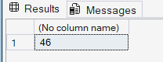
Example:
SELECT AVG(Age), Gender FROM Amin
GROUP BY Gender

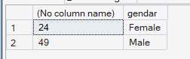

1.4 String Functions
- LEN(x): returns the length of the character string. It works on literal strings or string values in a column. Example: LEN('My house is white.') returns 18.
- UPPER(x): returns all characters as upper case. Example: UPPER('George') returns 'GEORGE'.
- LOWER(x): returns all characters as lower case. Example: LOWER('McDougal') returns 'mcdougal'.
- CHARINDEX(value, x): returns the first location of value in x. Example: CHARINDEX('hi', 'My white house') returns 5, which is the 5th character in the string. It is usually used for search use cases.
- LTRIM(x): removes leading spaces. Example: LTRIM(' Bill') returns 'Bill' without the leading spaces.
- RTRIM(x): removes trailing spaces. Example: RTRIM('Leather Shoes ') returns 'Leather Shoes' without the trailing spaces.
- TRIM(x): removes spaces from both sides. Example: TRIM(' Leather Shoes ') returns 'Leather Shoes'.
- CONCAT(x, '---', y): returns the strings concatenated together. It works just like the concatenation operator above (same as using + with strings). Example: CONCAT(LastName, ', ', FirstName) → 'Jones, Bill'.
- SUBSTRING('...', n, m): returns m characters starting from the nth letter. Example: SUBSTRING('My White House', 4, 5) returns 'White', which is 5 characters long and begins at the 4th character.
- LEFT(x, n): returns a string of the first n characters of x. Example: LEFT('Bill Jones', 2) returns 'Bi'.
- RIGHT(x, n): returns a string of the last n characters of x. Example: RIGHT('Bill Jones', 2) returns 'es'.
- REPLACE(x, 'A', 'B'): replaces every occurrence of A with B in the original string x. Example: REPLACE('Good shoes at the shoe store', 'shoe', 'shirt') returns 'Good shirts at the shirt store'.

1.5 Functions in other commands
Functions are not limited to SELECT — they can appear in WHERE, GROUP BY, HAVING, and ORDER BY too:
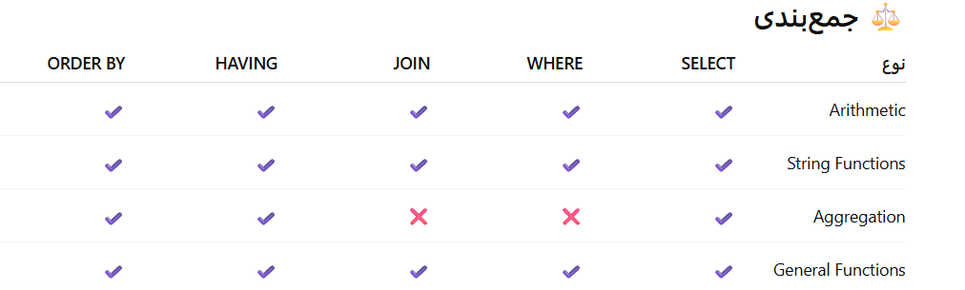

2. GROUP BY

Review
- SELECT
- FROM
- WHERE
- ORDER BY
As mentioned before, GROUP BY is usually used with aggregation functions such as COUNT(), SUM(), MIN(), MAX(), and AVG().

Query: what is the average list price of products per category?
SELECT Category, AVG(ListPrice) FROM Product
GROUP BY Category

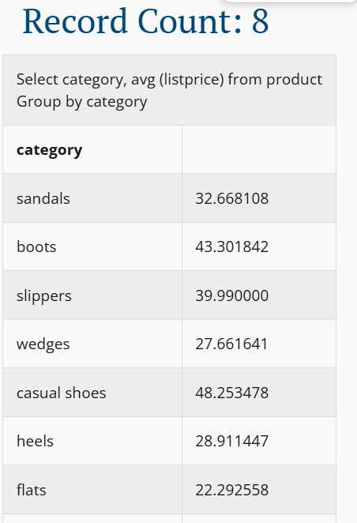

When is it good to use GROUP BY?
a) (Basic) Sometimes we don’t need aggregation but still want to group by something.
SELECT Gender FROM Amin
GROUP BY Gender

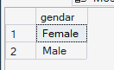
b) (Pro) Where there is various data for one single item. For example, one student has various grades. Or one customer has different orders.
Then we might ask:
- What was the maximum sale for each customer so far?
SELECT MAX(SalePrice), CustomerID FROM Sale
GROUP BY CustomerID

- What was the average grade of each student?
SELECT StudentID, AVG(Grade) FROM Student
GROUP BY StudentID

It’s also good to know when we do not need GROUP BY
a) When we are not looking for any aggregation information:
SELECT FirstName, LastName
FROM Customer;

No need for any aggregation information.
b) When we are looking for a single aggregation for the whole table:
SELECT SUM(Amount)
FROM Sale

We need an aggregation — but only for the whole table.
c) When we are looking for a single aggregation for only one row:
SELECT CustomerID, SUM(Amount)
FROM Sale
WHERE CustomerID = 10

We need an aggregation, and an attribute comes in SELECT alongside the aggregation — but we only need it for one row (WHERE).
💡 Golden Rule of GROUP BY
Conditions: (1) we want to use an aggregation function, and (2) we want to use GROUP BY.
If we want to use any attribute in SELECT, we must have that attribute in the GROUP BY clause (or it must also be aggregated).

Look at this example — it is wrong:
SELECT Category, ProductName, AVG(ListPrice)
FROM Product
GROUP BY Category;

Correction:
SELECT Category, ProductName, AVG(ListPrice)
FROM Product
GROUP BY Category, ProductName;

When you add more attributes to the GROUP BY clause, the results become more specific. When you have only one attribute, the grouping is more general.
SELECT Category, ProductName, AVG(ListPrice)
FROM Product
GROUP BY Category, ProductName;

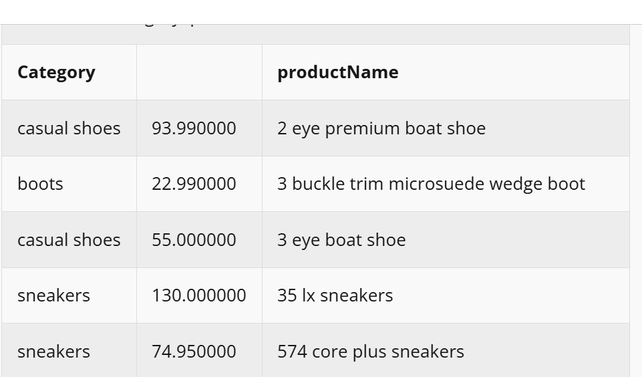
SELECT Category, AVG(ListPrice)
FROM Product
GROUP BY Category

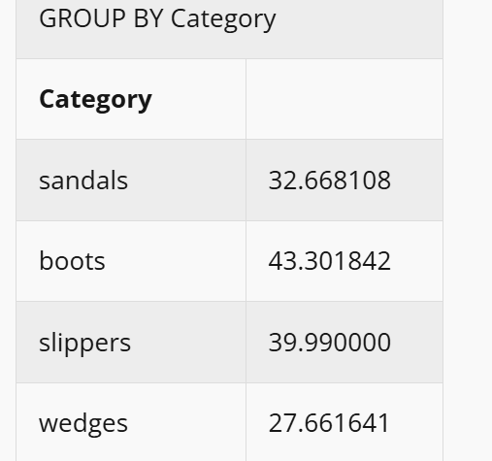

More examples

Query: what groups of products exist?
[No aggregation required, but grouping intended — basic mode (a).]
SELECT Category
FROM Product
GROUP BY Category;

Query: for each product category, what is the highest list price for a product in that category?
[Aggregation required, grouping intended — pro mode (b).]
SELECT Category,
MAX(ListPrice) AS MaxListPrice
FROM Product
GROUP BY Category

Query: what is the number of people per gender?
(Pro mode.)
SELECT Gender, COUNT(Gender) FROM Amin
GROUP BY Gender

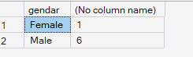

Using ORDER BY with GROUP BY
We can also use ORDER BY after GROUP BY.

Query: what is the average price of products in each category? [sorted]
SELECT Category, AVG(ListPrice) AS Avg_Price
FROM Product
GROUP BY Category
ORDER BY AVG(ListPrice) DESC;

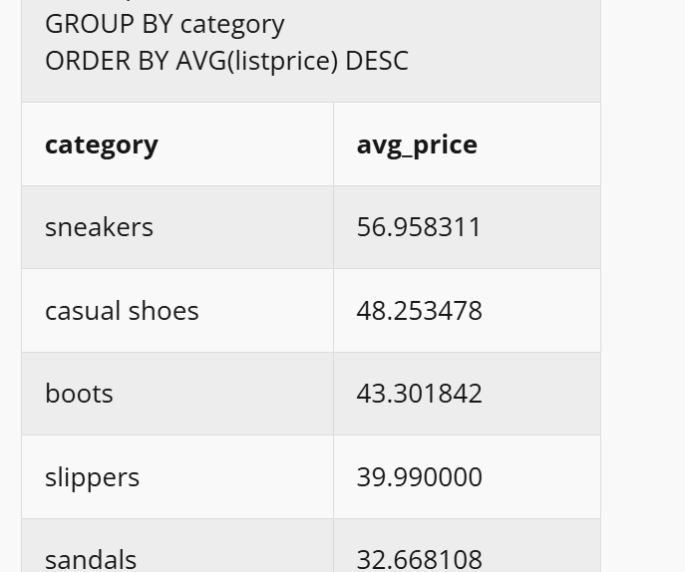

Using WHERE with GROUP BY

Query: for each product category, what is the average list price of black shoes?
SELECT Category, AVG(ListPrice) FROM Product
WHERE Color = 'Black'
GROUP BY Category

PARTITION BY
With GROUP BY, the number of rows is reduced. But with PARTITION BY, you can have aggregation info for each row while keeping all the rows.
Example — take this table:
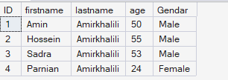
SELECT Gender, AVG(Age) AS AgeAvg FROM Amin
GROUP BY Gender

Result:
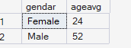
Now, look at PARTITION BY:
SELECT FirstName, LastName, Age, Gender,
AVG(Age) OVER (PARTITION BY Gender) AS AgeAvg
FROM Amin

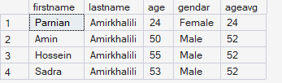
Not only do we have the age average — we can still see all the rows.
PARTITION BY usually comes with these functions:
AVG() OVER (PARTITION BY ...)
SUM() OVER (PARTITION BY ...)
COUNT() OVER (PARTITION BY ...)
ROW_NUMBER() OVER (PARTITION BY ...) -- example in Notebook 3.4
RANK() OVER (PARTITION BY ...)

3. HAVING
HAVING is a limitation/condition after we group something. (WHERE is a limitation/condition before we group.)

Query: for each category containing more than 50 products, what is the maximum list price in that category?
Each category has a condition: containing more than 50 products.
SELECT Category,
MAX(ListPrice) AS MaxListPrice
FROM Product
GROUP BY Category
HAVING COUNT(*) > 50

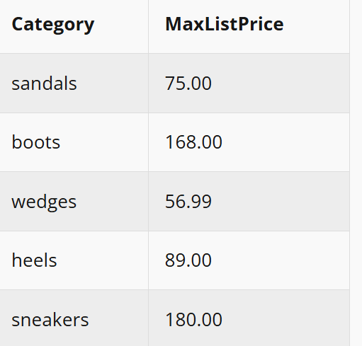
The difference between the WHERE clause and the HAVING clause is that the WHERE clause is applied to rows, while the HAVING clause is applied to groups.

Using WHERE and HAVING with GROUP BY

Query: for each product category, what is the average list price of black shoes? Consider only those categories having no product priced over $100.
SELECT Category, AVG(ListPrice) FROM Product
WHERE Color = 'Black'
GROUP BY Category
HAVING MAX(ListPrice) <= 100

💡 Remember
If you want to use any attribute in HAVING (such as price), it must be aggregated. So we write MAX(ListPrice), not ListPrice.
The reason: after grouping, there are no longer individual rows — they are groups now.
In HAVING, the only things that are OK are: any attribute already used in the GROUP BY clause, and any attribute inside an aggregation function.

Examples:
SELECT Gender, AVG(Age) FROM Amin
GROUP BY Gender
HAVING AVG(Age) < 30

SELECT Gender, AVG(Age) FROM Amin
GROUP BY Gender
HAVING Gender LIKE 'Male'

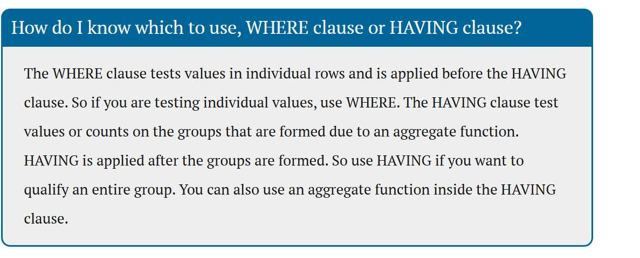
⏭️ Coming up in Notebook 3.3
Advanced level I — why we join tables, inner joins, outer joins (left, right, full), joining a table to itself, and joining multiple tables.

