DATABASE MANAGEMENT AND DESIGN
A Practical Learning Series
Notebook 3.3
SQL and Data Analysis — Advanced Level I
Joining Tables: Inner & Outer Joins
By Amin Amirkhalili
Business & Data Analyst
Based on Chapter 2 (Section 2-3) and Chapter 6 (Sections 6-4 & 6-9) of:
Database Management and Design
Gove Allen, PhD · Gary Hansen, PhD · Robert Jackson, PhD

About This Series
This notebook is part of a practical learning series on database management and design. The series follows a logical progression — from understanding business needs, through conceptual modelling, all the way to writing SQL code on real databases.
1 — Fundamentals
Notebook 1 | Introduction: The Database Is the Heart of Information Systems
2 — Database Management
Notebook 2.1 | Conceptual Data Model: From Conceptual Design to a Relational Model
Notebook 2.2 | Database Design: From Schema Creation to Data Management
3 — SQL & Data Analysis
Notebook 3.1 | Beginner Level: SELECT, FROM, WHERE, ORDER BY
Notebook 3.2 | Intermediate Level: Functions, GROUP BY, HAVING
Notebook 3.3 | Advanced Level I: Joining Tables — Inner & Outer Joins ◀ You are here
Notebook 3.4 | Advanced Level II: Subqueries, Views, Temp Tables, CTEs
Notebook 3.5 | Data Cleaning with SQL (coming soon)
4 — Data Mining
Notebook 4.1 | SQL in Data Mining (coming soon)

📌 What This Notebook Covers
Notebook 3.3 explains why we need to join tables, then covers inner joins (FK–PK and non-FK–PK), joining a table to itself, joining multiple tables, the old 1987-style join in the WHERE clause, outer joins (left, right, full), and common pitfalls when averaging over joined tables. A practice version with runnable code is available on Google Colab.

Why Do We Need to Join Tables?
Before answering that, we need to answer a fundamental question: does all data have to be in one table? (If so, we would not need to join tables.)
The answer is no. But why?
Because keeping everything in one table causes:
- Unwanted repetition in data entry. Suppose we record a location for each sale made in a chain store. Then the location has to be entered every time.
Sale 1 → NL
Sale 2 → NL
...

It is wiser to keep all locations in a different table:
Store 1: StoreID, StoreName, Location (NL)
Store 2: StoreID, StoreName, Location (BC)
...

Then, in the Sale table, we only keep related and more dynamic info:
SaleID, SaleDate, CustomerID, ProductID, StoreID, ...

- Inconvenience when some data has been corrupted or needs revision. If the location of one store has been recorded incorrectly, all the rows need to be revised. But if locations live in a different table, we only need to change it once.
Therefore, the solution is to separate each independent entity into separate tables (normalization).
⚠️ Attention
To separate tables correctly, we need to know normalization (see Notebook 2.1, Part 5).

Now, because we have separate tables in our database, we need to join them to answer some of the queries.

Types of joins
- Inner join
- Outer join: left outer, right outer, full outer

Inner Join
INNER JOIN is a synonym for the common term JOIN. It joins two tables together but only includes rows that meet the matching criteria.
What does that mean? It means: only show the rows that have a complete match between the two (or more) tables.
Example:
EmployeeID | EmployeeName
01 | Alan
02 | Ahmad
03 | Elli
04 | Luke
05 | James
06 | Alex

CustomerID | CustomerName | EmployeeID
01 | Kim | 02
02 | Andrews | 05
03 | John | 03
04 | George | 04
05 | Kevin | 07
06 | Sam | 09

Inner join result:
CustomerID | CustomerName | EmployeeID | EmployeeID | EmployeeName
01 | Kim | 02 | 02 | Ahmad
02 | Andrews | 05 | 05 | James
03 | John | 03 | 03 | Elli
04 | George | 04 | 04 | Luke

This is the most common join used in SQL.

1. Joining two tables together
We can join two tables with:
- FK–PK (foreign key to primary key)
- Non FK–PK
The version of joining tables with “JOIN ... ON” first became a standard in 1992. In a prior version of SQL (the 1987 standard), the join condition was placed within the WHERE clause. We talk about JOIN ... ON first, and mention the WHERE version in a later section.

FK–PK
The FK is usually in the child table, and the primary key is in the father table.
SELECT * FROM Left_Table
JOIN Right_Table ON ForeignKey = PrimaryKey
WHERE ...

Example:
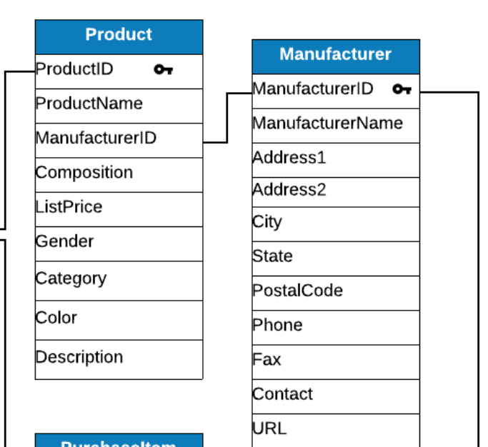
SELECT * FROM Product P
JOIN Manufacturer M ON P.ManufacturerID = M.ManufacturerID
WHERE City = ...

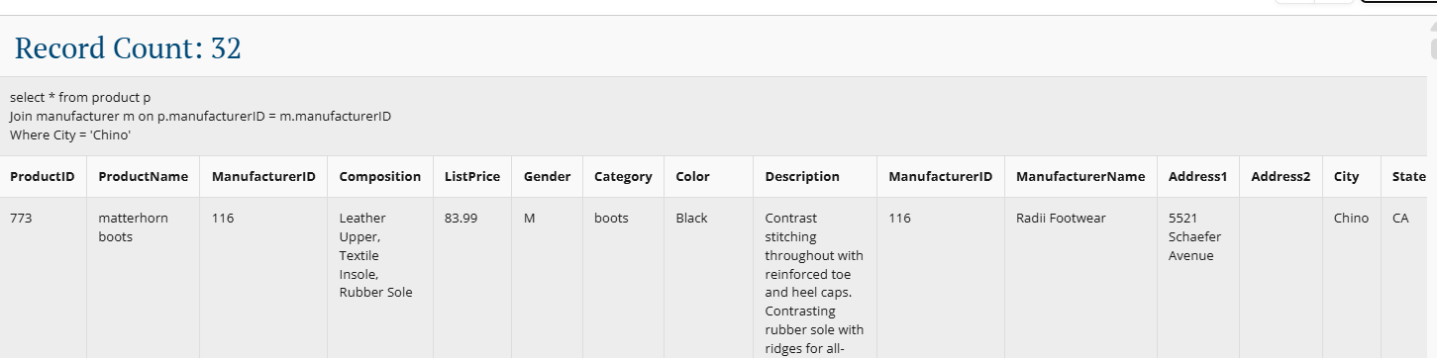
In joined tables, all attributes from both tables are shown in the result (as seen above). But if we write TableName.* in SELECT, only that table’s attributes are shown.
SELECT P.* FROM Product P
JOIN Manufacturer M ON P.ManufacturerID = M.ManufacturerID
WHERE City = ...

To avoid writing the long table.attribute names, we can use an alias:
SELECT P.*
FROM Product P
JOIN Manufacturer M
ON P.ManufacturerID = M.ManufacturerID

If the joined attribute names are different in the two tables, we do not need an alias:
SELECT c.* FROM Car c
JOIN Amin a ON
FirstName = OwnerFirstName AND
LastName = OwnerLastName

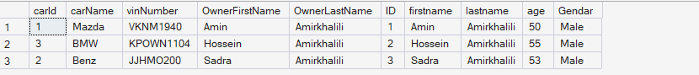
If we want all attributes from one table and some attributes from the other:
SELECT P.*, M.ManufacturerID
FROM Product P
JOIN Manufacturer M
ON P.ManufacturerID = M.ManufacturerID

As mentioned before, JOIN comes after SELECT and FROM, before anything else.
SELECT ProductID, ProductName, ListPrice, Gender, Category, ManufacturerName
FROM Product P
JOIN Manufacturer M
ON P.ManufacturerID = M.ManufacturerID
WHERE ManufacturerName = 'Fila'

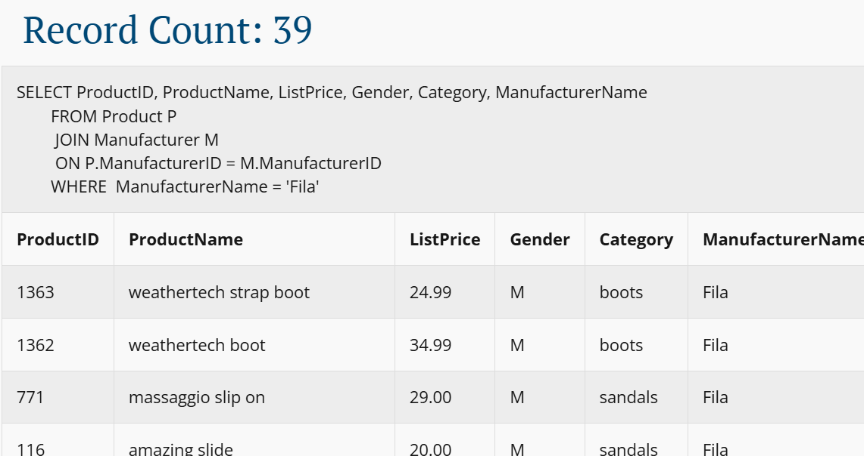

Could we join any two attributes in two tables?
No.
The join condition fields must be the same data type and have the same range of values.
This example is wrong — an ID joined to a city:
SELECT ProductID, ProductName, ListPrice, Gender, Category, ManufacturerName
FROM Product P
JOIN Manufacturer M
ON P.ManufacturerID = M.City -- ✗ different types, meaningless
WHERE ManufacturerName = 'Fila'

Non FK–PK
We can join any non foreign-key–primary-key pair together — but, as mentioned earlier, they must have the same data type and range.

Query: list the names of customers that live in the same city as a shoe manufacturer. Include the manufacturer name and the city name.
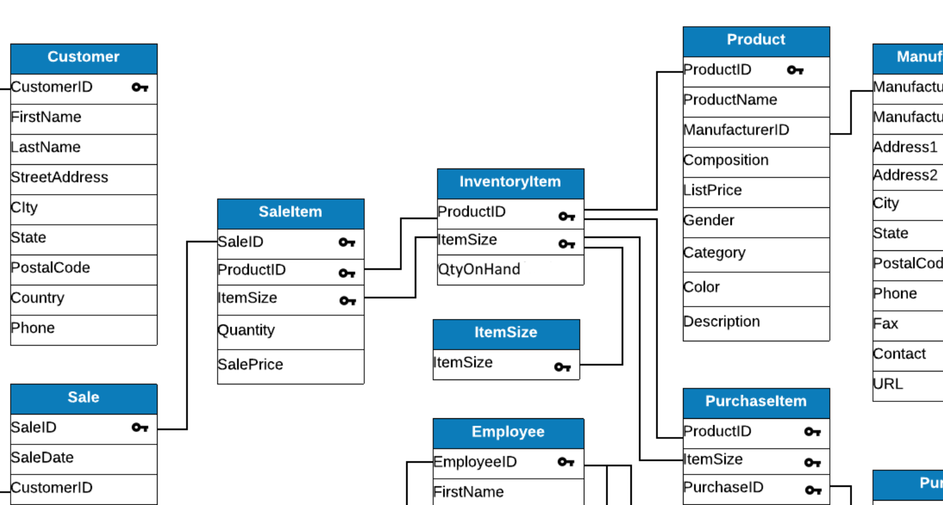
SELECT
CustomerID,
FirstName,
LastName,
ManufacturerName,
m.City,
c.City
FROM Manufacturer m
JOIN Customer c ON c.City = m.City

A limitation of join
One of the main limitations of join is that it produces repetition, which is redundancy. See this simple example:
Customers: Manufacturers:
Sara – Boston Nike – Boston
Amin – Boston Adidas – Boston

When we join these tables, we have:
Sara – Boston – Nike
Sara – Boston – Adidas
Amin – Boston – Nike
Amin – Boston – Adidas

It is not wrong (especially since this form is normal). But one other way to show it is:
Sara – Boston – Nike, Adidas
Amin – Boston – Nike, Adidas

This way of showing it is not normal, but it is easy to understand. How can we make it? With GROUP BY:
SELECT
c.CustomerID,
c.FirstName,
c.LastName,
c.City,
STRING_AGG(m.ManufacturerName, ', ') AS Manufacturers
FROM Customer c
JOIN Manufacturer m ON c.City = m.City
GROUP BY
c.CustomerID,
c.FirstName,
c.LastName,
c.City
ORDER BY c.City;

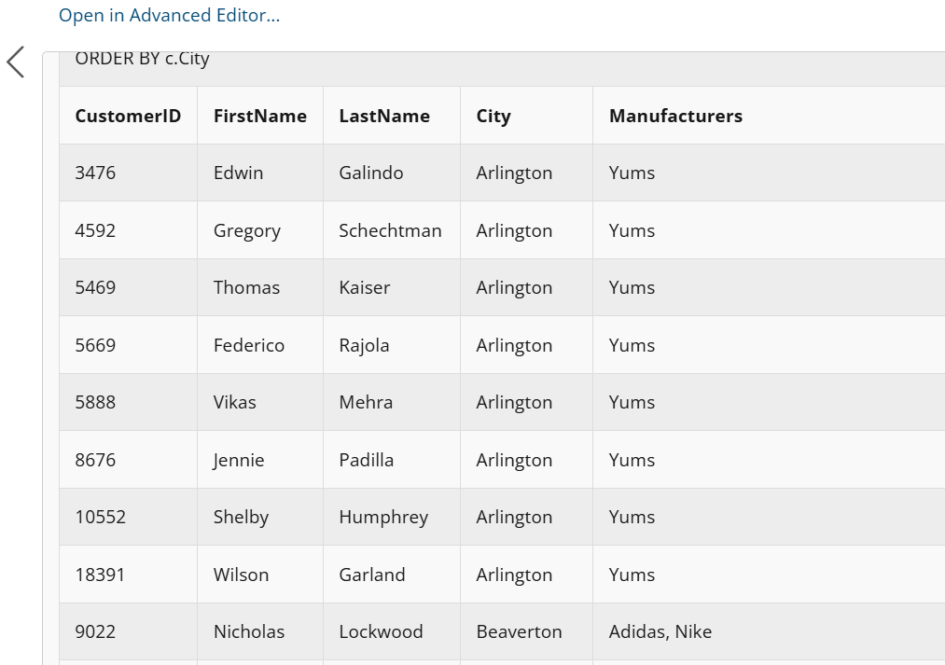
Therefore, we only have unique customers (customers do not repeat, but their cities repeat). BUT, this form is not normalized.

2. Joining a table to itself
One of the main uses of joining a table to itself is to show organizational hierarchy.
SELECT E.FirstName AS EmpFirstName,
E.LastName AS EmpLastName,
M.FirstName AS MgrFirstName,
M.LastName AS MgrLastName
FROM Employee E
JOIN Employee M
ON E.ManagerID = M.EmployeeID

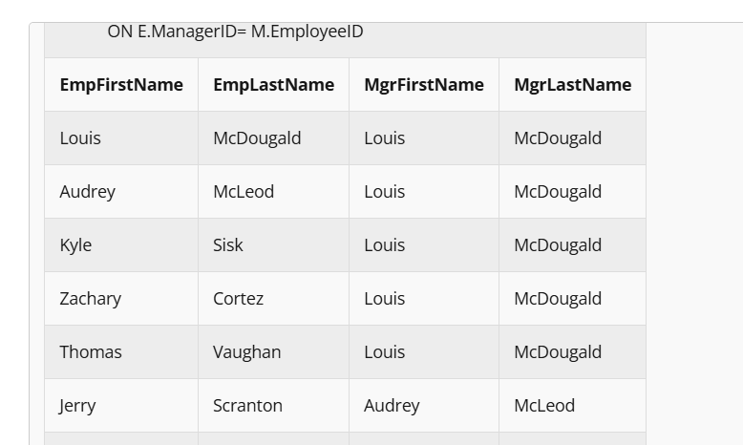

3. Joining multiple tables
Look at the database schema:
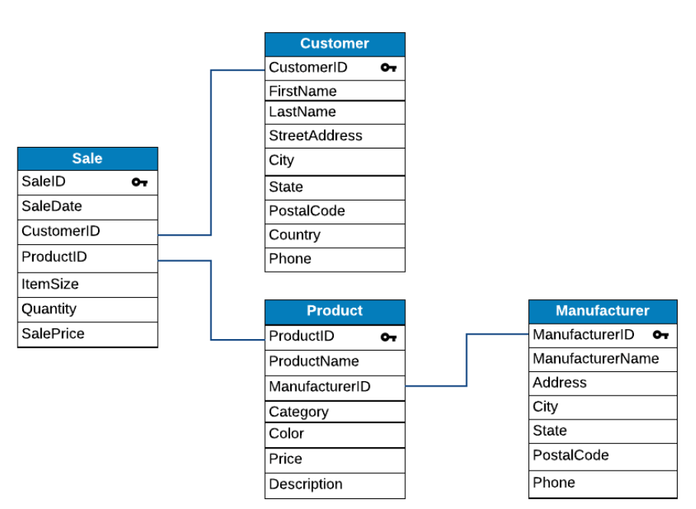

Joining 3 tables

Query: list products made in New Jersey that have sold in January.
SELECT DISTINCT ProductName
FROM Sale S
JOIN Product P
ON S.ProductID = P.ProductID
JOIN Manufacturer M
ON P.ManufacturerID = M.ManufacturerID
WHERE State = 'NJ'
AND MONTH(SaleDate) = 1

Another example:
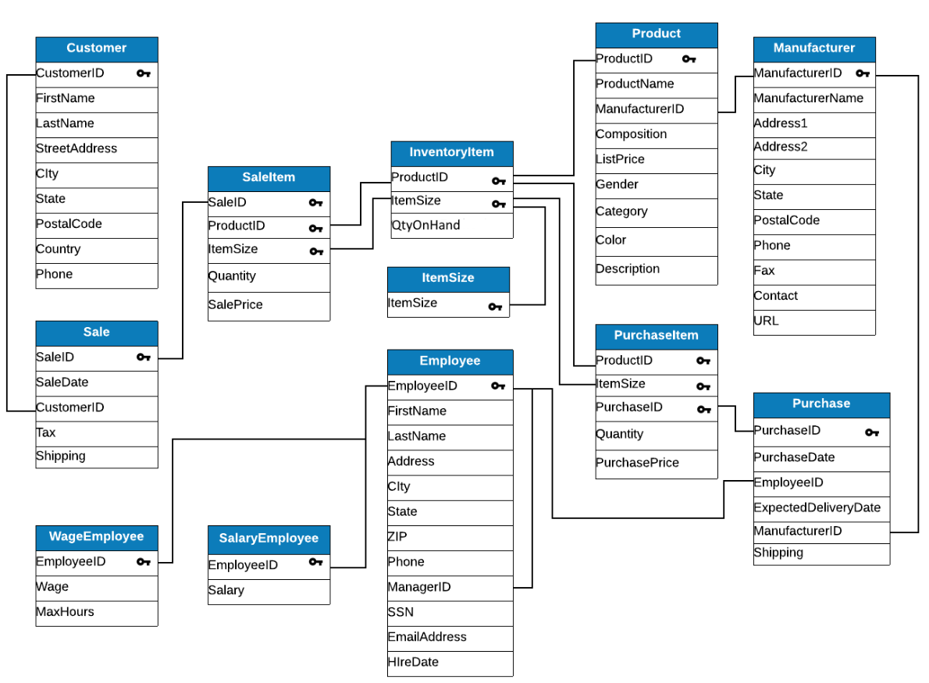

Query: list sales of black sneakers.
SELECT S.SaleDate,
P.ProductName,
P.Category,
P.Color,
SI.Quantity,
SI.SalePrice
FROM Sale S
JOIN SaleItem SI
ON S.SaleID = SI.SaleID
JOIN Product P
ON SI.ProductID = P.ProductID
WHERE Category = 'Sneakers'
AND Color = 'Black'

⚠️ Attention
We could also join SaleItem with InventoryItem first, then with Product. But as InventoryItem does not hold important data here, we can skip it and join SaleItem with Product through a non FK–PK join.

Joining four tables

Query: list products made in New Jersey sold to customers in Illinois.
SELECT ProductName
FROM Sale S
JOIN Product P
ON P.ProductID = S.ProductID
JOIN Customer C
ON S.CustomerID = C.CustomerID
JOIN Manufacturer M
ON P.ManufacturerID = M.ManufacturerID
WHERE C.State = 'IL'
AND M.State = 'NJ'

The final example

Query: list the customers who have made at least one purchase of a product from a manufacturer located in the same city as the customer. Return the customer’s first and last name, the manufacturer name, and the shared city (one row per matching customer–manufacturer pair), ordered by city.
SELECT DISTINCT
c.FirstName,
c.LastName,
m.ManufacturerName,
c.City
FROM Customer c
JOIN Sale s ON s.CustomerID = c.CustomerID
JOIN SaleItem si ON si.SaleID = s.SaleID
JOIN Product p ON p.ProductID = si.ProductID
JOIN Manufacturer m ON m.ManufacturerID = p.ManufacturerID
WHERE c.City = m.City
ORDER BY c.City;

In general, it’s easy to see that if we join n tables, we’ll have n−1 join conditions. Therefore, we can join as many tables as we need in order to answer a given query.

Join, 1987 style (in the WHERE clause)
In a prior version of SQL (the 1987 standard), the join condition was placed within the WHERE clause. The syntax is as follows:
- The tables to be joined are simply listed in the FROM clause, separated by commas.
- The joining conditions (i.e. the ON clause) are listed in the WHERE clause.

Query: list sales details for black sneakers.
SELECT S.SaleDate,
P.ProductName,
P.Category,
P.Color,
SI.Quantity,
SI.SalePrice
FROM Sale S, SaleItem SI, Product P
WHERE S.SaleID = SI.SaleID
AND SI.ProductID = P.ProductID
AND Category = 'Sneakers'
AND Color = 'Black'

Outer Join
An OUTER JOIN returns all rows from one (or both) of the tables, even if the matching criteria fails.

Left join
It takes the left table as the base and shows all of its rows plus their matched rows in the other table. Whenever it cannot find a match, it just puts NULL.
EmployeeID | EmployeeName | CustomerID | CustomerName | EmployeeID
01 | Alan | NULL | NULL | NULL
02 | Ahmad | 01 | Kim | 02
03 | Elli | 03 | John | 03
04 | Luke | 04 | George | 04
05 | James | 02 | Andrews | 05
06 | Alex | NULL | NULL | NULL

Right join
It takes the right table as the base and shows all of its rows plus their matched rows in the other table. Whenever it cannot find a match, it just puts NULL.
CustomerID | CustomerName | EmployeeID | EmployeeID | EmployeeName
01 | Kim | 02 | 02 | Ahmad
02 | Andrews | 05 | 05 | James
03 | John | 03 | 03 | Elli
04 | George | 04 | 04 | Luke
05 | Kevin | 07 | NULL | NULL
06 | Sam | 09 | NULL | NULL

Full outer join
Shows all rows of both tables:
EmployeeID | EmployeeName | CustomerID | CustomerName | EmployeeID
01 | Alan | NULL | NULL | NULL
02 | Ahmad | 01 | Kim | 02
03 | Elli | 03 | John | 03
04 | Luke | 04 | George | 04
05 | James | 02 | Andrews | 05
06 | Alex | NULL | NULL | NULL
NULL | NULL | 05 | Kevin | 07
NULL | NULL | 06 | Sam | 09

💡 How do I know which OUTER JOIN to use?
Use LEFT OUTER JOIN when you want to see all rows from the left table, including unmatched rows. (The left table is the first one listed.)
Use RIGHT OUTER JOIN when you want to see all rows from the right table, including unmatched rows. (The right table is the second one listed.)
Use FULL OUTER JOIN when you want to see all rows of both tables, even unmatched rows — i.e. when the matching criteria fails.

How to do an outer join
SELECT Attributes FROM Left_Table
LEFT/RIGHT/FULL OUTER JOIN Right_Table
ON Left_Table.Attribute = Right_Table.Attribute
WHERE ...

Suppose we have employee information and their purchases in two tables.

Example — left outer join

Query: list all salaried employees (EmployeeID, FirstName, LastName) along with the date and manufacturer ID of their December purchases. Include salaried employees that have made no purchases.
Left table: SalEmployee. Right table: DecPurchase.
SELECT E.EmployeeID, FirstName, LastName, PurchaseDate, ManufacturerID
FROM SalEmployee E LEFT OUTER JOIN DecPurchase P
ON E.EmployeeID = P.EmployeeID

It means: show all employees, whether they have purchased anything or not.
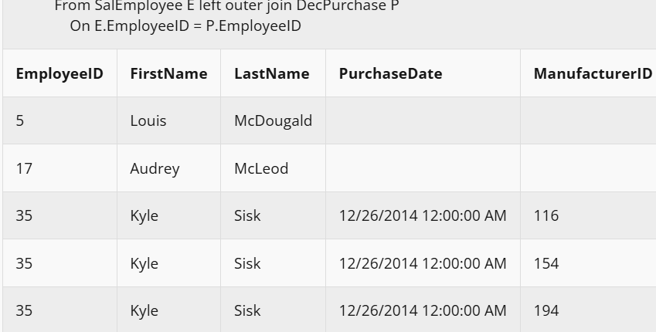

Example — right outer join

Query: list all the December purchases (PurchaseDate, ManufacturerID) and the associated salaried employees (EmployeeID, FirstName, LastName). Include all December purchases.
Left table: SalEmployee. Right table: DecPurchase.
SELECT E.EmployeeID, FirstName, LastName, PurchaseDate, ManufacturerID
FROM SalEmployee E RIGHT OUTER JOIN DecPurchase P
ON E.EmployeeID = P.EmployeeID

It means: show all the purchases, whether they are connected to any employee or not.
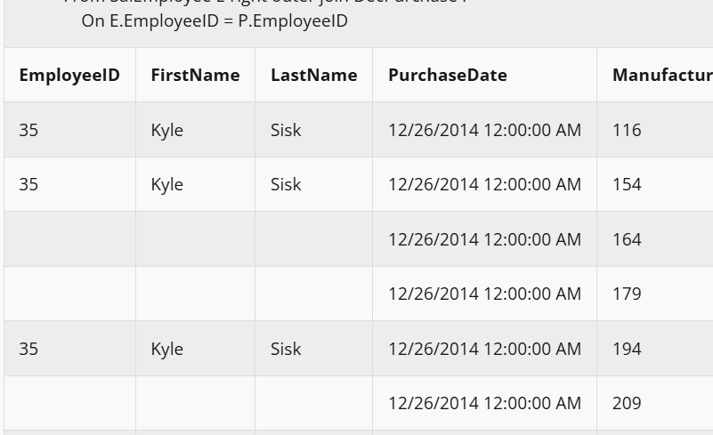

Example — full outer join

Query: list all salaried employees (EmployeeID, FirstName, LastName) and all December purchases (PurchaseDate, ManufacturerID), showing which December purchases were made by salaried employees.
SELECT E.EmployeeID, FirstName, LastName, PurchaseDate, ManufacturerID
FROM SalEmployee E FULL OUTER JOIN DecPurchase P
ON E.EmployeeID = P.EmployeeID

It means: show everything — the employees who purchased (inner join), the employees who have not purchased (left outer join), and the purchases that are not related to any employee (right outer join).
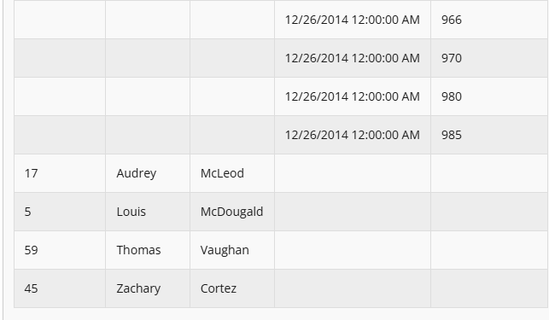

WHERE with outer joins — be careful
Attention: we can still use a WHERE clause with an outer join, but we have to make sure it does not turn the outer join into an inner join.
SELECT
W.EmployeeID, W.FirstName, W.LastName, W.City,
P.PurchaseDate, P.ManufacturerID
FROM
WgEmployee W LEFT OUTER JOIN DecPurchase P
ON W.EmployeeID = P.EmployeeID
WHERE W.City = 'San Diego'

In this example, the left outer join performs correctly, because the WHERE clause applies to the left table.
Now, suppose we want to see all the employees who purchased something in month 12 or have not purchased anything. If we write this query:
SELECT E.EmployeeID, FirstName, LastName, PurchaseDate, ManufacturerID
FROM SalEmployee E LEFT OUTER JOIN Purchase P
ON E.EmployeeID = P.EmployeeID
WHERE MONTH(PurchaseDate) = 12

First FROM applies (meaning the join is done). Second, WHERE applies (meaning only the ones with a purchase in month 12 are picked, so all rows without purchase data are dropped — but we wanted them). Third, SELECT applies.
It means the left outer join no longer has any effect. (We don’t see the employees who have not purchased anything.)

What is the solution?
There are two solutions:
- Using a view (we discuss this in Notebook 3.4).
- Using the condition inside the JOIN statement:
SELECT E.EmployeeID, FirstName, LastName, PurchaseDate, ManufacturerID
FROM SalEmployee E
LEFT OUTER JOIN Purchase P
ON E.EmployeeID = P.EmployeeID
AND MONTH(P.PurchaseDate) = 12

Here, first FROM applies (the join), and at the same time the month-12 check happens: if a match exists, use the data; if not, use NULL. Then SELECT applies. Therefore, the left outer join works properly.

Avoiding the Pitfalls in Join

Query: what is the average list price of products sold this month?
If we only wanted the average list price of products [not in any month], we would not need any joining:
SELECT AVG(ListPrice) FROM Product

BUT the Product table does not have any time attribute. So, to answer the query, we need to join tables.
OK — then let’s join tables. Suppose we have:
ProductID | Name | ListPrice
01 | A | 100
02 | B | 200
03 | C | 150

SaleID | CustomerID | SaleDate
001 | Amin | 03-06-2026
002 | Sadra | 02-06-2026
003 | Hossein | 31-05-2026

SaleID | ProductID | Quantity | SalePrice
001 | 01 | 10 | 1000
001 | 02 | 5 | 1000
002 | 03 | 1 | 150

Now suppose we join the tables and then calculate the average. The query would be:
SELECT AVG(ListPrice)
FROM Sale S
JOIN SaleItem SI ON S.SaleID = SI.SaleID
JOIN Product P ON SI.ProductID = P.ProductID
WHERE MONTH(SaleDate) = MONTH(GETDATE())

This means: we had two sales in June — 001 and 002. What has been counted? 100 + 100 + ... + 100 [10 times], as well as 150.
AVG = (10 × 100 + 150) / 11 = 104.54

-- But a better average would be:
AVG = (100 + 150) / 2 = 125

What if we calculate the average based on sale price instead of list price?
SELECT (SUM(SalePrice * Quantity) / SUM(Quantity)) AS WeightedAverageSalePrice
FROM Sale S
JOIN SaleItem SI ON S.SaleID = SI.SaleID
JOIN Product P ON SI.ProductID = P.ProductID
WHERE MONTH(SaleDate) = MONTH(GETDATE())

Another interpretation: we can check whether a product was sold in the month — if it was, count it in the average; if it was not, don’t count it.
SELECT AVG(ListPrice) AS AverageListPrice
FROM Product
WHERE ProductID IN
(SELECT ProductID
FROM SaleItem
WHERE SaleID IN
(SELECT SaleID
FROM Sale
WHERE MONTH(SaleDate) = MONTH(GETDATE())
)
)

⏭️ Coming up in Notebook 3.4
Advanced level II — subqueries/nested queries, views, temp tables, CTEs, and PARTITION BY + CTE.

