DATABASE MANAGEMENT AND DESIGN
A Practical Learning Series
Notebook 3.4
SQL and Data Analysis — Advanced Level II
Subqueries/Nested Queries, VIEW, Temp Tables, CTE, PARTITION BY + CTE
By Amin Amirkhalili
Business & Data Analyst
Based on Chapter 6 (Sections 6-6 and 6-8) of:
Database Management and Design
Gove Allen, PhD · Gary Hansen, PhD · Robert Jackson, PhD

About This Series
This notebook is part of a practical learning series on database management and design. The series follows a logical progression — from understanding business needs, through conceptual modelling, all the way to writing SQL code on real databases.
1 — Fundamentals
Notebook 1 | Introduction: The Database Is the Heart of Information Systems
2 — Database Management
Notebook 2.1 | Conceptual Data Model: From Conceptual Design to a Relational Model
Notebook 2.2 | Database Design: From Schema Creation to Data Management
3 — SQL & Data Analysis
Notebook 3.1 | Beginner Level: SELECT, FROM, WHERE, ORDER BY
Notebook 3.2 | Intermediate Level: Functions, GROUP BY, HAVING
Notebook 3.3 | Advanced Level I: Joining Tables — Inner & Outer Joins
Notebook 3.4 | Advanced Level II: Subqueries, Views, Temp Tables, CTEs ◀ You are here
Notebook 3.5 | Data Cleaning with SQL (coming soon)
4 — Data Mining
Notebook 4.1 | SQL in Data Mining (coming soon)

📌 What This Notebook Covers
Notebook 3.4 covers subqueries in the WHERE, SELECT, and FROM clauses (correlated and non-correlated), views, temp tables, CTEs, when to use each, and a practical PARTITION BY + CTE pattern. A practice version with runnable code is available on Google Colab.

Section 1 — Subqueries / Nested Queries
Definition: subqueries are queries that come inside an outer/main query.
- Subqueries can be non-correlated or correlated with the main query.
- Subqueries can come in the WHERE, SELECT, FROM, ... clauses.

1.1 Subqueries in the WHERE clause — non-correlated mode
Non-correlated subqueries are independent of the main queries that use them. Therefore, they run first. Then the main query runs.

Query: what are the categories of products made by manufacturers located in New Jersey?
SELECT DISTINCT Category
FROM Product
WHERE ManufacturerID IN
(SELECT ManufacturerID
FROM Manufacturer
WHERE State = 'NJ')

Subqueries offer a partial alternative to the join:
SELECT DISTINCT P.Category
FROM Product P
JOIN Manufacturer M ON M.ManufacturerID = P.ManufacturerID
WHERE State = 'NJ'

Another example — query: list sales of black sneakers.
With join:
SELECT S.SaleDate, P.ProductName, P.Category, P.Color,
SI.Quantity, SI.SalePrice
FROM Sale S
JOIN SaleItem SI ON S.SaleID = SI.SaleID
JOIN Product P ON SI.ProductID = P.ProductID
WHERE Category = 'Sneakers'
AND Color = 'Black'

With subqueries:
SELECT *
FROM Sale
WHERE SaleID IN
(SELECT SaleID
FROM SaleItem
WHERE ProductID IN
(SELECT ProductID
FROM Product
WHERE Category = 'Sneakers' AND Color = 'Black'))

1.2 Correlated subqueries
Correlated subqueries are subqueries whose value upon execution depends on the row being examined by the main query. In correlated subqueries, we usually need to make different copies of the main tables — one for the subquery and one to run the main query.
- Copy 1: list of employees’ salaries → join Employee E with SalaryEmployee SE.
- Copy 2: list of managers’ salaries → join Employee M with SalaryEmployee SM.

Query: list employees who receive a higher salary than their managers.
SELECT FirstName, LastName FROM Employee E
JOIN SalaryEmployee SE ON E.EmployeeID = SE.EmployeeID
WHERE SE.Salary > (SELECT SM.Salary FROM Employee M
JOIN SalaryEmployee SM ON M.EmployeeID = SM.EmployeeID
WHERE M.EmployeeID = E.ManagerID)

Query: for each manufacturer, show its higher-priced products. We define higher-priced products to be those whose list price is higher than the average list price for that manufacturer.
Again, we need two copies of the only table we need:
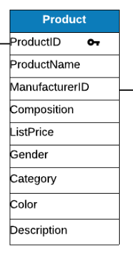
SELECT ManufacturerID,
ProductID,
ProductName,
ListPrice
FROM Product P1
WHERE ListPrice > (SELECT AVG(ListPrice)
FROM Product P2
WHERE P2.ManufacturerID = P1.ManufacturerID)
ORDER BY ManufacturerID

1.3 Subqueries in WHERE with aggregate functions

Non-correlated — query: which employees receive a higher-than-average salary?
SELECT FirstName, LastName, Salary
FROM Employee E JOIN SalaryEmployee SE ON E.EmployeeID = SE.EmployeeID
WHERE Salary >
(SELECT AVG(Salary)
FROM SalaryEmployee)

Correlated — query: which employees receive a salary higher than the average for employees reporting to the employee’s manager?
SELECT FirstName, LastName, Salary
FROM Employee E1 JOIN SalaryEmployee SE1 ON E1.EmployeeID = SE1.EmployeeID
WHERE Salary >
(SELECT AVG(Salary)
FROM Employee E2 JOIN SalaryEmployee SE2 ON E2.EmployeeID = SE2.EmployeeID
WHERE E2.ManagerID = E1.ManagerID)

1.4 What is the difference between IN and EXISTS in the WHERE clause?
SELECT *
FROM Customer
WHERE CustomerID IN
(SELECT CustomerID
FROM Sale);

SELECT *
FROM Customer C
WHERE EXISTS (
SELECT 1
FROM Sale S
WHERE S.CustomerID = C.CustomerID
);

IN and EXISTS are very similar, but:
- IN: it creates the list first, and then checks.
- EXISTS: it takes each row, and then checks.

1.5 Subquery in the SELECT clause

Non-correlated
SELECT A, B, C, (SELECT ... FROM ...) AS D FROM Table_Name
-- (SELECT ... FROM ...) → a constant: the same d for every row

A | B | C | D
 |  |  | d
 |  |  | d

Correlated
SELECT A, B, C, (SELECT ... FROM ...) AS D FROM Table_Name
-- depending on each row, D is different: d1, d2, d3, ...

A | B | C | D
 |  |  | d1
 |  |  | d2

Example:
SELECT CustomerID,
FirstName,
LastName,
(SELECT SUM(SalePrice * Quantity)
FROM SaleItem SI
JOIN Sale S ON SI.SaleID = S.SaleID
WHERE S.CustomerID = C.CustomerID) AS TotalSold
FROM Customer C

CustomerID | FirstName | LastName | TotalSold
 |  |  | d1
 |  |  | d2

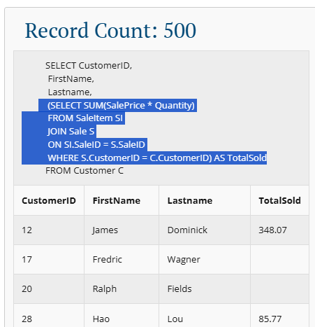

1.6 Subquery in FROM
As a subquery in SELECT makes a column, a subquery in FROM makes a table.
It creates a temporary table so we can select, join, or use WHERE on it.
The big difference between a subquery and a VIEW (which we define later in this document) is that a subquery is gone after the query finishes, BUT the view is permanent.

Query: show the total value of sales for each customer.
SELECT C.CustomerID,
FirstName,
LastName,
TotalSold
FROM Customer C
JOIN (SELECT CustomerID,
SUM(SalePrice * Quantity) AS TotalSold
FROM Sale S
JOIN SaleItem SI
ON S.SaleID = SI.SaleID
GROUP BY CustomerID) SumQuery
ON C.CustomerID = SumQuery.CustomerID

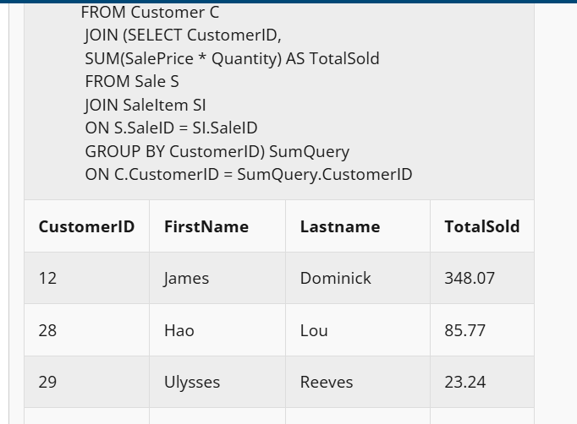
In fact, we use subqueries to break more complicated queries into two or more simple ones.
We could write this query without a subquery:
SELECT
C.CustomerID,
C.FirstName,
SUM(SI.SalePrice * SI.Quantity) AS TotalSales
FROM Customer C
JOIN Sale S
ON C.CustomerID = S.CustomerID
JOIN SaleItem SI
ON S.SaleID = SI.SaleID
GROUP BY
C.CustomerID,
C.FirstName

What is the difference between a subquery in SELECT and a subquery in FROM?
Subquery in SELECT | Subquery in FROM
Row-by-row calculation | Precomputed result set
Usually correlated | Usually non-correlated
Returns one value per row | Returns multiple rows and columns
Evaluated for each outer row | Evaluated once, then treated as a table
Often used for totals, counts, averages per row | Often used for aggregations and temporary tables before joins

All subqueries in one view
Subquery Location | Subquery Output | How Many Times Executed? | Correlated? | Main Purpose
SELECT | A single value (scalar) | Once per row | Usually yes | Calculate a column value for each row
FROM | A complete table (derived table) | Once | Usually no | Create a temporary table
WHERE | A value / list / condition | Depends on the type | Can be either | Filter rows

Section 2 — VIEW

What is a view in SQL?
A view, in fact, is a saved query. That is all. A view is not a table or anything else — just a query, so we do not need to write it out every time.

Why do we need views?
Views are useful for maintaining confidentiality (by restricting access to selected parts of the database) and for simplifying frequently used query types.

How to create a view
CREATE VIEW BasicEmployee AS
SELECT EmployeeID, FirstName, LastName, SSN, Phone, ManagerID
FROM Employee

This query is now saved as BasicEmployee.
We can also tell the view how to show the result of the saved query:
CREATE VIEW BasicEmployee (EmpID, FullName, Salary) AS
SELECT ID, Name, Wage
FROM Employee;

If we do not name the columns, it inherits them from the base table.
Sometimes there is not a single base table from which we want to create a view — we want to create a view from a joined table (which also needs to be created).

Query: information about women’s shoes made in California.
⚠️ Attention
Like creating tables in SQL, before we create a view, make sure there is not a view with that name already.

DROP VIEW IF EXISTS CalifWomenShoes;

CREATE VIEW CalifWomenShoes AS
SELECT ProductName,
ManufacturerName,
Category,
Color,
ListPrice
FROM redcat.Product P
JOIN redcat.Manufacturer M
ON P.ManufacturerID = M.ManufacturerID
WHERE Gender = 'F'
AND State = 'CA';

Examples of using the view:
SELECT * FROM CalifWomenShoes;

SELECT DISTINCT Color
FROM CalifWomenShoes
WHERE ManufacturerName = 'Fashion Lab'

💡 Remember
A view is saved in the database, so it exists until you delete it: DROP VIEW ...
A view is dynamic: if the base table info changes, the view also changes.

Views and the outer-join problem (from Notebook 3.3)
Remember: we can use a WHERE clause with an outer join, but we have to make sure it does not turn the outer join into an inner join.
SELECT
W.EmployeeID, W.FirstName, W.LastName, W.City,
P.PurchaseDate, P.ManufacturerID
FROM
WgEmployee W LEFT OUTER JOIN DecPurchase P
ON W.EmployeeID = P.EmployeeID
WHERE W.City = 'San Diego'

In this example, the left outer join performs correctly because the WHERE clause applies to the left table.
Now, suppose we want to see all the employees who purchased something in month 12 or have not purchased anything. If we write this query:
SELECT E.EmployeeID, FirstName, LastName, PurchaseDate, ManufacturerID
FROM SalEmployee E LEFT OUTER JOIN Purchase P
ON E.EmployeeID = P.EmployeeID
WHERE MONTH(PurchaseDate) = 12

First FROM applies (the join is done). Second, WHERE applies (only the ones with a purchase in month 12 are picked, so all rows without purchase data are dropped — but we wanted them). Third, SELECT applies. It means the left outer join no longer has any effect (we don’t see the employees who have not purchased anything).
There are two solutions: (1) using a view, or (2) using the condition inside the JOIN statement (covered in Notebook 3.3). Now we see solution 1.
Using a view, we first create the view. This means the WHERE happens first; then we join the tables:
CREATE VIEW DecPurchase AS
SELECT * FROM Purchase WHERE MONTH(PurchaseDate) = 12;

DecPurchase is a view showing all purchases in month 12. Then we join that view with Employee:
SELECT E.EmployeeID, FirstName, LastName, PurchaseDate, ManufacturerID
FROM SalEmployee E LEFT OUTER JOIN DecPurchase P
ON E.EmployeeID = P.EmployeeID

Using a view instead of a subquery
Example with a subquery:
SELECT *
FROM
(
SELECT Country,
AVG(Population) AS AvgPopulation
FROM Population
GROUP BY Country
) AS P
WHERE AvgPopulation > 60;

Now we use a view to replace the subquery:
CREATE VIEW CountryAverage AS
SELECT Country,
AVG(Population) AS AvgPopulation
FROM Population
GROUP BY Country;

-- Now:
SELECT * FROM CountryAverage
WHERE AvgPopulation > 60;

So, what is the difference between the subquery and the view here? The subquery runs only one time. But you can use the view as many times as you want in other scripts.

Section 3 — Temp Tables
Temp tables are temporary tables that can be used to avoid working on base tables — when we just want a part of a table, or we need to replace a query (replacing subqueries), such as a join or a subquery.
We create them exactly like base tables (to review how to create a table, see Notebook 2.2).
Let’s create a temp table:
DROP TABLE IF EXISTS #temp_amin

CREATE TABLE #temp_amin (
ID INT, FirstName VARCHAR(100), LastName VARCHAR(100), Age INT)

INSERT INTO #temp_amin SELECT ID, FirstName, LastName, Age FROM Amin

SELECT * FROM #temp_amin;

💡 Remember
A temp table is saved in memory. If we disconnect from the database and reconnect again, the temp table is gone.

As temp tables are built like base tables, we can also build them by copying from a table:
DROP TABLE IF EXISTS #temp_amin

SELECT * INTO #temp_amin
FROM Amin

Using temp tables instead of subqueries
Example with a subquery:
SELECT *
FROM
(
SELECT Country,
AVG(Population) AS AvgPopulation
FROM Population
GROUP BY Country
) AS P
WHERE AvgPopulation > 60;

With a temp table:
SELECT Country,
AVG(Population) AS AvgPopulation
INTO #CountryAverage
FROM Population
GROUP BY Country

-- Now:
SELECT * FROM #CountryAverage
WHERE AvgPopulation > 60;

Again, the subquery only runs once. But the temp table stays there, and you can change it without changing any base tables.
The difference between a view and a temp table: if the base table changes, the view is updated but the temp table is not. In this example, if some data changes in the Population table, the view sees it but the temp table does not.

Section 4 — CTE (Common Table Expression)
A CTE is also used to simplify big queries, helping to replace subqueries.
How to use it:
WITH CTE AS (SELECT ...)
SELECT * FROM CTE

Example (subquery):
SELECT * FROM
(SELECT * FROM Amin WHERE Gender LIKE 'Male') AS t

Now we use a CTE:
WITH cte_gender AS (SELECT * FROM Amin WHERE Gender LIKE 'Male')
SELECT * FROM cte_gender

💡 Remember
A CTE only exists if you run the query starting from WITH ... every time. If you only run "SELECT * FROM cte_gender" on its own, it gives an error.

So, how do we know when to use a subquery, a view, a temp table, or a CTE?
Let’s see it metaphorically:
- You are writing a report. In the middle of the report, you need to calculate the average 2026 sale amount of all products. This is a one-time job. So you use a subquery. DONE.
- Now, imagine that before you start the report, you calculate all the data you need up front, then use it in your report. You use a CTE: WITH cte_1 AS (SELECT ...), cte_2 AS (SELECT ...), then SELECT from them.
- Now, imagine you calculate something and write it on a piece of paper. You use it while writing the report, then throw it away. You use a temp table. You work on it — add something, update, delete, ...
- Now imagine you create a notebook, and later you can always refer back to it. You have a view.

Golden Comparison Table
Feature | Subquery | CTE | Temp Table | View
What is it? | A query inside another query | A named query | A temporary physical table | A saved query
Stores data? | ❌ No | ❌ No | ✅ Yes | ❌ No (usually)
Lifetime | Only during that part of the query | Only during the current query | Until the session ends | Until it is dropped
Reusable? | ❌ No | Only within the same query | ✅ Yes, within the same session | ✅ Yes, permanently
Readability | Low | High | High | High
Good for multi-step processing? | ❌ No | Limited | ✅ Yes | ❌ No

5-Second Rule (For Exams)
If the question asks for... | Use
A query inside another query | Subquery
Making a large query more readable | CTE (Common Table Expression)
Reusing the same query throughout the project | View
Storing intermediate results for multi-step processing | Temp Table

Section 5 — Using PARTITION BY + CTE
Suppose we have countries with COVID records over time. We want to calculate a measure based on their newest data.
First, we create a CTE:
WITH Latest AS (
SELECT
location,
continent,
date,
total_cases,
population,
ROW_NUMBER() OVER (PARTITION BY location ORDER BY date DESC) AS rn
FROM CovidDeaths
)

The result looks like:
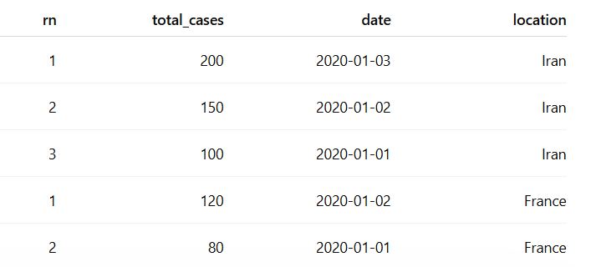
What ROW_NUMBER() OVER (PARTITION BY location ORDER BY date DESC) does is divide the table into sub-tables based on countries, count and name the rows as rn, and order them from the newest date to the oldest.
Then we want to select only the newest data, which means rn = 1:
SELECT
location,
date,
(CAST(total_cases AS DECIMAL(16,8)) / NULLIF(population, 0)) * 100 AS LatestInfectionRate
FROM Latest
WHERE continent IS NOT NULL
AND rn = 1
ORDER BY LatestInfectionRate DESC;

The final result is:
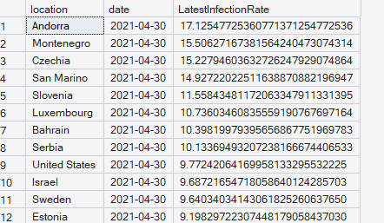
⏭️ Coming up in Notebook 3.5
Data Cleaning with SQL — CAST, REPLACE, and preparing messy data for analysis.

