COMMERCIAL INVOICE

NO. 20251124001 DATE: APR,29, 2026
Buyer & Consignee Party: MEDICO
PO.BOX:384
HOMS, SYRIA

WE DECALRE THAT THIS INVOICE SHOWS THE ACTUAL PRICE OF THE GOODS DESCRIBED AND THAT ALL PARTICULARS ARE TRUE AND CORRECT

Products Quantity Price Total Amount
ACYCLOVIR 2,500 KG USD 38.5/KG USD 96,250

BATCH NO.: A251219 MFG. DATE: 18,12, 2025 / EXP. DATE: 17,12, 2030
BATCH NO.: A251222 MFG. DATE: 21,12, 2025 / EXP. DATE: 20,12, 2030
BATCH NO.: A251224 MFG. DATE: 23,12, 2025 / EXP. DATE: 22,12, 2030
BATCH NO.: A251227 MFG. DATE: 26,12, 2025 / EXP. DATE: 25,12, 2030
BATCH NO.: A251228 MFG. DATE: 27,12, 2025 / EXP. DATE: 26,12, 2030
BATCH NO.: A251229 MFG. DATE: 28,12, 2025 / EXP. DATE: 27,12, 2030

TOTAL AMOUNT: ($96,250) SAY NINTY-SIX THOUSAND TWO HUNDRED AND FIFTY USD ONLY.
MANUFACTURER : ZHEJIANG ZHEBEI PHARMACEUTICAL CO.,LTD.
ORIGIN : CHINA
DELIVERY TERMS : CIF BEIRUT BY SEA IN TRANSIT TO DAMASCUS
PORT : FROM CHINA TO SYRIA
TERMS OF PAYMENT : THE INVOICE VALUE IS PREPAID
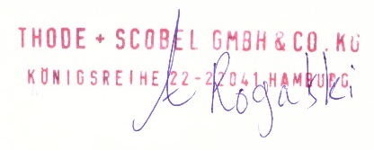
THODE + SCOBEL GMBH & CO. KG

