Packing and Weight List

NO. 20251124001 DATE: APR,29, 2026

Buyer & Consignee Party: MEDICO
PO.BOX:384
HOMS, SYRIA

PRODUCT: ACYCLOVIR
PACKED IN: 100 DRUMS OF 25 KG NET.

TOTAL NET WIGHT: 2,500.00 KGS
TOTAL GROSS WEIGHT: 2,800.00 KGS
TOTAL PACKAGES: 100 DRUMS ON 7 PALLESTS
DELIVERY TERMS: CIF BEIRUT BY SEA IN TRANSIT TO DAMASCUS

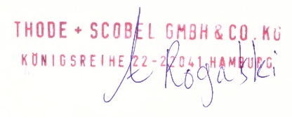
THODE + SCOBEL GMBH & CO. KG

