Packing and Weight List

NO. TYI261065 DATE: AUG.14,2026

Buyer & Consignee Party: MEDICO
PO.BOX:384
HOMS, SYRIA

PRODUCT: BRIVARACETAM
PACKED IN: 10KGS/DRUM*2, 5KGS/DRUM*1

TOTAL NET WIGHT: 25.00 KG
TOTAL GROSS WEIGHT: 34.30 KG
TOTAL PACKAGES: THREE (3) DRUMS OF BRIVARACETAM
DELIVERY TERMS: CIF BEIRUT BY SEA IN TRANSIT TO DAMASCUS

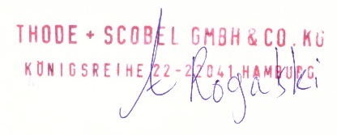
THODE + SCOBEL GMBH & CO. KG

