COMMERCIAL INVOICE

NO. 20260711001 DATE: AUGUST 16, 2026
Buyer & Consignee Party: MEDICO
PO.BOX:384
HOMS, SYRIA

WE DECALRE THAT THIS INVOICE SHOWS THE ACTUAL PRICE OF THE GOODS DESCRIBED AND THAT ALL PARTICULARS ARE TRUE AND CORRECT

Products Quantity Price Total Amount
ACYCLOVIR 1,500 KG USD 42/KG USD 63,000

BATCH NO.: A260516 MFG. DATE: 2026-05-16 / EXP. DATE: 2031-05-15
BATCH NO.: A260517 MFG. DATE: 2026-05-16 / EXP. DATE: 2031-05-15

TOTAL AMOUNT: (USD 63,000) SAY SIXTY THREE THOUSAND USD ONLY.
MANUFACTURER : ZHEJIANG ZHEBEI PHARMACEUTICAL CO., LTD.
ORIGIN : CHINA
DELIVERY TERMS : CIF BEIRUT BY SEA IN TRANSIT TO DAMASCUS
PORT : FROM CHINA TO SYRIA
TERMS OF PAYMENT : THE INVOICE VALUE IS PREPAID
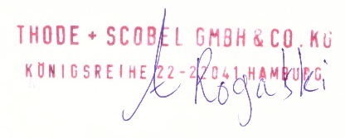
THODE + SCOBEL GMBH & CO. KG

