CERTIFICATE OF ANALYSIS

Product Name: |  | Test Date:
Net weight: |  | Batch No:
Manufacture Date: |  | Exp Date:

Items | SPECIFICATION | Result
Appearance |  | Conform
Identification |  | Conform
Melting point
Optical rotation
Heavy metals |  | <10mg/kg
Water
Residue on ignition |  | 0.22%
Isomers
Residual solvents
Related substances
Related substances | 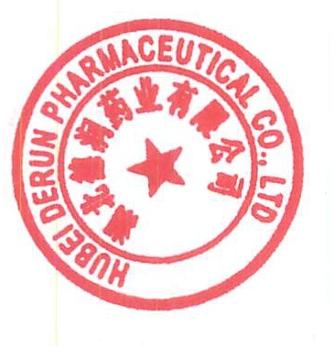
Assay (HPLC) |  | 97.5%
CONCLUSION:
Loss on drying
pH
As
Cadmium
Mercury
Lead
Coliforms

