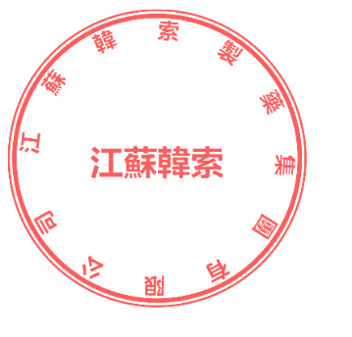
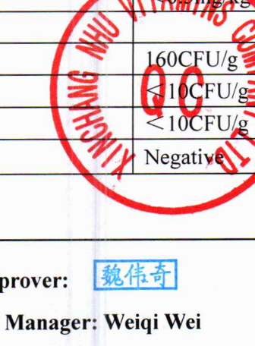
CERTIFICATE OF ANALYSIS
Product Name: β-Carotene 20% CWS/S
Batch No: YSC-1519-2601001
Manufacture Date: Oct.09,2025 | Exp Date: Oct.08,2027
Test Items | Specifications | Test Result
Appearance | Red to reddish-brown microcapsule. The product contain white particles of corn starch. | Qualified
Solubility | Dispersible in cool water forming an emulsion | Qualified
Identification | A. The absorbance ratio A455/A483 is between 1.14 and 1.18. **B. The retention time of the major peak of the Sample solution corresponds to that of the Standard solution, as obtained in the test for Content of Beta Carotene. | Qualified
Heavy metals | ≤10mg/kg | <10mg/kg
Assay | >20.0% | 21.0%
Loss on Drying | ≤5.0% | 3.2%
Colour intensity of aqueous solution | A(1%, 1cm) ≥140 | 204
Sieve Analysis | 100% Through Sieve No.20 (US) | 100%
 | ≥85% Through Sieve No.40 (US) | 87.8%
 | ≤15% Through Sieve No.100 (US) | 11.0%
*Arsenic | ≤1.0mg/kg | <1.0mg/kg
*Pb | ≤0.5mg/kg | <0.5mg/kg
*Cd | ≤0.5mg/kg | <0.5mg/kg
Total Plate Count | ≤1000CFU/g | 160CFU/g
Mould & Yeast | ≤100CFU/g | <10CFU/g
Coliforms | ≤10CFU/g | <10CFU/g
Salmonella | Negative (In 25g) | Negative
CONCLUSION | The Product Complies with The Requirements of The Above Specifications.

