COMMERCIAL INVOICE

NO. TYI261065 DATE: AUG.14,2026
Buyer & Consignee Party: MEDICO
PO.BOX:384
HOMS, SYRIA

WE DECALRE THAT THIS INVOICE SHOWS THE ACTUAL PRICE OF THE GOODS DESCRIBED AND THAT ALL PARTICULARS ARE TRUE AND CORRECT

Products Quantity Price Total Amount
BRIVARACETAM 25 KGS USD 400/KGS USD 10,000

BATCH NO.: 14200-260707 MFG. DATE: 2026.07.23 / EXP. DATE: 2030.07.22

TOTAL AMOUNT: (USD 10,000) SAY TEN THOUSAND USD ONLY.
MANUFACTURER : Zhejiang Tianyu Pharmaceutical Co., Ltd.
ORIGIN : CHINA
DELIVERY TERMS : CIF BEIRUT BY SEA IN TRANSIT TO DAMASCUS
PORT : FROM CHINA TO SYRIA
TERMS OF PAYMENT : THE INVOICE VALUE IS PREPAID
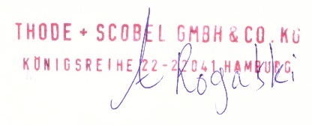
THODE + SCOBEL GMBH & CO. KG

