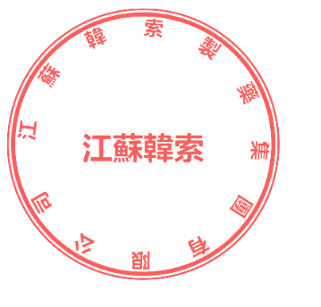

CERTIFICATE OF ANALYSIS
Product Name: PIZOTIFEN MALATE BP
Batch No: YSC-1519-2601001
Manufacture Date: 2026.03.03 | Exp Date: 2026.03.03
Test Items | Specifications | Test Result
Appearance | White or Almost crystalline powder | conforms
Solubility | Very slightly soluble in water, slightly soluble in ethanol (96%); sparingly soluble in methanol | conforms
Identification | Positive | conforms
Related substances | ≤0.5% | conforms
Assay | 98.5%~101.0% | 99.99%
Clarity and color of solution | Clear and not more than BY6 | <BY6
Sulphate ash | ≤0.2% | 0.03%
Loss on drying | ≤0.5% | 0.13%
CONCLUSION | The Product Complies with The Requirements of The Above Specifications.

