COMMERCIAL INVOICE

NO. 2746IN26 DATE: 25.06.2026
Buyer & Consignee Party: MEDICO
PO.BOX:384
HOMS, SYRIA

WE DECALRE THAT THIS INVOICE SHOWS THE ACTUAL PRICE OF THE GOODS DESCRIBED AND THAT ALL PARTICULARS ARE TRUE AND CORRECT

Products Quantity Price Total Amount
Bromfenac Sodium 0.500 KGS USD 10000/KGS USD 5,000

BATCH NO.: EL-05/A388/26003 MFG. DATE: MAY-2026 / EXP. DATE: APR-2031

TOTAL AMOUNT: (USD 5,000) SAY FIVE THOUSAND USD ONLY.
MANUFACTURER : Enaltec Labs Private Limited
ORIGIN : INDIA
DELIVERY TERMS : CIF BEIRUT BY SEA IN TRANSIT TO DAMASCUS
PORT : FROM CHINA TO SYRIA
TERMS OF PAYMENT : THE INVOICE VALUE IS PREPAID
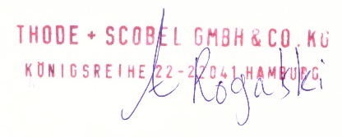
THODE + SCOBEL GMBH & CO. KG

