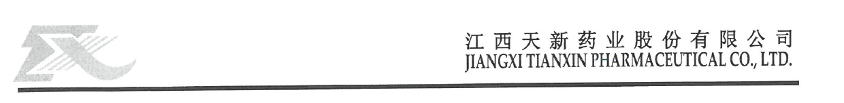
CERTIFICATE OF ANALYSIS

Product name: THIAMINE HYDROCHLORIDE Batch No: Y01202411219
Manufacturing date | FEB,27,2026 | Reporting date | FEB,28,2026
Exp date | FEB,27,2029 | Article No. | 06102
Package | 25 kg per drum | Order No | 26-26
Executive Standard | USP2025 | Quantity | 1000 Kg
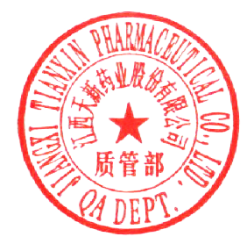
Test Item | Specification | Result
Appearance | White or almost white crystals or crystalline powder | White crystalline powder
Solubility | Sparingly soluble in water, slightly soluble in alcohol, very slightly soluble in chloroform | Comply
Identification | Meet the requirement  IR, Physical and chemical identification | ( 1 ) positive reaction
Assay | 98.0~102.0 | 99.9%
pH | 6.0~7.5 | 3.0
Loss on Drying | ≤1.0 | 0.26
Residue on Ignition | ≤0.2 | 0.06%
Chloride and Sulfate | ≤0.06 | <0.06
Related Compounds | ≤1.0 | 0.53
Residual Solvent (Methanol) | ≤3000 | < 0.3%
Conclusion: The batch complies with the specification of USP2025
Remake: preserve in a tightly closed container, protected from light.
Identification
Appearance of solution
Sulphates
Limit of nitrate
Lead
Cadmium
Mercury
Arsenic
Water
Absorbance of solution
Residual Solvents —Ethanol
Related substances —Impurity A
Related substances —Impurity B
Related substances —Impurity C
Related substances —Any impurity
Related substances —Total impurities
Chromatographic purity
Microbials —S. Aureus
Microbials —Salmonella
Microbials —E.Coli
Microbials —Total Plate Count
Microbials —Yeast and Mold
