Packing and Weight List

NO. 20260711001 DATE: AUGUST 16, 2026

Buyer & Consignee Party: MEDICO
PO.BOX:384
HOMS, SYRIA

PRODUCT: ACYCLOVIR
PACKED IN: OUTER PACKAGE: FIBER DRUM (25 KG/DRUM) INNER PACKAGE: TWO-LAYER PE BAGS

TOTAL NET WIGHT: 1,500.00 KG
TOTAL GROSS WEIGHT: 1,680.00 KG
TOTAL PACKAGES: TOTAL PACKED IN SIXTY (60) DRUMS ONLY
DELIVERY TERMS: CIF BEIRUT BY SEA IN TRANSIT TO DAMASCUS

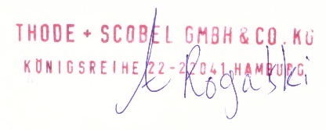
THODE + SCOBEL GMBH & CO. KG

