
Hunan KYF Pharmaceutical. Co., Ltd. KYF PHARM No. Jinshi Avenue, Industrial Park Hunan Province, 415400 China
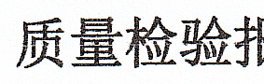
FRE
Certificate of Analysis
Pe eR  Product Name | — | ; Desoges | EAB  trel (CAS NO. : 54 | 024-22-5) | oo
KS  Batch No. | 1520260102F  | | RE  Quantity  | oo | 0.5¢ | Specification | EP 11.0
Ae ABA  Mfg. Date | 2026.01.16 | RE A  | Rep. Date | 2026.01.20 | BRA  Ret. Date  oe ee | 2030.01.15

Re Bl |  Items | br teBle  = Specification | Results
So eee eT |  Characters | Sey ST Sy ay Sy ST Oy a ate Say ae es ee Se eee  Piha ie ER  White or almost white crystalline powder. | Beare  White crystalline powder
Solubility | ARTETA, FRR a, TE  AKLBALA PT kT a.  Practically insoluble in water, very soluble in  , methanol, freely soluble in anhydrous ethanol  - and in methylene chloride. | “mee |  Conform
es yf | | AREAL EEL Sb PR Ss oe Pha wt A A — 2  | IR: Identical to reference standard | Conform
| Identification | | Be We BE  Specific optical rotation | Conform
Chere  Specific optical rotation  | AR  Related substance | : ee eee  453° ~+57° (UF eRdhtT, Dried substance)  #2) Impurity A <0.2%  #2) Impurity B<0.2%  32 i Impurity C <0.2%  245% Impurity D <0.1% | +56°  0.03%  0.02%  N/D  0.01%
 | 28 Total Impurities<0.5%  FARE Methanol <3000ppm |  JEG Hexyl hydride <290ppm | 6.11%  101ppm |  a
| INESIAUAL OOIVENT | | RAs OUra = ECUPAMYOrOhurdi —/ 2uppil :  JERR Dipropylmethane <5000ppm | | LNG RP ;  po
 | EER Aceticacid<5000ppm ts | N/D
Loss on Drying | |  <0.5% | 0.2%
RIS  Sulfated ash |  | 0.04%
ee  Assay | | 98.0% ~102.0%(AF edit, Dried substance) | 99.89%
ALR  Particle Size | D90<20pm | Conform
Be  Conclusion | Conform | meee oO
Reported by va 7 | | Checked PPSSE 5.96 9 | ee  Pou Gm a | eckKe by _ ? §? w/AY OC | Pu.

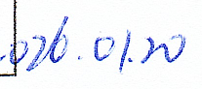
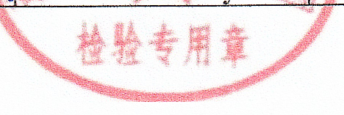
3

