Packing and Weight List

NO. 2746IN26 DATE: 25.06.2026

Buyer & Consignee Party: MEDICO
PO.BOX:384
HOMS, SYRIA

PRODUCT: Bromfenac Sodium
PACKED IN:

TOTAL NET WIGHT: 500.00 G
TOTAL GROSS WEIGHT: 1.75 KG
TOTAL PACKAGES: 1.00 DRUM
DELIVERY TERMS: CIF BEIRUT BY SEA IN TRANSIT TO DAMASCUS

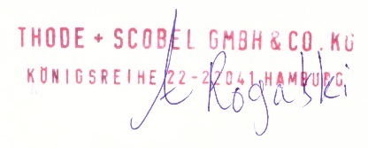
THODE + SCOBEL GMBH & CO. KG

