
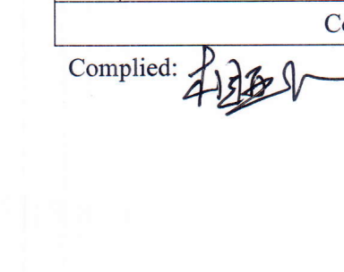
CERTIFICATE OF ANALYSIS
Product Name: Vonoprazan Fumarate
Batch No: YSC-1519-2601001
Manufacture Date: 2025-AUG-05 | Exp Date: 04/01/2030
Test Items | Specifications | Test Result
Appearance | White or off-white crystalline powder | Conforms
Solubility | Soluble in dimethyl sulfoxide, sparingly soluble in N,N-dimethylacetamide, slightly soluble in methanol and in water, practically insoluble in acetonitrile and in ethyl acetate | Conforms
Identification | A. HPLC:The retention time of the major peak of the Sample solution corresponds to that of the Reference solution, as obtained in the Assay. B. IR:Compare the infrared absorption spectrum of vonoprazan fumarate and that of the Reference Standard: both spectra exhibit similar intensities of absorption at the same wave numbers. | Conforms
Water | ≤0.5% | 0.01%
Residue on ignition | ≤0.1% | 0.03%
Heavy metals | ≤10ppm | Conforms
Related substances | Impurity D:≤0.15% | 0.04%
Related substances | Impurity E:≤0.15% | Not detected
Related substances | Impurity F:≤0.15% | 0.03%
Related substances | Impurity I:≤0.15% | Not detected
Related substances | Impurity O:≤0.30% | 0.04%
Related substances | Other single impurity:≤0.1% | 0.02%
Related substances | Total impurities:<1.0% | 0.13%
Residual solvents I | Acetonitrile:≤0.041% | Not detected
Residual solvents I | Methanol:≤0.3% | 0.01%
Residual solvents I | Dichloromethane:≤0.06% | Not detected
Residual solvents I | Tetrahydrofuran:≤0.072% | Not detected
Residual solvents I | Ethyl acetate:≤0.5% | Not detected
Residual solvents 2 | Triethylamine:≤0.5% | Not detected
Residual solvents 2 | N,N-Dimethylacetamide:≤0.109% | Not detected
Assay | ≥98.5% (Anhydrous basis) | 99.7%
PSD | D90≤50μm | 49.9μm
CONCLUSION | The Product Complies with The Requirements of The Above Specifications.

