

YILDIZ TECHNICAL UNIVERSITY
FACULTY OF ELECTRICAL AND ELECTRONICS ENGINEERING
COMPUTER ENGINEERING DEPARTMENT

SENIOR PROJECT

DATA MINING FOR E-COMMERCE

Project Supervisor: Asist. Prof. Banu DİRİ

Project Group
03011107 Sedat SEVGİLİ

İstanbul, 2010

© All rights reserved to Yıldız Technical University, Computer Engineering Department.

CONTENT
FIGURE LIST iii
TABLE LIST iv
ABSTRACT v
ÖZET……………………………………………………………………………………vi
1. INTRODUCTION 1
1.1. Data Mining vs. Classic Statistics 1
1.2. Data in E-Commerce Applications 3
2. SYSTEM ORGANIZATION 4
2.1. Getting Data From E-Commerce Sites 4
2.1.1. Data Templates 4
2.1.2. Export Modules 9
2.1.3. Signing Up 11
2.2. Handling Data Mining Methods 11
2.3. Giving Results Back 11
3. PRE-EXAMINING AND FEASIBILITY 12
3.1. Technical Feasibility 12
3.1.1. Hardware Feasibility 12
3.1.2. Software Feasibility 12
3.2. Economic Feasibility 13
3.3. Time Feasibility 14
4. DEVELOPING STEPS 15
4.1. Administration Development 15
4.2. Usage Development 19
4.3. 4.2.1 Sites 20
4.4. 4.2.2 Imported Data 20
4.5. 4.2.3 An Example Of Analysis with Naive Bayes Classifier 21
5. PERFORMANCE MEASUREMENTS 24
6. CONCLUSION 27

FIGURE LIST
Figure 1.1 Prestashop Stats Page
Figure 2.2 Products Xml Template
Figure 2.3 Customers Xml Template
Figure 2.4 Visitors Xml Template
Figure 2.5 Orders Xml Template
Figure 2.6 Visits Xml Template
Figure 2.7 UML Diagram of Prestashop Catalog Export Module
Figure 2.8 UML Diagram of Prestashop Customer Export Module
Figure 2.9 UML Diagram of Prestashop Order Export Module
Figure 2.10 UML Diagram of Prestashop Stat Export Module
Figure 3.11 Gantt Diagram
Figure 4.1 E-R Model
Figure 4.13 Uml Diagram of Basic Classes
Figure 4.14 Model Uml Diagram
Figure 4.15 Module Structure
Figure 4.16 View Uml Diagram
Figure 4.17 Controller Uml Diagram
Figure 4.18 Admin Login Page
Figure 4.19 Admin Menu
Figure 4.20 Member Menu
Figure 4.21 Member Sites
Figure 4.22 Add Import
Figure 4.23 Import List
Figure 4.24 Selecting Imported Data To Analyze
Figure 4.25 Choosing Class Between Attributes
Figure 4.26 Creating Test Data Set
Figure 4.27 Analyze ResultTABLE LIST
Table 2.1 Products Excel Template
Table 2.2 Customers Excel Template
Table 2.3 Visitors Excel Template
Table 2.5 Visits Excel Template
Table 5.6 Performance Measurements of Decision Tree Classification with 1 Sample
Table 5.7 Performance Measurements of Decision Tree Classification with 3 Samples
Table 5.8 Performance Measurement of Naive Bayes Classification with 1 Sample
Table 5.9 Performance Measurement of Naive Bayes Classification with 3 Samples
ABSTRACT
Nowadays, thanks to expanding of world wide web, online shopping has becomed a new trend of trading. This new trend arising has caused new opportunuties for saling and shopping, and also distributing. In consequence of this progress, many trade companies have started to use some specific web tools, named as e-commerce, to reach more customers.
The aim of this project is to provide data-mining tools for e-commerce companies like analysing customer habits, giving results of new trends, using basket analysis, etc.
To use this system, first of all, e-commerce site administrators will sign the system up and transfer their catalog, order and customer data. Then they will run data analysers in the system and get results of in many ways like saving as files, visualizing on their web based systems, or getting raw data results to refactor or preapare them before presenting.
With using the system, e-commerce system owners will have more chances to estimate new trends, more knowledge about their customers and more knowledge about what kind of products they can sale more easily.

ÖZET
Günümüzde, dünya çapındaki ağın genişlemesi sayesinde, internet üzerinden alışveriş yapmak yeni bir alışveriş trendi haline gelmiştir. Bu trendin ortaya çıkması yeni satış, alış ve de dağıtım olanaklarının doğuşuna yol açmıştır. Bu sürecin sonucu olarak, birçok ticari şirket daha çok müşteriye ulaşabilmek için, e-ticaret olarak da adlandırılan, bazı özel web tabanlı sistemleri kullanmaya başlamışlardır.
Projenin amacı e-ticaret şirketlerine müşterilerinin alışkanlıklarını analiz edebilecek, yeni trend sonuçlarını verebilecek, sepet analizinin kullanılmasına olanak verecek veri madenciliği araçlarını sunmaktır.
Sistemi kullanmak için, öncelikle e-ticaret site yöneticileri sisteme kaydolacaklar, katalog, sipariş ve müşteri bilgilerini sisteme ekleyeceklerdir. Daha sonra sistem içinde bulunan veri analizcileri yardımıyla istedikleri sonuçları dosyalara kaydetmek, kendi web tabanlı sistemlerinde göstermek, ön işlemeye tabi tutabilmek için ham verileri almak şeklinde çeşitli şekillerde elde edebileceklerdir.
E-ticaret sistem sahipleri bu sistemi kullanarak yeni trendleri yakalama konusunda daha fazla şans elde edecekler, müşterileri hakkında daha fazla bilgiye sahip olacaklar ve de hangi ürünleri daha kolay satabilecekleri hakkında bilgi edinebileceklerdir.

INTRODUCTION
Day by day, online trading volume is growing up because of expanding of web usage. In return of this progress, count of IT products and companies that providing online shopping infrastructure are increasing directly. This increasement triggers competitive intensity between IT companies works on electronic commerce and pushing them to find new different ways to get more profit. E-commerce companies, want to get more profit easily, organize some campaigns, rebates and look for ways on reaching more customers or making their customers to more buy. To get maximum profit from their customers without changing customer portfoilo, they analyze their customers’ usages statistically and in that point, data mining becomes more valuable.
In the past, classical statistical approaches could be enough to determine getting information from order, catalog and customer data. However, because of increasement of competitive intensity between e-commerce companies and development of getting useful information in real life from raw data in reasonable time has increased value of using data mining approach.

Data Mining vs. Classic Statistics
Actually, data mining approach and classic statistic approach are not real competitors theorically. In fact, most data mining subjects includes many statistical rules. However, in many data oriented applications, includes some e-commerce applications like Prestashop and oscommerce even, only classic statistic methods are in use.
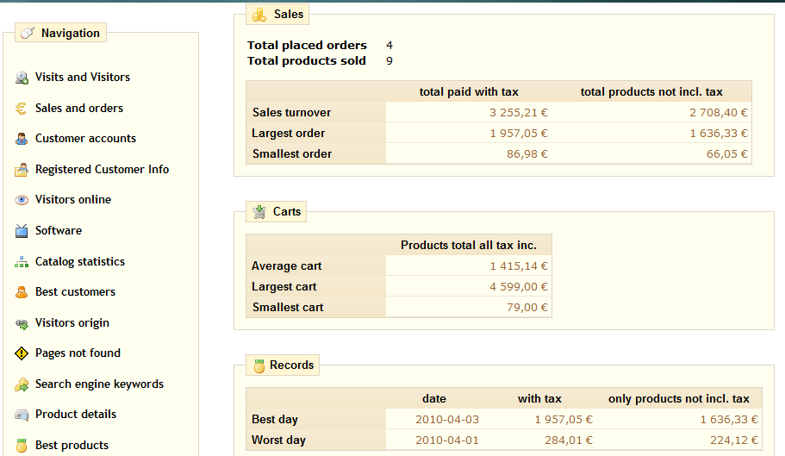
Figure 1.1 Prestashop Stats Page
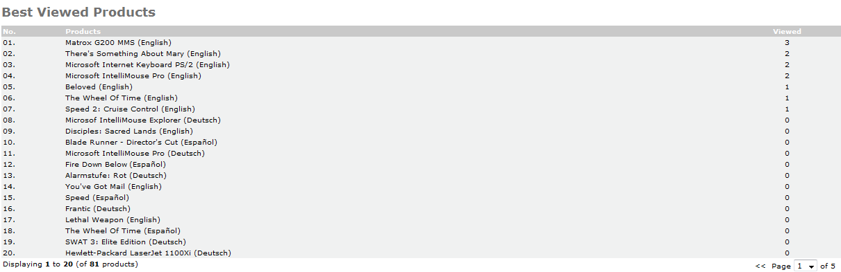
Figure 1.1 Oscommerce Stats Page
In kind of these applications, recorded data can be viewed in sensible groups but they cannot give information based on real life. With statistical solutions, e-commerce administrators can see which most products are saled in specific times but they can not see which most products will be saled in future. They can see which customers have shopped more but they can’t see what kind of customers have bought what kind of products. At these and similar points, using data mining methods to get useful informations about sales and customers becomes necessary.

Data in E-Commerce Applications
Generally, these three data models are basis of e-commerce applications: catalog, customers and orders. In catalog model, products are at the core and categories and brands are bound products. Furthermore, products can have attributes and options with different prices, images, details and labels. And also products can have more than one categories and brands. In customer models, beside base customer data like name, age, sex, location, etc., page visit data can be vary and valuable to classifying or clustering processes. And in the order models, there can be more than one product and attributes or options of products data with can differ in price, currency data has been saved when orders accepted, customer data and billing and shipping addresses.
Because of these three data models are more common[1], they have been chosen to design data transfer templates between e-commerce sites and the system.

SYSTEM ORGANIZATION
The all system consists of three parts basically: getting data from e-commerce sites, handling data mining methods and giving processed results back.

Getting Data From E-Commerce Sites
Before modules that create data to mine in the system have been designed, data templates are created for standardizing input anda output between e-commerce sites and the systems. Until now, two output types have been used: getting data into xml files, getting data into Excel files. After the main system implemented, web services between e-commerce sites and the system will be ready to use.

Data Templates
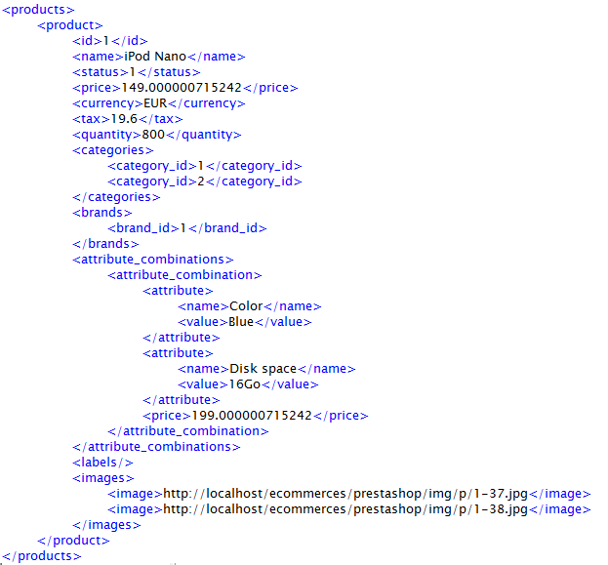
Figure 2.2 Products Xml Template
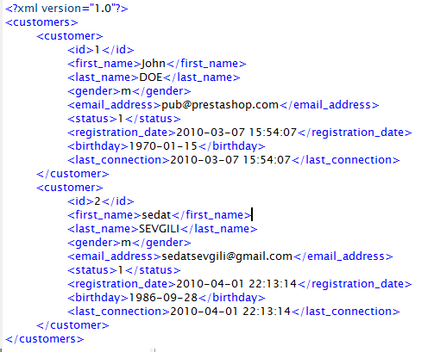
Figure 2.3 Customers Xml Template
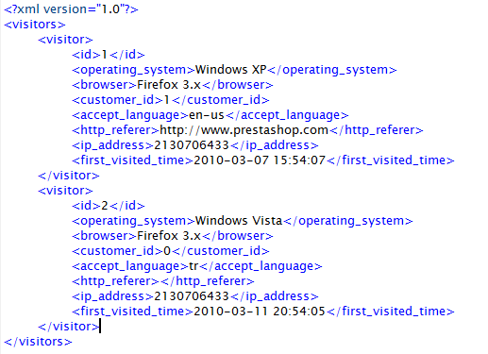
Figure 2.4 Visitors Xml Template
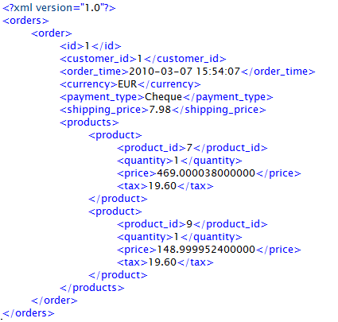
Figure 2.5 Orders Xml Template
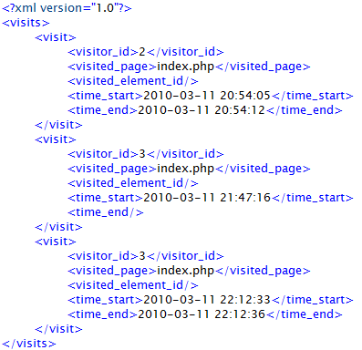
Figure 2.6 Visits Xml Template

Table 2.1 Products Excel Template
ID | NAME | CAT1 | BRAND1 | STATUS | PRICE | TAX | QUANTITY | LABEL1
1 | iPod Nano | 1 | 1 | 1 | 149 | 19,6 | 800
2 | iPod shuffle | 1 | 1 | 1 | 78,99999 | 19,6 | 100
5 | MacBook Air | 4 | 1 | 1 | 1799 | 19,6 | 274
6 | MacBook | 1 | 1 | 1 | 1400 | 19,6 | 250 | apple
7 | iPod touch | 1 |  | 1 | 289 | 19,6 | 180 | Ipod touch

Table 2.2 Customers Excel Template
ID | FIRST  NAME | LAST  NAME | GENDER | EMAIL | REG  DATE | BIRTH  DAY
1 | John | DOE | Male | pub@prestashop.com | 2010-03-07 15:54:07 | 1970-01-15
2 | sedat | SEVGILI | Male | sedatsevgili@gmail.com | 2010-04-01 22:13:14 | 1986-09-28

Table 2.2.3 Visitors Excel Template
ID | OSNAME | BROWSER | CUSTOMER  ID | LANGUAGE | FIRSTTIME
1 | Windows XP | Firefox 3.x | 1 | en-us | 2010-03-07 15:54:07
2 | Windows Vista | Firefox 3.x | 0 | tr | 2010-03-11 20:54:05
3 | Windows Vista | Firefox 3.x | 0 | tr | 2010-03-11 21:47:16
4 | Windows Vista | Firefox 3.x | 0 | tr | 2010-03-12 21:31:41
5 | Windows Vista | Firefox 3.x | 0 | tr | 2010-03-15 20:19:57
6 | Windows Vista | Firefox 3.x | 0 | tr | 2010-03-16 20:36:46
7 | Windows Vista | Firefox 3.x | 0 | tr | 2010-03-18 21:40:33

Table 2.4 Orders Excel Template
ORDER  ID | CUSTOMER  ID | ORDER  TIME | CURRENCY | PAYMENT  TYPE | SHIPPING  PRICE
1 | 1 | 2010-03-07 15:54:07 | EUR | ChÃ¨que | 7,98
2 | 2 | 2010-04-01 22:18:53 | EUR | Cheque | 7,98
3 | 2 | 2010-04-01 22:19:45 | EUR | Bank Wire | 7,98
4 | 2 | 2010-04-03 23:23:36 | EUR | Bank Wire | 0
5 | 2 | 2010-04-04 16:33:41 | EUR | Bank Wire | 0
Table 2.5 Visits Excel Template
VISITORID | PAGE | ELEMENTID | STARTTIME | ENDTIME
2 | index.php |  | 2010-03-11 20:54:05 | 2010-03-11 20:54:12
3 | index.php |  | 2010-03-11  21:47:16
3 | index.php |  | 2010-03-11 22:12:33 | 2010-03-11 22:12:36

Export Modules
To implement getting raw data from e-commerce site sequence, two open source e-commerce applications have been choosen for now: Prestashop, Oscommerce. Prestashop is an OOP based application and to add a module that can create output the system need, this OOP approach is used. In Prestashop administration mechanism, tab objects are core modules can provide display forms and process post values. So, these four tab classes are written to manage exporting data: AdminCatalogExporter, AdminCustomerExporter, AdminOrderExporter and AdminStatExporter.
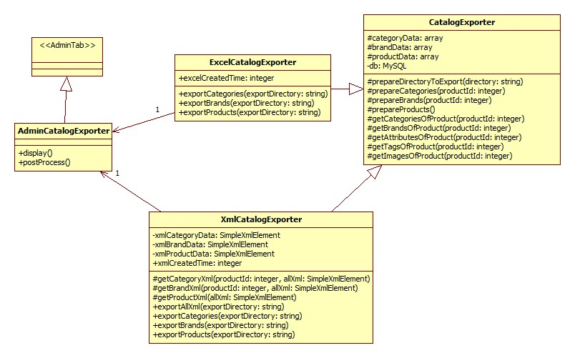
Figure 2.7 UML Diagram of Prestashop Catalog Export Module
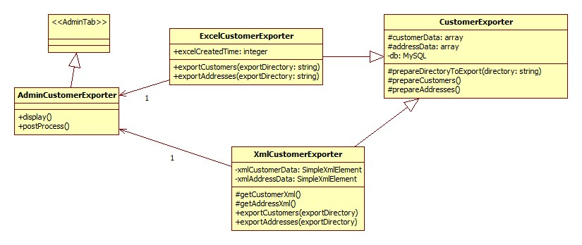
Figure 2.8 UML Diagram of Prestashop Customer Export Module
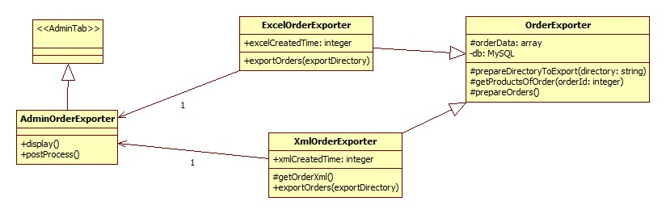
Figure 2.9 UML Diagram of Prestashop Order Export Module
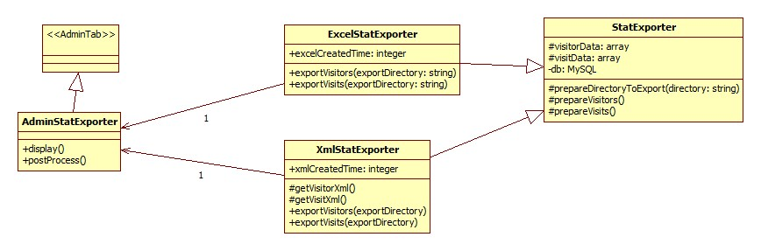
Figure 2.10 UML Diagram of Prestashop Stat Export Module

Because of creating modules on oscommerce can give catalog, order and customer outputs are not finished yet, documentation about that modules are not included in that report.

Signing Up
E-commerce administrators want to use the data mining system will be have to sign the system up. So, they will be able to fetch their unique results.

Handling Data Mining Methods
Data mining methods that e-commerce administrators will use can basically seperate into four groups: Classifying Methods, Clustering Methods, Regression Methods and Association Rule Learning Methods. Before applying these methods, there will be also preprocessing methods for specific process like fraud detection. Administrators will be able to choose methods in one of these methods after preprocessing and get results in way they will want.

Giving Results Back
There will be three ways to get mined data: saving results into a xml or excel file, transferring results to e-commerce sites via web services, and displaying results in the main system panel. E-commerce administrators will be able to save results in different times and will be able to fetch them in those three ways again when they want.

PRE-EXAMINING AND FEASIBILITY
Technical, economic and time feasibilities of this project is listed here.

Technical Feasibility
Technical feasibility is examined in two groups: hardware feasibility, software feasibility.

Hardware Feasibility
To run this system in stability, minimum hardware specifications are:
1400 Mhz processor
256 Mb memory
1 Gb harddisk
The recommended hardware specifications are:
3 Ghz processor
2 Gb memory
10 Gb harddisk

Software Feasibility
To implement the system, web scripting languages have been considered first, because e-commerce administrators will already be online mostly, and a web based system will make easier them to use the system. So, PHP is chosen to implement the system through web scripting languages because of OOP support, flexibility about using types, functions, methods and classes, many libraries include functions will be need and finally free for using non-commercial applications.
Beside PHP, Apache web server is chosen to run PHP codes, Mysql is chosen to use relational database management server because of being free for non-commercial applications, good suitability with PHP about performance and easily reaching well documentations.
Through operating systems, Ubuntu 9.10 is chosen because of being free to use, good suitability with PHP and Mysql about performance.
Beside all, to develop the system more reliably, an svn server and an svn client programs used.
Through IDE’s, Netbeans is chosen because of good PHP support like code completion, well svn support and being free.

Economic Feasibility
There is the examined economic feasibility table about implementing this system:
Table 3.1 Economic Feasibility
Main Computer | 1500 $
Worker Salary(4 months) | 4266 $
SDSL Connection with 1000mb/s, 2048 Gb bandwidth(4 months) | 1600 $
Total | 7366 $

Time Feasibility
The gantt diagram for this project is here:
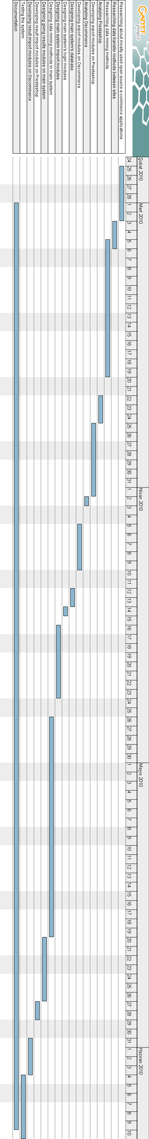
Figure 3.11 Gantt Diagram

DEVELOPING STEPS
Development steps can be seperated two groups basically: administration development, usage development.

Administration Development
To implement system, data models are defined first. There are these 8 data models for now: Accounts, Classifiers, Clusterers, Imports, Import Types, Import Fields, Sites and Users.
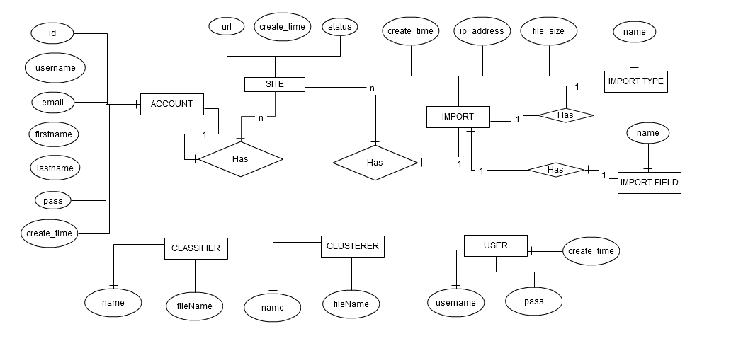
Figure 4.12 E-R Model

To implement system, these basic php classes is written for error handling, database, session and data transfer operations: Ajax, DB, Error, Lib and Runner.
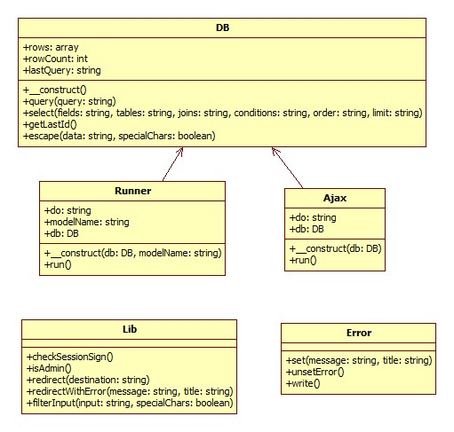
Figure 4.13 Uml Diagram of Basic Classes

When data models are set, php modules is written to enabling administration. In this modular structure, for each data models, a model class is written into “bean” directory and a directory is created in same name with model. In each model directories, php pages is written to provide adding, updating and deleting these models.
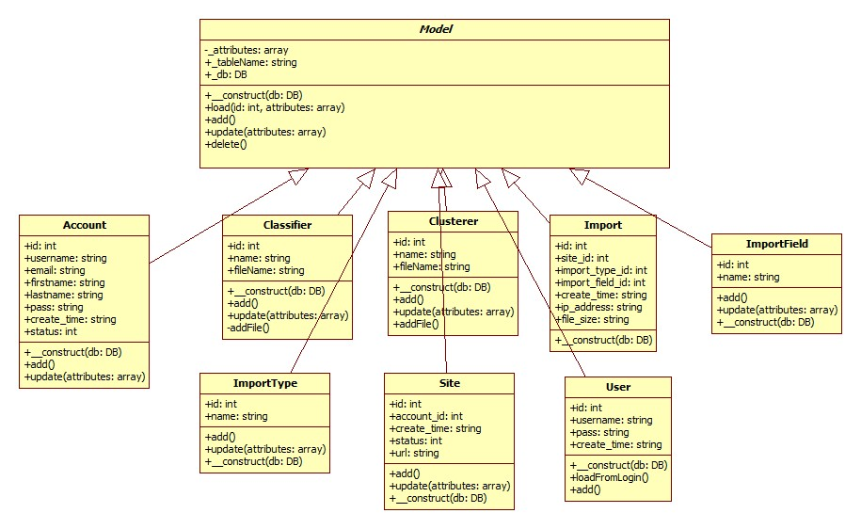
Figure 4.14 Model Uml Diagram
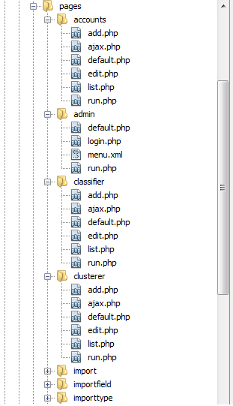
Figure 4.15 Module Structure
To make easier administrating these models and modules, some view classes are responsible for viewing data models in different ways and controller classes are responsible for making connection between model classes and view classes.
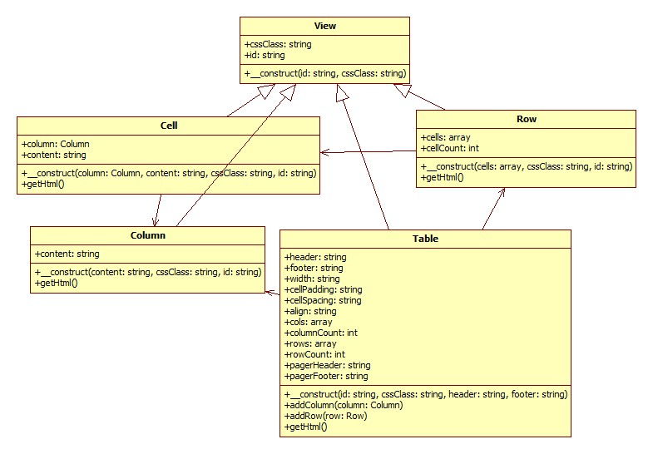
Figure 4.16 View Uml Diagram
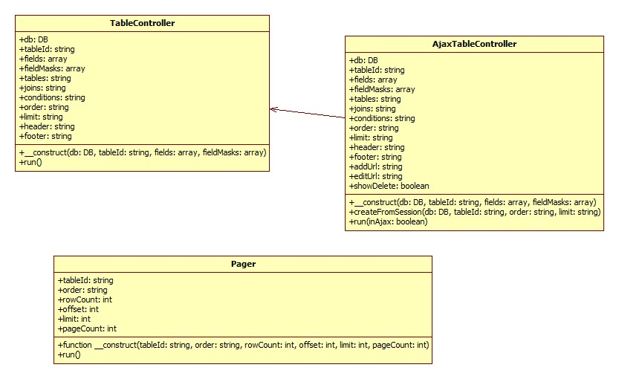
Figure 4.17 Controller Uml Diagram
In administration part of this system, user must be login.

Figure 4.18 Admin Login Page
When user logins, an administration menu helps the user to navigate him between modules.

Figure 4.19 Admin Menu
For each module, there are default, list, add and edit pages and run and ajax pages make connections between view pages and controller pages. When an user makes an action to update a model, a runner page runs and manipulates the model class.

Usage Development
In usage development, imported data are important. Because of that, for every imported data model, such as categories, orders, visits, products, etc. an imported table created in database. When creating these tables, the xml and excel export templates used to export data from e-commerce sites are considered. So, these import model tables and export templates have same fields typically.

To manage imported data, users must be login into the system first of all. After user logins into the system, he/she will be able to use the member panel. In the member panel, members can manage their site informations, imported data, and analyze their imported data.

Figure 4.20 Member Menu

4.2.1 Sites
Members can use multiple sites to analyze their data, so they will be able to compare analyze results between their sites. Furthermore, to import any data to the system, they will need a site to associate their data.
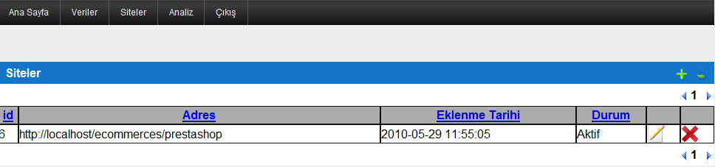
Figure 4.21 Member Sites

4.2.2 Imported Data
Imported data is kept in database and also files in “imports” directory to restore backup of imported data easily. Every imported data must be associate with a site, an import type like xml or excel and an import field like category, brand or visit.
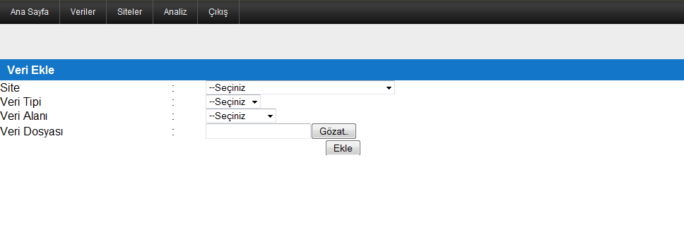
Figure 4.22 Add Import
Also, members can list their imported data in any order way they want and download their imported data.
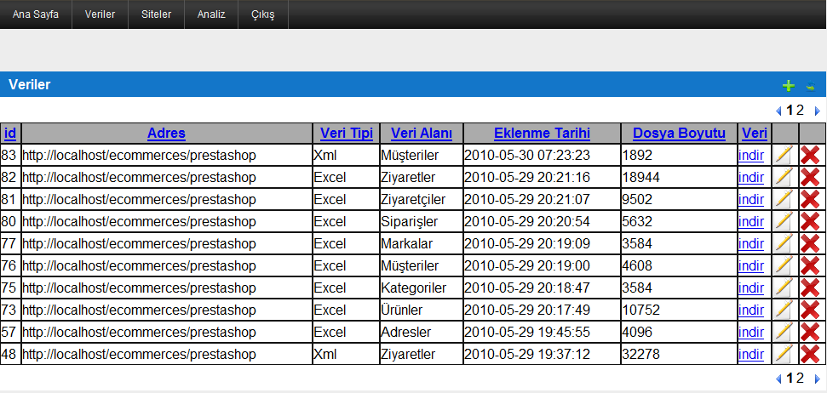
Figure 4.23 Import List

4.2.3 An Example Of Analysis with Naive Bayes Classifier
Before analyzing some imported data with using Naive Bayes Classifier in this system, member must choose an imported data and way to create test data. Members are be able to use their imported data or add new data to create test data.
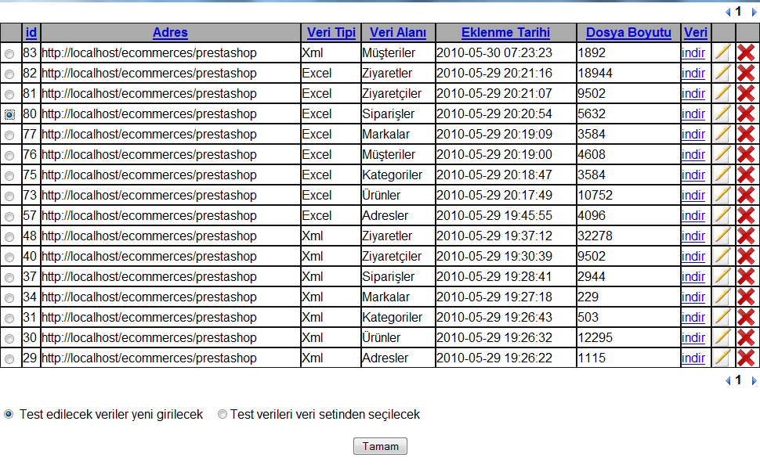
Figure 4.24 Selecting Imported Data To Analyze
Then member must choose a class between attributes to classify data.
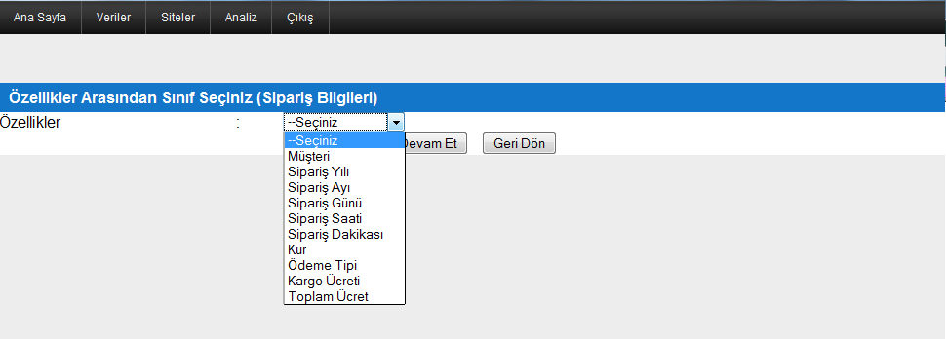
Figure 4.25 Choosing Class Between Attributes
In this example, member chose adding test data manually. In next screen, the model data set and a test data adding form is presented to create test data set.
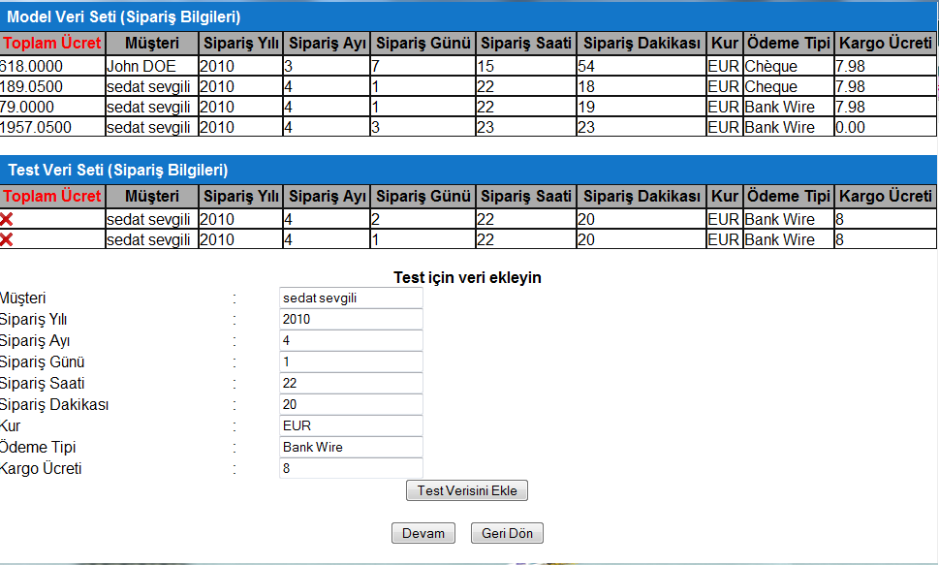
Figure 4.26 Creating Test Data Set

At the final step, for each test data member entered, probabilities and class values are shown with the attribute values of test data.
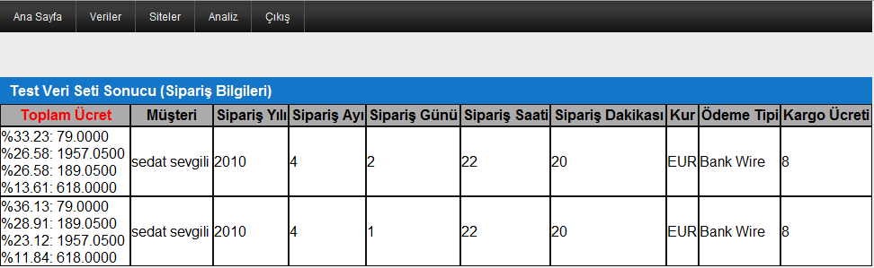
Figure 4.27 Analyze Result

PERFORMANCE MEASUREMENTS
To measure performance of the system, these 3 functions included in php are used: memory_get_usage, memory_get_peak_usage and microtime. The memory_get_usage function returns total allocated memory size in bytes for running php script[2]. The memory_get_peak_usage functions returns maximum allocated memory size in bytes when the php script runs[3]. Finally, the microtime function returns unix timestamp value in microsecondsError: Reference source not found. To calculate how much bytes a code block allocates, getting memory usage before that block with using memory_get_usage into a variable and subtracting it from measured allocated memory size after the code block with using memory_get_usage function is enough.
Table 5.6 Performance Measurements of Decision Tree Classification with 1 Sample
Model Sample Count | Empty Attribute Count | Memory Usage | Memory Peak Usage | Total Memory Usage | Total Memory Peak Usage | Time Usage
452 | 0 | 0 bytes | 0 bytes | 6029312 bytes | 6029312 bytes | 0.035806894302368 seconds
452 | 1 | 0 bytes | 0 bytes | 6029312 bytes | 6029312 bytes | 0.036634206771851 seconds

Table 5.7 Performance Measurements of Decision Tree Classification with 3 Samples
Model Sample Count | Empty Attribute Count per Test Sample | Memory Usage | Memory Peak Usage | Total Memory Usage | Total Memory Peak Usage | Time Usage
452 | 3 | 0 bytes | 0 bytes | 6029312 bytes | 6029312 bytes | 0.13881897926331 seconds
452 | 5 | 0 bytes | 0 bytes | 6029312 bytes | 6029312 bytes | 0.17689990997314 seconds

Considering the performance measurements about decision tree classifying, we can see easily that total allocated memory always will be same. This is consequent of building same tree always with using same model samples. Additionally, when test sample count or count of empty attributes increases, time usage of classifying process increases too. This is consequent of the class searching process of all new samples.
Table 5.8 Performance Measurement of Naive Bayes Classification with 1 Sample
Model Sample Count | Laplace Addition Count | Memory Usage | Memory Peak Usage | Total Memory Usage | Total Memory Peak Usage | Time Usage
452 | 0 | 0 bytes | 0 bytes | 4718592 bytes | 4718592 bytes | 0.021576881408691 seconds
452 | 1 | 0 bytes | 0 bytes | 4718592 bytes | 4718592 bytes | 0.018949031829834 seconds

Table 5.9 Performance Measurement of Naive Bayes Classification with 3 Samples
Model Sample Count | Laplace Addition Count per Test Sample | Memory Usage | Memory Peak Usage | Total Memory Usage | Total Memory Peak Usage | Time Usage
452 | 3 | 0 bytes | 0 bytes | 4718592 bytes | 4718592 bytes | 0.05171799659729 seconds
452 | 5 | 0 bytes | 0 bytes | 4718592 bytes | 4718592 bytes | 0.051032066345215 seconds

According to these results, there is not any memory leak in classifying processes. Same model samples always cause same memory allocations. In Naive Bayes classifying, only time usage increases because of increment of test samples or laplace additions. If we want to compare performance tests of Naive Bayes classification and Decision Tree classification, Naive Bayes classification needs less hardware features than Decision Tree classification.

CONCLUSION
With using this system, e-commerce site owners will be able to determine specific patterns about their data. They will be able to see what will status of new orders have given price be, how many orders new customers will have, which products will be able to sold in next month or next year, etc.
However, this system can be developed more, especially with using web services, e-commerce site owners will be able to analyze their imported data without login the system, besides with using their sites. Additionally, visualizing the results of analyzed imports can be improved with using some graphics, bars, pie charts, etc.
Consequently, in addition to this system is able to provide mining specific e-commerce data such as products, orders, customers and visits, is open to some development and being more user-friendly.
REFERENCES
[1] http://www.daveegerton.com/assets/images/database-schema-prestashop.png, 04.03.2010
[2] http://tr.php.net/manual/tr/function.memory-get-usage.php, 14.06.2010
[3] http://tr.php.net/manual/tr/function.memory-get-peak-usage.php, 14.06.2010

