The basic approach for changing the association of a file from one program to another.

Associating .xp and .sedphat files with sedphat. Two approaches are given.

Many file types in Microsoft Windows XP and Windows 2000 are registered to be opened by a particular program. For example, Notepad starts when you want to open a text (.txt) file. You can change the program that starts when you open a file of a certain type.
1. In My Computer or Windows Explorer, click the Tools menu, click Folder Options, and then click the File Types tab.
2. In the Registered file types list, click the file type you want to open with a different program, and then click Change.
3. In the Open With dialog box, select the program you want to use, and then click OK.
4. Click OK in the Folder Options dialog box.

However, this does not always work and under those conditions one must start with the restore button and follow the instructions below
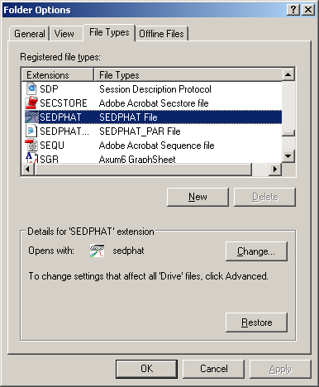

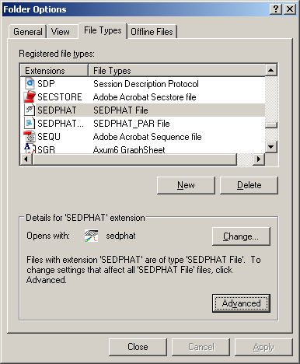
Click restore button

Click advanced button
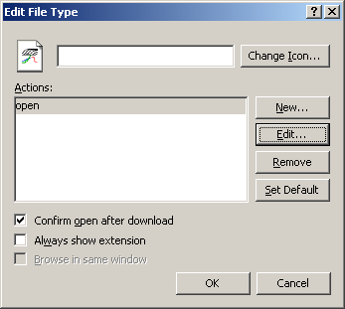

Click open button and then edit button.
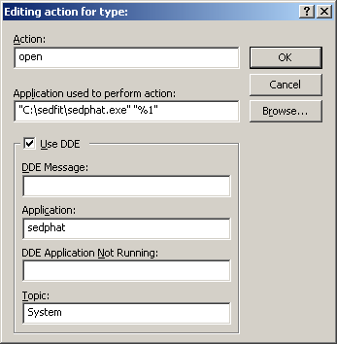

Click on browse , go to sedfit folder, click on sedphat program, click on open command
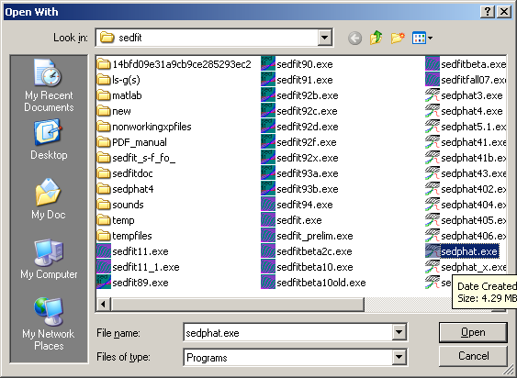

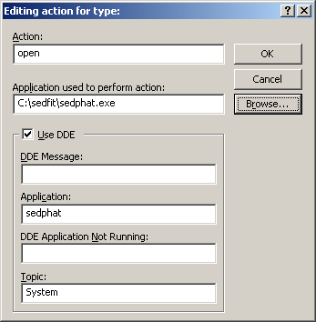
Screen should look like this

Click on ok: you may not see
Sedphat under application

System under topic but windows
Should add them.

If you go back to this window after closing it using the edit button you should see the following in the application used
C:\sedfit\sedphat.exe "%1"
now click on change icon

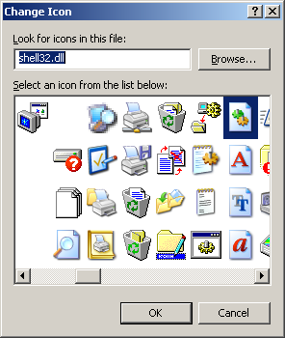

Click on browse and go to
Sedfit folder.
Double click on sedphat.exe

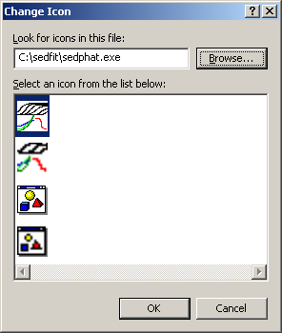

Double click on the icon that you prefer and then click ok a final time on window for the file type.

