**Real-Time Audio Equalizer with QAM Visualization with MATLAB**

**OBJECTIVE:**

* The objective of this project is to design and implement an interactive MATLAB application that simulates real-time audio playback while concurrently visualizing the audio signal as a Quadrature Amplitude Modulation (QAM) signal. The application aims to demonstrate how audio signals can be transformed into a QAM format and visualized dynamically, allowing users to observe the modulation process in both 2D and 3D QAM constellations.

Principle:

* The principle of this application is to convert an audio signal into Quadrature Amplitude Modulation (QAM) for real-time visualization. The audio is modulated and displayed as dynamic QAM constellations in both 2D and 3D formats. Users can interact with the visualization by adjusting the modulation order and controlling playback, providing a hands-on learning experience.

BLOCK DIAGRAM:

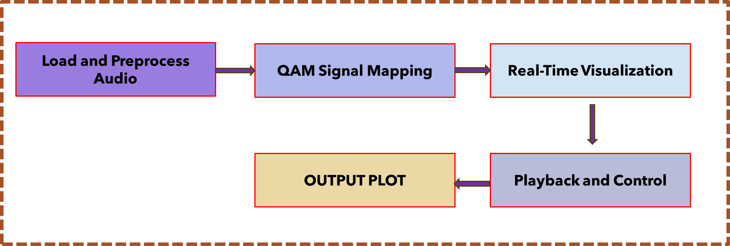

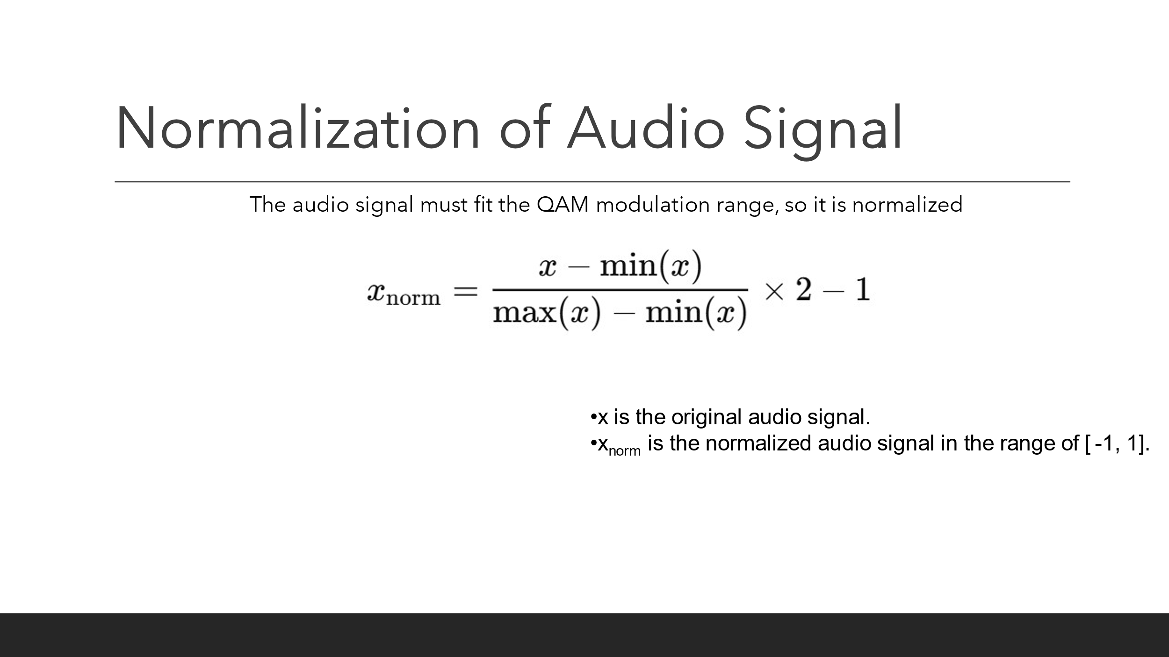

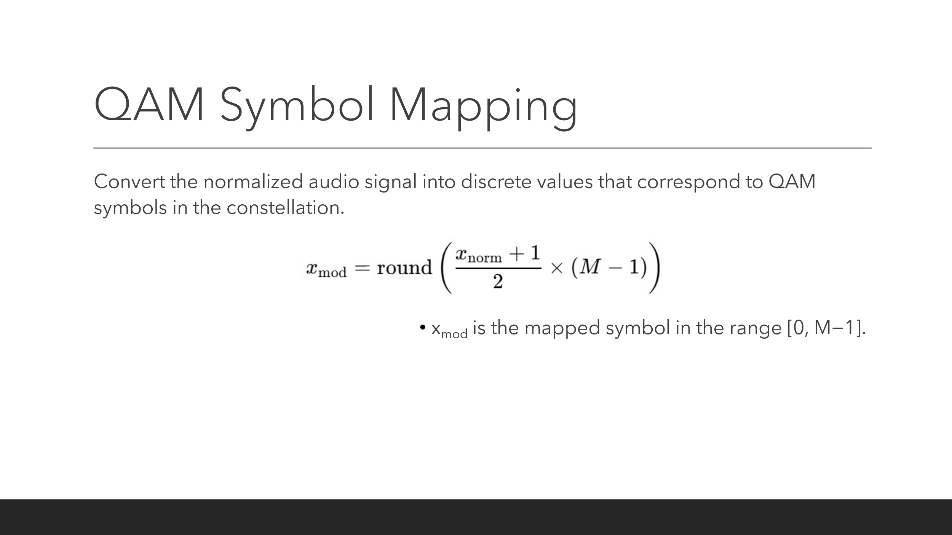

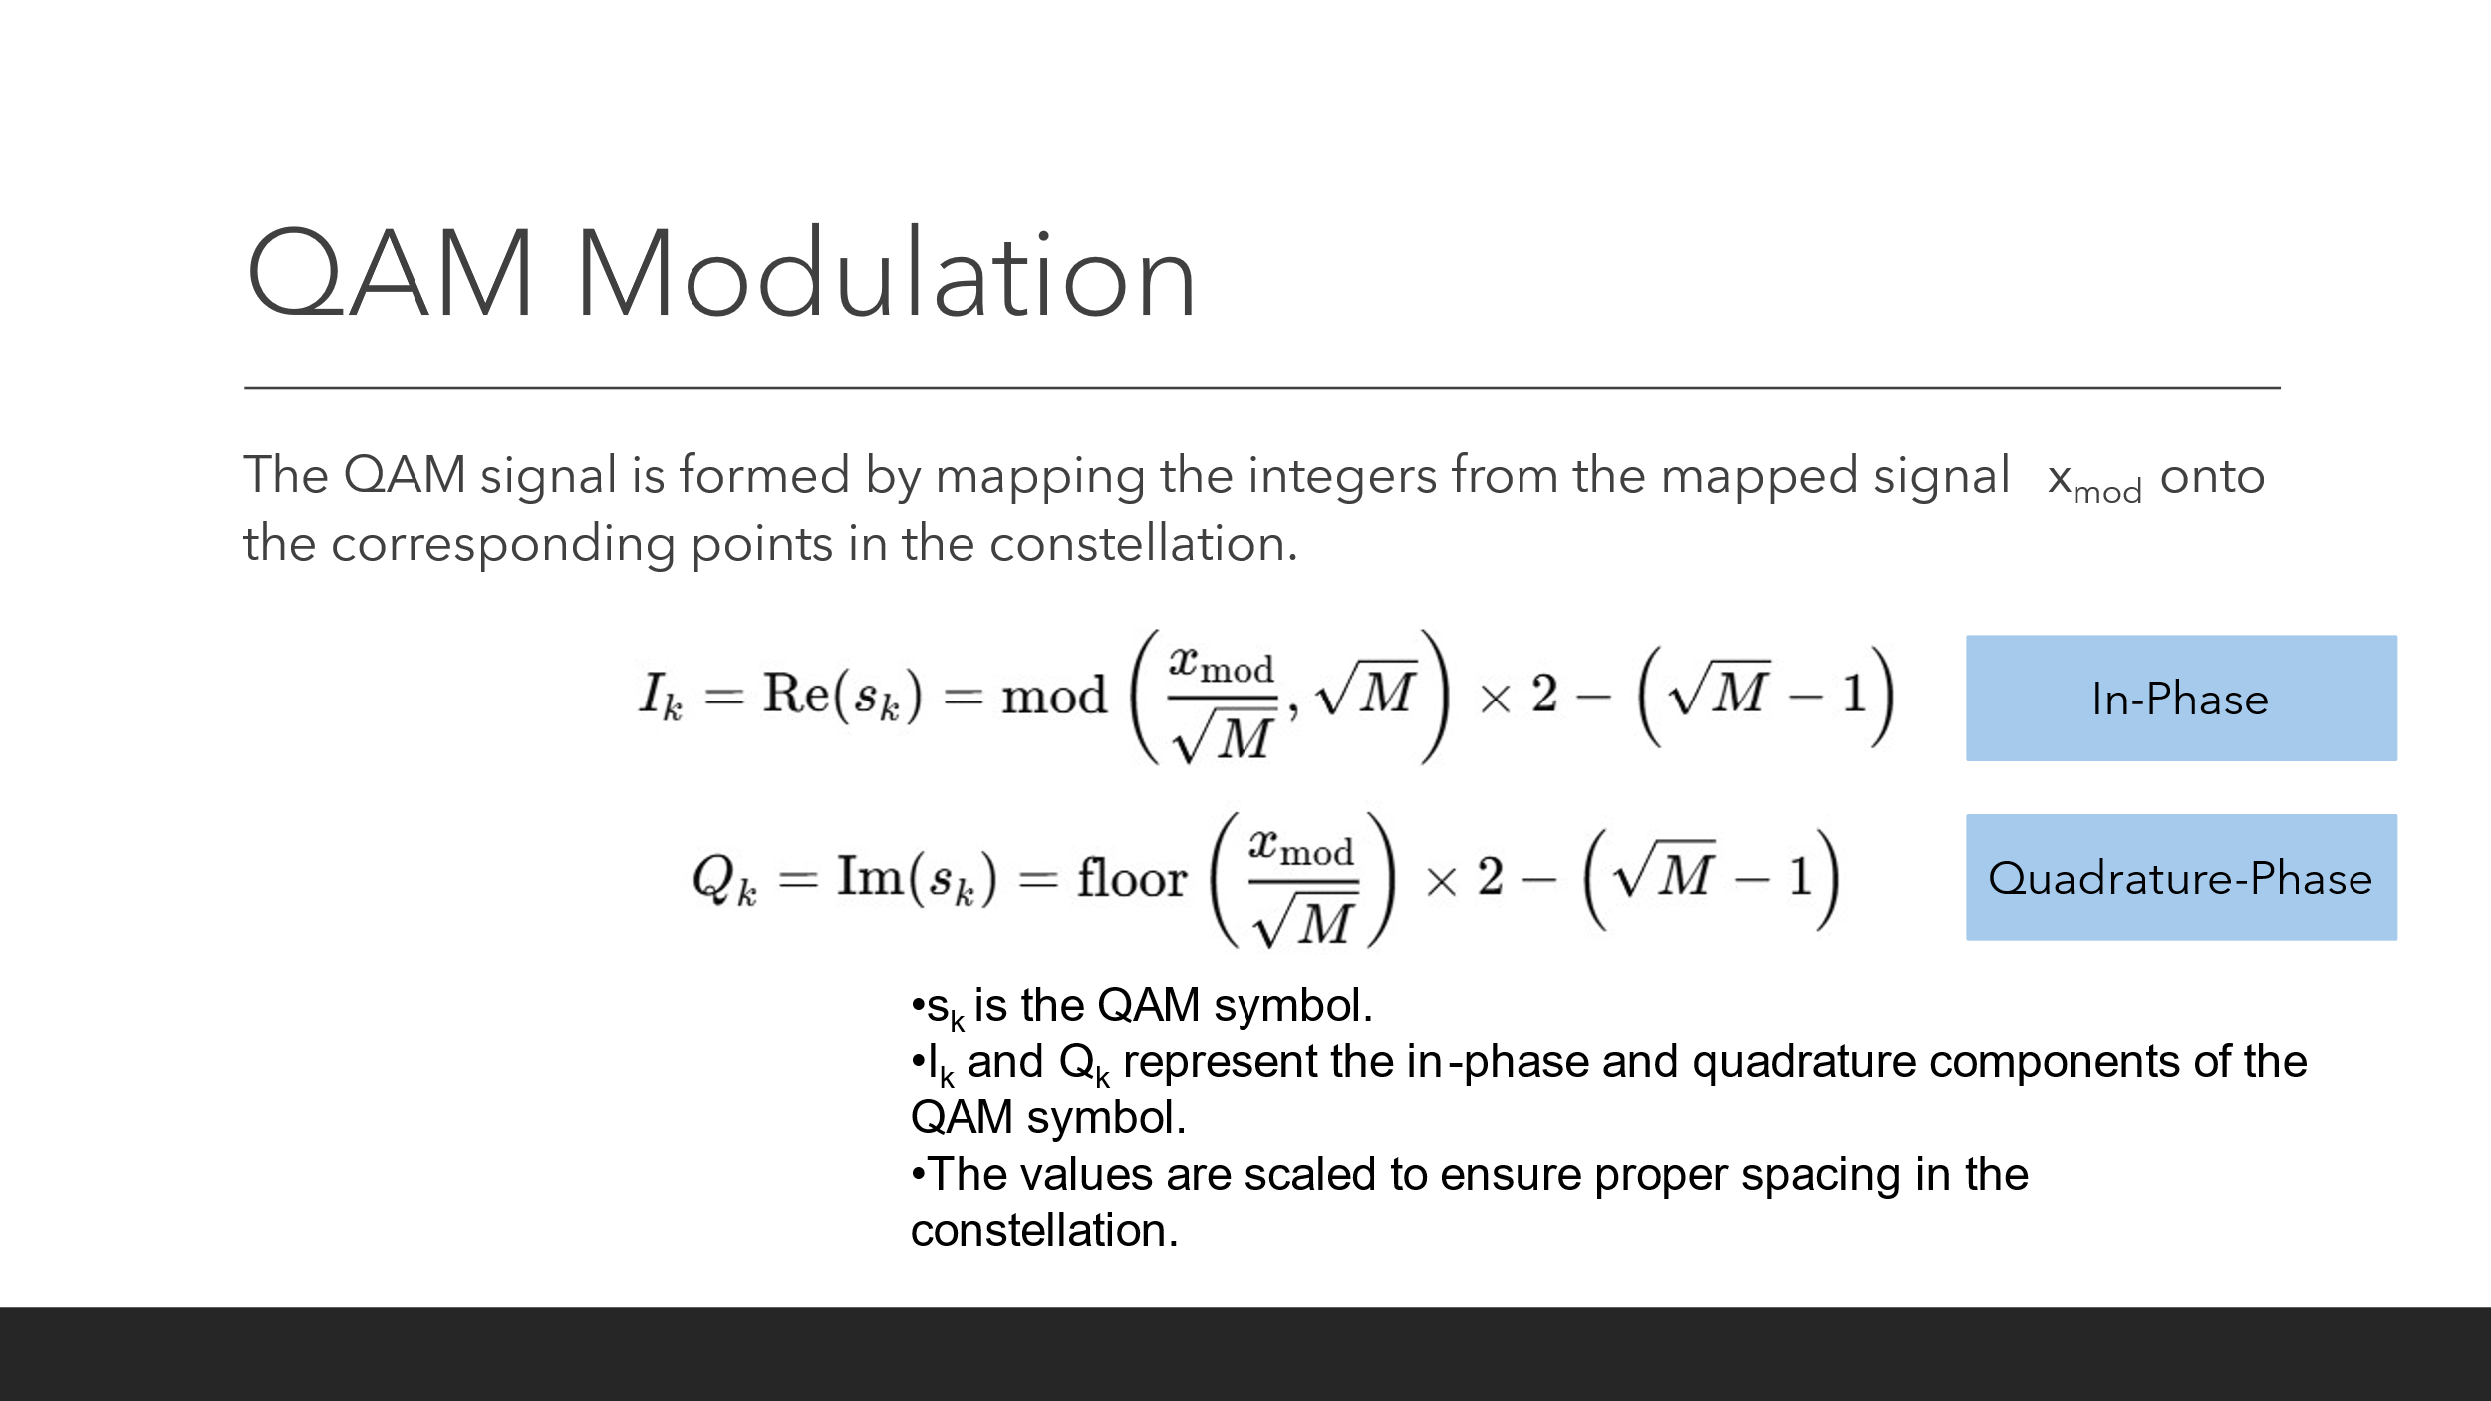

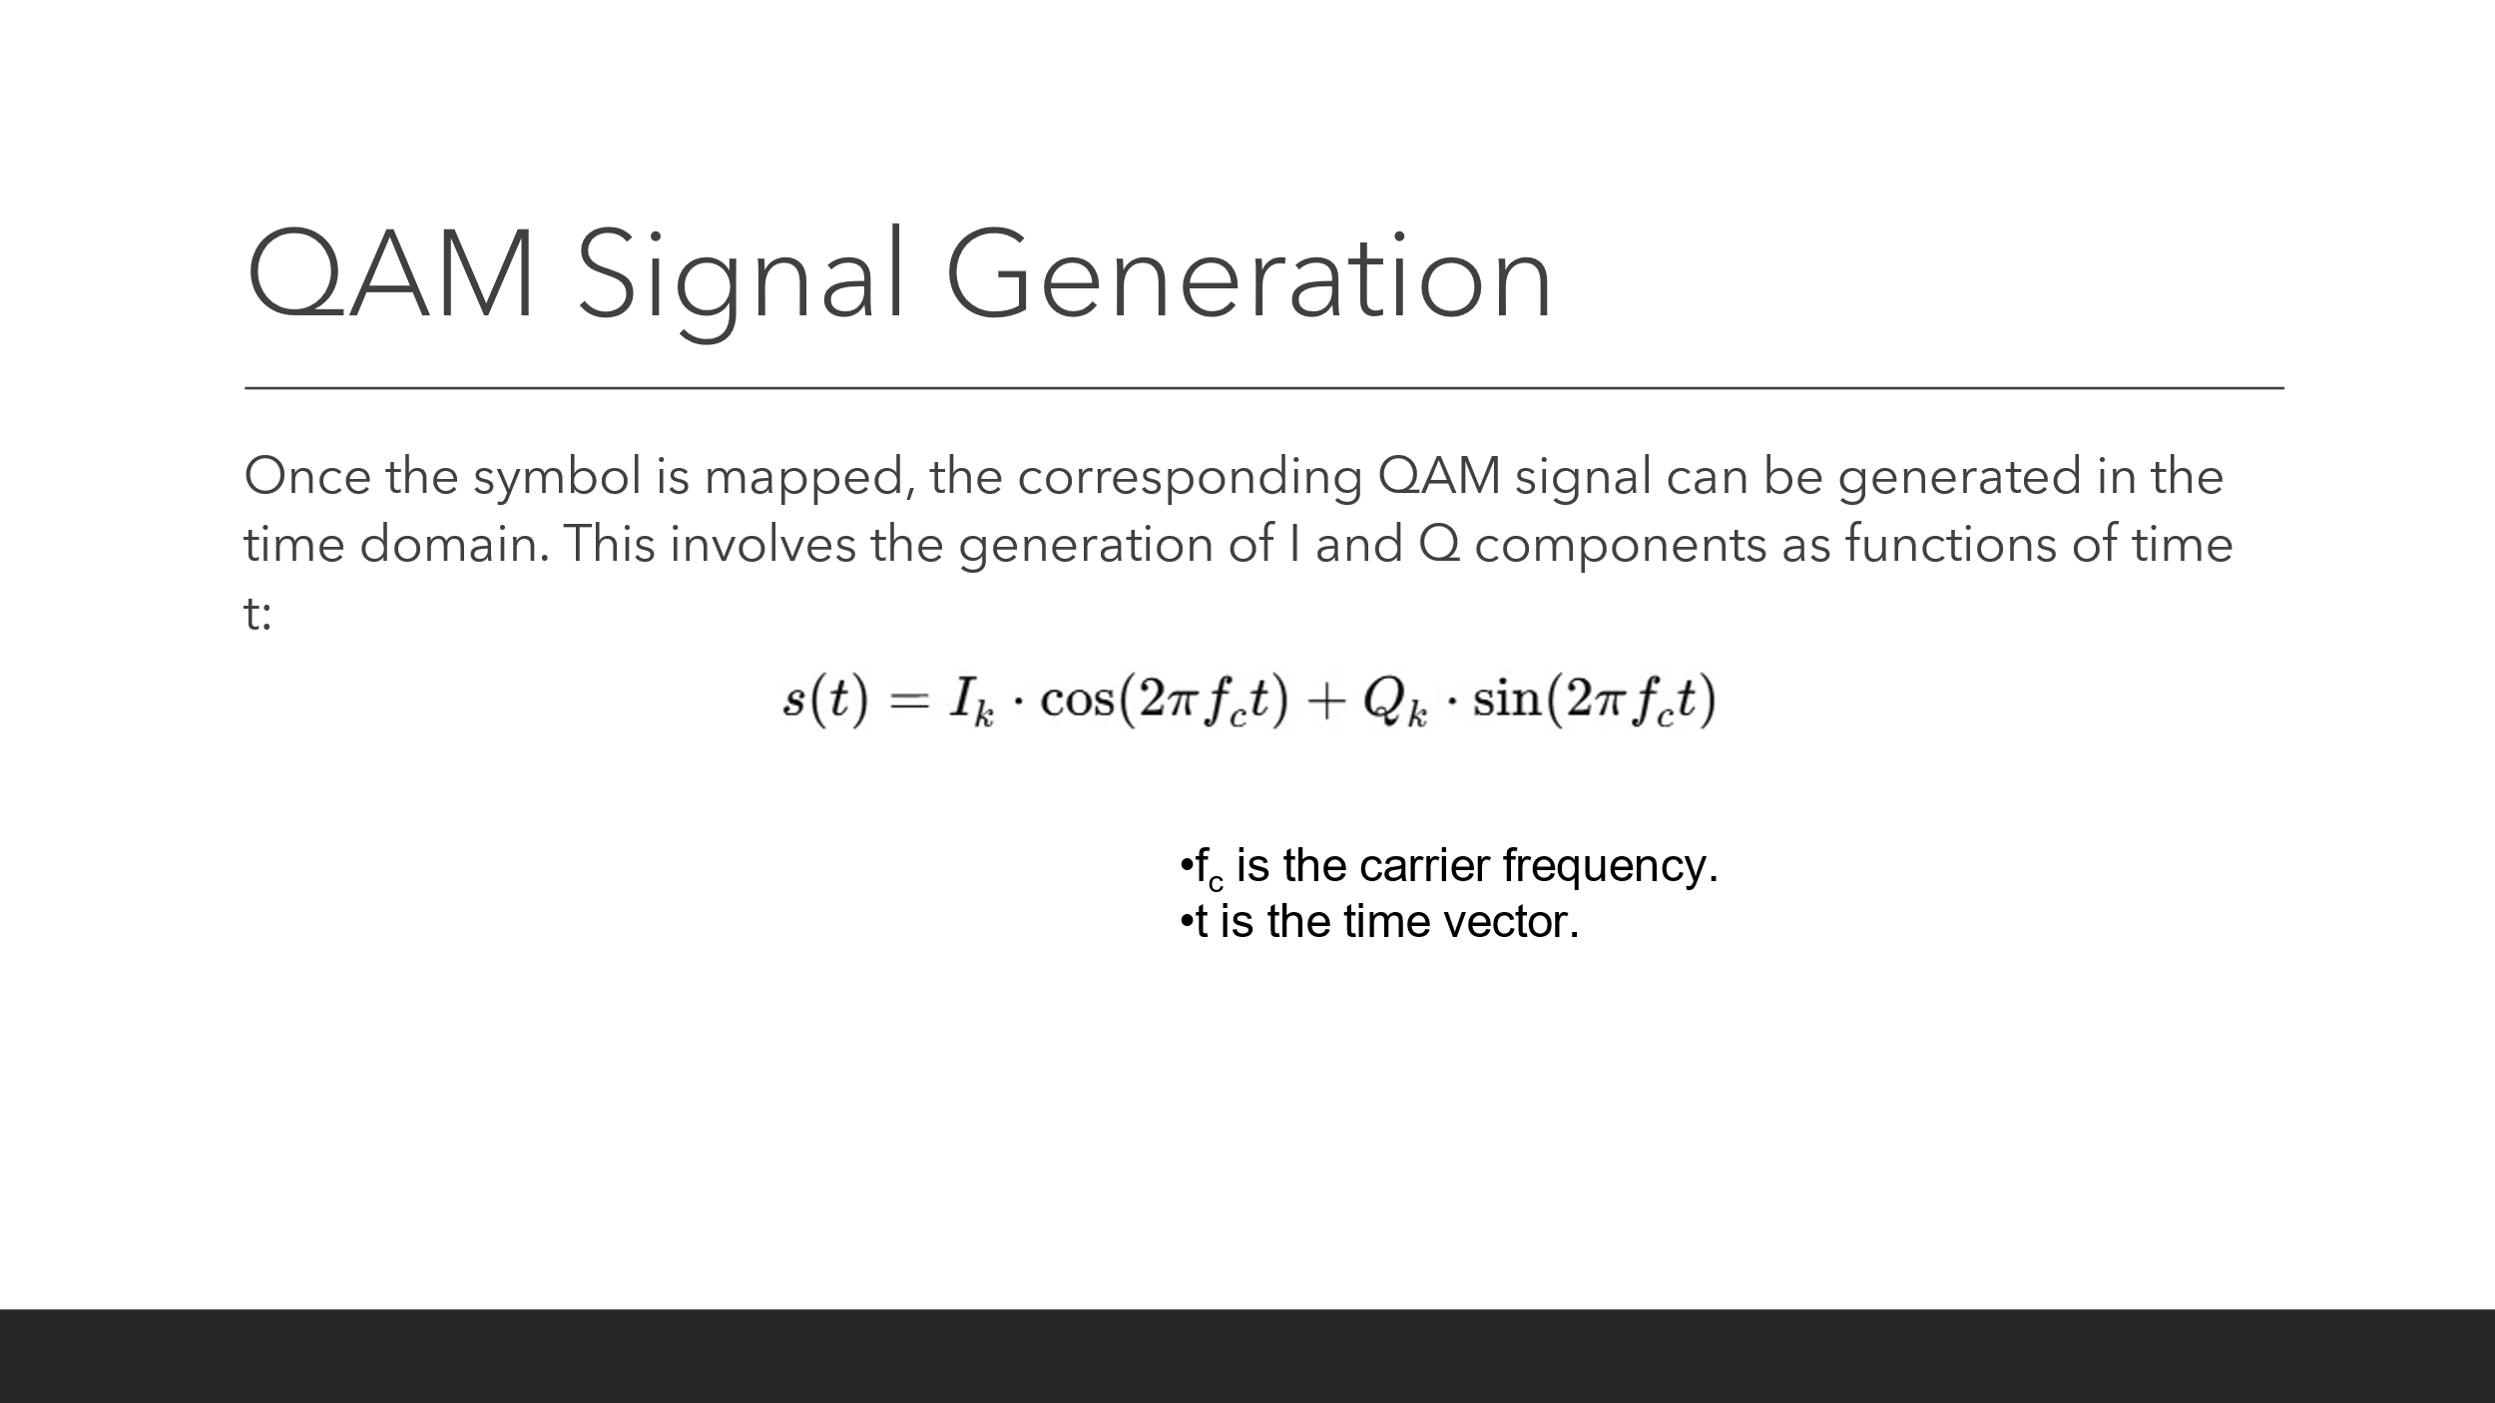

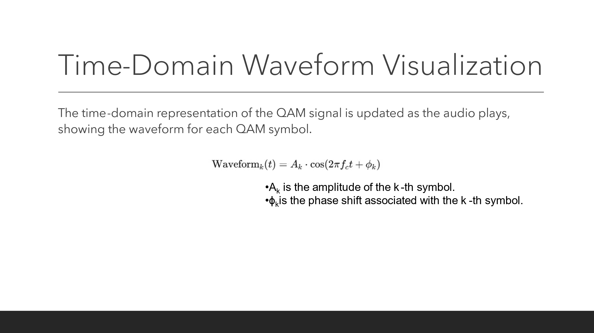

OUTPUT:

CONCLUSION:

* This project successfully demonstrates the real-time conversion of audio signals into Quadrature Amplitude Modulation (QAM) for visualization and analysis. By integrating audio signal processing with QAM modulation techniques, the application provides an interactive environment where users can explore how audio data can be mapped to digital modulation schemes. The real-time QAM visualization, including 2D and 3D constellations, allows users to observe the dynamic evolution of the signal during playback.

Reference:

1. <http://www.diva-portal.org/smash/get/diva2:1334188/FULLTEXT02.pdf>
2. <https://www.researchgate.net/figure/sualization-of-reached-M-QAM-modulation-formats-based-on-measured-parameters-3-MHz_fig9_340007882>