Here’s a chronological summary of how entity-recognition (NER) and large language model (LLM) technologies have evolved — adapted for your HypatiaX project context (NER training → LLM generation). You can map your project epochs (years of tech implemented) onto this timeline for clarity.

NER (Named Entity Recognition) Timeline
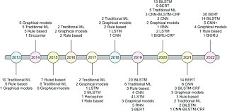

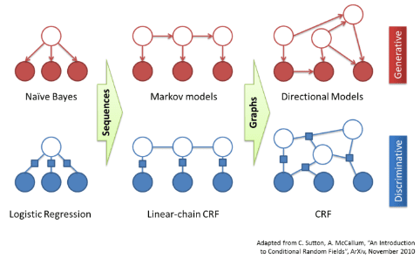
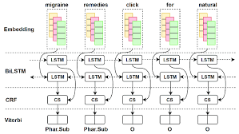

6
- Early / rule-based era (pre-2000s)
Early NER systems relied on hand-crafted rules and lexicons (e.g., lists of names, gazetteers) rather than statistical learning.
- Machine-learning era (2000s)
Models like Hidden Markov Models (HMMs), Maximum Entropy, Conditional Random Fields (CRFs) became standard for sequence‐labelling NER. immwit.com+1
Example: CRFs around ~2001 gained popularity. immwit.com+1
- Deep-learning era (~2015-)
Around 2015 and onwards, Recurrent Neural Networks (RNNs), Long Short-Term Memory (LSTM), BiLSTM-CRF architectures started dominating NER work. immwit.com
Fine-tuning pre-trained models like BERT for NER became common after ~2018. arXiv
- Modern & multilingual / zero-shot NER (2020s)
Focus shifts to multilingual models (mBERT, XLM-RoBERTa), nested entity recognition, low-resource languages and domain adaptation. immwit.com+1
- Project mapping tip:
For HypatiaX: if you implemented NER training in “years of tech” you might label epochs like “CRF era (2010)”, “Deep-LSTM era (2016)”, “Transformer fine-tune era (2020)”.

LLM (Large Language Model) Timeline
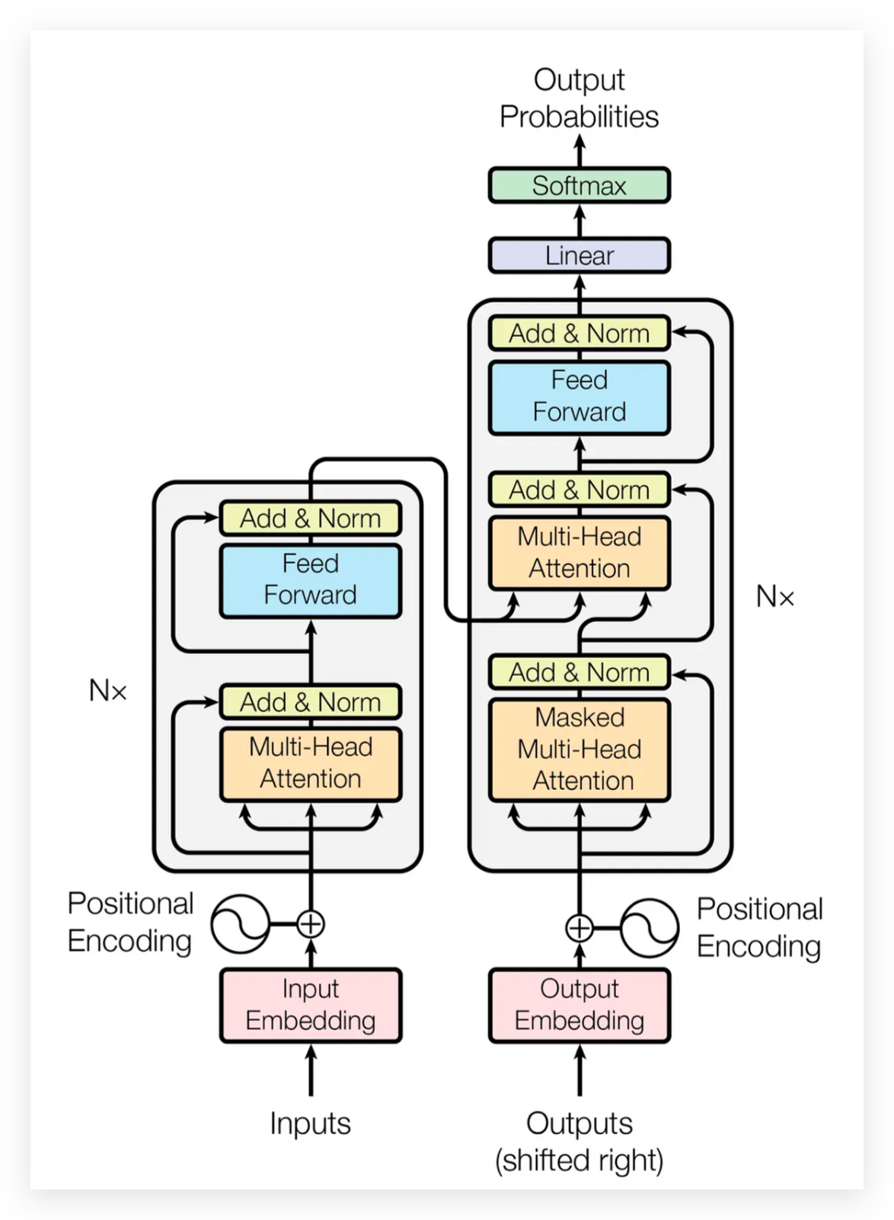
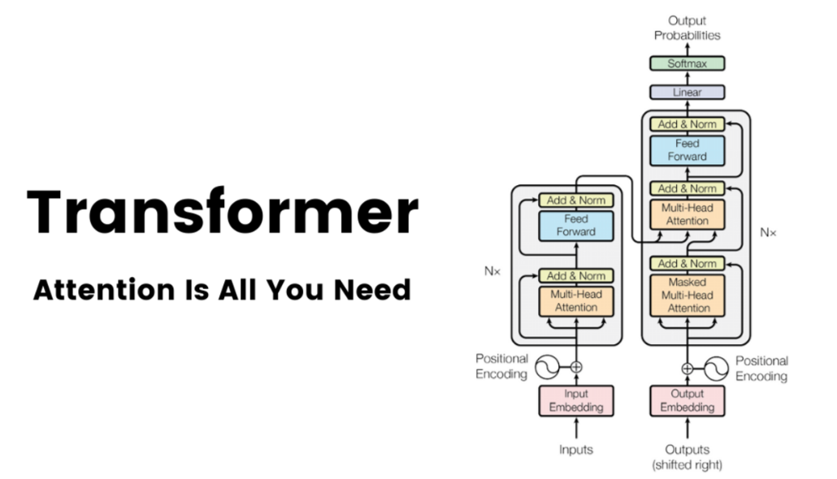
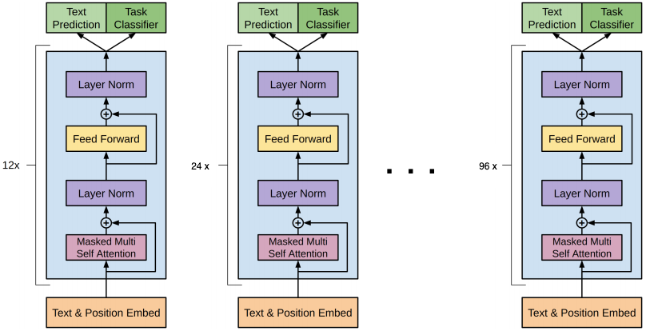
6
- Foundations (1950s-2000s)
Early NLP and language modelling: rule-based systems, statistical n-gram models. vanhansewijck.com+1
- Neural-network & embedding era (2010-2016)
Word embeddings (Word2Vec 2013) and sequence-to-sequence models; RNNs, LSTMs. GeeksforGeeks
- Transformer era (~2017)
The landmark paper Attention Is All You Need (2017) introduced the Transformer architecture which enabled large-scale training and attention mechanisms. Wikipedia+1
- First LLMs (2018-2020)
For example: BERT (2018) introduced contextual embeddings; GPT-2 (2019) with 1.5B parameters; GPT-3 (2020) with ~175 billion parameters. Travtus+2Office Timeline+2
- Instruction-tuning, alignment & open-source era (2021-2022)
The use of RLHF (Reinforcement Learning from Human Feedback), instruction-tuned models, rise of open-source large models. meta-guide.com+1
- Multimodal & production-scale LLMs (2023-2025)
Models that handle text + image + audio, deployed at scale (e.g., GPT-4, etc.). Encyclopedia Britannica
- Project mapping tip:
In your HypatiaX context: you might label “LLM era 2020 (GPT-3)”, “Instruction-tuned era 2022”, “Production-multimodal era 2024”.

Combined Chronology for HypatiaX Project
Here’s a suggested mapping of years of tech implemented for your project’s modules:
Year | Tech epoch | What was implemented
~2010 | NER – ML era | CRF-based entity extraction module
~2016 | NER – Deep-learning | BiLSTM-CRF entity extractor integration
~2020 | NER + early LLM | Fine-tuned Transformer for NER; start of generative mapping via LLMs
~2022 | LLM production rollout | Instruction-tuned LLM mapper (GPT-class) becomes main path
~2024 | LLM + routing + scaling | Smart-router combining LLM + fallback; caching, batching, monitoring added
(Future) | Full system & hybrid | Integration of RAG + fine-tuned local models; multimodal mapping

If you like, I can generate a full visual timeline (SVG/PDF) for HypatiaX mapping all those epochs with icons, plus a detailed markdown snippet for embedding in your documentation. Would you like me to do that?

