Genlogistic or Logistic?. Which is better to make Binary Classification?

On Linear Classification Logistic function is usually used and can be found in various machine learning packages: Statsmodels, Scikit-learn, Pytorch, Keras, etc.

After some experimentation with the Logistic function on Pima Indias Dataset, an increment of false positive/negative rate was registered. This issue was the motivation to contrast its performance with other datasets: Sonar and Ionosphere.

PCA method was employed to select a features subset of size about 90%,  as well as, a c-shape parametric Genlogistic function with 0.1 <c<=1. Logistic function belongs to this family for the value c=1.

Results seem to indicate that Genlogistic function could reduce the false positive/negative rate more than Logistic predictions. The following table shows the above observations:

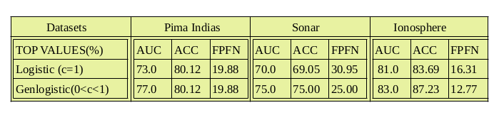

Max. AUC -Area under Roc Curve (%)

Max. ACC - Precision of prediction (%)

MIN FPFN -False Positive/Negative Rates (%)

More details can be found in

**https://github.com/sednabcn/SiMLeng/tree/BinaryClassificationGenlogistic**