CREDIT RISK ANALYSIS
Using Logistic Regression
German Credit Dataset | MSc Statistics Project
Logistic Regression (Core Analysis)
Sedna Bhanja





1. Introduction
Credit risk analysis is one of the most critical applications of statistical modelling in the banking and financial sector. It involves assessing the likelihood that a borrower will default on a loan, allowing financial institutions to make informed lending decisions.

This report presents the Logistic Regression component of a three-model comparative study on credit risk classification. Using the German Credit Dataset (n = 1000), we build a binary classification model to predict whether a loan applicant is a good or bad credit risk, identify statistically significant predictors through the Wald Test, and interpret the effect of each variable using odds ratios.

1.1 Objective
To model the probability that a loan applicant is a credit risk (bad) using Logistic Regression, identify significant predictors using the Wald Test, and interpret the effect of each variable through odds ratios.

1.2 Dataset Overview
Attribute | Details
Total Observations | 1,000 loan applicants
Total Variables | 10 (9 predictors + 1 target)
Target Variable | Risk (good / bad)
Good Risk (0) | 700 (70%)
Bad Risk (1) | 300 (30%)
Missing Values | Saving accounts (183), Checking account (394)

2. Exploratory Data Analysis (EDA)

2.1 Distribution of Risk (Target Variable)
The bar chart and pie chart below illustrate the distribution of the target variable Risk in the dataset. Out of 1,000 applicants:
- 700 applicants (70%) are classified as Good Risk (low probability of default)
- 300 applicants (30%) are classified as Bad Risk (high probability of default)

This represents a class imbalance of approximately 70:30. While not extreme, this imbalance means the model may be biased towards predicting the majority class (Good). This is reflected later in the relatively low sensitivity of the model.

[Insert Bar Chart and Pie Chart of Risk Distribution here]

The imbalance is an important consideration when interpreting model performance metrics such as accuracy and sensitivity.

3. Data Preprocessing

3.1 Target Variable Encoding
The Risk variable was converted from categorical (good/bad) to binary numeric format as required for logistic regression:
- good → 0 (No default)
- bad → 1 (Default)

3.2 Handling Missing Values
Variable | Missing Count | Treatment
Saving accounts | 183 | Replaced with category 'NA'
Checking account | 394 | Replaced with category 'NA'

Missing values in categorical variables were treated as a separate informative category (NA) rather than being imputed, as the absence of a savings or checking account is itself a meaningful financial indicator.

3.3 Variable Types After Preprocessing
Variable | Type | Notes
Age | Numeric | Continuous
Credit amount | Numeric | Continuous
Duration | Numeric | Continuous (months)
Job | Factor | 4 levels: 0, 1, 2, 3
Sex | Factor | 2 levels: male, female
Housing | Factor | 3 levels: own, rent, free
Saving accounts | Factor | 5 levels incl. Unknown
Checking account | Factor | 4 levels incl. Unknown
Purpose | Factor | 8 levels

4. Logistic Regression Model

4.1 Model Formulation
Logistic Regression models the log-odds (logit) of the probability of an event occurring. For our binary outcome (Risk = 1 for bad, Risk = 0 for good):

log( p / (1 - p) ) = β₀ + β₁X₁ + β₂X₂ + ... + βₖXₖ

where p = P(Risk = bad | X) is the probability of being a bad credit risk. The model parameters are estimated using Maximum Likelihood Estimation (MLE).

4.2 Full Model — Wald Test Results
A full logistic regression model was first fitted using all available predictor variables. The Wald Test (z-test on each coefficient) was used to identify statistically significant predictors at the 5% significance level (p < 0.05).

Variable | Estimate (β) | Std. Error | z value | p-value
(Intercept) | 0.1491 | 0.7488 | 0.199 | 0.8422
Age | -0.0144 | 0.0077 | -1.880 | 0.0600
Sex (male) | -0.3900 | 0.1728 | -2.257 | 0.0240 *
Duration | 0.0353 | 0.0083 | 4.242 | < 0.0001 ***
Credit amount | 0.0000 | 0.0000 | 0.782 | 0.4341
Checking_acct (moderate) | -0.4109 | 0.1949 | -2.108 | 0.0350 *
Checking_acct (NA) | -1.8316 | 0.2143 | -8.545 | < 0.0001 ***
Checking_acct (rich) | -0.9527 | 0.3419 | -2.786 | 0.0053 **
Saving_acct (NA) | -0.8372 | 0.2377 | -3.522 | 0.0004 ***
Saving_acct (rich) | -1.0739 | 0.4703 | -2.284 | 0.0224 *
Housing, Job, Purpose | — | — | — | > 0.05 (NS)

Significance codes: *** p < 0.001 ** p < 0.01 * p < 0.05 NS = Not Significant

The Wald test results indicate that Duration, Checking account status, and Saving account status are the most important predictors of credit risk. Variables such as Job, Housing, Purpose, and Credit amount were found to be statistically insignificant and were removed in the final model.

4.3 Final Reduced Model
Based on the Wald test results, a reduced model was fitted retaining only the significant predictors: Duration, Credit amount, Age, Checking account, and Saving accounts.

Likelihood Ratio Test (Full vs Reduced Model):

Test | Chi-square | df | p-value
LR Test (Full vs Reduced) | 20.09 | 13 | 0.093 (NS)

Since p-value = 0.093 > 0.05, we fail to reject the null hypothesis. The reduced model fits the data equally well as the full model. Therefore, the reduced model is preferred for its parsimony.

4.4 Final Model Equation
The final logistic regression equation is:

log( p / (1-p) ) = -0.2101
+ 0.0332 × Duration
+ 0.00003 × Credit_amount
- 0.0148 × Age
- 0.4463 × Checking_moderate
- 1.8685 × Checking_NA
- 1.0215 × Checking_rich
- 0.7995 × Saving_NA
- 0.9884 × Saving_rich
where p = P(Risk = bad | X) is the predicted probability of being a bad credit risk.

5. Odds Ratios and Interpretation

5.1 Odds Ratio Table
Odds ratios (OR = e^β) quantify the change in odds of default associated with each predictor variable. An OR > 1 indicates increased risk of default, while OR < 1 indicates decreased risk.

Variable | OR (e^β) | 95% CI Lower | 95% CI Upper | Direction
Duration | 1.0337 | 1.0180 | 1.0500 | ↑ Risk
Credit amount | 1.0000 | 1.0000 | 1.0001 | Negligible
Age | 0.9853 | 0.9717 | 0.9988 | ↓ Risk
Checking_moderate | 0.6400 | 0.4427 | 0.9226 | ↓ Risk
Checking_NA | 0.1544 | 0.1019 | 0.2305 | ↓↓ Risk
Checking_rich | 0.3600 | 0.1806 | 0.6805 | ↓↓ Risk
Saving_NA | 0.4496 | 0.2815 | 0.7019 | ↓ Risk
Saving_rich | 0.3722 | 0.1352 | 0.8695 | ↓↓ Risk

5.2 Detailed Interpretation
Duration (OR = 1.0337): Each additional month of loan duration increases the odds of default by 3.37%. Longer loans are riskier — borrowers who take extended repayment periods are more likely to encounter financial difficulties.

Age (OR = 0.9853): Each additional year of age decreases the odds of default by 1.47%. Older applicants tend to be more financially stable and responsible borrowers.

Credit Amount (OR = 1.0000): The effect of credit amount is negligible when controlling for duration and account balance. This suggests that loan size alone is not a strong independent predictor of default.

Checking Account — NA (OR = 0.1544): Applicants with unknown checking account status have 84.56% lower odds of default compared to those with little balance. This counterintuitive result may reflect that applicants without checking accounts are low-borrowing, low-risk individuals.

Checking Account — Rich (OR = 0.3600): Applicants with rich checking accounts have 64% lower odds of default — confirming that higher financial liquidity strongly reduces default risk.

Saving Account — Rich (OR = 0.3722): Applicants with rich savings have 62.78% lower odds of default. Higher savings serve as a financial safety net, reducing default probability significantly.

6. Model Evaluation

6.1 Confusion Matrix
The model's predictions were evaluated at a classification threshold of 0.5:

 | Actual: Good (0) | Actual: Bad (1)
Predicted: Good (0) | 628 (TN) | 187 (FN)
Predicted: Bad (1) | 72 (FP) | 113 (TP)

6.2 Performance Metrics
Metric | Value | Interpretation
Accuracy | 74.10% | Correctly classifies 74.1% of all applicants
Sensitivity (Recall) | 37.67% | Detects 37.67% of actual bad risk applicants
Specificity | 89.71% | Correctly identifies 89.71% of good risk applicants
AUC | 0.7636 | Fair discriminating ability between risk classes

The model achieves an overall accuracy of 74.1%. The high specificity (89.71%) indicates the model is excellent at identifying good borrowers. However, the relatively low sensitivity (37.67%) means the model misses approximately 62% of actual bad risk applicants — a common challenge in imbalanced credit datasets where the model is biased towards the majority class.

6.3 ROC Curve & AUC
The AUC (Area Under the ROC Curve) of 0.7636 indicates fair discriminating ability. The model correctly ranks a randomly selected bad risk applicant above a randomly selected good risk applicant 76.36% of the time.

AUC Range | Interpretation
0.5 | Random guessing
0.6 – 0.7 | Poor
0.7 – 0.8 ← Our model | Fair ✓
0.8 – 0.9 | Good
0.9 – 1.0 | Excellent

[Insert ROC Curve plot here]

7. Conclusion
This study applied Logistic Regression to the German Credit Dataset to model the probability of credit default. The key findings are:

- Duration is the strongest positive risk factor — each additional month of loan duration increases the odds of default by 3.37%.
- Age acts as a protective factor — older applicants are less likely to default, with each additional year reducing default odds by 1.47%.
- Checking and Saving account balances are strong protective factors — applicants with higher balances show substantially lower default odds.
- Variables such as Job, Housing, Purpose, and Credit amount were found to be statistically insignificant and excluded from the final model.
- The final model achieves 74.1% accuracy with an AUC of 0.7636, indicating fair predictive performance.

Compared to LDA/QDA (Person 2) and Tree-based models (Person 3), Logistic Regression provides the most statistically interpretable model with direct probabilistic outputs and quantifiable effect sizes through odds ratios. This makes it the preferred choice in regulated financial environments where model explainability is critical.

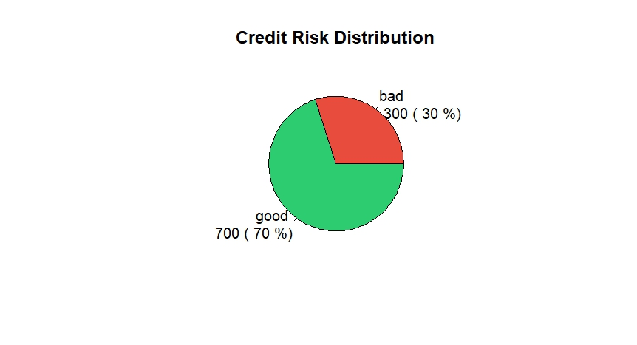
8.Relevant graphs

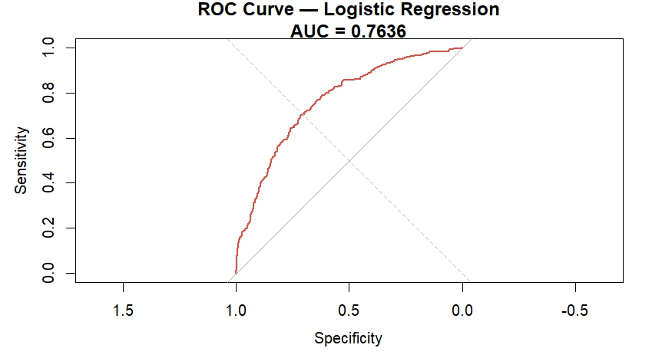
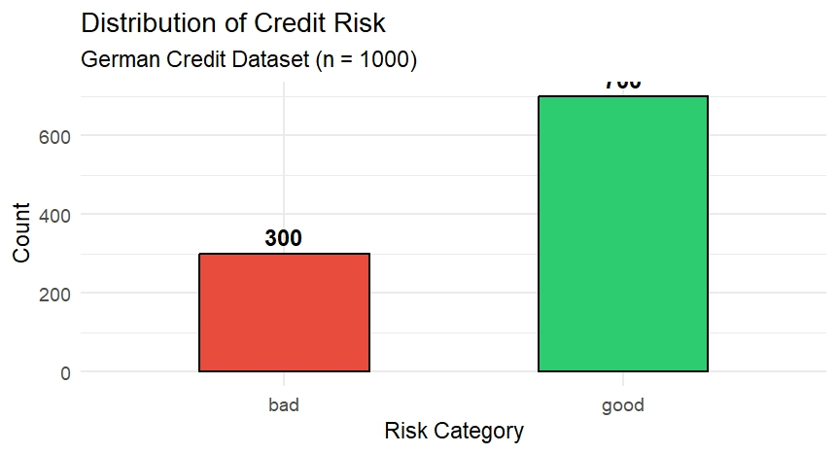

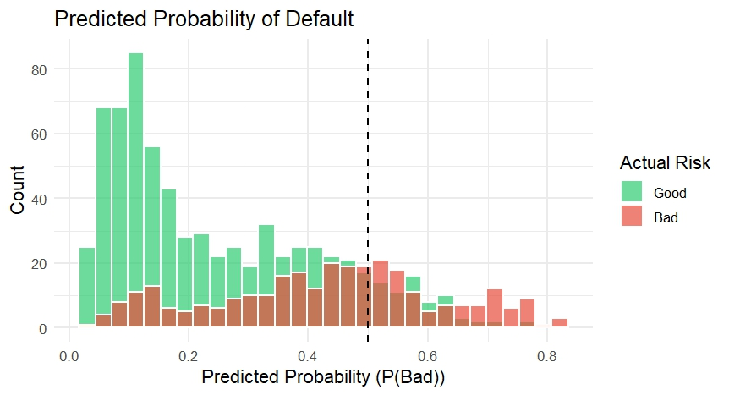

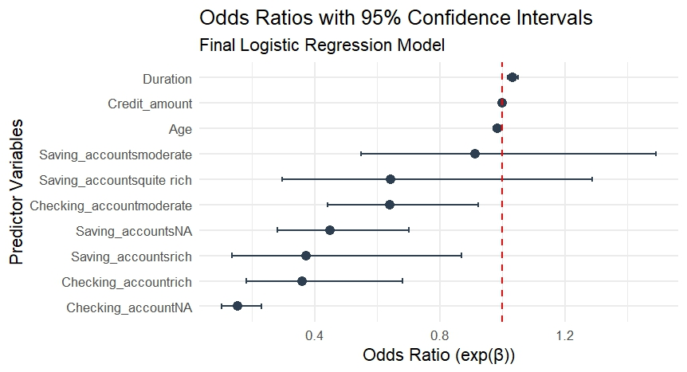

9. References
1. Hosmer, D.W. & Lemeshow, S. (2000). Applied Logistic Regression. 2nd ed. Wiley.
2. UCI Machine Learning Repository. German Credit Data. https://archive.ics.uci.edu/ml/datasets/statlog+(german+credit+data)
3. R Core Team (2024). R: A Language and Environment for Statistical Computing. R Foundation for Statistical Computing, Vienna, Austria.
4. James, G., Witten, D., Hastie, T. & Tibshirani, R. (2021). An Introduction to Statistical Learning. 2nd ed. Springer.

