**Sedos Audition Notice**

**THREE SISTERS**

**By Anton Chekov**

**A version by Nicholas Wright**

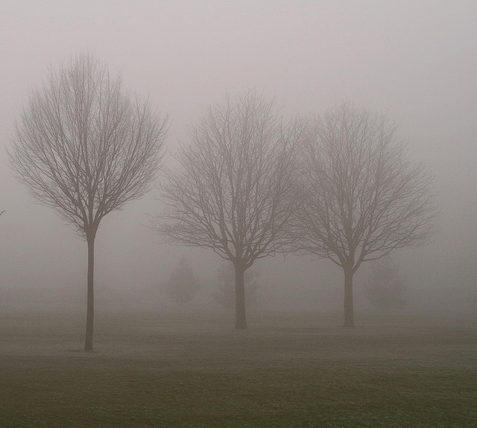

**28th February – 3rd March 2012**

**Bridewell Theatre**

**Director: Roger Beaumont**

Workshop: Saturday 3rd December at 2.00pm

Auditions: Saturday 10th December at 10.30am, 1pm & 3.30pm

Sunday 11th December at 10.30am, 1pm & 3.30pm

Recalls: Saturday 17th December at 2.00pm

To book an audition slot please email: [rogerbeaumont88@hotmail.com](mailto:rogerbeaumont88@hotmail.com)

***Three Sisters*** premiered in at The Arts Theatre in 1901. Since then it has inspired a bewildering number of interpretations, having been viewed as both as a comedy and a tragedy, a poignant testimony to the eternal yearning for love and happiness and as a searing indictment of inert gentility and the folly of daydreaming. In ***Three Sisters***, Chekov gives us a world that does not allow for easy sentimental responses, where, as in life, no one actually has the answers. This unsettling quality is what still makes it a radical play today. The depth of detail and characterisation allows for as many reactions to the play as there are audience members and it touches us on the most personal and intimate level.

Four young people are left stranded in a provincial backwater after the death of their father, an army general. They focus on returning to Moscow, a city remembered through the eyes of childhood as a place where happiness is possible.

*“It seems you’ve got to believe in something, or at least look for something to believe in, or your life is empty. Completely empty. If you don’t know why the cranes are flying, or why children are born, or why there stars in the sky.....If we don’t know what we are here for, then our lives have no meaning, they’ve just sprayed up like weeds.”*

For the three sisters, Olga, Masha, Irina, their brother Andrey, and for all those characters who orbit around the Prozorov household, there is a longing to make sense of life. There is a pressing need to have a sense of a future distinct from the stagnant and boring military-provincial society in which they live. Virtually everyone wants change; virtually no one believes it is possible. They fantasize about returning to Moscow; they talk about the need to work and yet they represent a generation whose whole energy is consumed in the very process of becoming conscious of its own inadequacy and impotence.

**Dates:**

**Workshop: Saturday 3rd December at 2.00pm**

**Auditions: Saturday 10th December at 10.30am, 1pm & 3.30pm**

**Sunday 11th December at 10.30am, 1pm & 3.30pm**

**Recalls: Saturday 17th December at 2.00pm**

**Workshop:**

The workshop will be an opportunity to learn more about the play, the roles and the audition process, as well as read extracts from the script. No preparation is required and you do not need to attend in order to audition.

**Auditions / Recalls:**

When you apply for an audition, you will be allocated a time slot. We will try and accommodate first preferences as much as possible.

**Recalls will take place as required on Saturday 17th December at 2.00pm**

If you are unable to attend the auditions, please let us know. If possible, we will arrange additional auditions for anyone who can’t attend on the given dates.

**Audition Extracts:**

Audition pieces will be made available shortly.

**Notification:**

We will aim to inform you as quickly as possible after the auditions whether you have been shortlisted/cast. Whilst we would prefer to phone everyone individually we may notify you by e-mail. If you are unsuccessful, we will do our best to provide feedback when time permits if you would like it.

**Rehearsals:**

**Rehearsals will commence W/C 9th JANUARY.**

Subject to casting we plan to hold a read-through and meet and greet on a date before this, provisionally Saturday or Sunday afternoon the weekend of the 7th – 8th January.

Rehearsals will generally be on Tuesdays, Wednesdays, and Thursday evenings and all-day Saturdays. Actors will generally be required for up to two evening rehearsals each week.

**Venue:**

Workshops, Auditions, Recalls and Rehearsals will take place at:

Ocean House

10 Little Trinity Lane

London, EC4V 2AR

Nearest tubes: Mansion House and St Paul’s

**THREE SISTERS CAST LIST:**

***THE PROZOROVS:***

**ANDREY 26** The brother. He marries Natasha. In Act I, he is a young man on the way to being a Professor in Moscow. In Act II, he longs for his old days as a bachelor dreaming of life in Moscow but is now stuck in town with a baby and a job as secretary to the County Council. In Act III, his debts have grow and he is forced to mortgage the house. He doesn't tell his sisters. Act IV finds Andrey as a shell of his former self, now the father of two. He acknowledges that he is a failure and that he ridiculed in town because he is only a member of the village council, of which Protopopov, his wife's lover, is the president.

**OLGA 28** Eldest of the three sisters. She is the matriarch of the family although she is only 28. She is a teacher at the high school, where she frequently fills in for the absent headmistress. Olga is a spinster and at one point tells Irina that she would have married "any man, even an old man if he had asked" her. Olga is quite maternal even to the elderly servants, keeping on the elderly nurse/retainer Anfisa, long after she has ceased to be useful. When Olga reluctantly takes the role of headmistress, she takes Anfisa with her to escape the clutches of the Natasha.

**MASHA 25** Middle sister. She married her husband, Kulygin, when she was 18 and just out of school. She is disappointed in the marriage and falls in love with the idealistic Vershinin and they begin an affair. When he is transferred away, she is crushed, but returns to life with her husband, who accepts her back despite knowing what she has done. She has a short temper, and is the sister who disapproves the most about Natasha. Masha's directness often acts as tonic to the suffering in the play, and her vitality provides much of the play's humour. She trained as a concert pianist.

**IRINA 20** The youngest and it is her "name day" at the beginning of the play. Her desire is to go back to Moscow, which they left eleven years before the play begins. She believes she will find her true love and happiness in Moscow. When it becomes clear that they are not going she agrees to marry the Tuzenbach, whom she admires but does not love.

**ANFISA, *an old nursemaid of 80***  Anfisa is 82 years old and has worked for the Prozorovs for years. Natasha begins to despise her for her feebleness and threatens to throw her out, but Olga protects her and takes her to live in her school apartment. She is the one character in the play, apart from Natasha, who ends up content.

**A Housemaid Any age**

***THE ARMY:***

**CHEBUTYKIN, *an army doctor* 60** An army doctor, Chebutykin starts as a funny and eccentric old man who exults in his place as family friend. Later in the play, while drunk, he suffers an existential crisis and reveals to all about Natasha's affair with Protopopov.

**BARON TUZENBACH, *a Lieutenant* 25** Plays the piano. He often philosophizes to be part of the group and impress Irina whom he has loved for five years, he quits the Army to go to work in an attempt to impress her. He is repeatedly taunted by Solyony. He retaliates and prompts Solyony to challenge him to a duel in which he is killed.

**SOLYONY, *Junior Captain, Second Grade* 25** He spends much of his time mocking Tuzenbach, who is the closest thing he has to a friend, and ends up killing him in a pointless duel. He always carries a small perfume bottle which he frequently (almost pathologically) sprinkles his hands and body with.

**VERSHININ, *a Lieutenant Colonel* 35** He is the new commander of the artillery battery, replacing the sister’s late father. He is a philosopher. He knew the girls' father in Moscow and they talk about how when they were little they called him the "Lovesick Major." Despite being married, he enters into an affair with Masha but must end it when the battery is transferred.

**FEDOTIK, *Second Lieutenant* 25** He hangs around the Prozorov house and tries to express his love to Irina by buying her gifts. He also is an amateur photographer, and takes photos of the group and Irina. Latterly, he loses all his belongings in a fire, but retains his cheerful nature.

**RODE, *Second Lieutenant* 25** Friend to Fedotik he also hangs around the Prozorov house. Rode is also a coach at the high school where Kulygin teaches.

**A young soldier**

***THE DISTRICT:***

**KULYGIN, *a school teacher, Masha’s husband* 40** Masha's older husband and a teacher at the high school. Kulygin is a jovial, kindly man, who loves his wife, even when aware of her infidelity. His hobby is to go for rambles (long cross country walks) with the headmaster- Kulygin is the honorary secretary for the rambling society in the local town. At the end of the play, though knowing what his wife has been up to, he takes her back and accepts her failings.

**NATASHA, *a local girl, later Andrey’s wife* 22** Andrey’s love interest at the start of the play, later his wife. She begins the play as an awkward young woman who dresses poorly. She apparently has no family of her own. Act II finds a very different Natasha. She has grown bossy and uses her relationship with Andrey to manipulate the sisters into doing what she wants. She has an affair with Protopopov, the head of the local council (who is never seen), and almost openly cuckolds Andrey. She becomes even more controlling, confronting Olga head on about keeping on Anfisa, the elderly nurse, and throwing temper tantrums when she doesn't get her way. By the end she has wrested control of the house from Andrey, leaving the sisters dependent on her.

**FERAPONT, *an old servant of the District Council*** Door-keeper at local council offices, Ferapont is an old man with hearing loss. He repeatedly blurts out random facts, usually relating to Moscow

**These are playing ages only and there is room for some manoeuvre, so please still come to the audition if you are interested and your playing age is not quite within the range shown.**

**Should you be cast you will be expected to undertake some preparatory text work.**

**Sedos: Audition, participation and membership fees**

Sedos is one of London’s pre-eminent amateur theatre societies, with the aim of producing quality amateur shows to the best artistic quality possible. Please note that performers are not paid - not even expenses. To perform in *Three Sisters* you must be a member of Sedos (membership is currently £30 per year) and pay a participation fee of £30. There is a £5 audition fee for non-Sedos members. If you are cast in the show, your audition fee will be deducted from your participation fee.

To book an audition slot, obtain a copy of the script or for further information, please contact: [**rogerbeaumont88@hotmail.com**](mailto:arcadiaauditions@gmail.com)

***I look forward to seeing you at the auditions!***

***Roger***