Gormenghast
By Mervyn Peake
Adapted for the stage by John Constable

AUDITION NOTICE –
Auditions – 20th/22nd/24th Nov 2012
Show – 26th February to 2nd March 2013
at The Bridewell Theatre

An ancient castle in an ancient city.

A vast field of stones.

The Tower of Flints.

Tradition and Ritual.

No change.

A new Earl is born.

A kitchen boy.

Seduction.

Murder.

Conspiracy.

Treason.

An inferno.

A flood.

Gormenghast.

Director Andy Marchant (marchie77@googlemail.com)
Producer Matthew Hudson (mattkhudson@gmail.com)

Mervyn Peake’s classically dark trilogy of political fantasy with a heavy dose of monstrous satire was adapted by John Constable in 1992 and was brought to life by the David Glass Ensemble.

The novels are densely packed with intricate interweaving’s of larger than life characters, and details of deformed yet familiar aspects of life around us. To fit into a two hour play the tone and spirit of these books is an amazing feat, and a fantastically challenging opportunity.

Using physical performance, a minimalist approach, choral work, ensemble work, puppetry, lighting, sound, and keeping in touch with the essence of Peake’s novels, Gormenghast will provide a great opportunity to embrace all kinds of performance and performers.
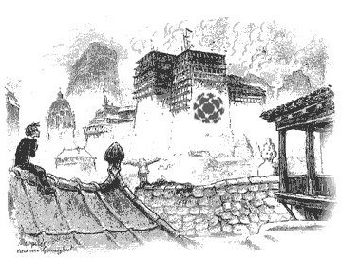

Gormenghast begins with a birth. Titus, 77th Earl of Groan is born, and throughout Gormenghast Castle, everyone is jubilant, with the exception of one high dangerously imaginative kitchen boy called Steerpike. John Constable’s adaptation takes the vast trilogy of novels and lets the youth in revolt uprising present in the book come to the forefront. In a city proudly proclaiming “No Change” and steeping itself in tradition and ritual, the young Titus and Steerpike make rival defiance to their world. One rises through the class structure with ruthless cunning. One fights against the roles he is assumed to take. One moves with seduction, murder and arson. The other is a hot-headed and dangerous rebel.

What happens when the immovable object of iron clad tradition and rock-like ritual meets the unstoppable force of defiant youth with a savage hunger for change?

Director Details

Who am I? I am Andy! I have been a SEDOS member since Comic Potential in 2007, so this show will mark my 6th anniversary with SEDOS.

This will be the fourth time I have directed for the company, previous shows being Julius Caesar (as co-director), Rosencrantz and Guildenstern are Dead, and The Tragedy of the Prince of Denmark (an adaptation of Hamlet that we took to Edinburgh. I have also been an actor (Comic Potential, Mary Stuart, Festen, Complete Works of William Shakespeare Abridged, Goss Indecency), a writer (Stag Nation, 6 plays, 7 Days) and a director.

I love to work on plays that are dark, or that have a sense of humour, or have a dark sense of humour. I like characters that are warped. I like stories where nobody is quite good and nobody is quite bad. I lean towards plays that a friend has previously described as “bonkers”. He is 80% accurate in that summation.

If you love dark stories, thinking outside the box, exploring new ideas in performance, dancing when you can’t, singing when you shouldn’t, putting up your hand and saying “what about this?”, putting your hand down when someone has an idea you want to hear more about, and if you can entertain me by your presence alone, YOU are perfect for me.

Roles Available

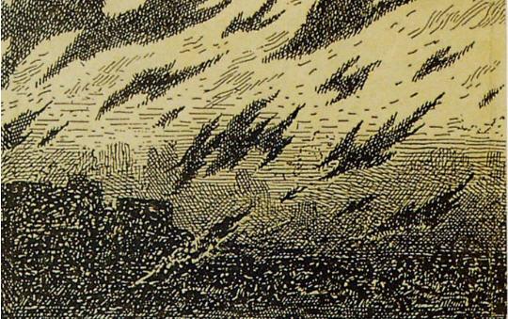
We will be looking for a cast of 15. Each actor will have a specific role, be it main character or “servant 3”, but all will be a member of the “ensemble” as well, and crucial to the precise running of the performance.

The actors and directing team will be working on making the unstageable stageable.

Obviously some characters will be a constant presence in the play, so if there were a preference for that (or a preference for being an ensemble member rather than being a more specific role), that would not be an obstacle in the casting process.

Gormenghast is a book FULL of what I like to think of as “Beautiful Monsters”. The characters are larger than life and almost cartoonish in Peake’s description of them. Not all of them make it into the adaptations, unfortunately. Sourdust is blended with Barquentine. Irma Prunesquallor and Nannie Slagg are not in. Neither is dear Bellgrove.

For details check out the character description document. In it are the key roles, both large and small. There are lines and moments for guards and servants to make up the rest of the roles.
IMPORTANT NOTE
All roles will be open to all actors. You may be a young pretty five foot nothing dancer, but be the perfect person for the fat, oozing chef. Or you may be the seasoned heroic dramatic lead and end up as the Countess if that hat fits you best. Don’t be afraid of being constrained by the gender, physicality or attitude of the characters!

I strongly encourage you to look at the novels before the audition, although it is not essential. A FREE COPY will be given to all those cast because I want you to be familiar with the source.

Please don’t look at the BBC version as any kind of influence. It’s what introduced me to the world of Gormenghast, it has a cracking cast, and it looks great, but it’s not right for this show and I will be staying well clear.

Auditions
First round 20th or 22nd Nov 2012 7-9:30. Call backs will be held on Saturday 24th Nov 2012 between 10-6. Please keep the call back time free, or let us know when registering if you cannot make it. If you would like to audition but are not available for first round, please do get in touch still as we may put another date on.
Auditions will consist of:

- Scene/character work
- Reading of an extract from the novel
- A physical audition to see how you make something out of nothing
- “Playing with objects”

There is nothing directly to prepare, but familiarising yourself with Gormenghast will do you a favour.
Registering for Auditions
To register for audition please email gormenghastsedos@gmail.com to confirm a place. Make the subject Gormenghast Audition. Please include the date you wish to attend first round (20th or 22nd Nov), your name, and any parts (if any) you may be interested in.

Rehearsals
Rehearsals will begin on 27th November and will be Tues/Thurs Evening and Saturday Day time. We are splitting the rehearsal period in two. Phase One 27th Nov- 15th Dec with some initial ensemble and text work. There will then be a break for Christmas/New Year returning from the 5th Jan until the show. In the new year Tues/Thur/Sat will remain.
Show Fees
Sedos is one of London's pre-eminent amateur theatre societies, producing quality shows to the highest standards. To perform in Gormenghast you must be a member of Sedos (membership is currently £30 per year) and pay a participation fee of £30. There is a £5 audition fee for non-Sedos members. If you are cast in the show, your audition fee will be deducted from your participation fee.

Excited but not an onstage person?

DESIGNERS/ARTISTS/VISIONARIES/CRAFTSMEN NEEDED

To create the world of Gormenghast on stage I am hoping to work with a team who can work with the tone and look I have in mind for the show.

The tone I need is of a dusty derelict moth-eaten abandoned toy box in the corner of some neglected attic, light streaming through the roles in the roof, catching the grit floating in the air.

Set
Andy has a set design in mind, but would like to coordinate on it.

Costume
The characters are the real selling point of the show, so nailing the look, the costume, the make up of them would be a fantastic project for someone wanting to showcase their costume design skills. The character notes can give you an idea on how people should look, and I’d be very keen for anyone wanting to try their hand at this daring project.

Puppetry
The show requires a few special moments with cats, birds and monkeys. I intend to use puppetry, and would REALLY LOVE to hear from anyone who has done puppetry before, or knows any puppeteers. Attached to this I would love to hear from anyone skilled in crafts. If you can MAKE stuff… carvings, stitchings, paintings, I’d love to hear from you.

We are really excited about this show and hope you will be as well. If you have any questions about on or off stage work then please do get in touch (emails on front page) We hope you have been enticed to get involved!

Thanks!
Andy and Matt

